BLUSH
Retail & Wholesale Management
Salesforce Architecture Summary | Phase 1
Prepared by: Swapnil Rupnar

Project goal
My plan is to bring Blush’s customer, product, sales and billing work into one Salesforce app instead of managing it in separate spreadsheets. The design covers both Retail and Wholesale sales, with automation for pricing, order calculations, follow-ups and invoice generation.

Solution at a glance
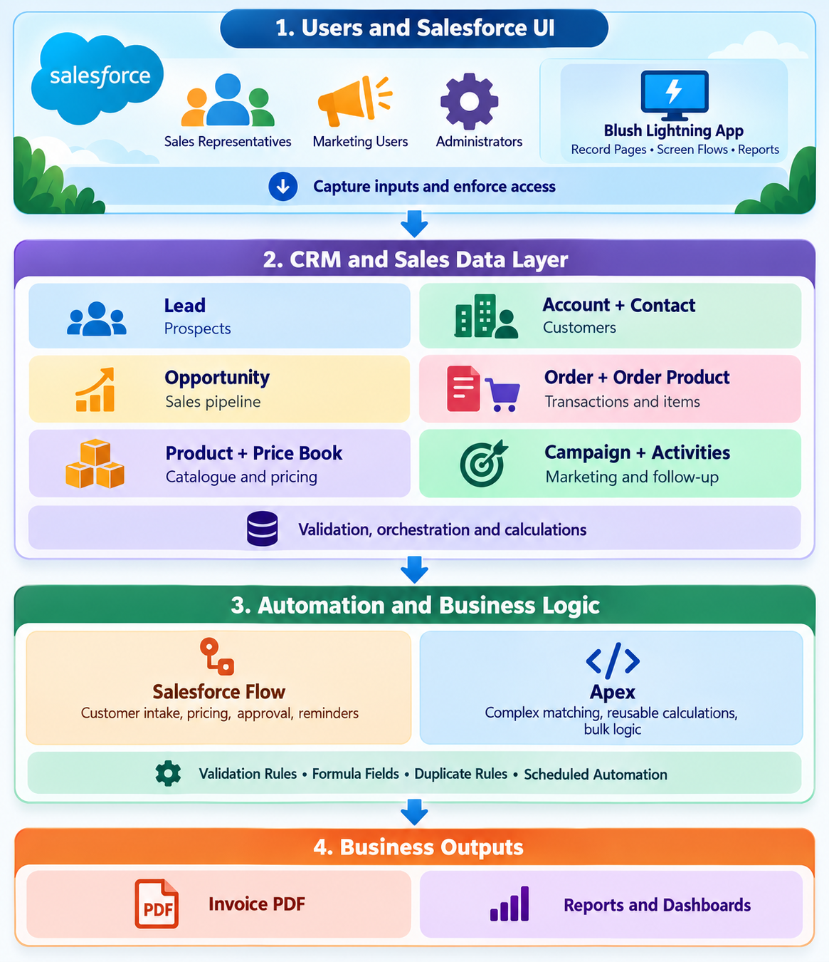
Figure 1. Overall architecture: Salesforce users, CRM data, automation and business outputs.
Implementation approach: Use standard Salesforce objects wherever possible, Flow for guided and scheduled automation, Apex for complex/reusable logic, and a Visualforce page to generate the invoice PDF.

1. Data model and relationships
The model keeps each business record in one place and connects the sales process from prospect to invoice.
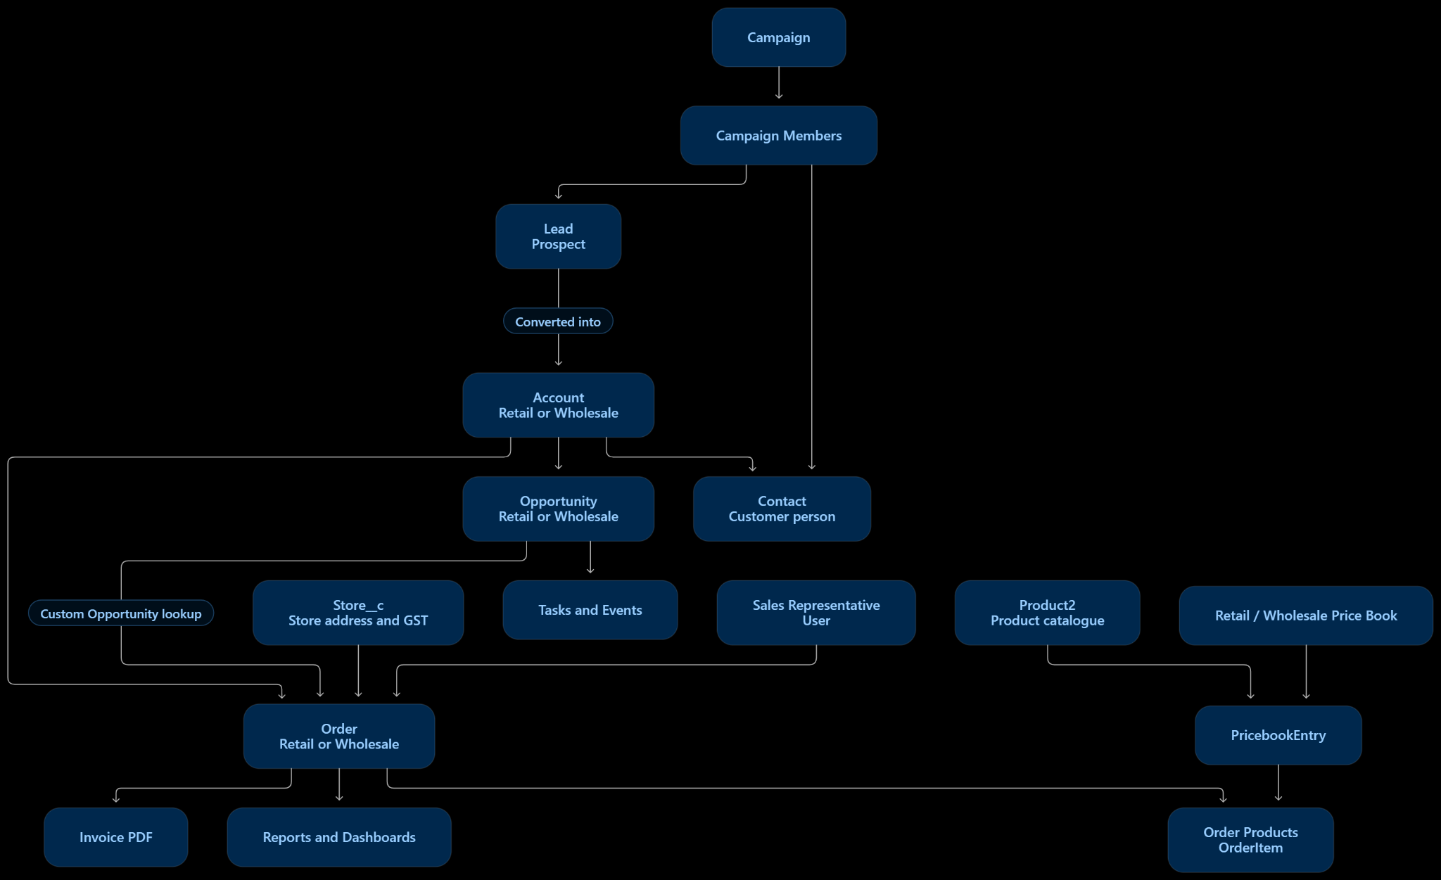
Figure 2. Main object relationships for Blush. Custom lookups connect Orders to Opportunities and Stores.

Main objects
Object | Purpose in the project
Lead | Stores prospects before qualification or conversion.
Account & Contact | Stores Retail/Wholesale customers and their people.
Opportunity | Tracks the sales pipeline and sales channel.
Product & Price Books | Stores the catalogue and separate Retail/Wholesale prices.
Order & Order Product | Stores the transaction, quantities, discounts, tax and totals.
Store__c | Stores branch address, phone and GSTIN for the invoice.
Campaign, Tasks & Events | Supports marketing activity and sales follow-up.

Relationships to configure
- Account → Contact / Opportunity: one customer can have several contacts and opportunities.
- Opportunity → Order: add an Opportunity__c lookup on Order to keep the originating deal connected.
- Order → Order Products: each order contains one or more product lines.
- Product → Price Book Entry: the same product can have different Retail and Wholesale prices; keep an active Standard Price Book entry as well.
- Order → Store / Sales Representative: use Store__c and a User lookup so the invoice and commission use the correct branch and owner.

2. Customer intake flow
This Screen Flow is launched when a Sales Representative starts a new sale. It checks for an existing Lead or customer before creating records, helping reduce duplicate customer data.
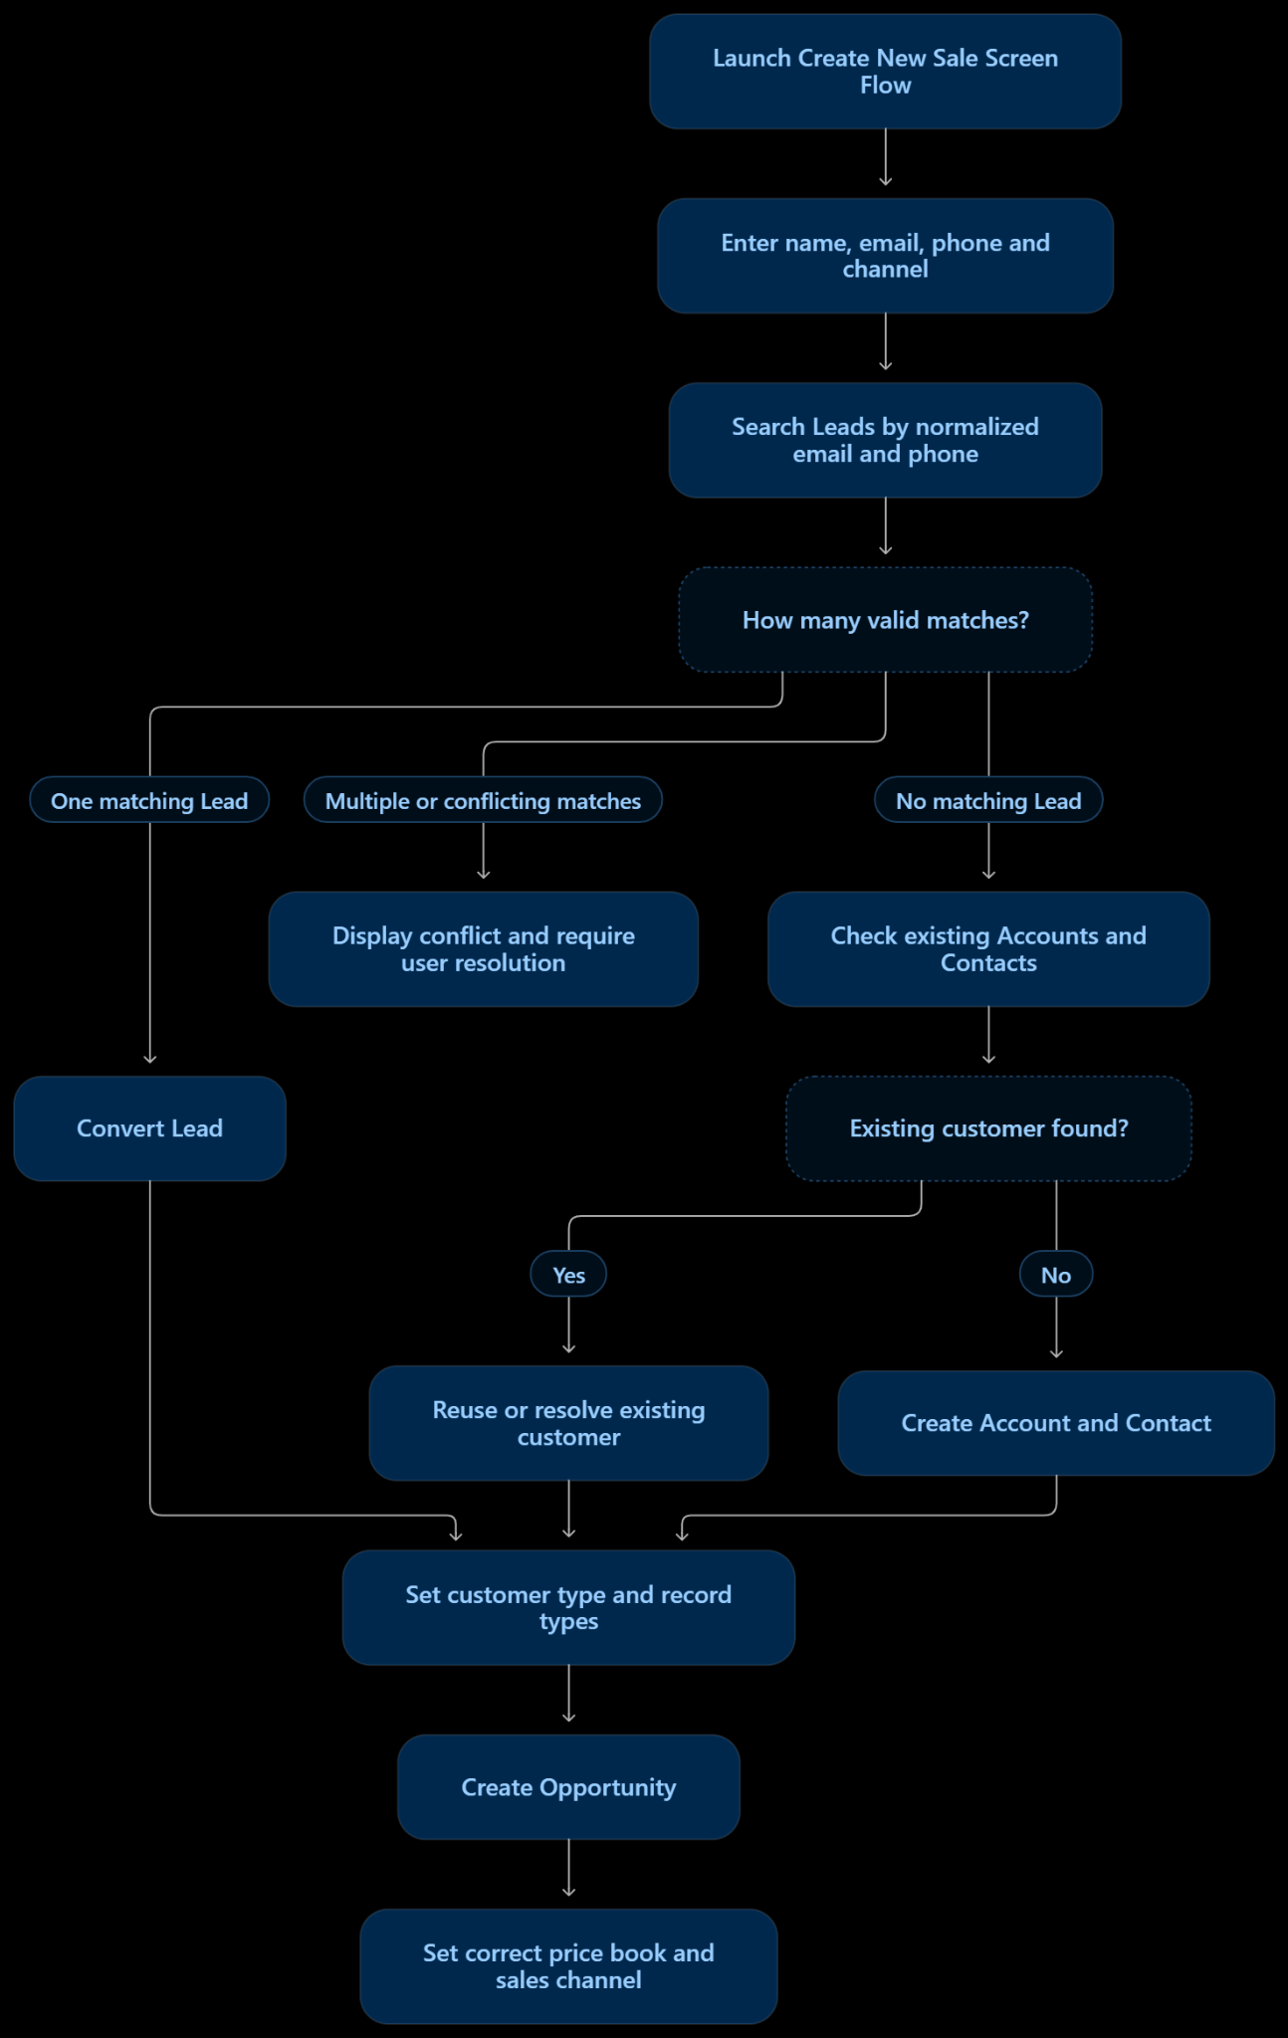
Figure 3. New sale Screen Flow: Lead matching, customer resolution and Opportunity setup.

Key decision points
- One matching Lead: convert the Lead and continue with the resulting customer records.
- Multiple or conflicting matches: stop automatic conversion and ask the user to resolve the conflict.
- No matching Lead: check Accounts and Contacts; reuse the correct customer or create a new Account and Contact.
- Finish setup: set the Retail/Wholesale customer type and record types, create the Opportunity, and use the matching sales channel and Price Book.

3. Main automation and business rules

A. Product and Price Book maintenance
- When Product changes: ensure its active Standard Price Book entry exists.
- Retail flag is enabled: create or update the Retail entry at the base price; otherwise do not sell it in Retail.
- Wholesale flag is enabled: create or update the Wholesale entry at 70% of base price; otherwise do not sell it Wholesale.
- Implementation: start with a record-triggered Flow; use a reusable Apex service if the Price Book Entry upsert cannot be handled reliably in Flow.

B. Order processing and invoice PDF
Create Order from Opportunity  - Confirm customer, sales channel, Store and matching Price Book.  - Create Order and Order Products, then calculate discounts, GST, total and commission.  - Route qualifying discounts for approval and block Sales edits after payment.  - Generate the PDF from the Order using BlushInvoicePdf and BlushInvoiceController. | 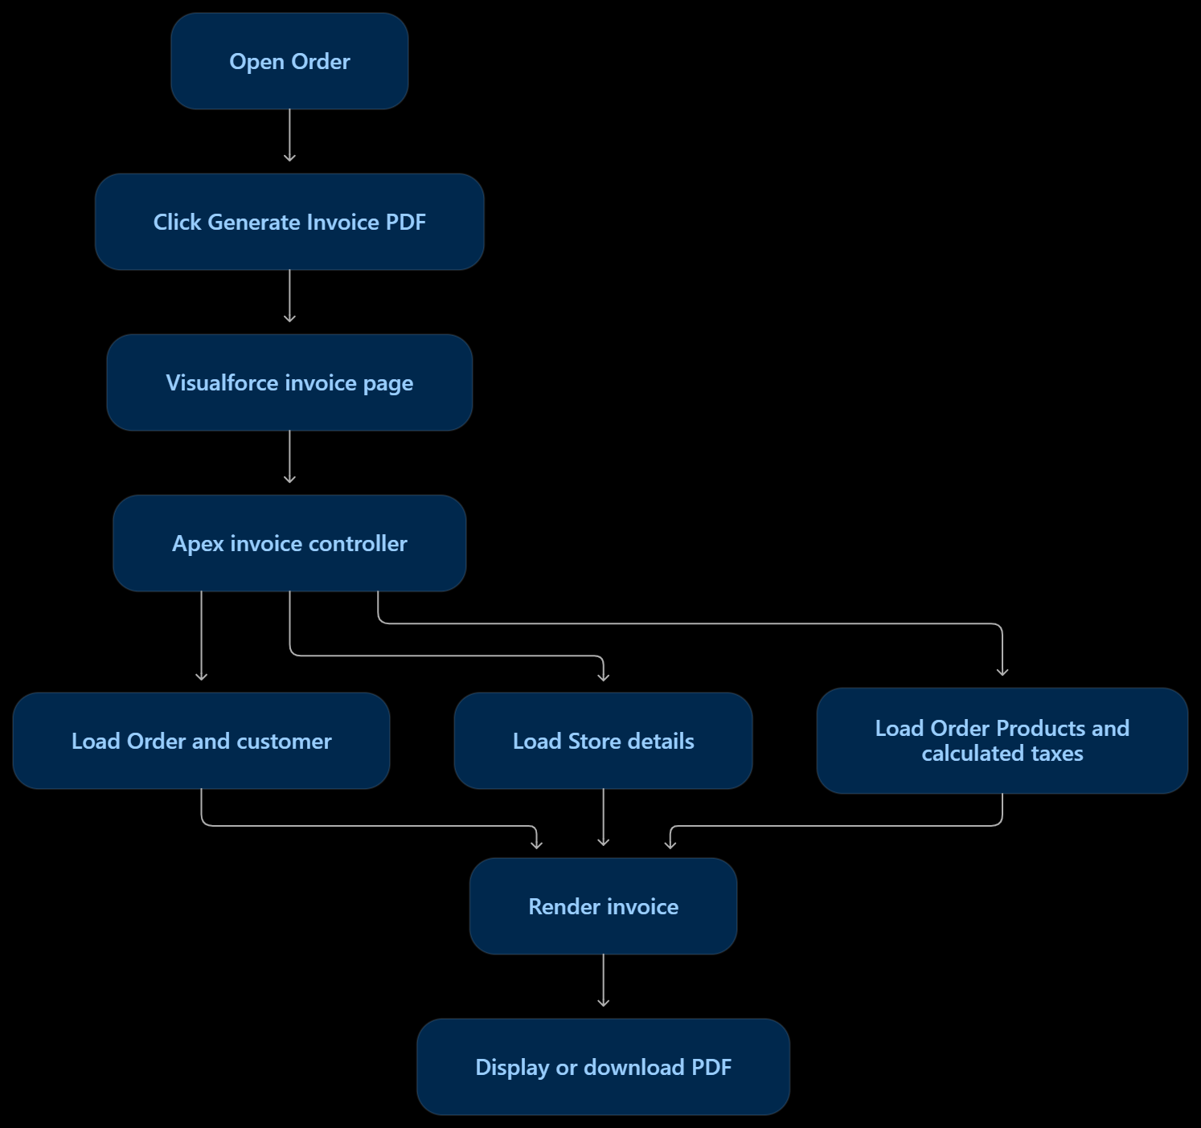

C. Daily follow-up reminders
A Schedule-Triggered Flow checks open Opportunities and qualifying unfinished Tasks/Events dated within the last five days. If the Opportunity has not received a reminder before, it creates one follow-up Task for the Opportunity owner and marks the reminder-tracking checkbox to prevent duplicates.

Calculation rules
Rule | Proposed handling
Taxable amount | (Unit Price − Discount per unit) × Quantity.
GST | Garments: 5% for amounts up to ₹1,000 and 12% above ₹1,000; Jewellery: 3%.
GST split | Maharashtra: CGST + SGST; outside Maharashtra: IGST, as required by the assignment.
Commission | 1% of the effective order amount when it is ≤ ₹1,000; ₹30 when it is > ₹1,000.

4. Testing approach
Testing will cover Apex unit tests, Flow debug runs, end-to-end scenarios and regression checks. Each test should verify expected records, field values, calculations and error handling.
- Apex test classes: Create @isTest classes such as BlushCustomerIntakeServiceTest, BlushProductPricingServiceTest, BlushOrderCalculationServiceTest (including OrderItemTrigger), BlushDiscountApprovalServiceTest and BlushInvoiceControllerTest. Create test data inside each test, use System.assertEquals for expected results and Test.startTest()/Test.stopTest() where needed; avoid SeeAllData=true. Cover success, failure, boundary and bulk scenarios. Target at least 75% org-wide Apex coverage for deployment and ensure every trigger is tested.
- Customer intake: Test zero, one and multiple Lead matches, normalized email/phone, conflicting matches, existing customers and new Account/Contact creation. Verify no unwanted duplicates and the correct Account, record type, Opportunity owner and sales channel.
- Product and Price Books: Test Retail-only, Wholesale-only, both-channel and neither-channel products. Verify the active Standard Price Book entry, Retail price at base price, Wholesale price at 70% of base price, channel availability and no duplicate entries after repeated updates.
- Order lines and calculations: Test Order creation and relationships to Opportunity, Account, Store, Sales Representative and Price Book. Insert, update and delete multiple Order Products; verify quantity, per-unit discount, GST rates at and around ₹1,000, CGST/SGST versus IGST, order totals and commission for values ≤ ₹1,000 and > ₹1,000.
- Discount approval and paid-order protection: Test discounts below and above the approval threshold, approval and rejection outcomes, and attempts by Sales users to edit a Paid Order or its Order Products. Verify that blocked changes leave data unchanged.
- Scheduled follow-up Flow: Test open and closed Opportunities, incomplete Tasks/Events inside and outside the last-five-days window, correct Task owner and relationship, and repeated scheduled runs. Verify that each qualifying Opportunity receives no more than one reminder.
- Invoice PDF: Test BlushInvoiceController data loading and invalid/missing Order handling with Apex tests. Then manually inspect the generated PDF for invoice number/date, customer and Store details, GSTIN, product rows, discounts, applicable tax components, totals and return/exchange terms.
- Reports, security and regression: Check the current-month Campaign filter, representative ranking, monthly/quarterly figures and Retail/Wholesale summaries. Test Sales and Marketing permissions, record sharing and field access, then rerun the full test set after changes.

