1) Break up 192.168.1.64/26 to support as many subnets as possible with 8 hosts per subnet.

Formula for number of hosts 2n – 2

**21 - 2** = 0 Hosts

**22** – 2 = 2 Hosts

**23** – 2 = 6 Hosts

**24** – 2 = 14 Hosts [satisfied]

**25** – 2 = 30 Hosts [wasting of hosts]

So, we can see from above calculations we require at least 4 bits in the host portion to satisfy our requirements. We currently have 6 bits in the host portion so we need to give two more bits to the subnet portion so it satisfies our condition.

Before changes

Network Subnet Host

192.168.1.01 00 0000 = 192.168.1.64/26

After changes

Network Subnet Host

192.168.1.0100 0000 = 192.168.1.64/28 [1st subnet]

192.168.1.0101 0000 = 192.168.1.80/28 [2nd subnet]

192.168.1.0110 0000 = 192.168.1.96/28 [3rd subnet]

192.168.1.0111 0000 = 192.168.1.112/28 [4th subnet]

4) Subnet the last new subnet you got from 192.168.1.64/26 with /30 masks and then allocate the subnets to the serial links. Configure the routers appropriately

Here is our last new subnet we got from subnetting 192.168.1.64/26.

Network Subnet Host

192.168.1.0111 0000 = 192.168.1.112/28

Now we need to further subnet it to /30 mask.

Network Subnet Host

192.168.1.011100 00 = 192.168.1.112/30

192.168.1.011101 00 = 192.168.1.116/30

192.168.1.011110 00 = 192.168.1.120/30

192.168.1.011111 00 = 192.168.1.124/30

Previous configurations [Router1 = 192.168.1.64/26]

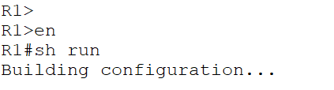

New configurations [Router1 = 192.168.1.112/30]

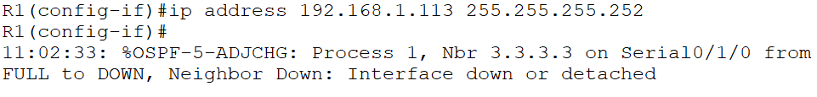

We can see that it shows us that **OSPF neighbor relationship has come down it’s** because both the router should be in the same subnet. So, lets change the configurations of the **IntRouter**.

Previous configurations [Router1 = 192.168.1.64/26]

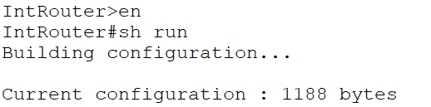

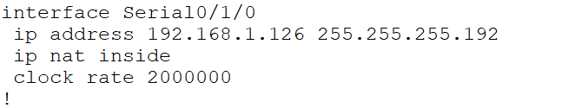

New configurations [Router1 = 192.168.1.112/30]   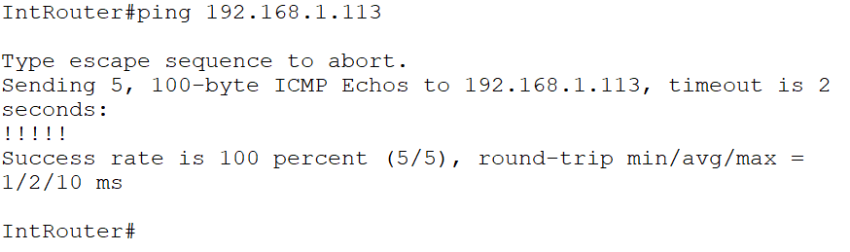

Let’s configure our **Site-03 Router-4** with the Network Address = **192.168.1.116/30**

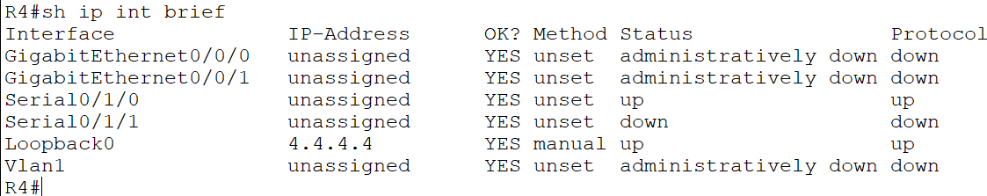  

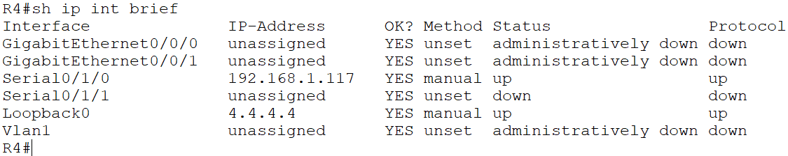

Now configure IntRouter s0/2/0 with last IP of subnet **192.168.1.116/30**

**Last IP = 192.168.1.118/30**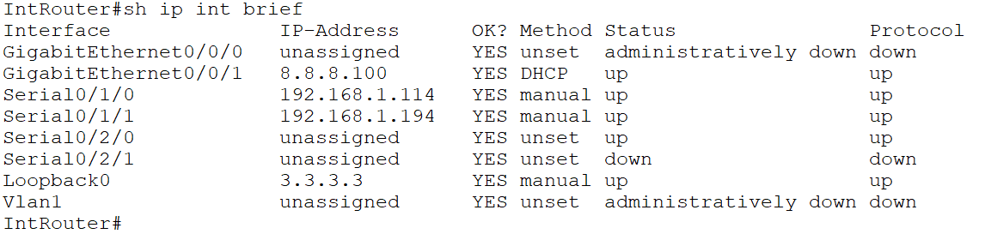

**We can see that s0/2/0 IP is currently unassigned and status is also down**

**We, can also see that OSPF network relationship has established. So, we can ping the router now.** 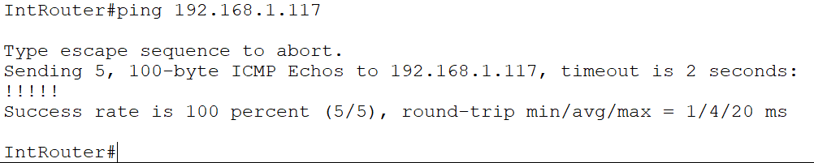

**Now we add name-server to our R4 so it can ping the internet servers.**

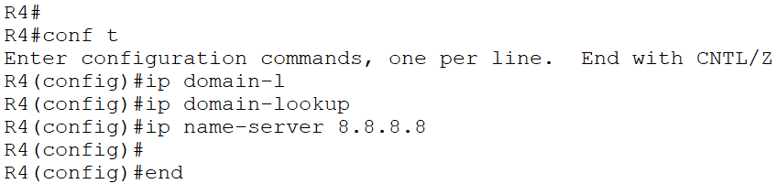

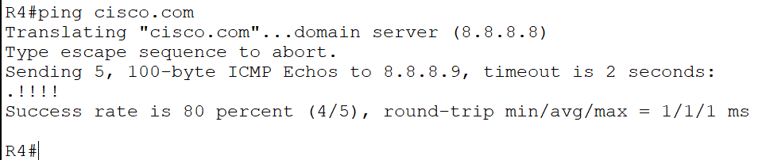

Now let’s configure **R4** with subnet **192.168.1.64/28**

**On int g0/0/0 of R4 = last IP of subnet 192.168.1.78/28**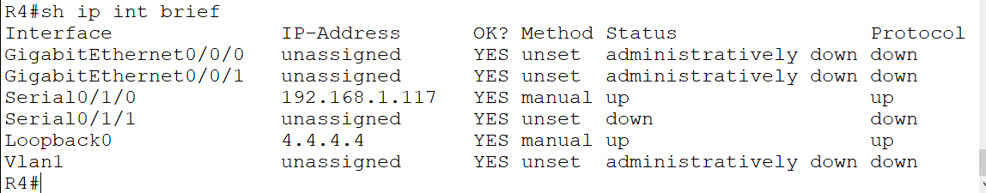 We can see that **int g0/0/0 IP is currently unassigned** and status is also **down**  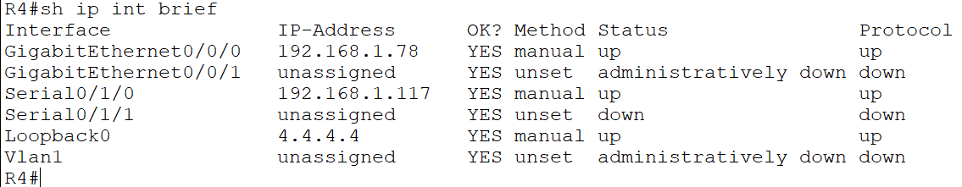

Now let’s configure **Switch** with subnet **192.168.1.64/28**

**On int vlan 1 of Switch = 2nd last IP of subnet 192.168.1.77/28** 

 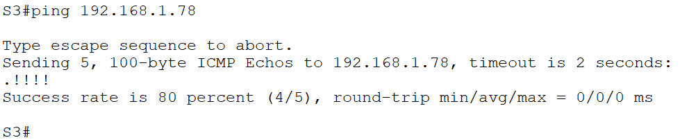

So, we can see that our **switch** can **ping** the **R4.**

**JUST FOR FUN**

**For this topology refer to serial-vlsm.pkt file**

1) Break up 192.168.1.192/26 to support as many subnets as possible with 8 hosts per subnet.

Formula for number of hosts 2n – 2

24 – 2 = 14 hosts [satisfied]

Network Subnet Host

192.168.1.11 00 0000 = 192.168.1.192/26

After changes

Network Subnet Host

192.168.1.110000 00 = 192.168.1.192/30 [1st subnet]

192.168.1.110001 00 = 192.168.1.196/30 [2nd subnet]

192.168.1.110010 00 = 192.168.1.200/30 [3rd subnet]

192.168.1.110011 00 = 192.168.1.204/30 [4th subnet]

192.168.1.111111 00 = 192.168.1.252/30 [last subnet]

4) The last new subnet you got from 192.168.1.252/30 with /30 masks and then allocate the subnets to the serial links. Configure the routers appropriately

Here is our last new subnet we got from subnetting 192.168.1.64/26.

Network Subnet Host

192.168.1.111111 00 = 192.168.1.252/30 [last subnet]

Network Subnet Host

Net 192.168.1.111111 00 = 192.168.1.252/30

1st IP 192.168.1.111111 01 = 192.168.1.253/30

2nd IP 192.168.1.011111 10 = 192.168.1.254/30

broad 192.168.1.011111 11 = 192.168.1.255/30

initial router’s configurations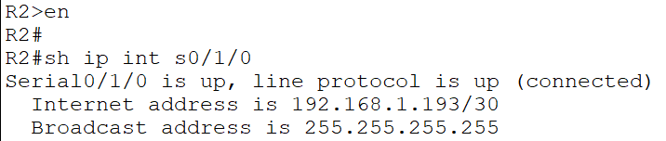

changing router’s configuration

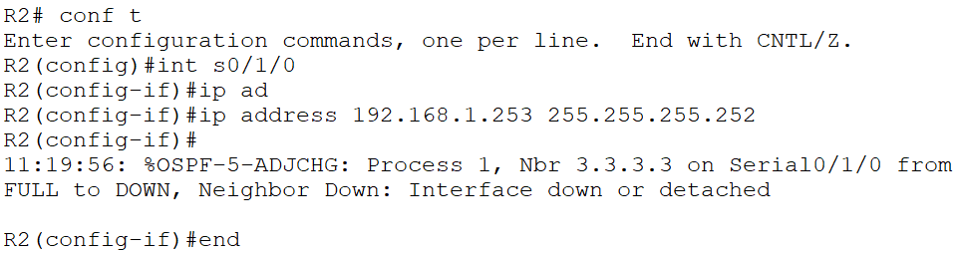From above image OSPF relationship has come down again

Because of this it cannot ping the IntRouter

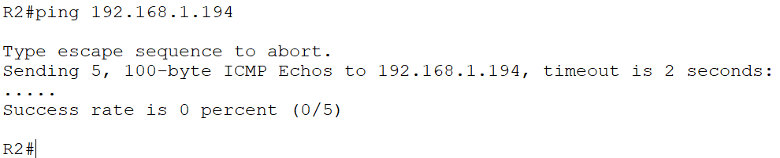

initial configurations of IntRouter

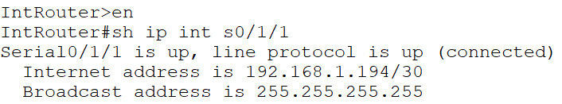

Changing the initial configurations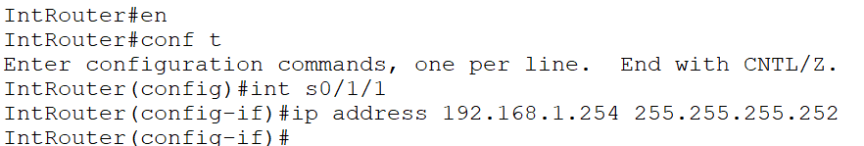

OSPF relationship has come up again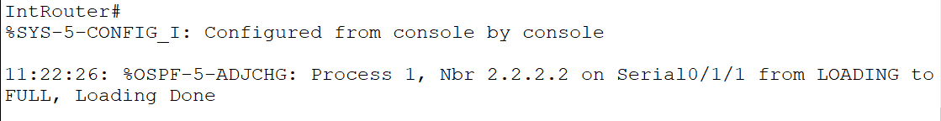

Now we are able to ping again.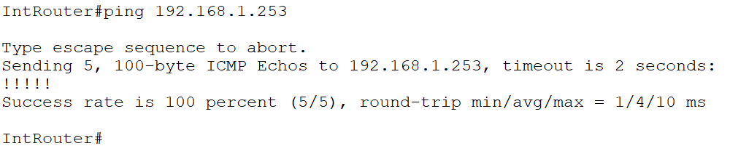

PC3 to PC1

1st it goes to PC3 local router [192.168.1.190/26]

2nd it goes to IntRouter [192.168.1.254/30]

3rd it goes to PC1 local router [192.168.1.113/26]

Finally, it reaches PC1 [192.168.1.2]

