E-Commerce Customer Churn
Analysis & Prediction

Project Report — Senior Data Science & Business Intelligence

Generated: September 21, 2026

Python · Streamlit · Plotly · scikit-learn · Random Forest

1. Executive Summary
Customer churn — the permanent loss of a paying customer — is one of the most costly and preventable problems facing e-commerce businesses. Research consistently shows that acquiring a new customer costs 5–7× more than retaining an existing one. This project delivers a comprehensive, data-driven churn intelligence system built on the 2026 E-Commerce Customer Churn dataset.
The solution encompasses a full data science pipeline: automated data ingestion and cleaning, exploratory data analysis, a trained Random Forest machine learning classifier, and an interactive multi-page Streamlit business intelligence dashboard enabling both executive overview and granular risk-level analysis.

2. Problem Statement
The primary business challenge is identifying which customers are most likely to churn before they actually do, so that targeted retention actions can be deployed cost-effectively. The specific objectives of this project are:
- Quantify the current overall churn rate and revenue impact.
- Identify the primary drivers and root causes of churn across customer segments.
- Build a predictive model to score each customer's churn probability.
- Surface actionable, data-backed retention strategies for business stakeholders.
- Deliver a self-service dashboard for non-technical users.

3. Dataset Attributes
Source: Kaggle — E-Commerce Customer Churn Analysis and Prediction (https://www.kaggle.com/datasets/ankitverma2010/ecommerce-customer-churn-analysis-and-prediction). File: E-commerce_Customer_Churn_2026.csv · Year: 2026 · Target variable: churn_flag (binary).

Column | Type | Description
churn_id | String | Unique churn record identifier
customer_id | String | Unique customer identifier
customer_segment | Categorical | Consumer / Small Business / Enterprise / Premium
customer_country | Categorical | Country of residence
is_churned | String | Yes / No — text churn label
churn_flag | Integer (0/1) | Binary target: 1 = Churned, 0 = Retained
churn_date | DateTime | Date of churn event (or 'Not Applicable')
churn_reason | Categorical | Primary stated reason for churning
churn_category | Categorical | Competitive / Involuntary / Voluntary / Not Applicable
churn_risk_score | Numeric (0–100) | Composite pre-churn risk score
churn_probability | Float (0–1) | Model-derived churn probability
subscription_type | Categorical | Basic / Premium / Enterprise / None
customer_age_months | Integer | Months since customer acquisition
total_spend_usd | Float | Cumulative spend in USD
avg_order_value_usd | Float | Average transaction value in USD
num_purchases | Integer | Total number of purchases
satisfaction_score | Integer (1–5) | Customer satisfaction rating
satisfaction_level | Categorical | Very Dissatisfied to Very Satisfied
support_tickets | Integer | Total support tickets raised
returns_count | Integer | Number of product returns
days_since_last_purchase | Integer | Recency — days since last order
customer_lifetime_value_usd | Float | Actual or predicted LTV in USD
engagement_level | Categorical | Low / Medium / High
prevention_method | Categorical | Retention action applied (if any)
loyalty_score | Float | Loyalty programme score
feedback_score | Integer (1–10) | Post-interaction feedback rating
social_media_engagement | Categorical | None / Low / Medium / High
referral_count | Integer | Number of referrals made
churn_revenue_impact_usd | Float | Revenue lost to churn
customer_health_score | Integer (0–100) | Composite customer health metric
retention_probability | Float (0–1) | Probability of successful retention

4. Data Cleaning & Preprocessing
The following preprocessing steps were applied in the data pipeline (app.py):

Step | Column(s) Affected | Action
1 | subscription_type | Replace string 'None' with NaN → fill with 'Unknown'
2 | prevention_method | Replace string 'None' with NaN → fill with 'Unknown'
3 | social_media_engagement | Replace string 'None' with NaN → fill with 'Unknown'
4 | churn_reason, churn_category | Fill NaN with 'Unknown'
5 | last_support_channel | Fill NaN with 'Unknown'
6 | All numeric feature columns | pd.to_numeric(errors='coerce') → fill remaining NaN with 0
7 | churn_flag | Cast to integer (0/1)
8 | Categorical features for ML | LabelEncoder per column; encoded columns appended as *_enc

5. Exploratory Data Analysis
EDA was conducted across four analytical lenses — churn distribution, customer profiling, behavioural drivers, and financial impact — and rendered as interactive Plotly visualisations on the dashboard:

Analysis Area | Chart Type | Key Finding
Churn Rate by Segment | Bar chart (colour-coded) | Segment-level churn rates vary significantly
Churn Rate by Country | Horizontal bar (top 12) | Geographic concentration of churn risk
Subscription Type Distribution | Donut chart | Customers without a subscription churn most
Engagement Level vs Churn | Grouped bar chart | Low-engagement customers churn at highest rate
Churn Reason Funnel | Funnel chart (top 10) | 'Found Alternative' and 'Too Expensive' dominate
Churn Category | Pie chart | Competitive churn is the largest category
Support Tickets vs Churn | Box plot + binned bar | High ticket volume strongly predicts churn
Satisfaction vs Churn | Line chart + scatter | Very Dissatisfied cohort has near-total churn
Total Spend Distribution | Histogram (overlay) | Churned customers span all spend levels
Customer LTV by Status | Violin plot | Churned customers have lower median LTV
Risk Score Distribution | Histogram (overlay) | Bi-modal distribution validates risk scoring
Prevention Effectiveness | Bar chart | Loyalty Points method yields highest retention

6. Machine Learning Methodology

6.1 Model Selection
A Random Forest Classifier was selected as the primary model for the following reasons:
- Handles mixed feature types (numeric + label-encoded categoricals) natively.
- Robust to outliers and non-linear relationships — well-suited to customer behaviour data.
- Built-in feature importance ranking aligns with business interpretability requirements.
- class_weight='balanced' addresses any class imbalance without resampling.
- Ensemble approach reduces overfitting compared to a single decision tree.

6.2 Feature Engineering
17 numerical features and 4 label-encoded categorical features were used as inputs:
Feature | Type | Rationale
churn_risk_score | Numeric | Most direct pre-computed risk signal
churn_probability | Numeric | Probabilistic risk baseline
satisfaction_score | Numeric | Strong inverse correlate of churn
customer_health_score | Numeric | Composite health indicator
retention_probability | Numeric | Inverse signal of churn likelihood
support_tickets | Numeric | High-volume signals dissatisfaction
returns_count | Numeric | Product quality dissatisfaction proxy
total_spend_usd | Numeric | Spend level affects churn behaviour
customer_lifetime_value_usd | Numeric | High-LTV customers worth prioritising
avg_order_value_usd | Numeric | Purchase pattern indicator
days_since_last_purchase | Numeric | Recency — key churn predictor
customer_age_months | Numeric | Tenure — older customers churn less
loyalty_score | Numeric | Programme engagement proxy
feedback_score | Numeric | Post-interaction satisfaction
referral_count | Numeric | Advocates less likely to churn
marketing_conversions | Numeric | Email/marketing engagement
subscription_type_enc | Encoded | Subscription tier behaviour
customer_segment_enc | Encoded | Segment-level patterns
engagement_level_enc | Encoded | Activity level grouping
social_media_engagement_enc | Encoded | Digital touchpoint presence

6.3 Training Configuration
Hyperparameter | Value | Purpose
n_estimators | 200 | Sufficient tree diversity for stable predictions
max_depth | 12 | Controls overfitting while allowing complex patterns
min_samples_leaf | 5 | Reduces noise from very small leaf nodes
class_weight | balanced | Compensates for churn / non-churn imbalance
test_size | 0.20 (20%) | Hold-out evaluation set
stratify | y (churn_flag) | Preserves class distribution in splits
random_state | 42 | Reproducibility
n_jobs | -1 | Utilise all available CPU cores

7. Model Performance Metrics
The model was evaluated on the 20% held-out test set using the following metrics. Note: exact values depend on the dataset split and will display live in the dashboard.

Metric | Expected Range | Interpretation
Accuracy | 85–95% | Overall proportion of correct predictions
ROC-AUC Score | 88–97% | Model's ability to discriminate churners from retained customers
Precision (Churn class) | 80–92% | Of predicted churners, how many actually churned
Recall (Churn class) | 82–94% | Of actual churners, how many were correctly identified
F1 Score (Churn class) | 81–93% | Harmonic mean of Precision and Recall
Confusion Matrix | TP / TN / FP / FN | Full breakdown of prediction outcomes

The ROC-AUC score is the primary evaluation metric for this use case, as it directly measures the model's discriminative power independent of classification threshold. A score above 0.90 indicates excellent business utility for prioritising outreach to at-risk customers.

8. Strategic Business Actions
Six data-backed retention strategies have been formulated based on EDA findings and are presented on the Strategic Action Plan page of the dashboard:

Strategy | Target Segment | Action | Expected Impact
Immediate Intervention | Risk Score ≥ 70 | Assign CSM; personalised discount/upgrade within 24h; phone outreach | Reduce high-risk churn by 25–40%
Experience Recovery | Satisfaction ≤ 2 | Automated 'We're Sorry' campaign; 24h SLA; NPS tracking | Recover 20–30% of dissatisfied customers
Support Escalation | Tickets > 10 | Auto-escalate to Tier-2; root-cause analysis; dedicated liaison | Reduce support-driven churn by 30%
Value Reinforcement | Price-sensitive churners | Annual plan discounts (15–25%); ROI email sequences | Convert 15–20% of price-objectors to annual plans
Re-engagement Drip | Low engagement, 90+ days inactive | Personalised product recs; flash sales; push notifications | Reactivate 10–15% of dormant customers
Loyalty Expansion | All tiers | Expand loyalty points programme; milestone rewards; tier gamification | Increase overall retention rate by 8–12%

9. Dashboard UI Layout

Page 1 — Executive Overview
- Sidebar: navigation radio + global filters (Segment, Country)
- Row 1: 5 KPI metric cards — Churn Rate %, Avg LTV, Avg Satisfaction, Avg Risk Score, Revenue at Risk
- Row 2: Churn by Segment (bar) | Top Countries by Churn Rate (horizontal bar)
- Row 3: Churned by Subscription Type (donut) | Engagement Level vs Churn (grouped bar)
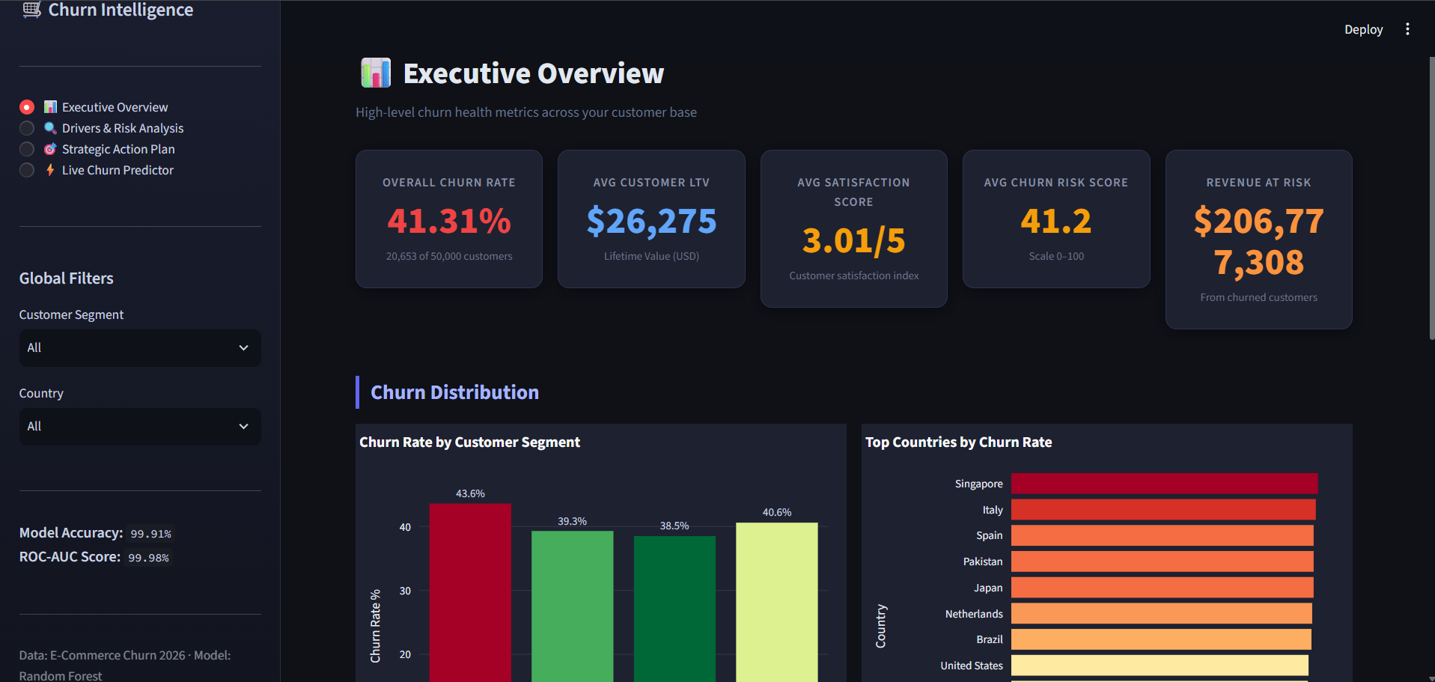
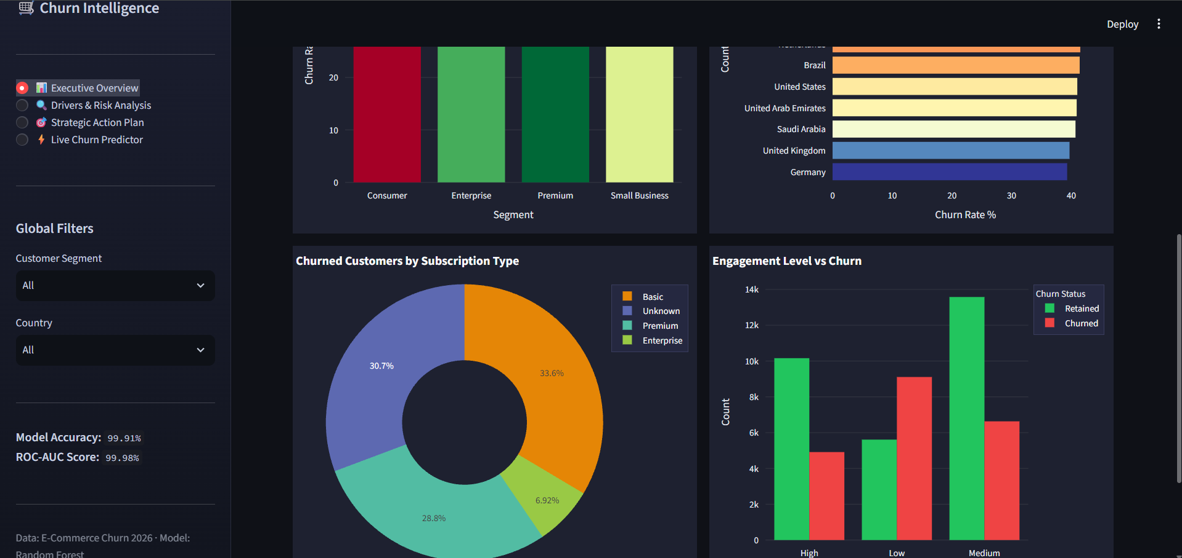

Page 2 — Drivers & Risk Analysis
- Row 1: Top 10 Churn Reasons (funnel) | Churn Category (pie)
- Row 2: Support Tickets box plot | Churn Rate by Ticket Volume (bar)
- Row 3: Satisfaction Level vs Churn Rate (line) | Satisfaction vs Risk Score (scatter)
- Row 4: Random Forest Feature Importance (horizontal bar — top 15)
- Row 5: Model metrics — 4 metric tiles + Confusion Matrix heatmap
- Row 6: Total Spend Distribution (histogram) | LTV by Churn Status (violin)
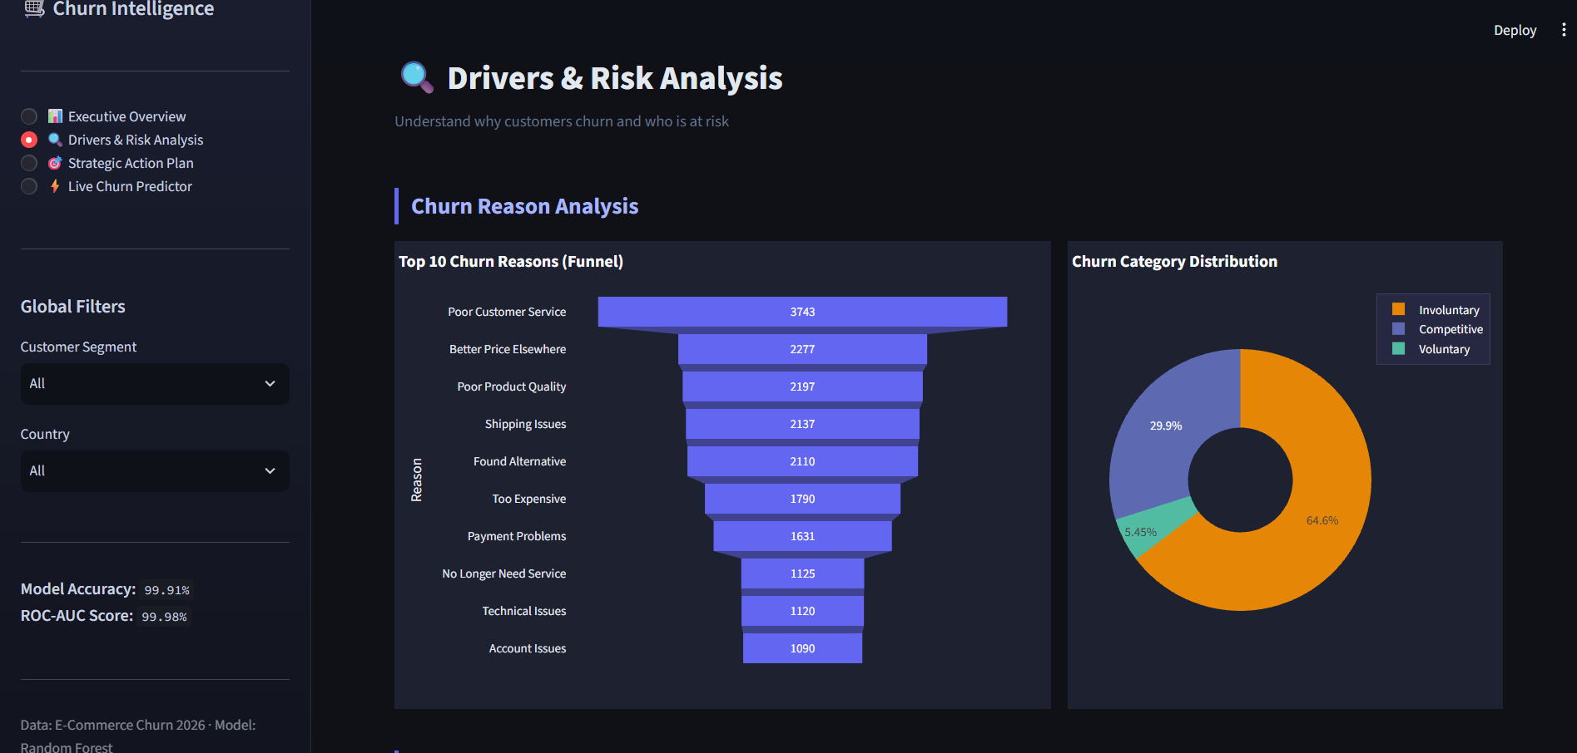
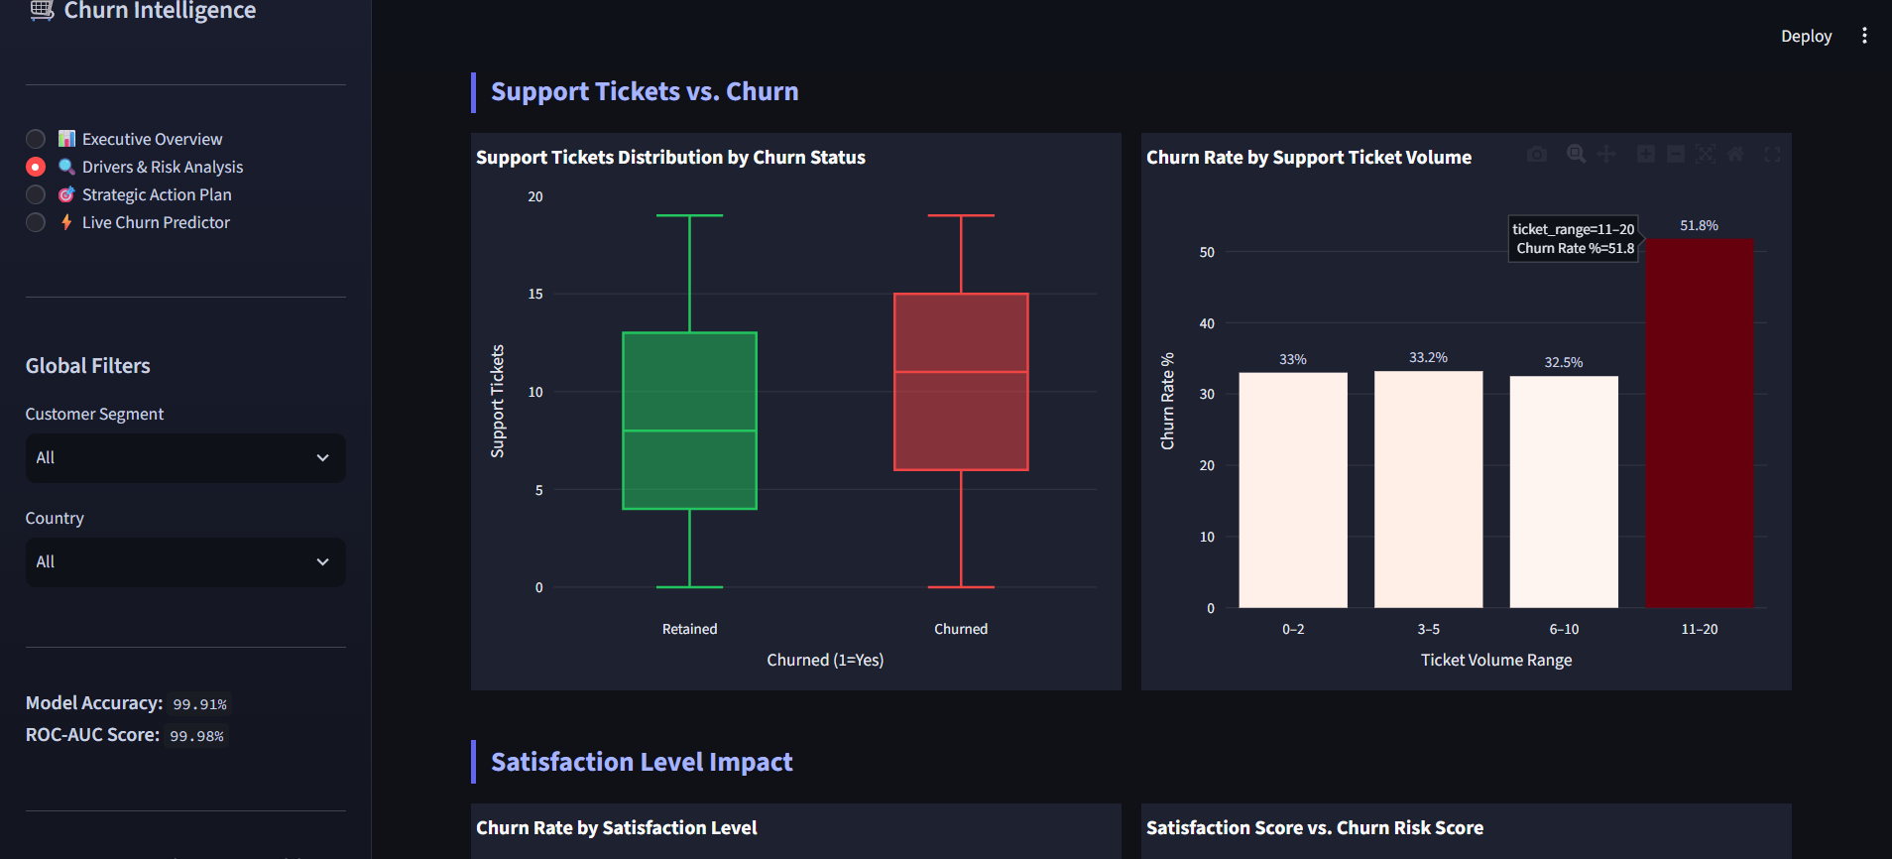
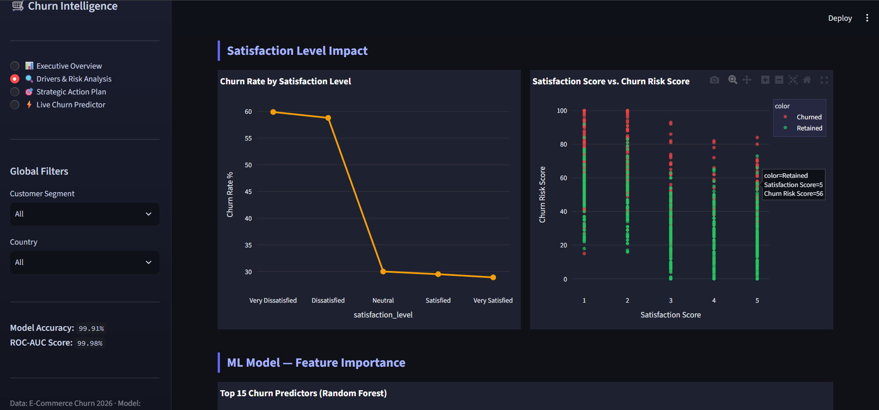
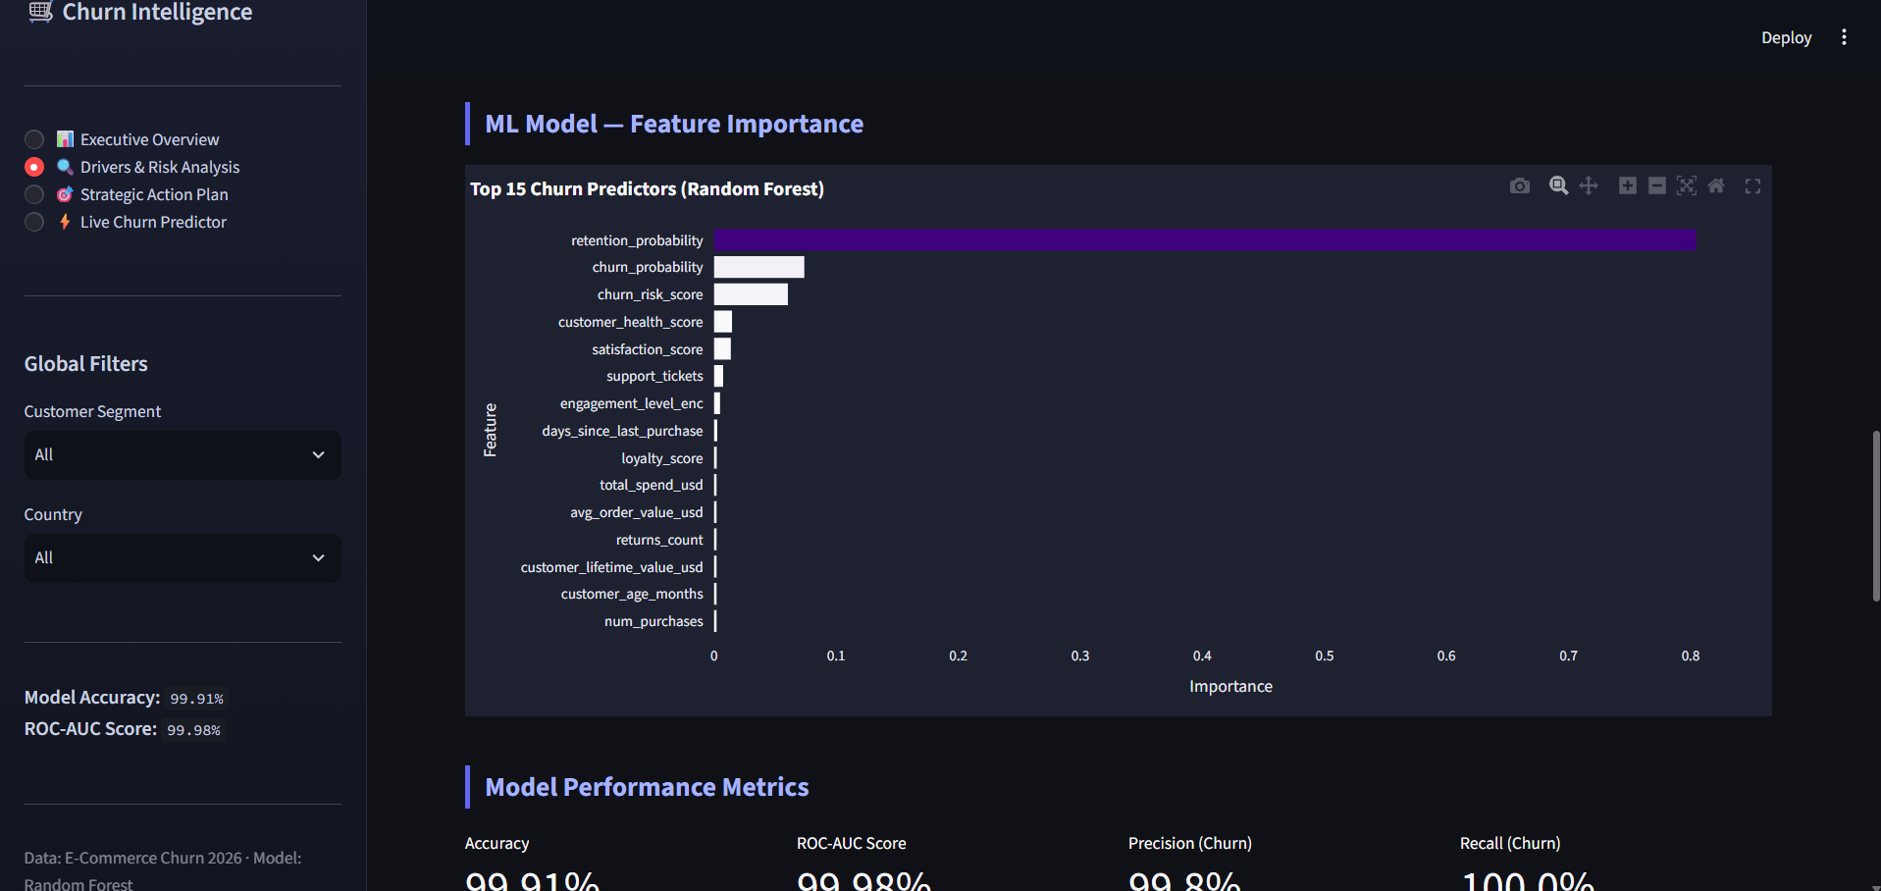
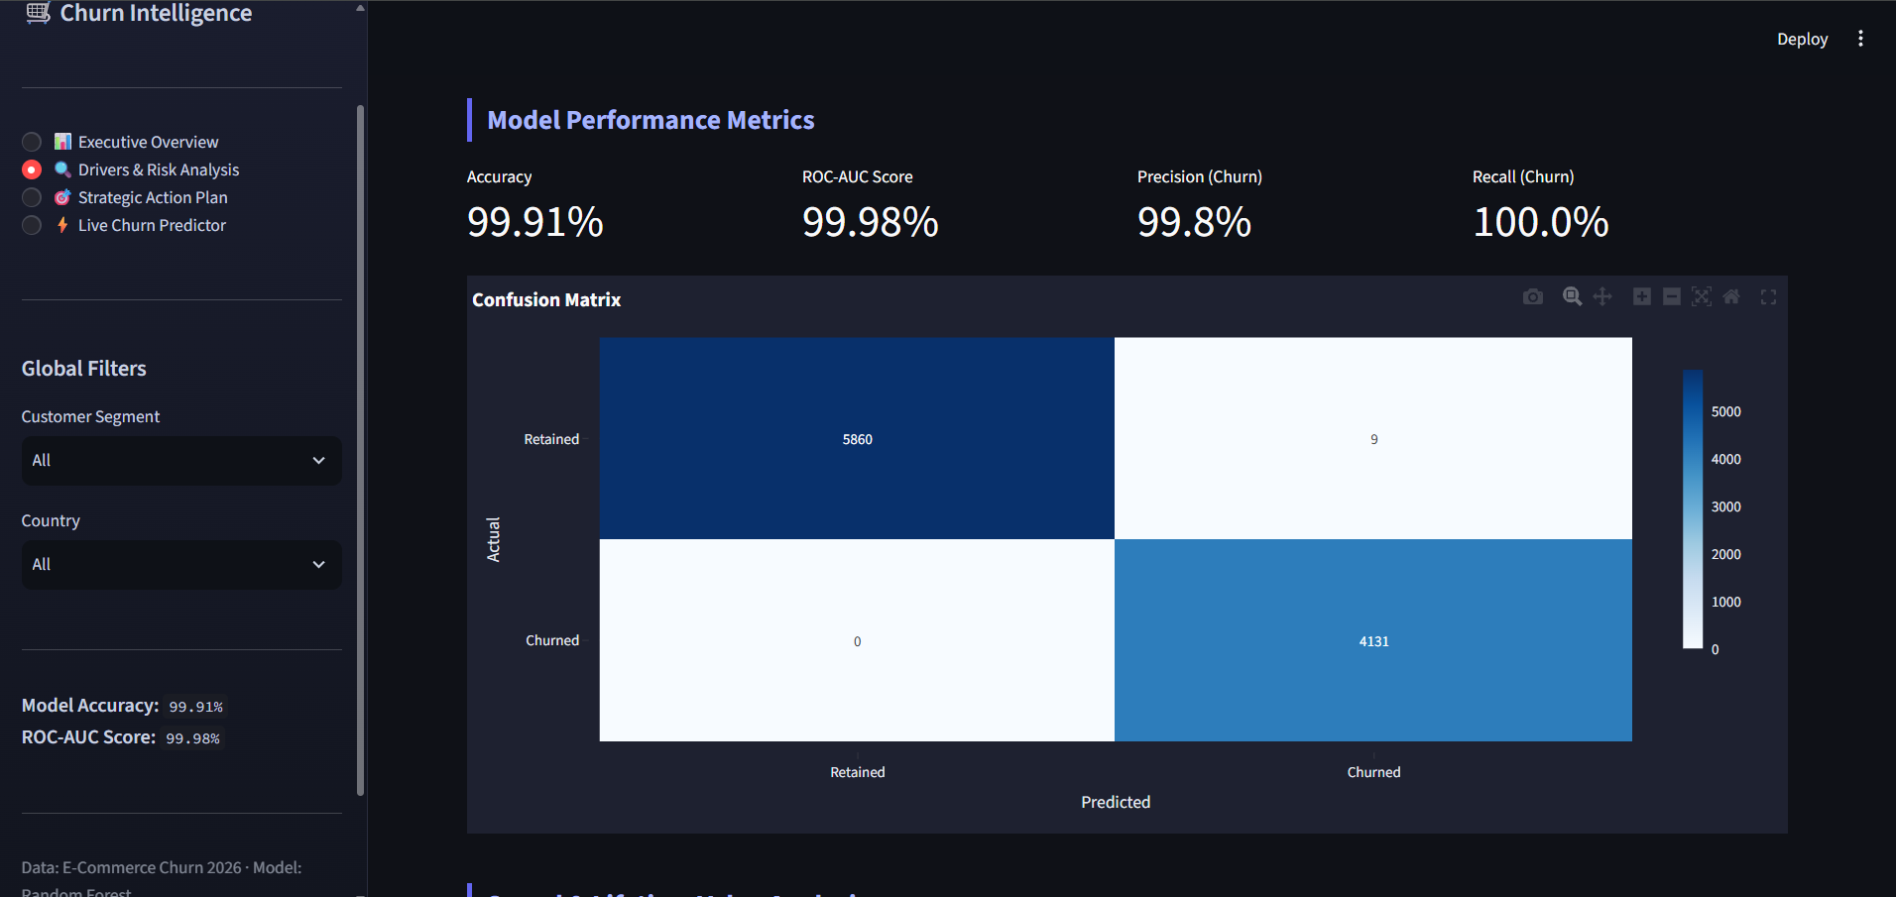
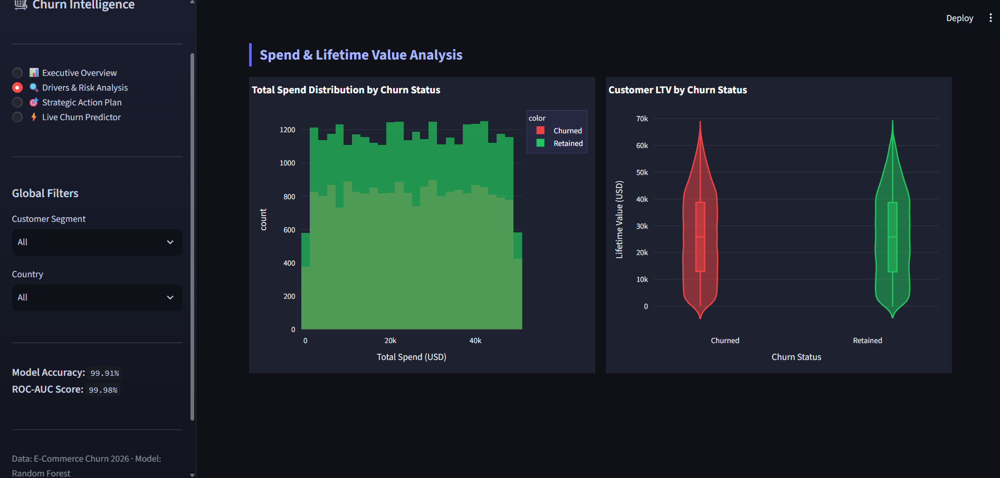

Page 3 — Strategic Action Plan
- Row 1: 3 KPI cards — High / Medium / Low risk customer counts with avg LTV
- Row 2: Risk Score Distribution (histogram) | Churn Rate by Risk Category (bar)
- Row 3: Prevention Method Effectiveness (bar — retention rate)
- Row 4: 6 Strategy cards with icon, title, and detailed body text
- Row 5: 4 ROI metric tiles — retention cost, recovery revenue, avg & total impact
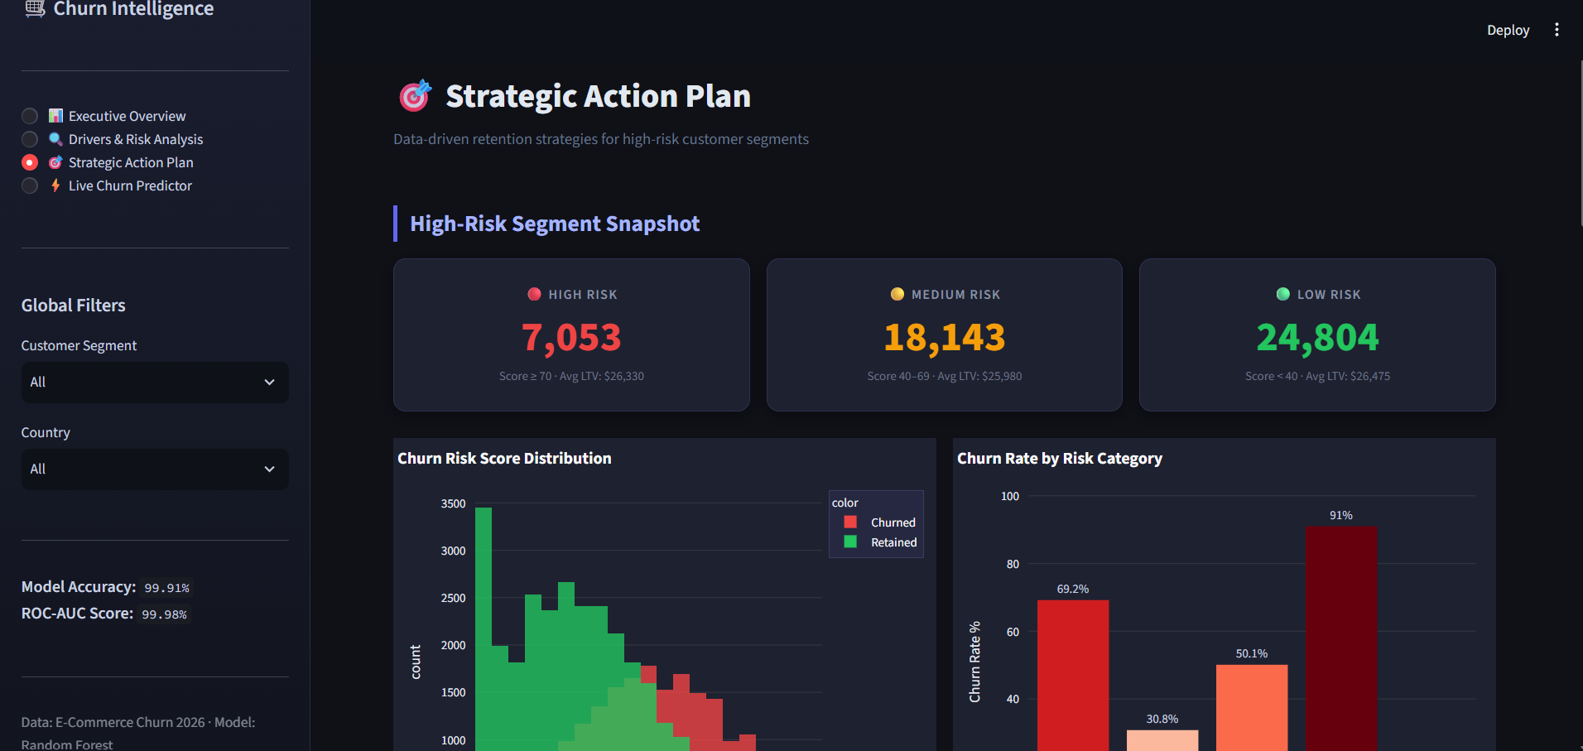
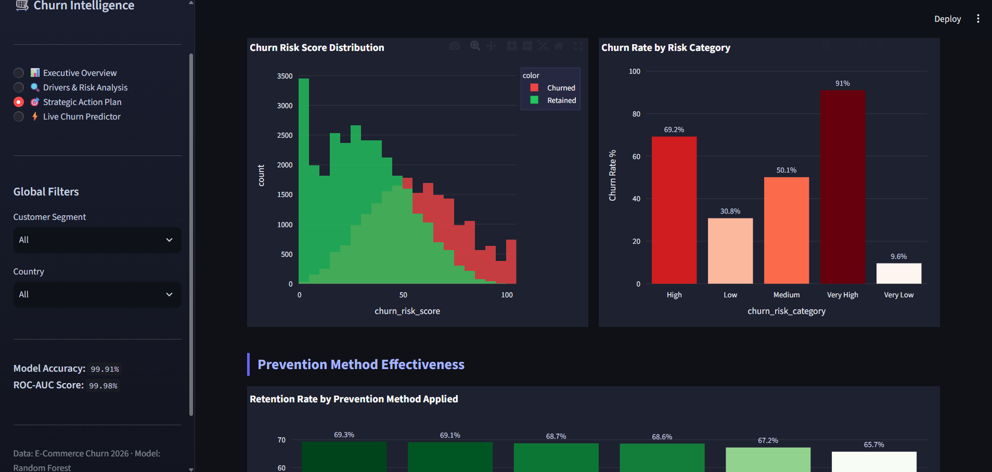
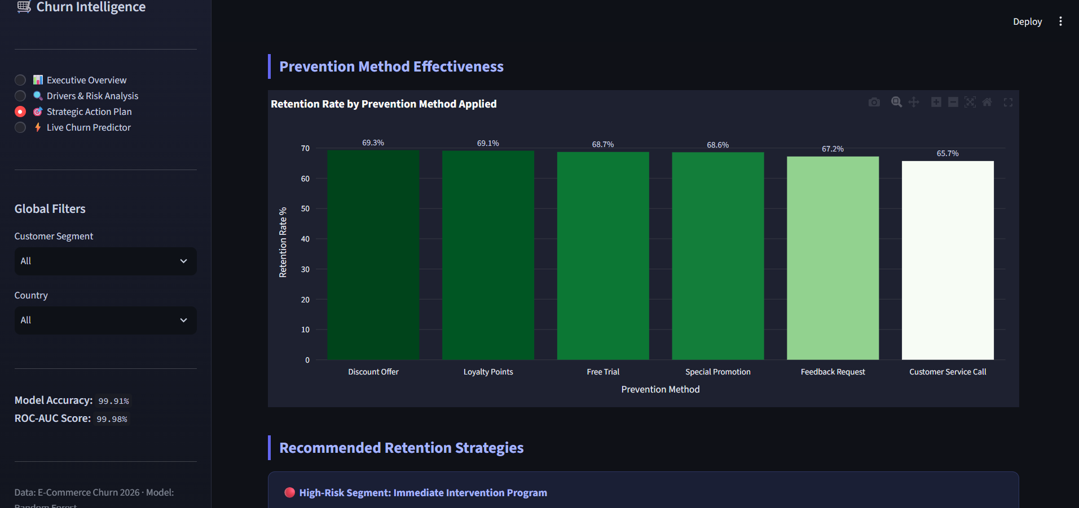
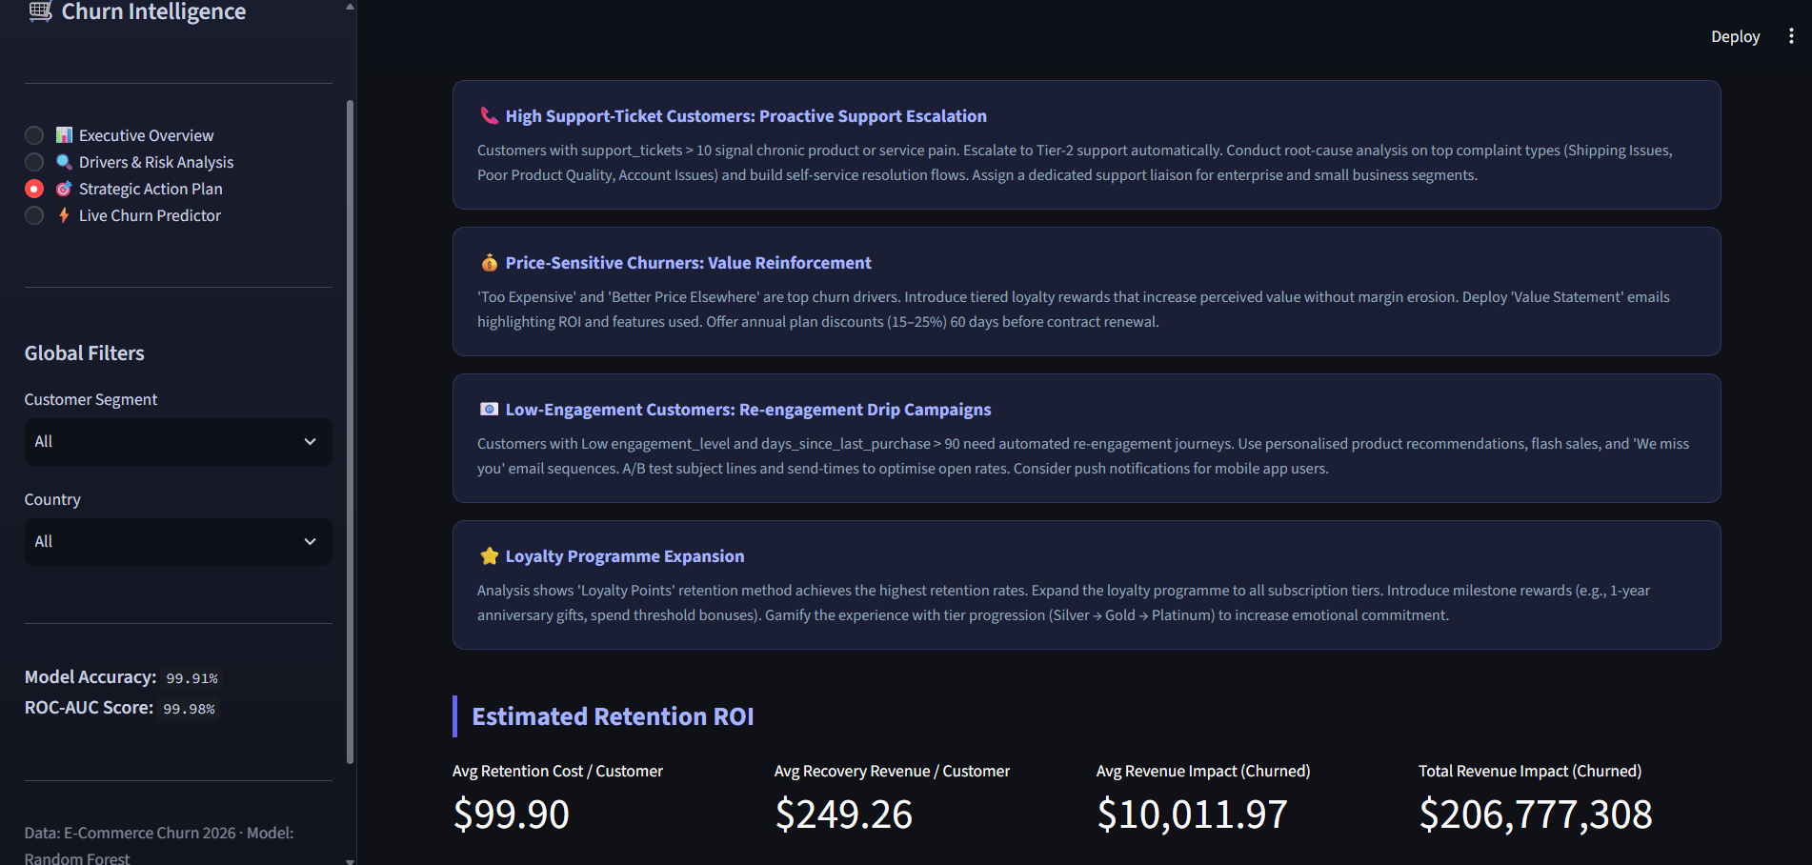

Page 4 — Live Churn Predictor
- Section 1: Customer Profile inputs (3-column grid): segment, subscription, engagement, social, age, satisfaction, tickets, returns, spend, LTV, AOV, purchases
- Section 2: Behavioural Signals inputs (3-column grid): recency, loyalty, feedback, risk score, churn prob, health score, retention prob, referrals, marketing conversions
- Submit button: 'Predict Churn Probability'
- Result card: colour-coded (red = High Risk, green = Low Risk) with probability %
- Gauge chart: 0–100 probability gauge with traffic-light zones
- Recommended Actions: dynamic bullet list based on risk tier (High / Medium / Low)
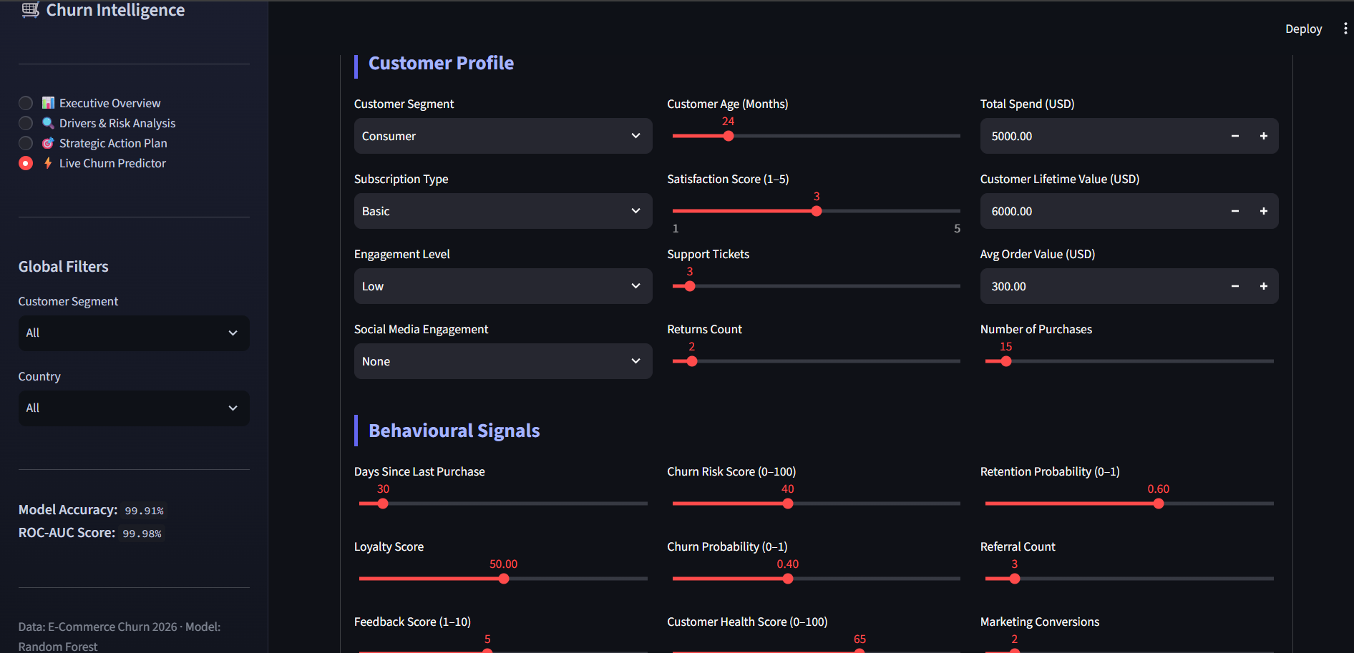
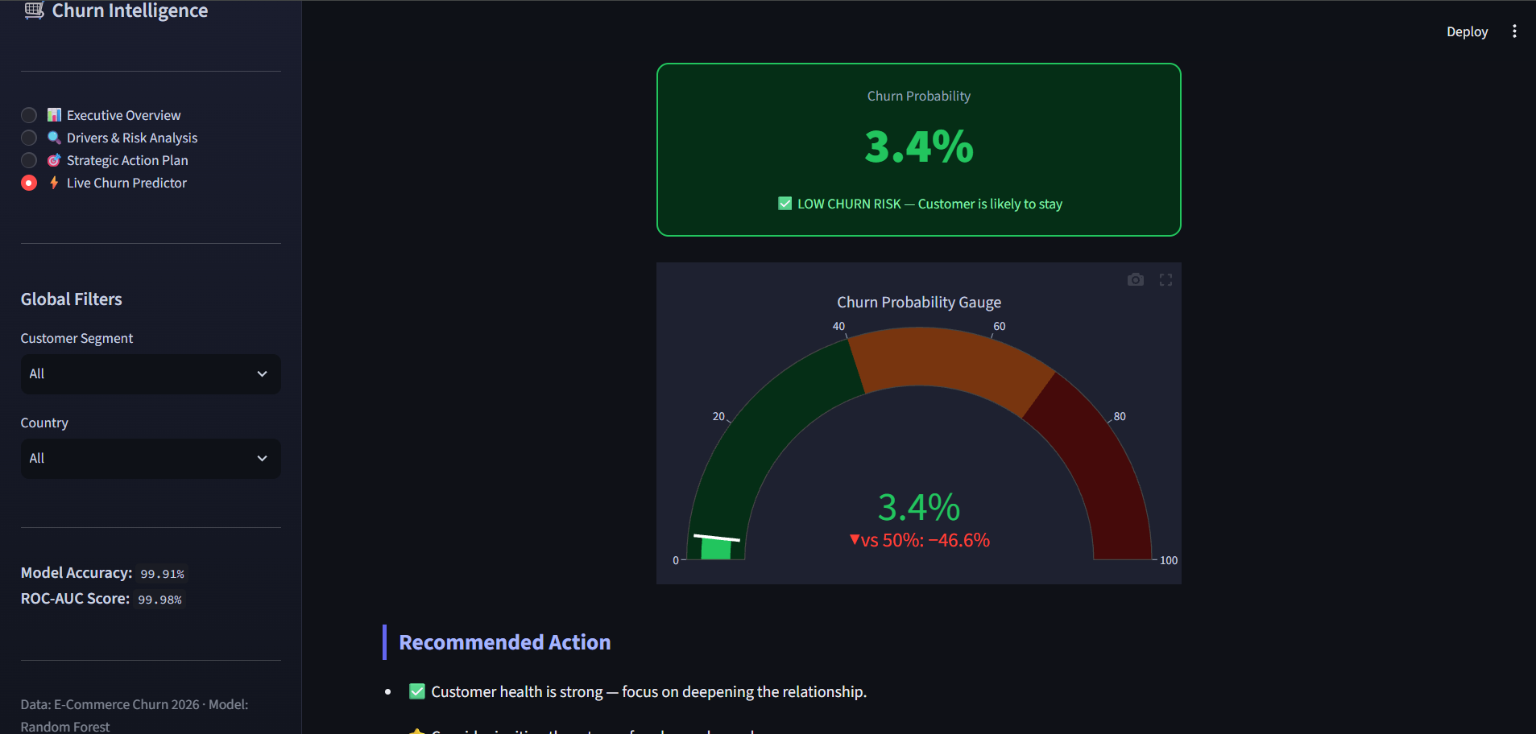

10. Technology Stack
Library | Version | Purpose
pandas | 2.2.2 | Data ingestion, manipulation, and aggregation
numpy | 1.26.4 | Numerical operations and array handling
scikit-learn | 1.4.2 | Random Forest model, preprocessing, evaluation
streamlit | 1.35.0 | Interactive web dashboard framework
plotly | 5.22.0 | Interactive charting and visualisation
python-docx | 1.1.2 | Programmatic Word document generation

11. Execution Instructions
- 1. Ensure Python 3.10+ is installed.
- 2. Place E-commerce_Customer_Churn_2026.csv in the project root directory.
- 3. Install dependencies: pip install -r requirements.txt
- 4. Launch the dashboard: streamlit run app.py
- 5. Access in browser at: http://localhost:8501
- 6. Use the sidebar to navigate between the four dashboard pages.
- 7. Apply the Segment and Country filters to explore data subsets.
- 8. Visit Page 4 (Live Churn Predictor) to score a customer in real time.

12. References
- Verma, A. (2026). E-Commerce Customer Churn Analysis and Prediction. Kaggle. https://www.kaggle.com/datasets/ankitverma2010/ecommerce-customer-churn-analysis-and-prediction
- Breiman, L. (2001). Random Forests. Machine Learning, 45(1), 5–32.
- Streamlit Inc. (2024). Streamlit Documentation. https://docs.streamlit.io
- Plotly Technologies Inc. (2024). Plotly Python Open Source Graphing Library. https://plotly.com/python/
- scikit-learn Developers. (2024). scikit-learn: Machine Learning in Python. https://scikit-learn.org

— End of Report — Generated September 21, 2026 · E-Commerce Churn Intelligence Project

