WEEK 2 TASK – DATA VISUALIZATION AND REPORTING
Virtual Logistics Data Analysis Intern
Based on the cleaned logistics dataset prepared in Week 1

1. Objective
The objective of Week 2 is to transform cleaned logistics data into meaningful visual representations that reveal patterns, trends and relationships. The visualizations are designed to support practical logistics decision-making by making order volumes and operational relationships easier to interpret.

2. Tool Selection and Setup
Python was selected as the visualization tool because it provides a reproducible workflow for data analysis and chart creation. Pandas was used for loading, grouping and summarizing the cleaned CSV, while Matplotlib was used to create the charts. The Week 1 cleaned dataset was used as the input so that visualization was performed on already-processed data.
- Python
- Pandas
- Matplotlib
- CSV cleaned logistics dataset

3. Dataset Overview
The dataset contains 60 observations and 13 operational fields. It includes non-urgent and urgent orders, order types A/B/C, fiscal-sector orders, traffic-controller orders, three banking-order measures and total orders.
Metric | Value
Average total orders | 300.87
Maximum total orders | 616.453
Minimum total orders | 129.412
Average urgent orders | 118.92
Average non-urgent orders | 172.55

4. Visualization Methodology
- Loaded the Week 1 cleaned CSV with Pandas.
- Created an observation index from 1 to 60 for ordered plotting; this is not a calendar date.
- Calculated averages, ranges, grouped averages and Pearson correlations.
- Created line, bar, pie and heatmap visualizations.
- Reviewed each chart and connected the observed pattern with a practical logistics implication.

5. Visualization 1 – Total Orders Over Observations
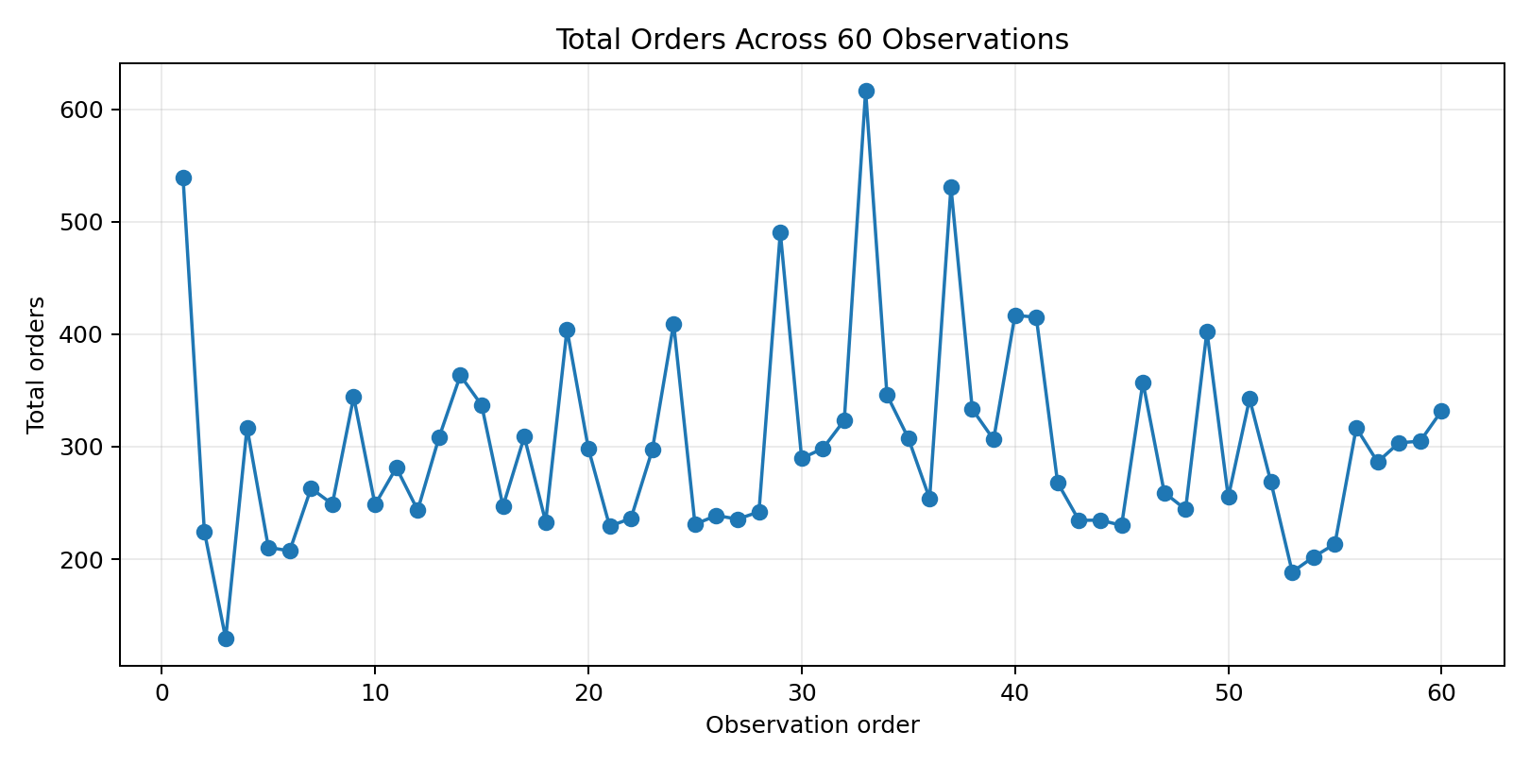
Insight: Total order volume fluctuates considerably across the 60 observations. The maximum is 616.453, while the minimum is 129.412.
Logistics implication: demand monitoring and flexible staffing or transport capacity can help operations respond to high-volume periods. The x-axis uses observation order because the source data provides week/day codes rather than full calendar dates.

6. Visualization 2 – Average Order Measures
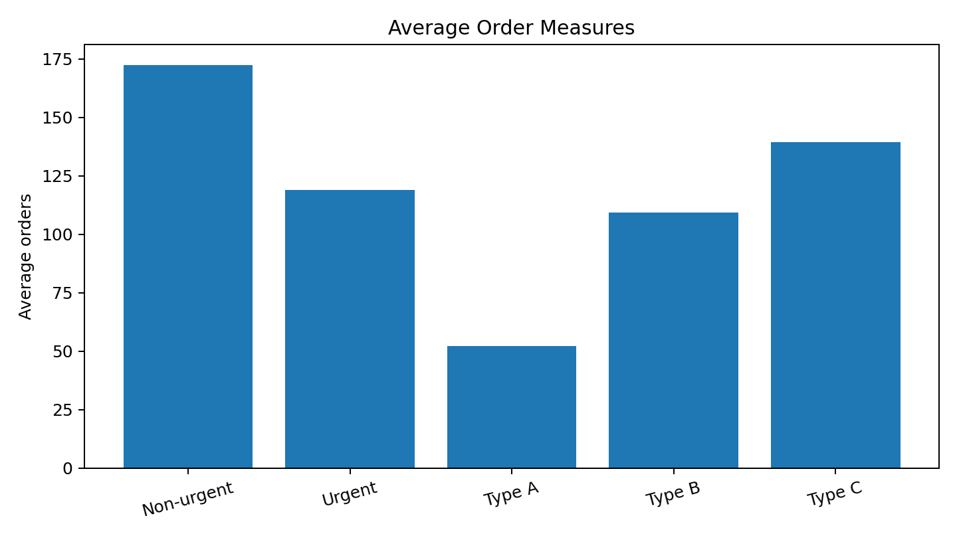
Insight: The bar chart compares the average magnitude of the main order measures. This makes differences among non-urgent, urgent and order-type measures easy to compare.
Logistics implication: category-level monitoring can help managers prioritize processing capacity and understand which demand components require attention.

7. Visualization 3 – Urgency Mix
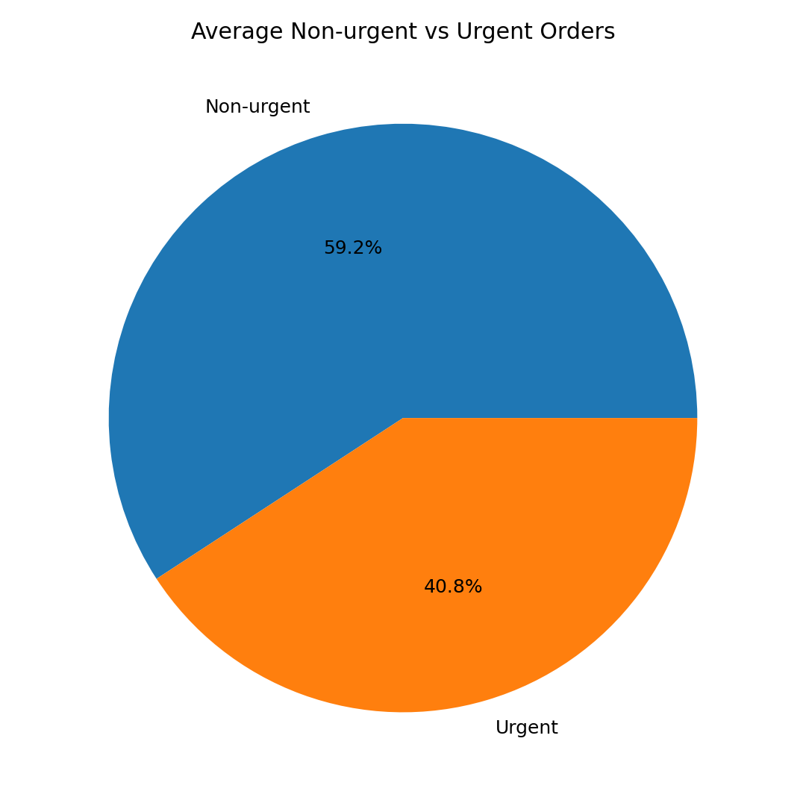
Insight: The average non-urgent order measure is 172.55, compared with 118.92 urgent orders. The pie chart shows their relative average magnitude, not individual shipment shares.
Logistics implication: separate tracking of urgent demand can support priority handling, dispatch decisions and contingency capacity.

8. Visualization 4 – Correlation Heatmap
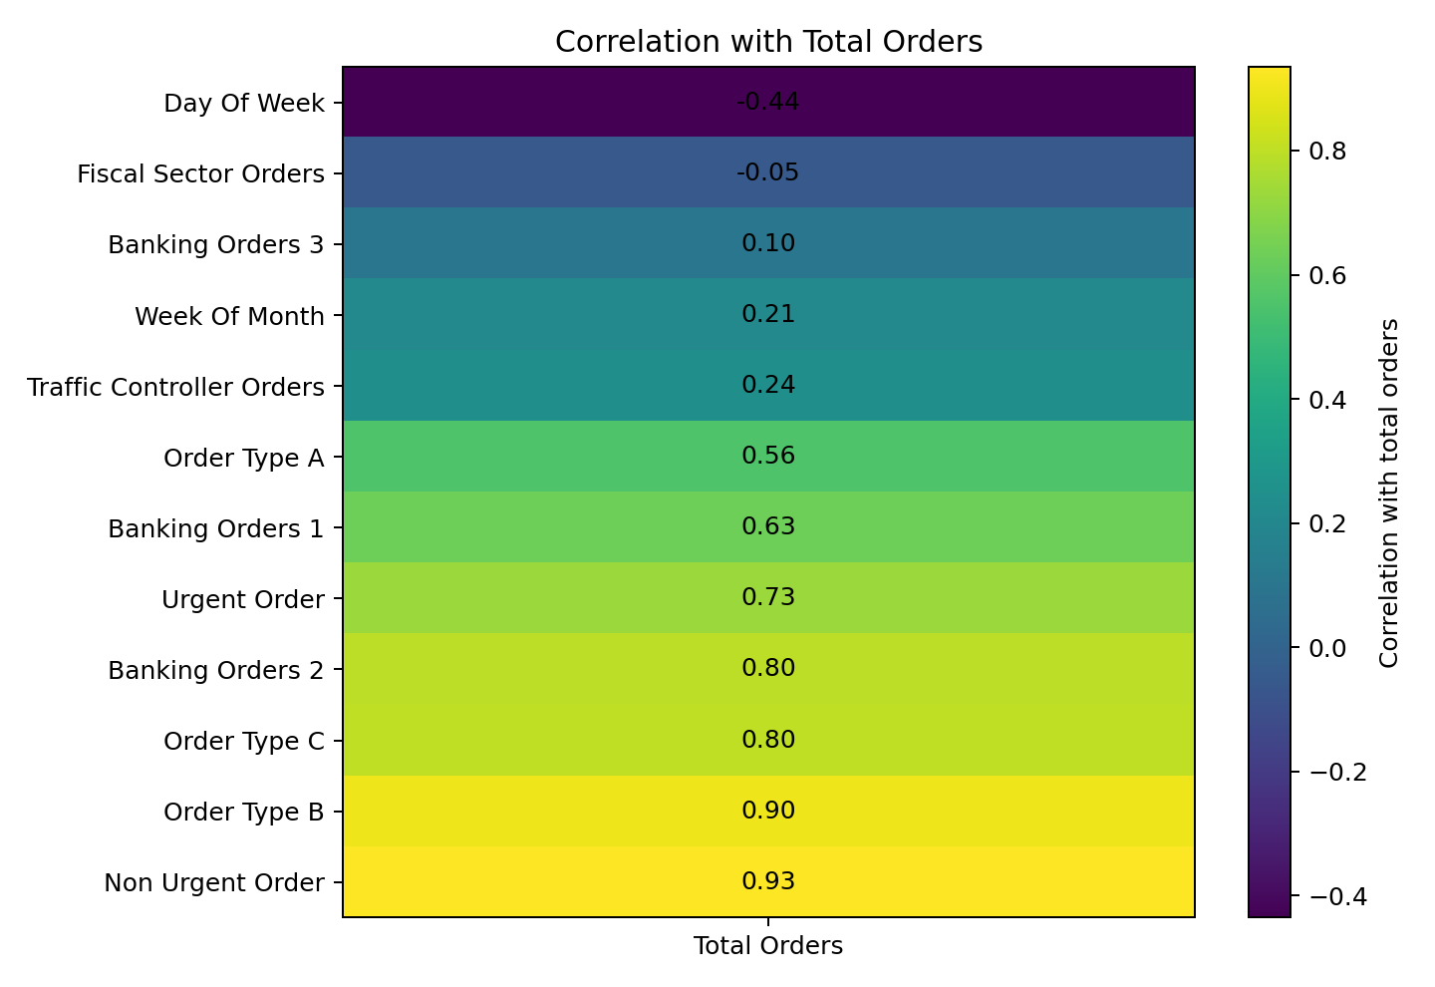
Insight: Urgent orders have a correlation of 0.73 with total orders; non-urgent orders have 0.93; banking_orders_2 has 0.80. Values closer to +1 indicate stronger positive linear relationships.
Logistics implication: strongly associated variables can be candidate inputs for future forecasting and monitoring, although correlation does not prove causation.

9. Visualization 5 – Average Orders by Week of Month
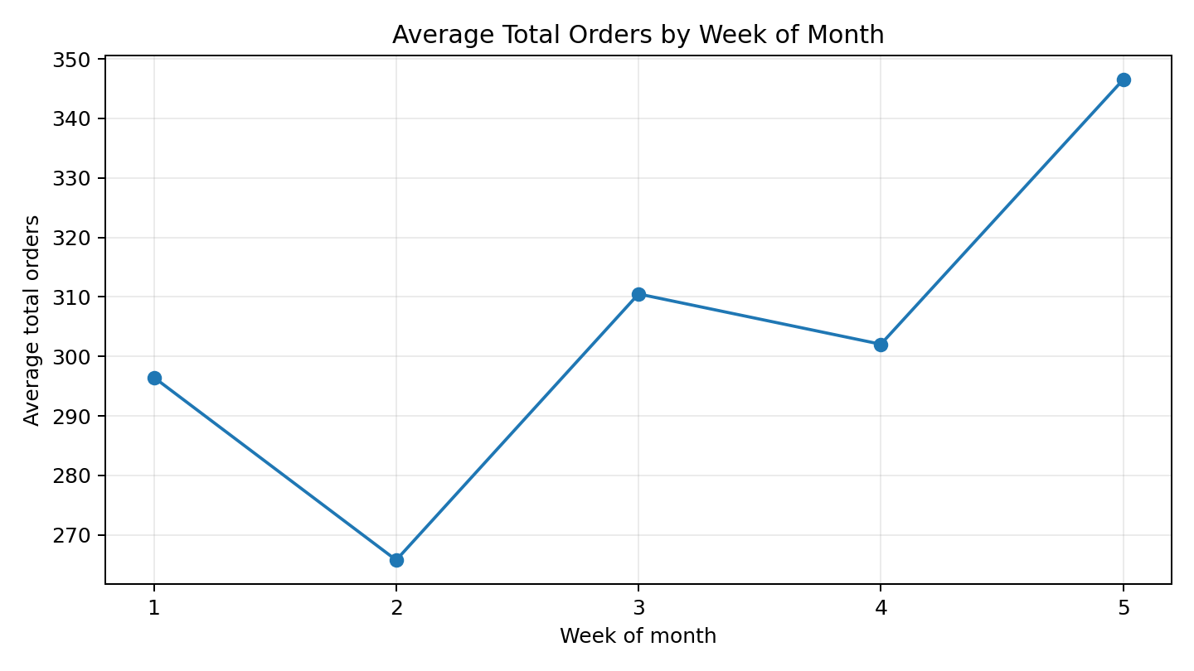
Insight: Average total orders differ across week-of-month categories, indicating that demand is not uniform throughout the month.
Logistics implication: historical week-of-month patterns may inform staffing and capacity planning, provided they are confirmed using a larger time series.

10. Visualization 6 – Average Orders by Day Code
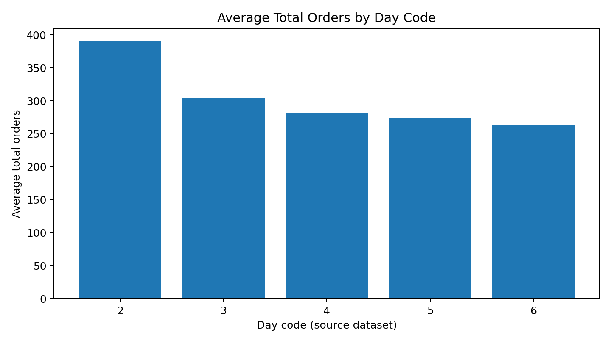
Insight: Average total orders differ across the numeric day codes used in the source dataset. The original codes are retained rather than assigning new weekday names.
Logistics implication: if a larger dataset confirms the same pattern, daily staffing and transportation capacity could be adjusted to expected demand.

11. Overall Analytical Findings
- Demand is variable, with total orders ranging from 129.412 to 616.453.
- Non-urgent and urgent order measures differ in average magnitude, supporting separate monitoring of priority demand.
- Operational variables show measurable relationships with total orders; these relationships can guide exploratory forecasting.
- Week-of-month and day-code comparisons show that demand is not uniform across the source time categories.
- Visualizations make numerical logistics data easier to interpret and communicate.

12. Practical Logistics Strategies
- Use a demand dashboard to monitor total and urgent orders.
- Keep staffing and transport capacity flexible during high-demand periods.
- Track urgent orders separately for priority processing.
- Use promising operational variables as candidate features for future forecasting models.
- Validate these patterns with a larger time-stamped dataset before making permanent operational changes.

13. Limitations
The dataset contains 60 observations and uses week/day codes rather than full calendar dates. Therefore, the report uses an observation index for ordered line charts and keeps the original numeric day codes. The charts describe patterns in this dataset and should not be treated as proof of long-term seasonal behavior.

14. Conclusion
This Week 2 analysis converted the cleaned logistics dataset into line charts, bar charts, a pie chart and a correlation heatmap. The visualizations revealed demand variability, differences among order measures and relationships between operational variables and total orders. These findings can support monitoring, staffing, transport capacity planning and future forecasting. The exercise demonstrates how effective visualization converts cleaned data into information that can support logistics decision-making.

15. Files Included
- Week_2_Data_Visualization_and_Reporting.docx – detailed report with embedded charts.
- 01_total_orders_line.png
- 02_average_orders_bar.png
- 03_urgency_pie.png
- 04_correlation_heatmap.png
- 05_weekly_pattern_line.png
- 06_day_pattern_bar.png
- visualization_summary.csv

