**Normalisation**is the process of organising data in a database to reduce redundancy and improve data integrity. It involves structuring a database in such a way that each piece of data is stored in one place only, making it easier to update, manage, and prevent inconsistencies.

There are 3 types of Normalisations

1NF- Ensure that each table column holds only one value, and there are no duplicate rows.

2NF-Make sure that all non-key columns are fully dependent on the entire primary key, not just part of it.

3NF-Remove columns that don’t directly depend on the primary key, eliminating unnecessary connections between data.

**Example: -**

1NF (First Normal Form)

**Objective:** Remove duplicate records and ensure that each table cell contains only one value.

I selected distinct values of track_id , unit_price , and invoice_line_id from invoice_line and created a new table data_invoice similarly select name,album_id, composer to from the table name_compose ,similarly I created album_title to hold distinct values of album_id,title,artist_id  
Finally, I merged these tables into one (NF) using joins, ensuring that each record is unique and contains atomic values.

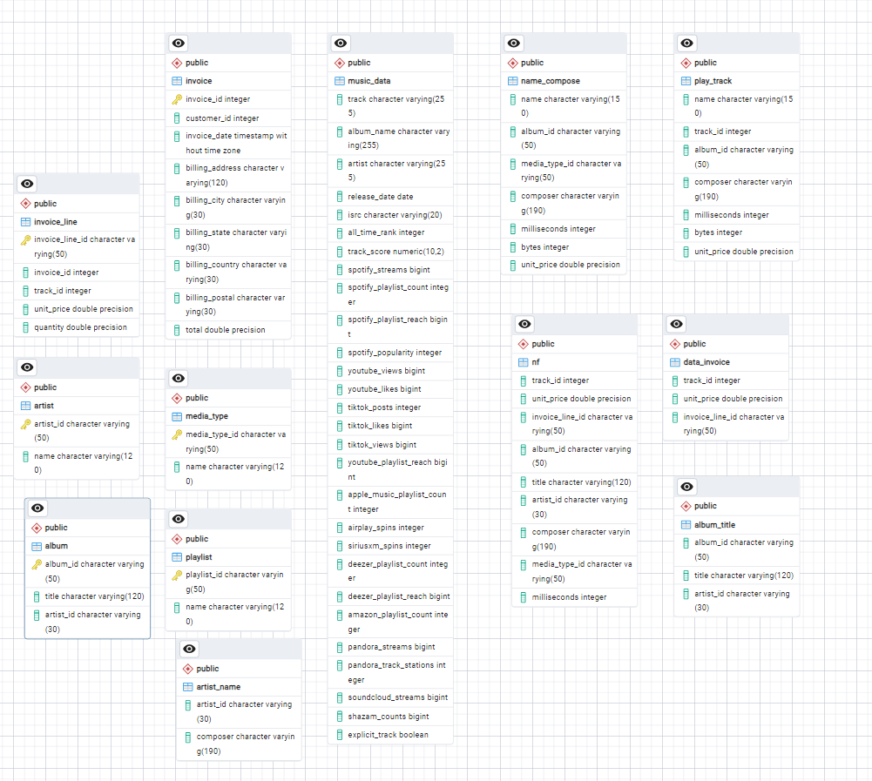

2NF- (Second Normal Form)

**Objective:** Eliminate partial dependencies, ensuring that non-key attributes are fully dependent on the primary key. I

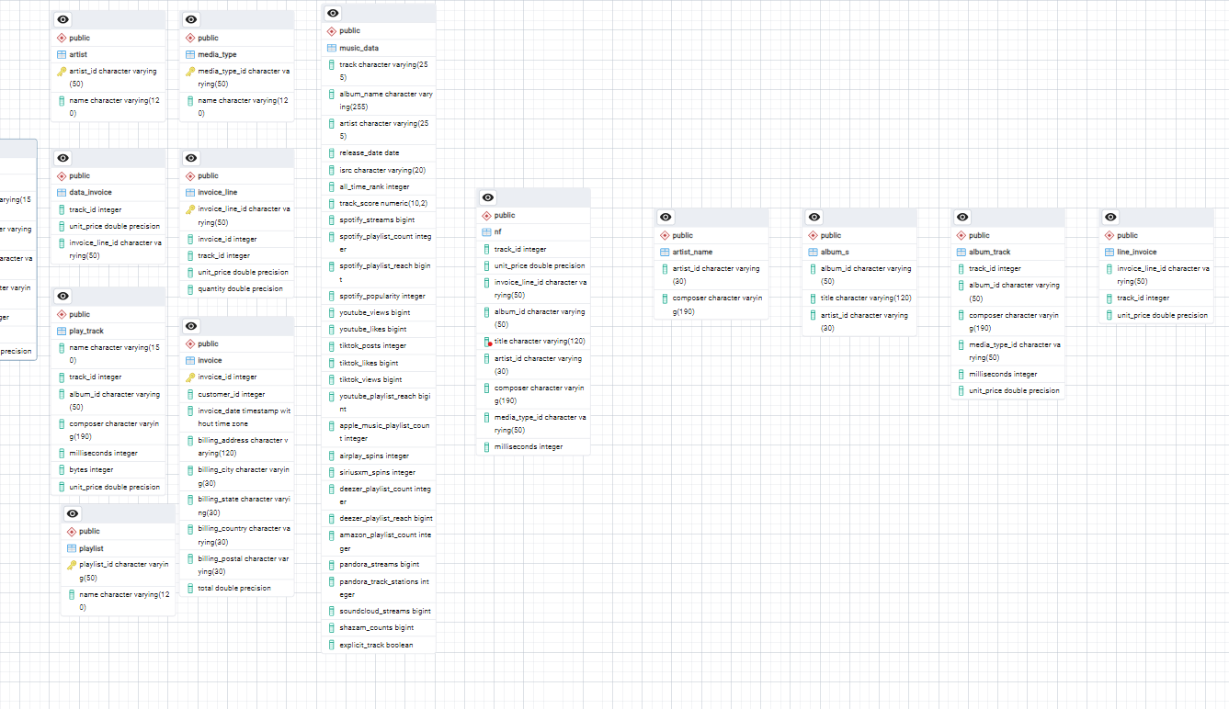I move artist_id and composer into a new table artist_name to remove partial dependencies. created album_s to hold distinct album information (album_id, title, artist_id). Separated the data into album_track (containing track details) and line_invoice to ensure all non-key attributes depend on the whole key.

3NF :-(Third Normal form)  
**Objective:** Remove transitive dependencies so that no non-key attribute depends on another non-key attribute.  
I dropped the composer column from album_track, as it could cause transitive dependency issues.  
Created a new table track_info by joining album_track with album_s to ensure that all columns only depend on the primary key without any transitive dependencies

