**Iowa Liquor Sales**

**Staging Tables:**

1. **Iowa_Liquor_Sales:**

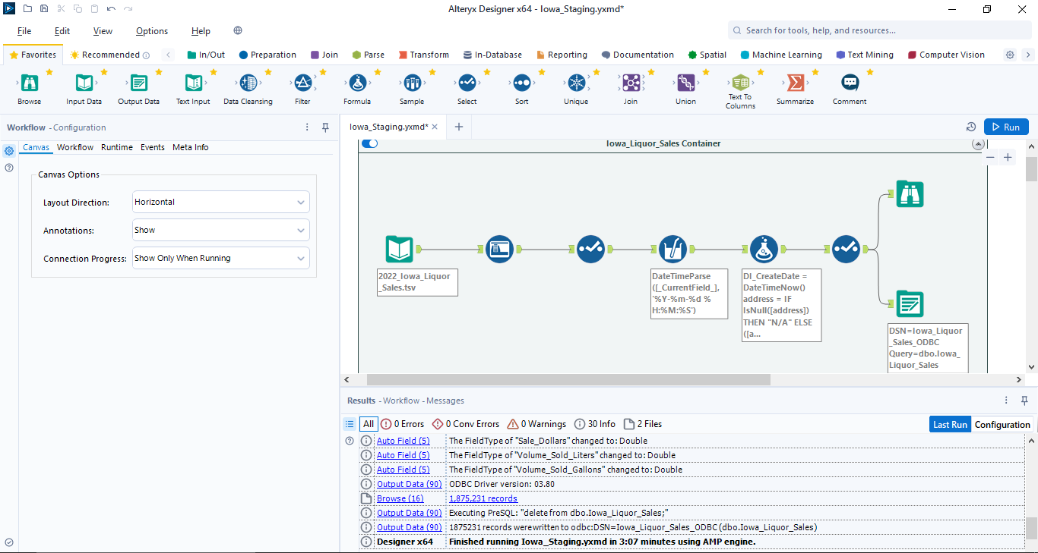

1. **Iowa_Liquor_Products:**

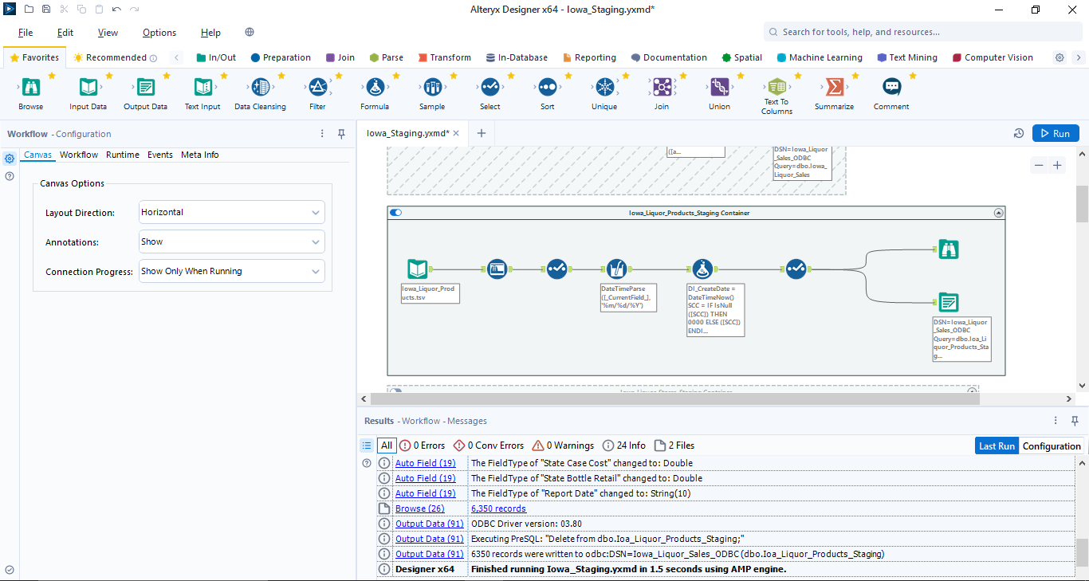

1. **Iowa_Liquor_Stores:**

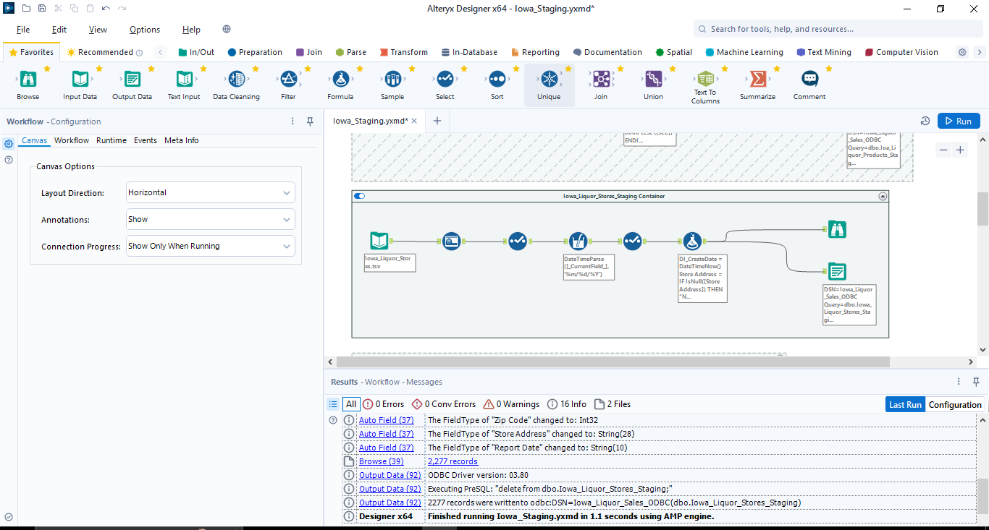

1. **Total_City_Population_By_Year:**

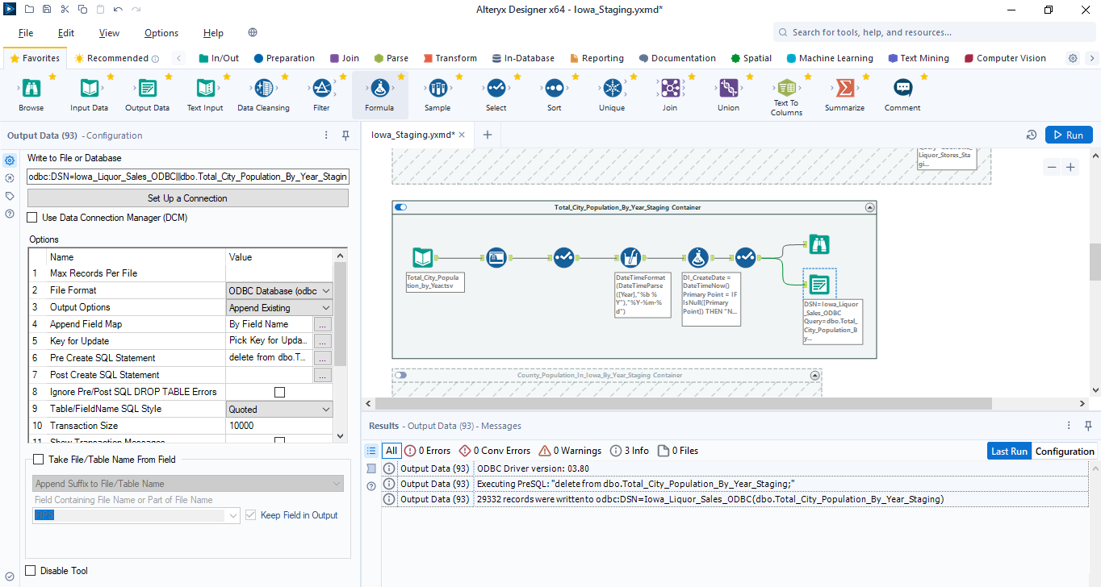

1. **County_Population_By_year:**

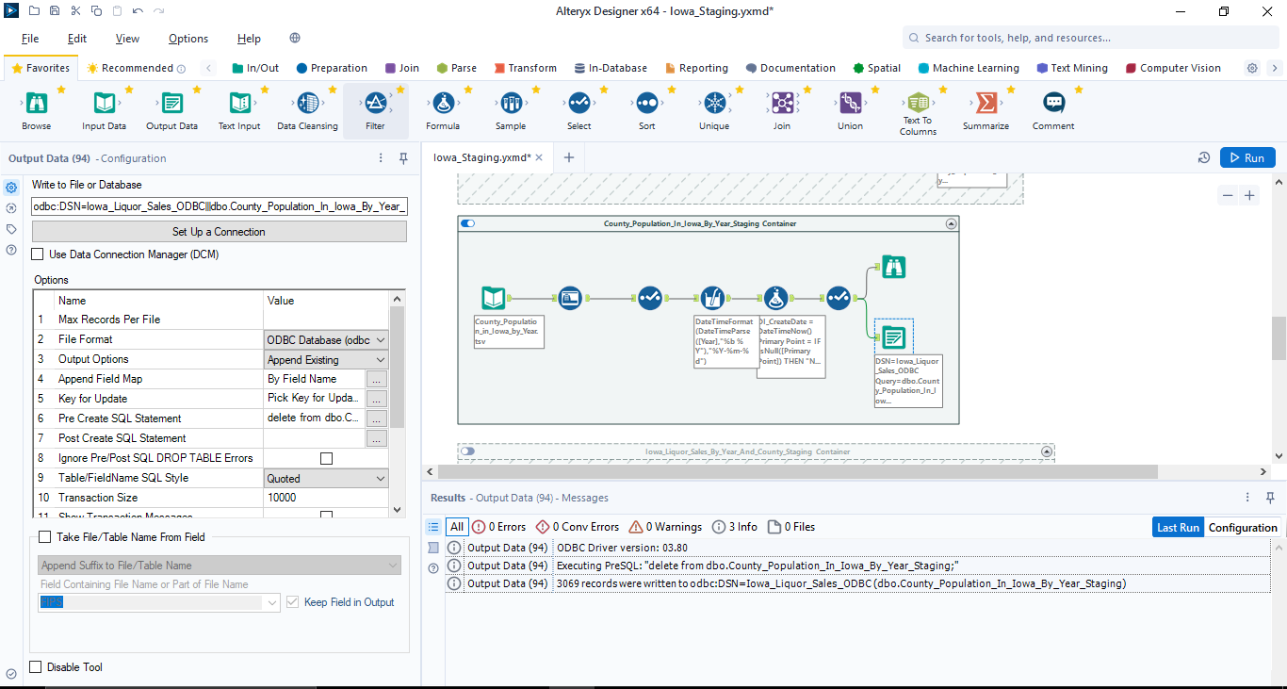

1. **Iowa_Liquor_Sales_By_Year_Count:**

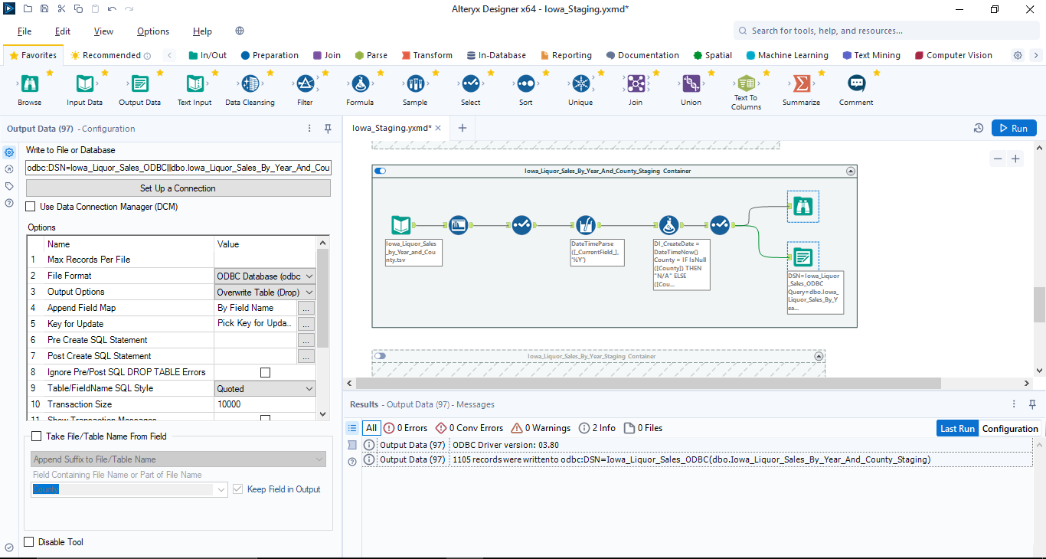

1. **Iowa_ Liquir_Sales_By_Year**

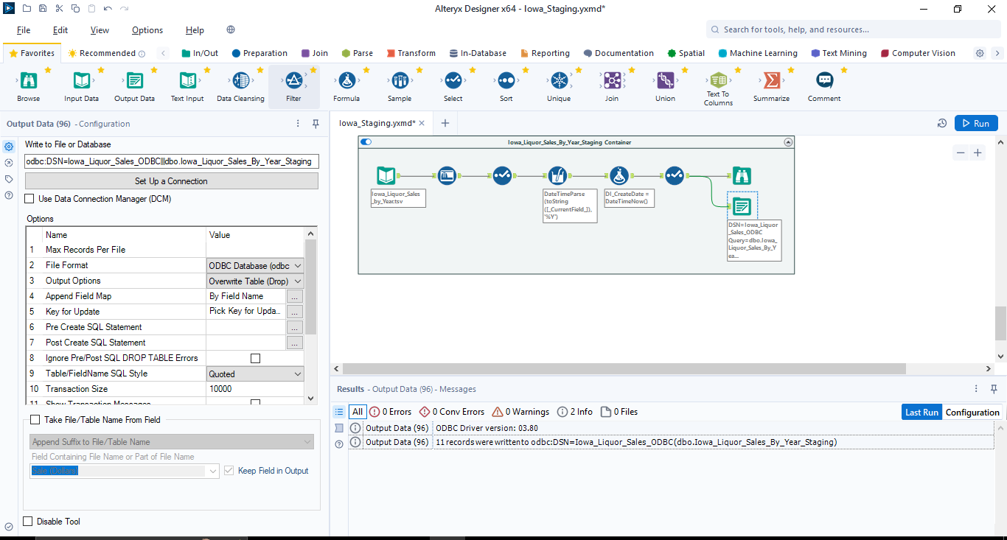

**Data Profiling Workflows:**

1. Products.tsv

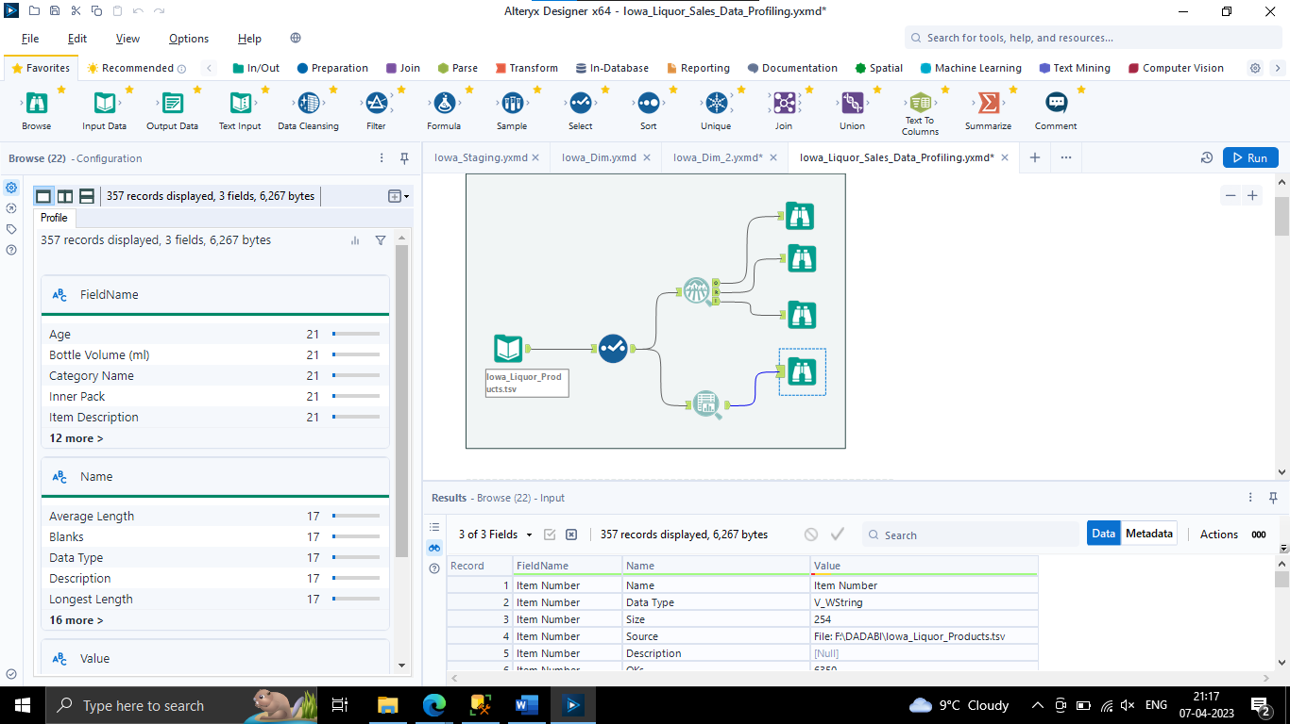

1. Liquor Sales

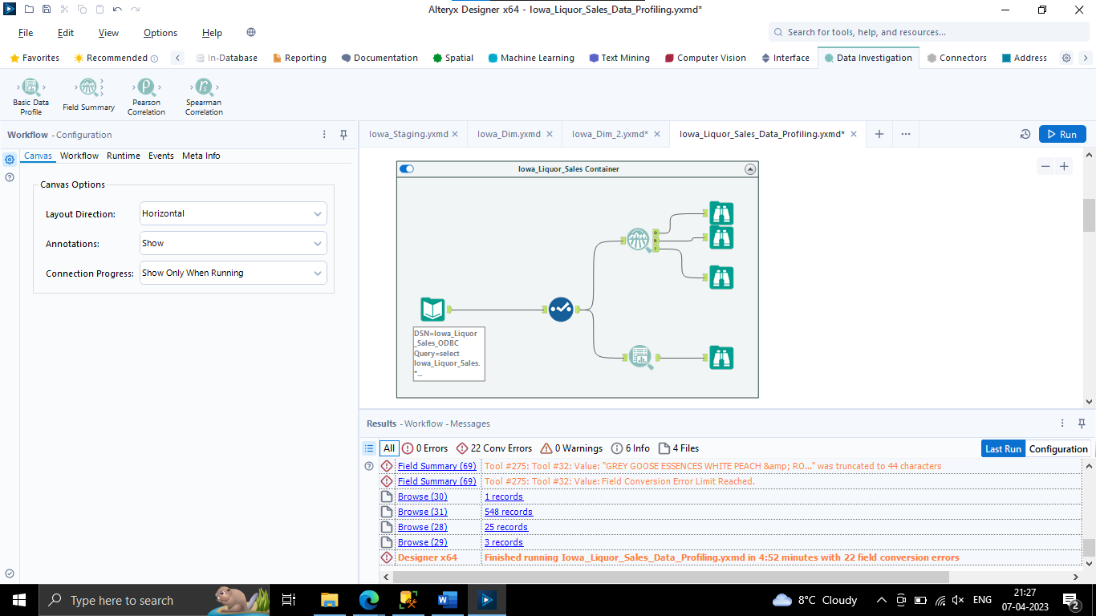

1. **Iowa Liquor Sales by year and County**

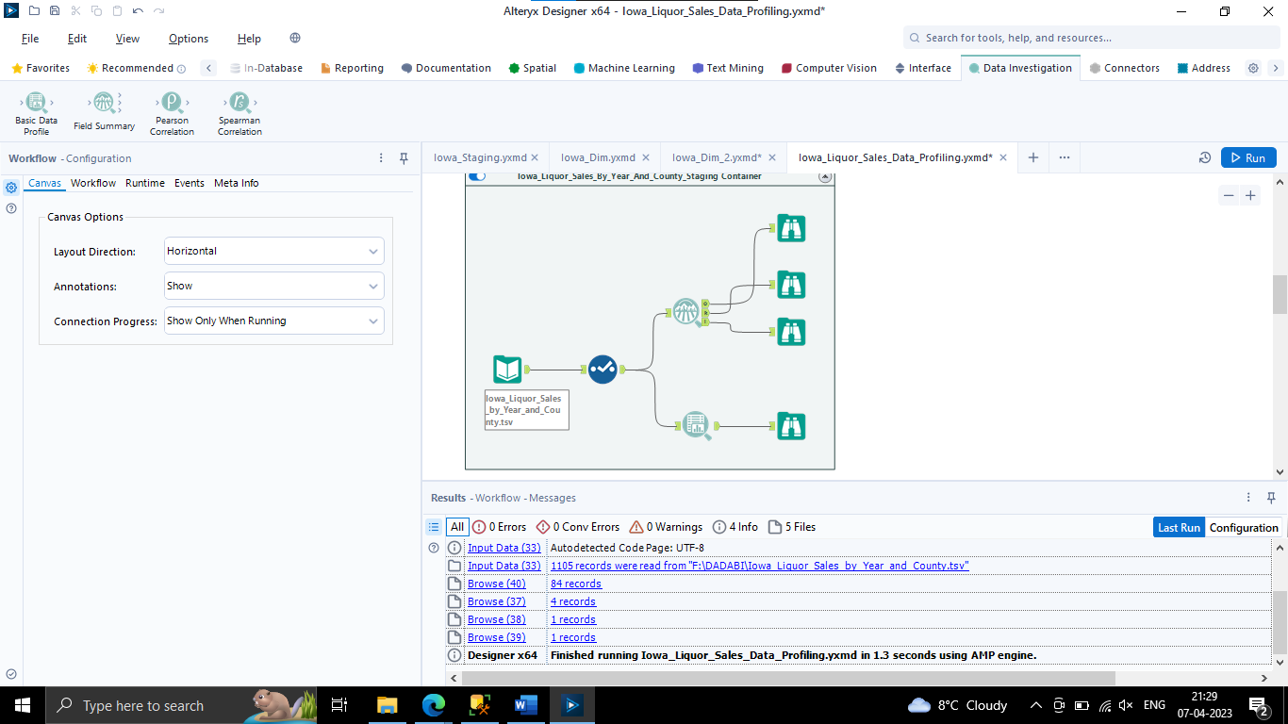

1. **Liquor Sales By Year**

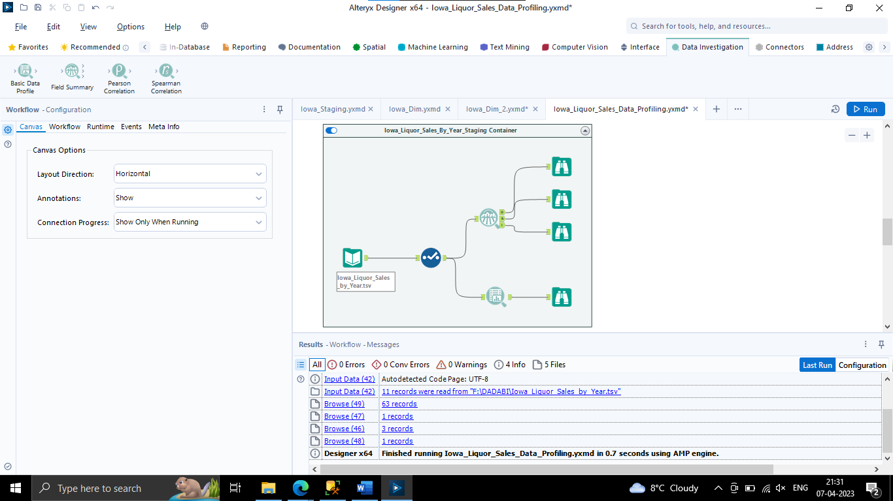

1. **Liquor Store**

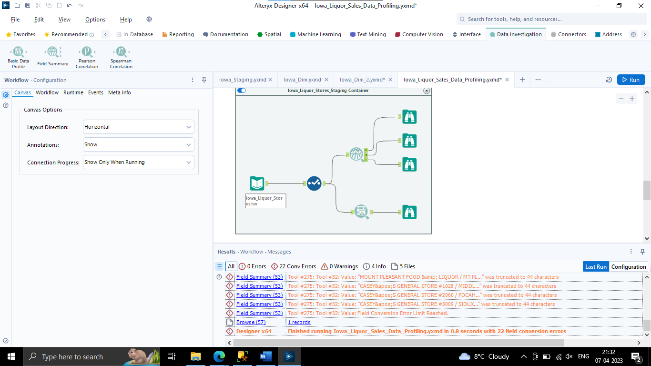

1. **Total city population by year**

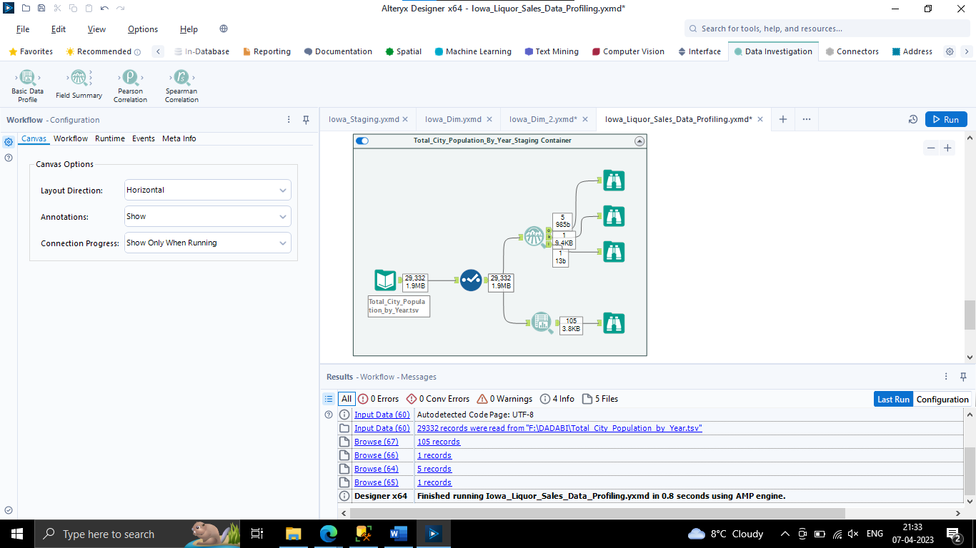

**Dimension Tables:**

1. Dim_Iowa_Product_Categories:

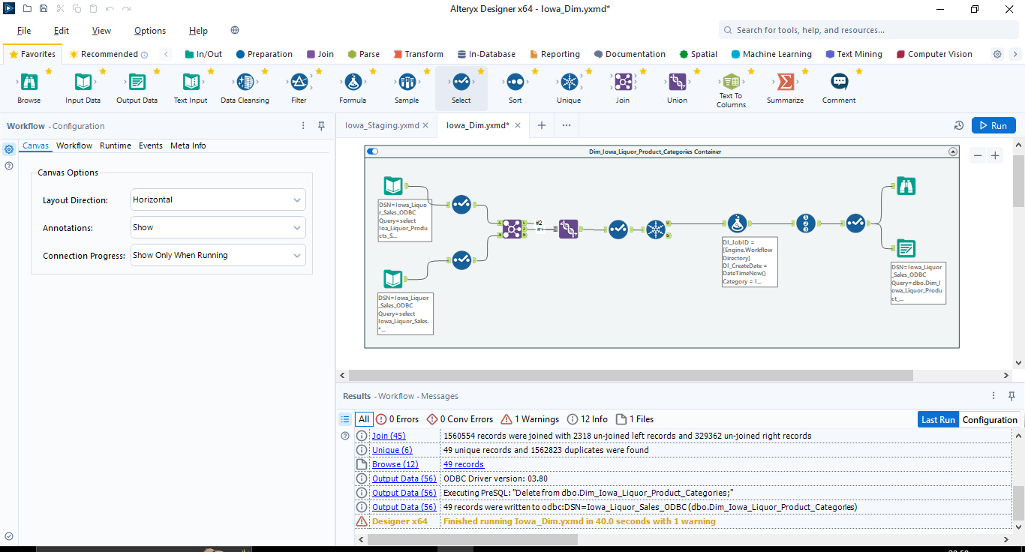

**Record Count: 49**

1. **Dim_Iowa_Liquor_Vendors:**

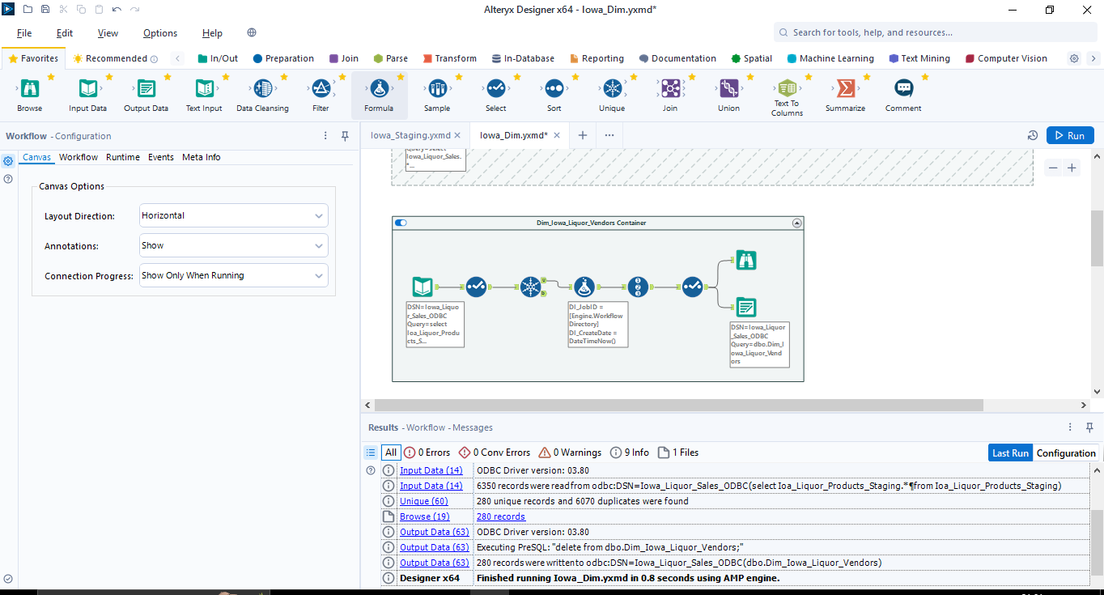

**Record Count: 291**

1. **Dim_Iowa_Liquor_Products:**

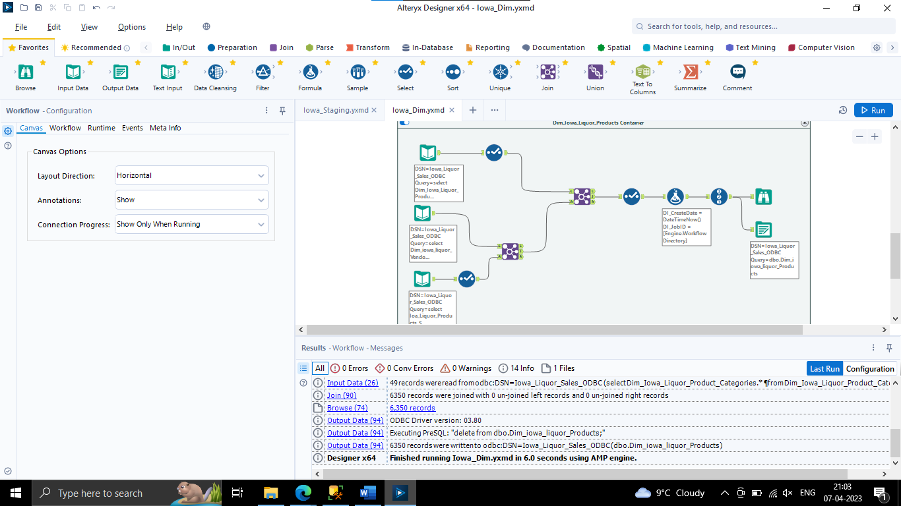

**Record Count: 6847**

1. **Dim_Iowa_City:**

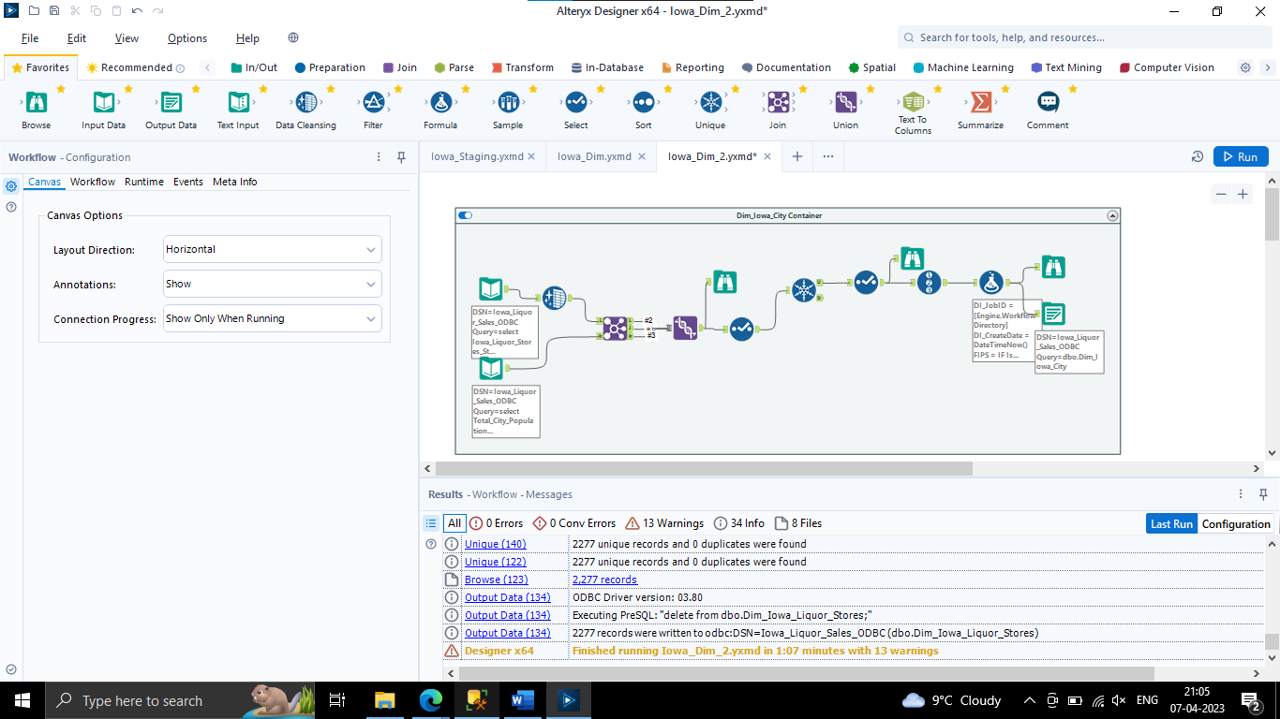

**Record Count: 983**

1. **Dim_Iowa_County:**

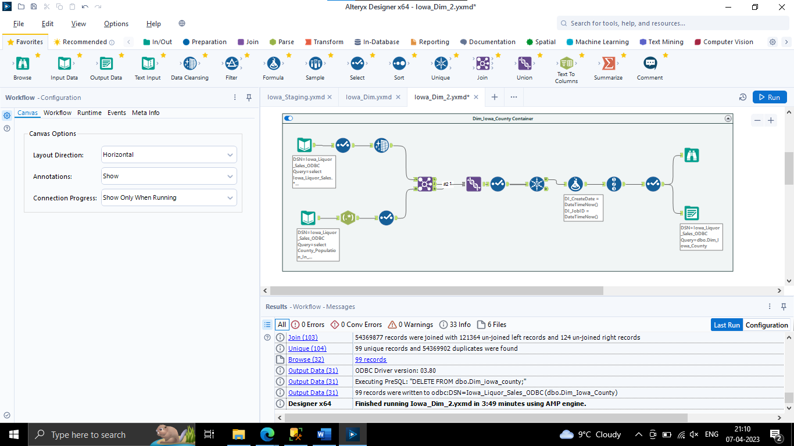

**Record Count: 99**

1. **Iowa_Liquor_Stores:**

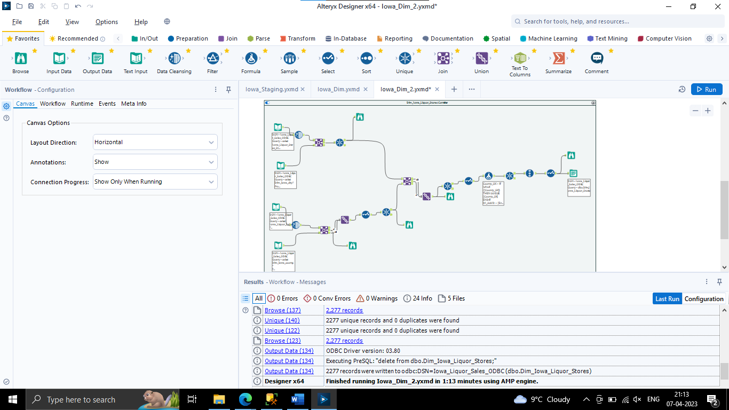

**Record Count: 2401**

**Fact Tables:**

1. **FCT_Iowa_City_Population_By_Year**

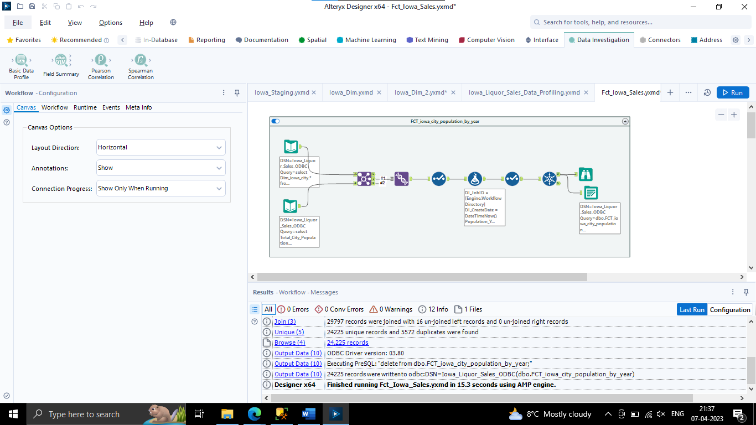

**Record Count: 25056**

1. **FCT_Iowa_County_Population_By_Year**

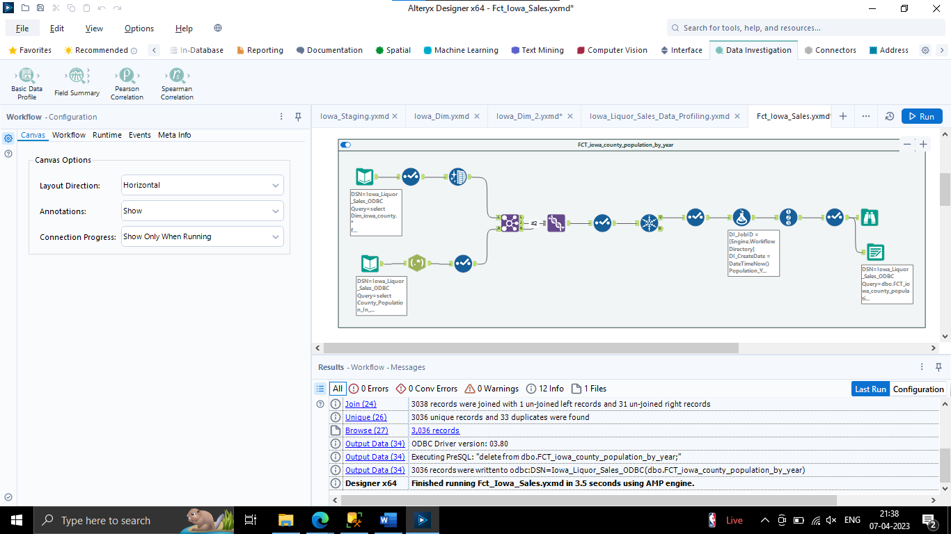

**Record Count: 3135**

1. **FCT_Iowa_Liquor_Sales_Invoice_Header**

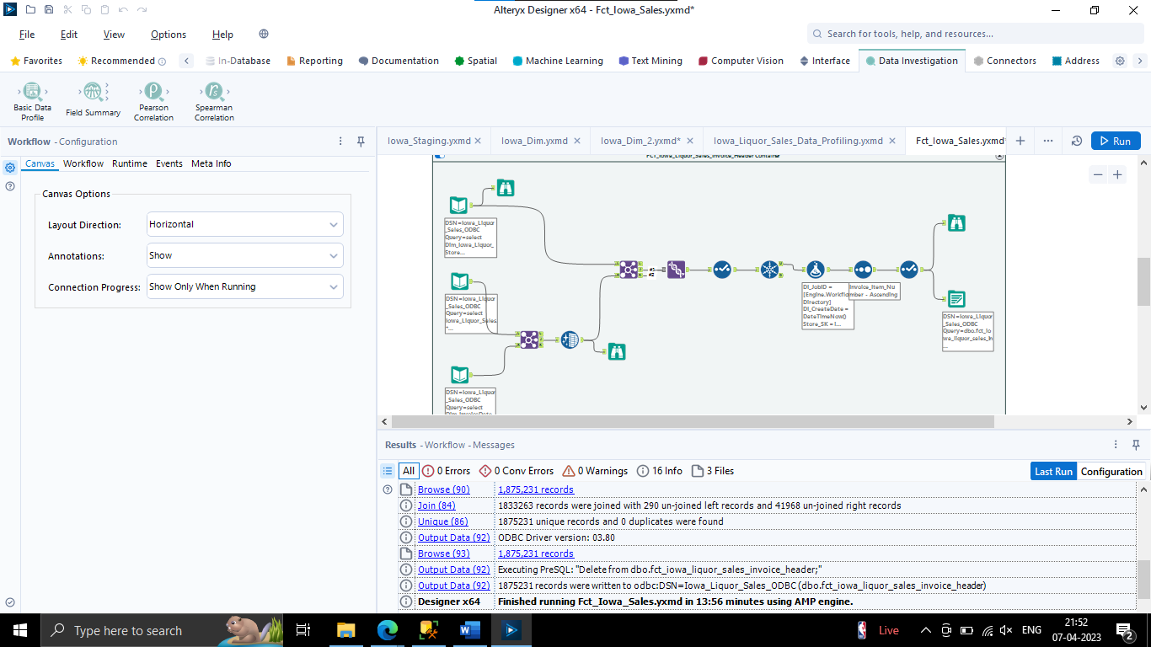

**Record Count: 26160915**

1. **FCT_Iowa_Liquor_Sales_Invoice_LineItem**

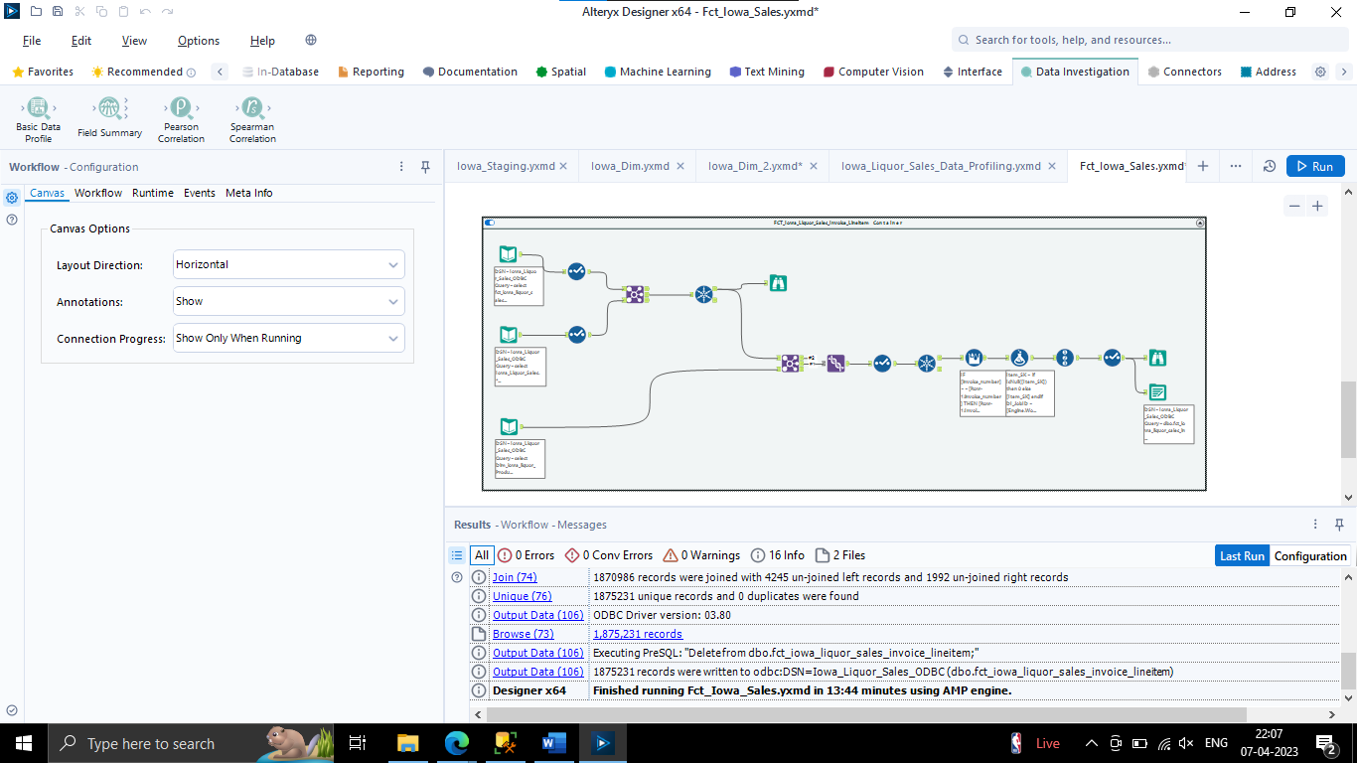

**Record Count: 26160915**