**SRS DOCUMENT ON**

**ONLINE VOTING SYSTEM**

**Purpose**

The purpose of the document is to make the data design and system architecture of the Online Voting System easy to comprehend. It also serves the purpose of making the functionality clear to system designers.

**Scope**

Manual voting system has been deployed for many years in our country. However in many parts of our country people cannot attend the voting because of several reasons. In order to solve these problems there is a need of online voting system in addition to manual voting system. The long-term goal of this project is to greatly reduce the cost and complexity of running elections and increase the accuracy of results by removing the direct involvement of humans in gathering and counting of votes. The voters will be able to give their votes at any field areas by using the system if they prefer online voting. In this system, the voter votes using Java application which can be downloaded over internet

**Objective**

The main objective of the proposed solution is to be automated the voting process and activities related to voting process through Internet. This solution will facilitate the voters and candidates with the different modules. This solution is very much necessary for the elections in the local bodies as well as general body.

**Definition**

OVS 🡪 Online Voting System

SRS 🡪 Software Requirements Specification

ER 🡪 Entity Relationship

SSL 🡪 Secure Socket Layer

HTML 🡪 Hyper Text Markup Language

CSS 🡪 Cascading Style Sheets

JDBC🡪 Java Database Connectivity

J2EE 🡪 Java 2 Platform Enterprise Edition

JSP 🡪 Java Server Pages

**Overview**

The remainder of this document identifies the actors (Voter, Candidate), ER & Class diagram, use-case scenarios, sequence/activity diagrams, assumptions and dependencies needed for the analysis and design of the Online Voting System. The rest of the document contains the overall description of the system, requirements and behavioural description of the system and project planning.

**ER Diagram**

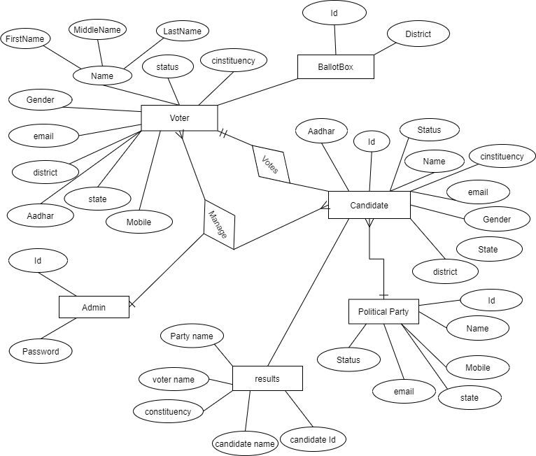

**Class Diagram**

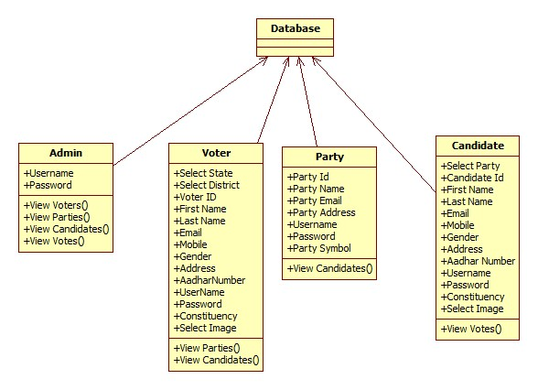

**Functional Requirement:**

**1. Registration**

* That system will be used only by the people who have been registered to the system. Main actor of the registration operator is the voters & candidates.
* For security purpose, System can generate user id & password.

**Activity/Sequence diagram for Registration**

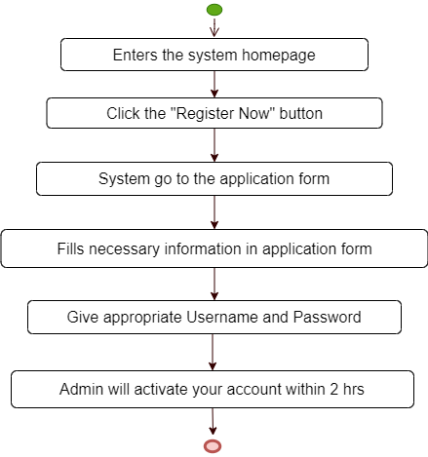

**2. Login as a voter**

1) The voter enters his/her login id and password

* If the login and password is valid, a session is opened
* If the login or password is not valid, the login screen is redisplayed with an error message

2) View Parties

* Voters can view party details.

3) View Candidates

* Voter can view candidate details (Which party and canstituency they are belongs to)

4) Vote

* Voter can enter his account using id and password.
* After selecting view candidates, display the names, symbols and parties of the candidates and also display “vote button”.

5) Logout

* The voter clicks on the logout button.
* The session is terminated and the login screen is displayed.

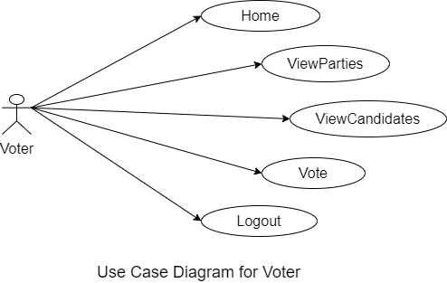

**3. Login as a candidate**

1) The candidate enters his/her login id and password

* If the login and password is valid, a session is opened
* If the login or password is not valid, the login screen is redisplayed with an error message

2) View Votes

* Candidates can view votes.

3) Logout

* The candidate clicks on the logout button.
* The session is terminated and the login screen is displayed.

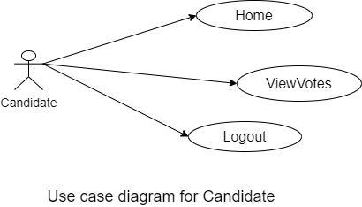

**3. Login as a Political Party**

1) The Party enters his/her login id and password

* If the login and password is valid, a session is opened
* If the login or password is not valid, the login screen is redisplayed with an error message

2) View Candidates

* Party can view Candidate list and check the list.

3) Activate Candidate account

* Candidate sends request to activate their account, party will approve this request.

3) Logout

* The Party clicks on the logout button.
* The session is terminated and the login screen is displayed.

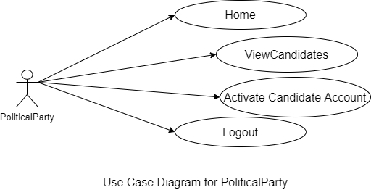

**Activity/Sequence diagram for Login/Logout**

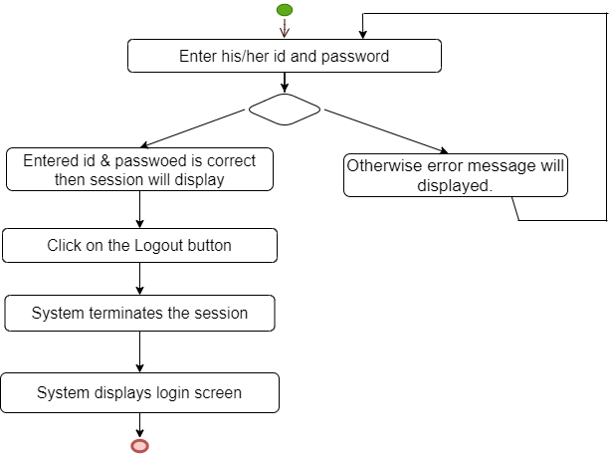

**Activity/Sequence diagram for Voting**

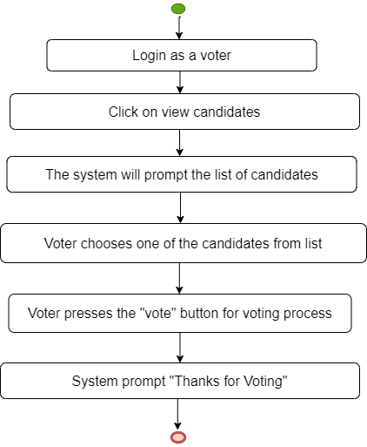

**4. System/Admin**

1) Admin enters his/her login id and password

* If the login and password is valid, a session is opened
* If the login or password is not valid, the login screen is redisplayed with an error message

2) View Parties

* Admin can view the list of parties and check the information.

3) View Candidates

* Admin can view the list of candidates and check the information.

4)View Voter

* Admin can view the list of voters and check the information.

**5) View Results**

* Admin can click on “View Votes” and see result and declares the result.

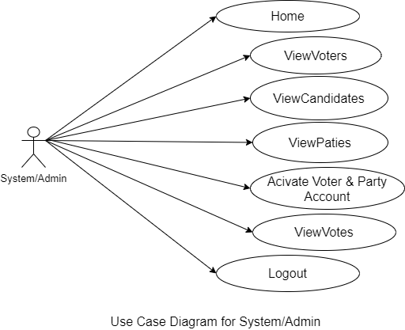

**6) Activate Account**

* Admin will activate Voter and PoliticalParty account.
* PoliticalParty will activate Candidate account.

**Activity/Sequence diagram for voter & party account activation**

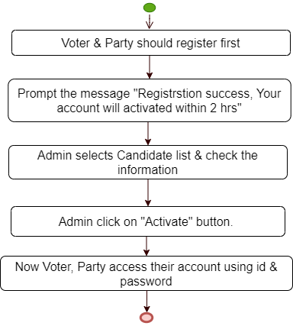

**Activity/Sequence diagram for candidate account activation**

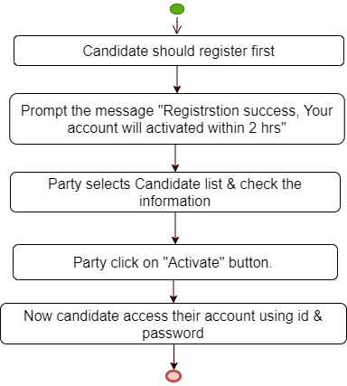

**Non-Functional Requirements**

**1. Efficiency Requirement**

When the Online Voting system will be implemented, Election Commission and the voters will have an easy access to cast vote since they need not manually go to the Voting Booth during each Voting season.

**2. Security Requirements**

The data transaction between client and server must be encrypted using SSL technology.

All the passwords that are generated or accepted must be stored in database in an encrypted form.

**3. Reliability Requirement**

The system should accurately perform voter validation, vote casting, report generation, party and candidate information retrieval and search.

**4. Usability Requirement**

The system is designed for a user friendly environment so that voters and candidates can perform the various tasks easily and in an effective way.

**5. Safety requirements**

To prevent data loss in case of system failure, the result of votes that are polled till then have to be saved in database.

In case admin detects any security problem in the system, he should be able to shut down the system and prevent all connection to the server immediately to preserve already polled votes.

**6. User requirements**

Accessibility has become an increasing requirement in services provided by service providers.

They have a high awareness level of various accessibility standards and guidelines.

**7. Policies**

The system should adhere to all the legal formalities of the particular countries.

The system should maintain security related to sensitive data.

**SYSTEM REQUIREMENTS:**

This section elaborates on the functional requirements of the application. The SRS itself can be divided into module, each module having specifications. In order to carry out the project, the following hardware and software is required.

**HARDWARE REQUIREMENTS:**

* System : i3 processor
* Hard Disk : 1 TB.
* Monitor : 15 VGA Colour.
* Mouse : Logitech.
* Ram : 4GB.

**SOFTWARE REQUIREMENTS:**

* Technology **:**  Java 2 Standard Edition, JDBC
* Web Server  **:** Tomcat 7.0
* Client Side Technologies **:** HTML, CSS, JavaScript
* Server Side Technologies **:** Servlets, JSP
* Data Base Server **:** MySQL