YOUTH VISION INDIA
Women & Legal Awareness Department
Research Paper Series – 01
Girls' Education in India:
Current Status, Challenges, Government Initiatives and Future Prospects
Author
Jagriti Sharma
Department Head
Women & Legal Awareness Department
Youth Vision India

Executive Summary
Girls' education in India has advanced substantially over the past two decades, with girls now comprising approximately 48.1% of total school enrolment and outperforming boys on the higher-education Gross Enrolment Ratio (31.2% vs 28.9%). This progress has been driven by constitutional guarantees, the Right to Education Act (2009), and a suite of targeted schemes — most notably the National Education Policy (NEP) 2020, Samagra Shiksha, Beti Bachao Beti Padhao, and Kasturba Gandhi Balika Vidyalayas.
However, national averages conceal sharp state-level disparities: female literacy exceeds 90% in Kerala and Mizoram but remains below 70% in Bihar, Rajasthan, and parts of Uttar Pradesh. Five structural challenges continue to limit outcomes — learning poverty, the digital divide, regional and social inequality, gender bias in subject choice, and a weak school-to-work transition.
This paper argues that India's policy priority must now shift from access to quality, completion, and employability. It recommends district-level planning, scheme-specific accountability, mentorship-based youth interventions, and closer tracking of state-wise indicators — while positioning organisations such as Youth Vision India as practical partners in translating national policy into local impact.
Key figures at a glance:
- Girls' share in school enrolment: 48.1% (UDISE+ 2023–24)
- Female GER in higher education: 31.2%, ahead of male GER at 28.9% (AISHE 2021–22)
- Female literacy range across states: ~55% (Jharkhand) to ~96% (Kerala)
- Governing policy framework: National Education Policy (NEP) 2020

Table of Contents

Girls' Education in India: Current Status, Challenges, Government Initiatives and Future Prospects

Abstract
Education is recognised as one of the most influential drivers of human development, economic growth, and social transformation. Among all educational priorities, girls' education occupies a unique position because of its direct contribution to gender equality, poverty reduction, improved public health, and inclusive national development. India has witnessed remarkable progress in girls' education over the past two decades through constitutional guarantees, educational reforms, targeted welfare programmes, and sustained policy interventions. According to the Unified District Information System for Education Plus (UDISE+) 2023–24, girls account for approximately 48.1% of total school enrolment across India, reflecting substantial progress towards gender parity in school education (Ministry of Education, 2024).
Despite these achievements, important challenges continue to influence educational equity. Regional disparities, socio-economic inequalities, digital exclusion, school retention, learning outcomes, and unequal access to higher education continue to affect educational opportunities for many girls. The COVID-19 pandemic further highlighted the digital divide, demonstrating that educational access increasingly depends upon technological inclusion as well as physical school attendance (UNESCO, 2024).
This paper critically examines the current status of girls' education in India through an analysis of constitutional provisions, educational policies, government initiatives, and emerging challenges. It evaluates major interventions including the National Education Policy (NEP) 2020, Samagra Shiksha, Beti Bachao Beti Padhao, Kasturba Gandhi Balika Vidyalayas, and scholarship programmes. The study argues that girls' education should no longer be viewed solely as a welfare initiative but as a strategic national investment capable of accelerating inclusive economic development, democratic participation, and sustainable social progress.

Keywords
Girls' Education; India; Gender Equality; Educational Policy; Women's Empowerment; UDISE+; NEP 2020; Sustainable Development Goals.

1. Introduction
No nation has achieved sustainable social and economic development without investing in the education of its girls. Across the world, girls' education has evolved from being regarded primarily as a social welfare concern to becoming a strategic public policy priority that influences economic productivity, democratic participation, public health, innovation, and intergenerational development. The quality of education available to girls determines not only their individual life opportunities but also the overall social and economic progress of a nation (UNESCO, 2024; United Nations, 2015).
India, home to one of the world's largest youth populations, recognises education as both a constitutional right and a developmental imperative. Constitutional provisions including Articles 14, 15, 21A, and 39(f) collectively establish equality before law, prohibit gender discrimination, guarantee the Right to Education, and encourage the protection of children's educational interests. These constitutional commitments have guided educational reforms aimed at reducing gender disparities while promoting equitable access to quality education (Constitution of India; Government of India, 2020).
Over the last two decades, India has recorded significant improvements in educational participation among girls. The UDISE+ Report 2023–24 indicates that girls constitute nearly 48.1% of total school enrolment, while the Gender Parity Index (GPI) has reached or exceeded 1.0 across several stages of school education, suggesting that gender gaps in enrolment have narrowed considerably (Ministry of Education, 2024). Similarly, the All India Survey on Higher Education (AISHE) reports that women's participation in higher education has continued to increase, with the female Gross Enrolment Ratio (GER) estimated at approximately 31.2%, exceeding the male GER of 28.9%, reflecting expanding educational opportunities for young women (Ministry of Education, 2024).
These achievements have been supported by multiple government initiatives, including the Right of Children to Free and Compulsory Education Act (2009), Samagra Shiksha, Beti Bachao Beti Padhao, Kasturba Gandhi Balika Vidyalayas, and the National Education Policy (NEP) 2020. Collectively, these initiatives seek to improve enrolment, retention, learning outcomes, digital inclusion, and educational quality through integrated policy interventions (Government of India, 2020).
Nevertheless, educational inclusion cannot be assessed solely through enrolment statistics. Persistent inequalities associated with socio-economic disadvantage, regional disparities, disability, school infrastructure, digital access, and educational quality continue to affect millions of girls across the country. The COVID-19 pandemic further exposed these structural inequalities, particularly in relation to digital learning, where unequal access to smartphones, internet connectivity, and digital literacy significantly affected educational continuity (UNESCO, 2024; UNICEF, 2024).
Contemporary discussions on girls' education must therefore extend beyond school attendance to include educational quality, digital competence, leadership development, career readiness, mental well-being, and lifelong learning. Such a comprehensive perspective aligns with Sustainable Development Goal 4 (Quality Education) and Sustainable Development Goal 5 (Gender Equality), both of which recognise education as a catalyst for inclusive and sustainable development (United Nations, 2015).
Accordingly, this paper examines the current status of girls' education in India through an evidence-based analysis of educational policies, institutional initiatives, official statistics, and emerging challenges. Rather than merely documenting government programmes, the study critically evaluates their contribution to educational equity while identifying policy priorities capable of strengthening girls' education in the coming decade.

2. Research Methodology
This study adopts a qualitative, descriptive, and analytical research design based exclusively on secondary sources of data. The objective is not to generate primary field evidence but to critically evaluate the current status of girls' education in India through an examination of official statistics, policy documents, and scholarly literature.
The analysis relies primarily on publications released by the Ministry of Education, Government of India, including the Unified District Information System for Education Plus (UDISE+) 2023–24 and the All India Survey on Higher Education (AISHE). Additional evidence has been drawn from reports published by UNESCO, UNICEF, the World Bank, NITI Aayog, the National Education Policy (2020), and relevant constitutional and legislative documents. These sources were selected because of their credibility, national coverage, and policy relevance.
A thematic analysis approach was employed to classify the collected information into four major domains: educational participation, institutional initiatives, persistent barriers, and future policy priorities. Rather than presenting statistics in isolation, the study interprets official data in relation to broader questions of educational equity, gender inclusion, and sustainable development.
Since the research is based entirely on publicly available documents, no human participants were involved and no ethical clearance was required. However, every effort has been made to ensure that interpretations remain objective, evidence-based, and consistent with recognised academic standards.

3. Current Status of Girls' Education in India
India has made measurable progress in expanding educational opportunities for girls during the last decade. This progress is reflected not only in enrolment figures but also in improved gender balance across different stages of schooling. Nevertheless, national averages should be interpreted with caution, as educational experiences continue to vary across states, income groups, and social categories.
According to the UDISE+ 2023–24 Report, girls constitute approximately 48.1% of total school enrolment in India, demonstrating that the historical gender gap in access to school education has narrowed considerably (Ministry of Education, 2024). Furthermore, the Gender Parity Index (GPI) has exceeded 1.0 at several educational stages, indicating that girls are participating in school education at rates comparable to—or slightly higher than—boys in gross enrolment terms (Ministry of Education, 2024).
The expansion of secondary education has also contributed to increased educational continuity among adolescent girls. Government-supported initiatives such as free textbooks, bicycles in some states, hostel facilities, scholarships, and nutritional support have reduced several barriers that previously discouraged girls from continuing their education. However, the transition from secondary school to higher secondary and tertiary education remains uneven, particularly among economically disadvantaged households.
At the higher education level, India has witnessed a notable increase in female participation. The AISHE Report 2021–22 reports that women account for nearly half of total higher education enrolment, while the female Gross Enrolment Ratio (GER) reached 31.2%, exceeding the male GER of 28.9% (Ministry of Education, 2024). This trend reflects changing parental attitudes, improved institutional access, and greater aspirations among young women to pursue university education.
Despite these encouraging trends, participation is not evenly distributed across academic disciplines. Women continue to be underrepresented in certain STEM specialisations, advanced research programmes, and senior academic leadership positions. This suggests that gender parity in enrolment does not automatically translate into equal representation across all educational and professional pathways.
Another important indicator is educational continuity. While access to primary education has improved substantially, retention during adolescence remains a policy concern. Factors such as financial hardship, domestic responsibilities, safety concerns, migration, and social expectations continue to influence whether girls complete secondary education. These challenges highlight the importance of moving beyond access-based policies towards strategies that support continuous learning and successful educational completion.
Table 1. Selected Indicators of Girls' Education in India
Indicator | Latest Status | Source
Girls' share in total school enrolment | 48.1% | Ministry of Education, UDISE+ 2023–24
Gender Parity Index (School Education) | Above 1.0 at several stages | UDISE+ 2023–24
Female Gross Enrolment Ratio (Higher Education) | 31.2% | AISHE 2021–22
Male Gross Enrolment Ratio (Higher Education) | 28.9% | AISHE 2021–22
National Policy Framework | NEP 2020 | Government of India
Source: Ministry of Education, UDISE+ 2023–24 and AISHE 2021–22 (Government of India, 2024).
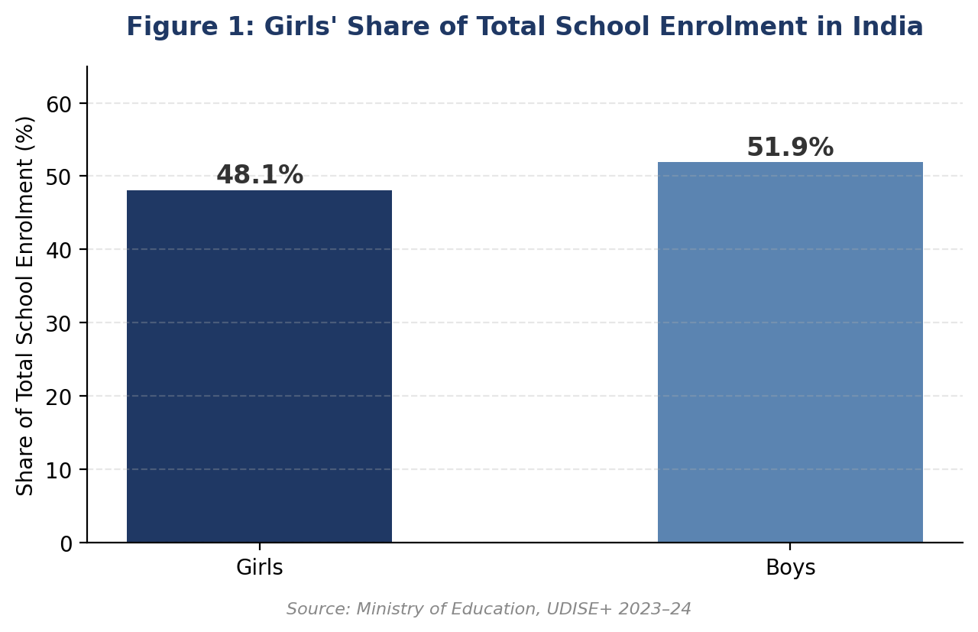
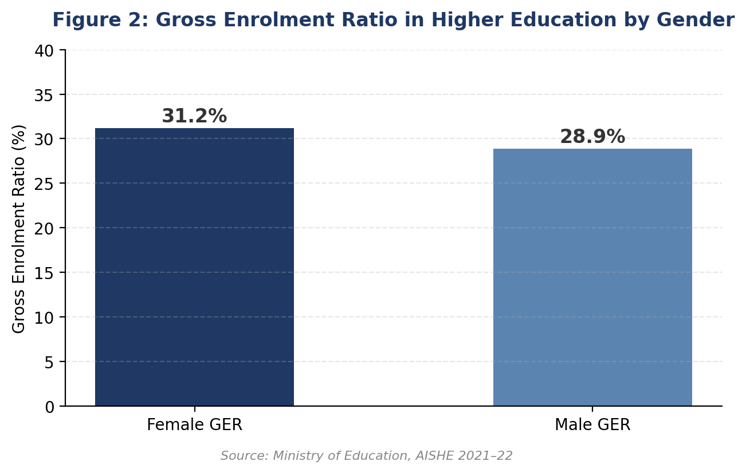

Analytical Interpretation
The indicators presented above demonstrate that India's educational policies have been successful in reducing historical gender disparities in educational access. However, the data also suggest that the policy discourse must now evolve beyond enrolment statistics. The next challenge is to ensure that girls not only enter educational institutions but also acquire high-quality learning, digital competencies, leadership skills, and equitable career opportunities. Consequently, future educational planning should evaluate success through outcomes such as learning achievement, employability, and educational completion rather than admission figures alone.
Key Findings — Current Status
- Girls now account for 48.1% of total school enrolment, close to numerical parity with boys.
- The Gender Parity Index exceeds 1.0 at several school stages, but this masks quality and completion gaps.
- Female GER in higher education (31.2%) has overtaken male GER (28.9%) for the first time in recent years.
- Access-based success has not yet translated into equal outcomes in STEM fields or senior academic roles.

4. Government Schemes and Policy Initiatives: A Critical Evaluation
India's progress in girls' education has been driven not by a single law but by a layered set of policy instruments, each targeting a different stage of the education pipeline — from enrolment and retention to quality and digital access. This section evaluates the four most significant interventions on their stated objectives, implementation mechanisms, and observed impact.

4.1 National Education Policy (NEP) 2020
NEP 2020 replaced the 1986 policy framework and introduced a Gender Inclusion Fund intended to give states resources to support the education of girls and transgender students. It also restructured schooling into a 5+3+3+4 model with an emphasis on foundational literacy and numeracy by 2025, and it encourages flexible re-entry points for girls who have dropped out (Government of India, 2020).
In practice, the policy's impact has been uneven: the Gender Inclusion Fund's state-wise disbursement and utilisation remain thinly documented in public reporting, and implementation depends heavily on individual state education departments. The policy's ambition on foundational literacy is a useful benchmark, but progress towards it should be tracked publicly and disaggregated by gender.

4.2 Samagra Shiksha
Samagra Shiksha is the umbrella scheme that merged the earlier Sarva Shiksha Abhiyan, Rashtriya Madhyamik Shiksha Abhiyan, and Teacher Education schemes into a single programme spanning pre-school to senior secondary education. For girls specifically, it funds self-defence training, sanitation and menstrual hygiene facilities, residential hostels in educationally backward blocks, and free textbooks and uniforms (Ministry of Education, 2024).
Its strength lies in integrating infrastructure (toilets, hostels) with retention incentives; its main limitation is that funding is routed through states, so the quality and consistency of implementation — for example, whether toilets remain functional or hostels adequately staffed — varies considerably by district.

4.3 Beti Bachao Beti Padhao (BBBP)
BBBP was launched by the Prime Minister on 22 January 2015 at Panipat, Haryana — a deliberate choice, since Haryana recorded one of the poorest Child Sex Ratios in the country at the time. Girls' education is one of its three core pillars alongside survival and protection, and the scheme funds district-level awareness campaigns, media outreach, and convergence with health and education departments (Ministry of Women and Child Development, 2024).
Haryana's own trajectory illustrates both the scheme's promise and its limits: the state's Sex Ratio at Birth rose from 871 girls per 1,000 boys in 2014 to a peak of 923 in 2019, standing at 916 in 2023 — a substantial improvement, though later data shows the gain is not fully linear (Women and Child Development Department, Haryana, 2024). Educational institutions across the state, including women's universities such as Bhagat Phool Singh Mahila Vishwavidyalaya, have run BBBP-aligned awareness and outreach activities as part of this broader community mobilisation effort.
Independent assessments have generally found BBBP more effective as an awareness and messaging campaign than as a direct driver of enrolment, since it does not itself fund school infrastructure or scholarships. Its long-term value lies in shifting community attitudes that indirectly support girls staying in school — Haryana's SRB recovery being a visible, if partial, indicator of that shift.

A Note from the Author
This section carries a personal dimension for me. As a student of Bhagat Phool Singh Mahila Vishwavidyalaya, I was one of approximately 150 girls who participated in a BBBP-aligned awareness journey — organised by the Indian Media Centre and flagged off by Rajeev Jain, then Haryana's BJP media chief and state coordinator for the Beti Bachao Beti Padhao campaign. The journey began in late December 2015 from the Wagah Border in Amritsar, travelling through Punjab, Chandigarh, and Haryana, with the group visiting schools and colleges along the route to raise awareness — explicitly linked, as contemporary press coverage noted, to reversing Haryana's poor child sex ratio (Dainik Jagran, Gurugram edition, 31 December 2015). That first-hand experience — seeing how a single campus-led outreach effort could open conversations within families about a daughter's schooling — is part of what motivated this paper. It also shaped my conviction, expressed throughout this study, that awareness campaigns work best when they are followed by sustained, institution-level support rather than treated as one-time events.

4.4 Kasturba Gandhi Balika Vidyalayas (KGBV)
KGBV, now merged under Samagra Shiksha, establishes residential upper-primary schools for girls from Scheduled Castes, Scheduled Tribes, Other Backward Classes, minority communities, and families below the poverty line, specifically in educationally backward blocks. This scheme directly targets the intersectional disadvantage discussed in Section 6.3, by combining residential safety with free schooling for the most vulnerable girls.
KGBV's model is among the more targeted of the four, since it is geographically and demographically means-tested rather than universal. Its impact is constrained mainly by the limited number of sanctioned schools relative to the scale of need in educationally backward districts.
Table 3. Comparative Snapshot of Major Government Schemes
Scheme | Primary Focus | Key Limitation
NEP 2020 | Systemic reform; Gender Inclusion Fund | Uneven state-level implementation and tracking
Samagra Shiksha | Infrastructure, hostels, hygiene, retention | Quality varies by district funding and oversight
Beti Bachao Beti Padhao | Awareness; sex-ratio and attitudinal change | Limited direct funding for schools or scholarships
Kasturba Gandhi Balika Vidyalayas | Residential schooling for the most disadvantaged girls | Limited number of schools relative to need
Source: Compiled by the author from Government of India (2020); Ministry of Education (2024); Ministry of Women and Child Development (2024).

Synthesis
Taken together, these schemes form a reasonably complete pipeline — policy architecture (NEP 2020), infrastructure and retention (Samagra Shiksha), community attitudes (BBBP), and targeted residential access (KGBV). The recurring weakness across all four is monitoring: publicly available, scheme-wise, state-disaggregated outcome data is limited, which makes it difficult to independently verify impact claims. Strengthening scheme-level data transparency should therefore be treated as a policy priority in its own right.
Key Findings — Government Schemes
- Four major schemes together cover policy architecture, infrastructure, attitudinal change, and targeted residential access.
- BBBP's Haryana experience shows awareness campaigns can support measurable SRB gains, but results are not always linear.
- The common weakness across all schemes is limited, publicly available, state-disaggregated outcome data.
- Scheme-level data transparency should be treated as a policy priority, not an afterthought.

5. State-Wise Disparities in Girls' Education
National figures such as the 48.1% enrolment share and the 1.0+ Gender Parity Index mask considerable variation across states. Female literacy — a longer-horizon indicator than current enrolment — illustrates this gap most clearly, ranging from the high nineties in some states to the mid-fifties in others (NFHS-5; Periodic Labour Force Survey 2023–24).
Table 4. Female Literacy Rate: Selected High- and Low-Performing States
State | Approx. Female Literacy Rate | Observation
Kerala | ~94% | Smallest gender gap nationally (~2 points); sustained public investment
Mizoram | ~98% | Highest female literacy rate in the country
Delhi | High (near-national top tier) | Strong urban infrastructure and school access
Uttar Pradesh | ~70% | Large population base; safety and infrastructure remain concerns
Rajasthan | ~66% | One of the widest male–female literacy gaps in India
Andhra Pradesh | ~67% | Below national female literacy average
Bihar | ~66–68% | Lowest-ranked state on overall literacy; early marriage a major dropout driver
Jharkhand | ~55% | Among the lowest female literacy rates nationally
Source: NFHS-5 (2019–21) and PLFS 2023–24 estimates; figures are approximate and rounded.
Note: Figures are approximate, compiled from Census/NSO, NFHS-5, and PLFS 2023–24 estimates, which use different reference periods and methodologies. Readers requiring precise, citable figures should consult the original NFHS-5 and PLFS state fact-sheets before quoting exact percentages.
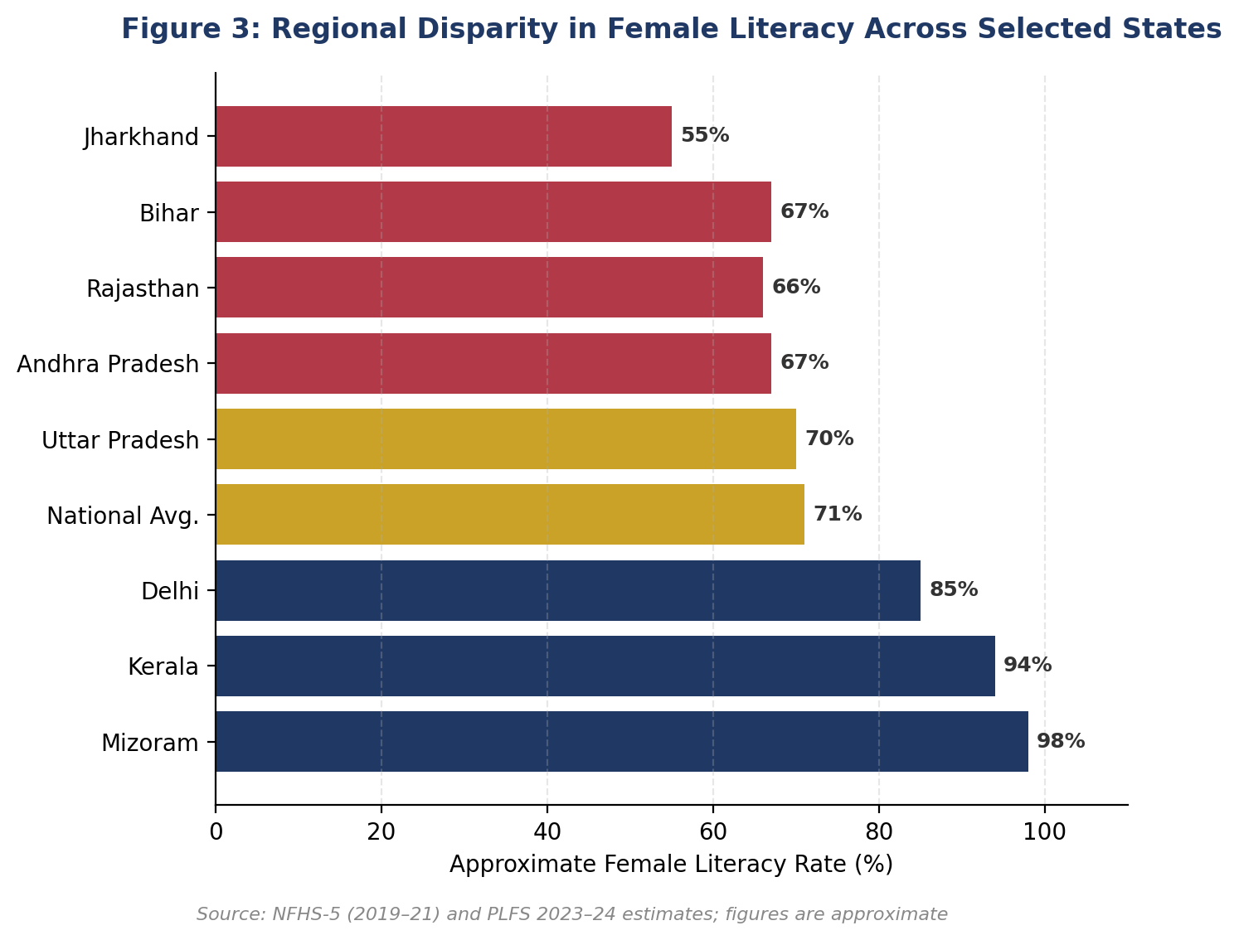
Note: A state-comparison chart is used here in place of a geographic choropleth map, as spatial mapping data was not available within this study's tools. Readers wishing to visualise this as a map may plot Table 4 onto any standard India state outline.

Why This Matters for Policy
The gap between Kerala/Mizoram and Bihar/Jharkhand is not primarily a funding gap — all states receive Samagra Shiksha and BBBP support — but a difference in decades of accumulated social investment, safety infrastructure, and administrative capacity. This reinforces the case, made throughout this paper, for district-specific rather than uniform national interventions, and for treating state-wise data transparency as a precondition for effective policy design.
Key Findings — State-Wise Disparities
- Female literacy ranges from ~55% (Jharkhand) to ~98% (Mizoram) — a gap of over 40 percentage points.
- Kerala has the smallest male–female literacy gap nationally (~2 points), reflecting decades of sustained investment.
- Bihar, Rajasthan, and Andhra Pradesh consistently rank near the bottom on female literacy.
- The disparity reflects accumulated social and administrative capacity, not just current-year scheme funding.

6. Structural Challenges Affecting Girls' Education in India
Although India has made substantial progress in improving educational participation among girls, the persistence of structural inequalities continues to influence educational quality and long-term outcomes. Contemporary challenges are no longer confined to school access; rather, they relate to the conditions that determine whether girls can complete education, acquire meaningful competencies, and successfully transition into higher education and employment. These barriers often intersect, creating cumulative disadvantages that disproportionately affect vulnerable groups.

6.1 Learning Poverty and Educational Quality
One of the most significant concerns facing India's education system is the gap between school attendance and actual learning. Increased enrolment does not necessarily translate into improved educational achievement. National and international assessments have repeatedly indicated that many students struggle to attain age-appropriate competencies in reading comprehension, numeracy, and analytical reasoning.
For girls, this issue is particularly important because limited learning outcomes reduce opportunities for higher education, competitive examinations, and skilled employment. Improving educational quality therefore requires greater investment in teacher capacity, competency-based learning, formative assessment, and learner-centred pedagogy rather than focusing exclusively on enrolment targets.

6.2 Digital Divide in the Post-Pandemic Era
The rapid expansion of digital learning has transformed educational delivery across India. However, unequal access to technology has emerged as a new dimension of educational inequality.
Evidence from UNESCO and UNICEF indicates that girls from economically weaker households frequently experience limited access to smartphones, computers, internet connectivity, and digital learning platforms. Even where digital devices are available, they may not be equally accessible to female learners because of household priorities and gender norms (UNESCO, 2024; UNICEF, 2024).
Consequently, digital exclusion should be understood not merely as a technological challenge but as an issue of educational equity requiring targeted public investment.

6.3 Regional and Social Disparities
National educational indicators often conceal considerable variation among states and social groups. Educational opportunities differ substantially across geographical regions due to variations in infrastructure, teacher availability, administrative capacity, and socio-economic development.
Girls belonging to Scheduled Castes (SC), Scheduled Tribes (ST), minority communities, economically weaker households, and children with disabilities frequently encounter multiple disadvantages simultaneously. Such intersectional inequalities demonstrate that uniform policy interventions may not adequately address diverse educational realities.
Future educational planning should therefore prioritise district-level planning, targeted resource allocation, and context-specific interventions rather than relying exclusively on national averages.

6.4 Gender Bias in Subject Choice and Career Aspirations
Although female participation in education has increased significantly, gender segregation across academic disciplines continues to influence future employment opportunities.
Women remain comparatively underrepresented in engineering, advanced technology, artificial intelligence, and certain scientific research domains despite gradual improvements in STEM participation. This imbalance is influenced by social expectations, limited mentoring opportunities, lack of visible female role models, and unconscious gender stereotypes rather than academic ability.
Educational institutions should actively encourage girls to participate in STEM education through mentorship programmes, career counselling, research exposure, and industry partnerships.

6.5 School-to-Work Transition
Educational attainment alone does not guarantee economic empowerment. Many young women encounter significant challenges while transitioning from formal education to employment.
Employability skills, internships, career guidance, entrepreneurship education, and industry exposure remain unevenly integrated within the educational system. As a result, a considerable proportion of educated young women experience delayed labour market participation despite academic qualifications.
Bridging this transition gap requires stronger collaboration between educational institutions, employers, skill development agencies, and public policy initiatives.
Table 2. Structural Challenges and Their Educational Implications
Challenge | Educational Impact | Policy Priority
Learning Poverty | Weak foundational competencies | Improve teaching quality and assessment reforms
Digital Divide | Unequal access to online learning | Expand affordable digital infrastructure
Regional Inequality | Uneven educational opportunities | District-specific planning and targeted funding
Gender Bias in Career Choices | Limited participation in STEM and leadership | Career mentoring and gender-responsive counselling
Weak School-to-Work Transition | Reduced employability | Strengthen internships, vocational education and career services
Source: Compiled by the author, synthesising UNESCO (2024), UNICEF (2024), and Ministry of Education (2024) reporting.

Critical Discussion
The challenges identified in this study indicate that the future of girls' education in India depends less on expanding educational access and more on improving educational effectiveness. Policies designed during the previous decade successfully addressed enrolment-related barriers; however, the emerging educational landscape demands a shift towards learning quality, digital inclusion, employability, and institutional responsiveness.
Furthermore, educational inequality should no longer be viewed solely through the lens of gender. Instead, policymakers must adopt an intersectional perspective that recognises how gender interacts with poverty, disability, geography, caste, and digital access to shape educational experiences. Such an approach would enable more equitable allocation of educational resources while ensuring that interventions reach girls who remain most vulnerable to educational exclusion.
Key Findings — Structural Challenges
- Five interlocking barriers persist: learning poverty, the digital divide, regional inequality, gender bias in subject choice, and weak school-to-work transition.
- These barriers intersect and compound — girls facing poverty, disability, or caste-based exclusion are affected on multiple fronts at once.
- The policy shift required is from access-based metrics to effectiveness-based metrics: learning outcomes, digital inclusion, and employability.

7. From Policy to Practice: The Role of Youth, Communities and Institutions
Educational transformation cannot be achieved by government policies alone. Sustainable change requires active participation from educational institutions, families, civil society organisations, youth volunteers, and local communities. Girls' education must evolve into a collective social responsibility rather than remaining solely a governmental agenda.

7.1 Role of Youth
Young people possess the ability to influence attitudes more effectively than institutions alone. Through peer learning, mentorship, awareness campaigns, digital advocacy, and volunteer-led educational initiatives, youth can help eliminate stereotypes that discourage girls' education. Universities and youth organisations should encourage students to become education ambassadors within their own communities.

7.2 Role of Youth Vision India
As a youth-led organisation committed to nation-building, Youth Vision India (YVI) can contribute significantly by transforming awareness into action. Beyond conducting campaigns, YVI can establish sustainable educational support systems that create measurable community impact.
Some practical initiatives include:
- Launching “Each One Teach One Girl” volunteer mentoring programmes.
- Organising career guidance and scholarship awareness sessions.
- Conducting digital literacy workshops for adolescent girls.
- Creating legal awareness modules on educational rights.
- Developing leadership fellowships for young women.
- Publishing evidence-based policy briefs and educational research.
- Building partnerships with schools, colleges, NGOs, and Panchayati Raj Institutions.
These initiatives require limited financial resources but can generate long-term educational and social impact.

A Value Proposition as Intermediary
The schemes evaluated in Section 4 are designed at the national and state level, but their success ultimately depends on last-mile delivery — the point at which policy reaches a specific school, family, or community. This is the space in which a youth-led organisation can add distinctive value, functioning as an intermediary between the state and the community rather than duplicating either.
This intermediary role rests on four practical advantages that neither government bodies nor individual schools typically have on their own:
- Local trust and access: as peers rather than officials, youth volunteers can open conversations with families and adolescent girls that formal state machinery often cannot.
- Speed and adaptability: unlike government bodies bound by administrative and budget cycles, a youth organisation can pilot a format, gather feedback, and revise it within weeks.
- A two-way feedback channel: because volunteers work close to the ground, they are positioned to surface implementation gaps — for example, in Samagra Shiksha or BBBP delivery — back to schools and policymakers, rather than only delivering messages downward.
- Cost-efficient delivery: a volunteer-based model can extend the reach of existing schemes without a proportional increase in public budget.
Concretely, to schools and colleges this translates into a low-cost delivery partner for mentorship, career guidance, and legal literacy sessions that institutions often lack the staff time to run themselves. To government departments and Panchayati Raj Institutions, it translates into a ground-level feedback partner — able to report, in aggregate, where a scheme is or is not reaching its intended beneficiaries — which can inform course correction between formal review cycles.

A Proposed Pilot Model: Partnering with NGOs and Community Educators
To put this intermediary role into practice, the pilot programme outlined in Section 7.6 is designed around three complementary channels of reach, instead of YVI attempting to act alone:
- Direct school and college outreach: seminars, awareness camps, and short workshops conducted across different schools and colleges, with format and content adapted to each institution's setting instead of a single fixed template.
- NGO partnerships in rural areas: rather than building new rural infrastructure from scratch, the pilot would work through NGOs already active in these areas, drawing on their established community trust and local networks.
- Community-based facilitators: educated women from within these same communities engaged as near-peer facilitators and mentors, since they combine local credibility with the ability to model, in person, the outcomes the programme seeks to encourage.
In this model, NGOs provide access and local legitimacy, community facilitators provide relatable and sustained mentorship, and YVI provides curriculum design, coordination, and evaluation. The combination is intended to give the pilot a realistic chance of reaching girls in areas a purely campus-based initiative would not.

Institutionalising Coverage: A Rotating Duty and Fallback Mechanism
Part of the awareness gap this paper documents is not about access to schooling as such, but about awareness of entitlements that already exist. Many rural households remain unaware of the government scholarship schemes available to girls, so uptake lags well behind availability regardless of what is on offer. Regular awareness camps — held monthly or every two months in every rural area with a resident female population — are proposed as a direct response to this specific gap, covering both the benefits of continuing education and the scholarships and schemes already in place to support it.
For this cadence to be sustained and not sporadic, accountability needs to be assigned instead of left informal. Local administrative officers — such as the Tehsildar or Sub-Divisional Magistrate — together with the relevant education department or Panchayati Raj institution, would hold a mandate to ensure that camps occur on this schedule within their jurisdiction. Where a village has more than one school, the duty of organising alternate camps could rotate between them by month or by day, distributing the workload rather than concentrating it on a single institution.
NGOs already active in a given state or district would carry a parallel obligation to organise or support these camps as part of their existing community presence. In areas where no NGO operates within a wide radius, this role would fall to the relevant government department, which would organise the camp directly, so that geographic gaps in NGO coverage do not become geographic gaps in awareness. The objective in every case is the same: reaching girls who have already dropped out, girls currently enrolled, and girls not yet in school, with practical information on available schemes and the benefits of continuing their education.
Table 5. Proposed Institutional Responsibility for Awareness Camps
Responsible Party | Assigned Duty | Trigger / Cadence
Tehsildar / SDM, with the Education Department or Panchayati Raj Institution | Mandate and monitor that camps occur on schedule within their jurisdiction | Continuous, across all scheduled camps
Schools (where a village has more than one) | Rotate hosting duty for camps so the workload is not concentrated on one institution | Alternate by month or by day
NGOs active in the district | Organise or support camps as part of existing community presence | Where an NGO is already active
Relevant government department | Organise the camp directly as a fallback | Where no NGO operates within a wide radius
Source: Proposed by the author as part of this paper's institutional accountability framework; not an existing government notification.

7.3 Role of Educational Institutions
Schools and higher educational institutions should move beyond curriculum delivery and function as centres of leadership development. Every institution should establish structured mentoring systems, career counselling services, gender sensitisation programmes, and safe reporting mechanisms that encourage girls to participate confidently in academic and extracurricular activities.

7.4 Community Participation
Communities influence educational decisions long before policies reach households. Parents, local leaders, self-help groups, alumni networks, and community-based organisations should collectively promote girls' education through regular dialogue, public recognition of educational achievement, and local scholarship support.

7.5 Beyond Access: Building Women's Agency After Education
Sections 3 and 6.5 of this paper show that access to education has expanded substantially, but that this expansion has not automatically translated into equal outcomes after school or college ends. A girl who completes her education does not automatically gain control over decisions about her career, the timing of her marriage, her mobility, or her finances — a gap this paper refers to as an agency gap, distinct from the access gap that national enrolment statistics primarily measure.
This is where the mentorship, career guidance, and legal literacy work described in Section 7.2 should extend beyond the school years rather than ending at graduation. Continuing this support into early adulthood is explicitly aimed at strengthening a young woman's capacity to exercise choice — not simply the credentials on her certificate. Measured this way, success is not only how many girls complete school, but how many go on to make independent decisions about their own lives.

7.6 A Phased, Pilot-to-Scale Implementation Roadmap
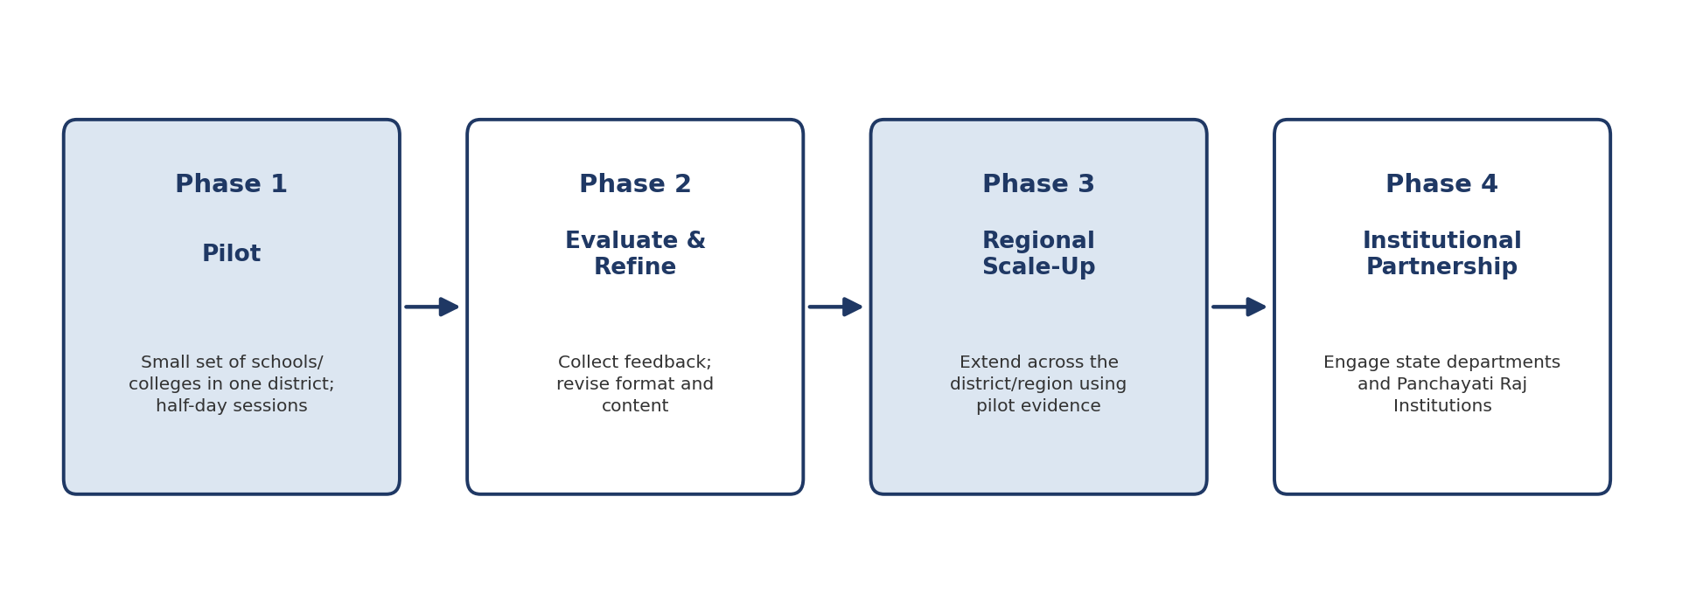
Figure 3. Proposed four-phase pilot-to-scale rollout for Youth Vision India's community education initiatives.
The initiatives outlined in this section are more credible as a staged rollout than as a simultaneous list of activities. A phased approach allows each element to be tested and adjusted before public or institutional commitments are scaled:
- Phase 1 — Pilot: run in a small, defined number of schools or colleges within a single district, using short-format interventions such as half-day sessions to test content, delivery, and engagement before any larger commitment is made.
- Phase 2 — Evaluate and refine: gather participant feedback and basic outcome indicators from the pilot, and revise the format and content accordingly before it is repeated elsewhere.
- Phase 3 — Regional scale-up: once the pilot format is validated, extend it across the wider district or region, using the pilot's own results as evidence to secure school and local administrative buy-in.
- Phase 4 — Institutional partnership and advocacy: use the validated, evidenced model to engage state education departments and Panchayati Raj Institutions, positioning the organisation's own track record as the basis for further scale.
This sequencing matters as much as the content of the initiatives themselves: it converts a list of aspirations into a realistic timeline, and it gives the organisation itself a structured opportunity to learn from early results and adjust its approach before committing further resources to a wider rollout.

Anticipated Challenges
This model is not without risk. NGO capacity and quality vary considerably across regions, so partner selection would need to be as deliberate as the programme content itself. Volunteer and mentor retention is a common weakness in youth-led initiatives, particularly once initial enthusiasm fades. Funding, even at pilot scale, would need to be secured before Phase 1 begins, not assumed along the way. The rotating duty mechanism proposed above also carries a familiar risk: a mandate without enforcement can become a formality instead of a functioning schedule, much as this paper notes regarding the Gender Inclusion Fund in Section 4.1. None of these risks are reasons to avoid the pilot; they are reasons to build monitoring and course-correction into the model from the outset — consistent with the data-transparency concerns this paper raises regarding the government schemes discussed in Section 4.

Author's Perspective
Girls' education should no longer be discussed only as an issue of equality; it should be recognised as a measure of a nation's developmental maturity. The true success of educational policy will not be reflected merely in enrolment statistics but in the confidence, leadership, innovation, and social contribution of educated young women. Every classroom that empowers a girl today strengthens the economic, democratic, and moral foundations of India tomorrow.

8. Conclusion
India has entered a phase where the primary challenge is no longer ensuring that girls enter schools but ensuring that they receive education capable of transforming their lives. While national policies have substantially improved access and participation, future progress depends upon strengthening educational quality, digital inclusion, institutional accountability, and leadership opportunities.
The evidence presented in this study demonstrates that girls' education is not simply an educational objective; it is an investment in constitutional values, economic resilience, and sustainable national development. The responsibility for achieving this vision extends beyond governments to educational institutions, communities, families, and youth-led organisations.
For organisations such as Youth Vision India, the opportunity lies not merely in advocating for girls' education but in creating practical models of community engagement, mentorship, legal awareness, and youth leadership. Such initiatives can bridge the gap between policy and practice while empowering young women to become informed citizens, ethical leaders, and agents of social transformation.
Ultimately, educating a girl is not an act of charity—it is an investment in India's future. The strength of a nation is measured not only by the number of schools it builds, but by the opportunities it creates for every girl to learn, lead, and thrive.

9. Future Scope of Research
While this paper has examined the present status of girls' education in India through policy analysis and secondary data, several areas require deeper academic investigation. Future research may explore state-wise educational disparities, the long-term impact of digital learning on girls, educational experiences of girls with disabilities, the effectiveness of scholarship programmes, and the relationship between girls' education and workforce participation. Comparative studies between India and other developing nations may also provide valuable insights for policy innovation.
Further research should increasingly adopt mixed-method approaches by combining quantitative educational data with qualitative evidence from students, teachers, parents, and community organisations. Such studies will contribute to more context-specific and evidence-driven educational reforms.

10. Limitations of the Study
This study is based entirely on secondary sources of information, including official government reports, policy documents, and publications of recognised international organisations. Since no primary field survey or interviews were conducted, the findings should be interpreted within the scope of available published evidence.
Furthermore, educational indicators continue to evolve with newly released datasets; therefore, future studies should update statistical analysis using the latest official reports.

Data Verification Note
All statistics in this paper are drawn from cited government and institutional sources current as of early-to-mid 2024–25 (principally UDISE+ 2023–24 and AISHE 2021–22). Newer editions of these reports — for instance, a UDISE+ 2024–25 release — may report marginally different figures (e.g., a slightly higher girls' enrolment share) due to methodology or reference-year changes. Before this paper is published, presented, or cited externally, the author recommends re-verifying every statistic, table, and figure against the latest available official release from the Ministry of Education, AISHE, NFHS, and PLFS.

11. Final Reflection
Girls' education is often discussed through statistics, enrolment rates, and policy documents. However, behind every educational indicator is a young girl whose future depends upon the opportunities society chooses to provide. Educational equality is therefore not achieved merely by opening school gates—it is achieved when every girl is able to enter, remain, learn, lead, and realise her full potential.
India has already demonstrated that political commitment and institutional reforms can reduce historical educational inequalities. The next challenge is to ensure that educational opportunities translate into meaningful capabilities, dignified employment, informed citizenship, and confident leadership.
The responsibility for achieving this vision extends beyond governments. Educational institutions, families, civil society organisations, researchers, and youth volunteers all have a shared role in creating an environment where girls are encouraged not simply to complete their education but to become innovators, professionals, policymakers, entrepreneurs, scientists, educators, and leaders.
For organisations such as Youth Vision India, the greatest contribution lies in transforming awareness into measurable action. Every mentorship programme, awareness campaign, scholarship drive, legal literacy workshop, research publication, and community initiative has the potential to change individual lives while contributing to national development.
Ultimately, girls' education should not be viewed as an expenditure—it is India's most valuable long-term investment. A nation that educates its girls invests simultaneously in healthier families, stronger institutions, inclusive economic growth, and a more democratic future.
“When a girl is educated, knowledge reaches a classroom; when millions of girls are educated, knowledge transforms a nation.”

Acknowledgement
The author gratefully acknowledges Youth Vision India for providing a platform that encourages youth-led research, public policy discussions, and community engagement. The organisation's commitment to education, constitutional awareness, leadership, and social responsibility has inspired the preparation of this research paper.
The author also acknowledges the Government of India, the Ministry of Education, UNESCO, UNICEF, the World Bank, and other institutions whose publicly available reports and datasets have supported evidence-based academic analysis.

References (APA 7th Edition)
Government Reports
1. Government of India. (2020). National Education Policy 2020. Ministry of Education.
2. Ministry of Education. (2024). Unified District Information System for Education Plus (UDISE+) Report 2023–24. Government of India.
3. Ministry of Education. (2024). All India Survey on Higher Education (AISHE) 2021–22. Government of India.
4. Ministry of Education. (2024). Samagra Shiksha Framework.
5. Ministry of Women and Child Development. (2024). Beti Bachao Beti Padhao Operational Guidelines.
6. Women and Child Development Department, Government of Haryana. (2024). Beti Bachao Beti Padhao: Key Achievements and Milestones in Haryana.
7. Dainik Jagran, Gurugram Edition. (2015, December 31). सैनिकों का सम्मान बढ़ाने निकली सूबे की बेटियां [Regional press coverage of the Indian Media Centre awareness journey], p. 5.
8. National Council of Educational Research and Training. (2023). National Achievement Survey Report.
9. National Statistical Office. (2023). Women and Men in India.
10. National Statistical Office, Ministry of Statistics and Programme Implementation. (2024). Periodic Labour Force Survey (PLFS) Annual Report, July 2023–June 2024.
11. International Institute for Population Sciences. (2022). National Family Health Survey (NFHS-5), 2019–21: India Report.
12. NITI Aayog. (2024). SDG India Index.
International Reports
1. UNESCO. (2024). Global Education Monitoring Report.
2. UNESCO Institute for Statistics. (2024). Education Database.
3. UNICEF. (2024). State of the World's Children.
4. UNICEF India. (2023). Girls' Education Programme Reports.
5. United Nations. (2015). Transforming Our World: The 2030 Agenda for Sustainable Development.
6. United Nations Development Programme. (2024). Human Development Report.
7. World Bank. (2024). Education Overview.
8. World Economic Forum. (2024). Global Gender Gap Report.
Legal and Constitutional Sources
1. Constitution of India.
2. Right of Children to Free and Compulsory Education Act, 2009.
3. Protection of Children from Sexual Offences Act, 2012.
4. National Commission for Protection of Child Rights. (2023). Annual Report.

Author's Declaration
This research paper is an original academic work prepared for educational and policy discussion purposes. The analysis is based on publicly available secondary sources, official government publications, and reports of recognised national and international organisations. Every effort has been made to maintain academic integrity, objectivity, and proper attribution of information through APA-style referencing.

