- Create a Login Form using HTML, CSS, and JavaScript with proper styling. Apply the following validations:
a. Username must be minimum 5 characters
b. Password must be minimum 6 characters
c. Password should contain at least one number
d. Prevent form submission if validation fails
e. Display error messages below each field.
<!DOCTYPE html>
<html lang="en">
<head>
<meta charset="UTF-8">
<title>Login Form Validation</title>
<style>
body { font-family: sans-serif; display: flex; justify-content: center; padding-top: 50px; }
.form-container { width: 300px; padding: 20px; border: 1px solid #ccc; border-radius: 8px; }
.error { color: red; font-size: 12px; margin-top: 4px; height: 15px; }
input { width: 100%; padding: 8px; box-sizing: border-box; }
.field { margin-bottom: 15px; }
</style>
</head>
<body>
<div class="form-container">
<h2>Login Form </h2>
<form id="loginForm">
<div class="field">
<input type="text" id="username" placeholder="Username (min 5 chars)">
<div id="userError" class="error"></div>
</div>
<div class="field">
<input type="password" id="password" placeholder="Password (min 6 chars, 1 number)">
<div id="passError" class="error"></div>
</div>
<button type="submit">Login</button>
</form>
</div>

<script>
document.getElementById('loginForm').addEventListener('submit', function(e) {
let isValid = true;
const username = document.getElementById('username').value;
const password = document.getElementById('password').value;
const userErr = document.getElementById('userError');
const passErr = document.getElementById('passError');

userErr.innerText = "";
passErr.innerText = "";
if (username.length < 5) {
userErr.innerText = "Username must be minimum 5 characters ";
isValid = false;
}
if (password.length < 6) {
passErr.innerText = "Password must be minimum 6 characters ";
isValid = false;
} else if (!/\d/.test(password)) {
passErr.innerText = "Password should contain at least one number ";
isValid = false;
}
if (!isValid) {
e.preventDefault(); // Prevent form submission if validation fails
} else {
alert("Form Submitted Successfully!");
}
});
</script>
</body>
</html>
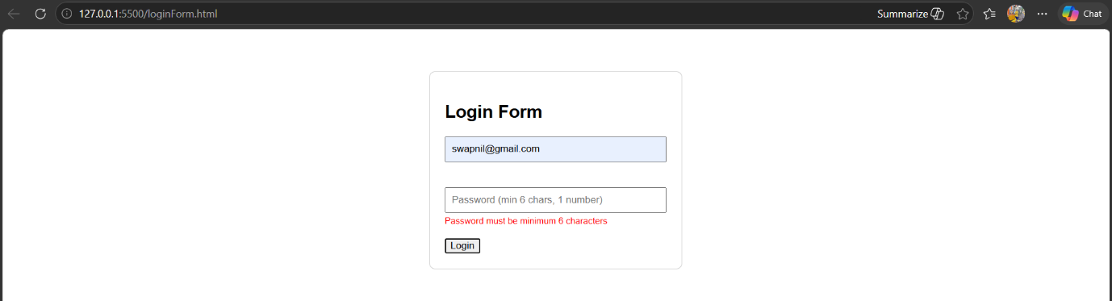
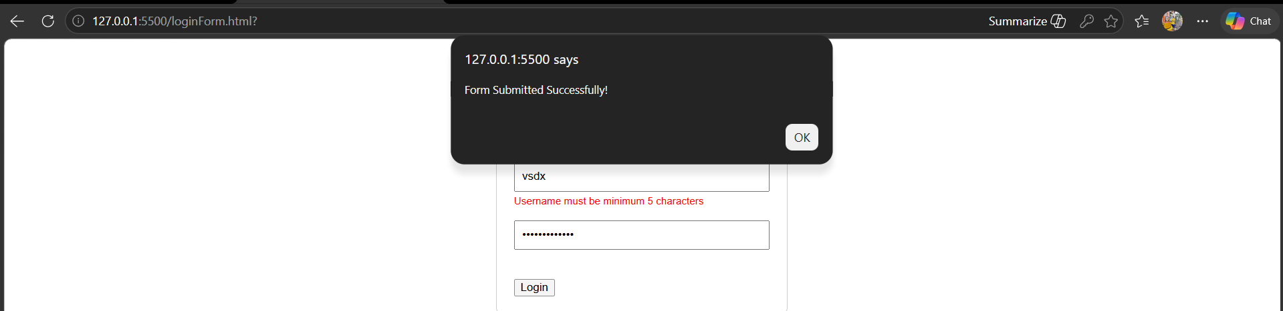
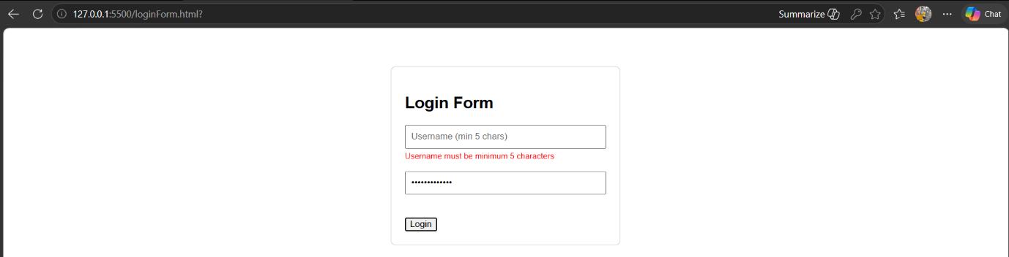
- Create a To-Do List application using HTML, CSS, and JavaScript. Design an attractive UI panel where users can add tasks, delete tasks, and mark tasks as completed.
<!DOCTYPE html>
<html lang="en">
<head>
<meta charset="UTF-8">
<title>To-Do List</title>
<style>
.panel { width: 350px; margin: auto; padding: 20px; box-shadow: 0 4px 8px rgba(0,0,0,0.2); border-radius: 10px; }
.task-item { display: flex; justify-content: space-between; margin: 10px 0; border-bottom: 1px solid #eee; padding-bottom: 5px; }
.completed { text-decoration: line-through; color: gray; }
button { cursor: pointer; }
</style>
</head>
<body>
<div class="panel">
<h3>To-Do List </h3>
<input type="text" id="taskInput" placeholder="Add a new task...">
<button onclick="addTask()">Add Task</button>
<div id="taskList"></div>
</div>

<script>
function addTask() {
const val = document.getElementById('taskInput').value;
if (!val) return;

const div = document.createElement('div');
div.className = "task-item";
div.innerHTML = `
<span onclick="this.classList.toggle('completed')">${val}</span>
<button onclick="this.parentElement.remove()">Delete</button>
`;
document.getElementById('taskList').appendChild(div);
document.getElementById('taskInput').value = "";
}
</script>
</body>
</html>

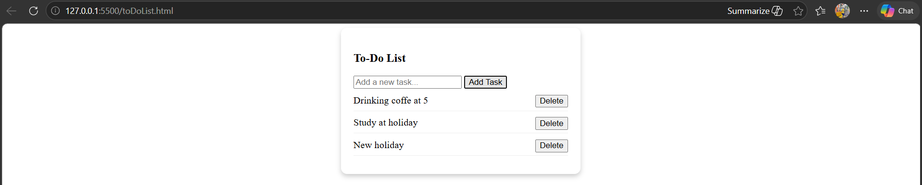
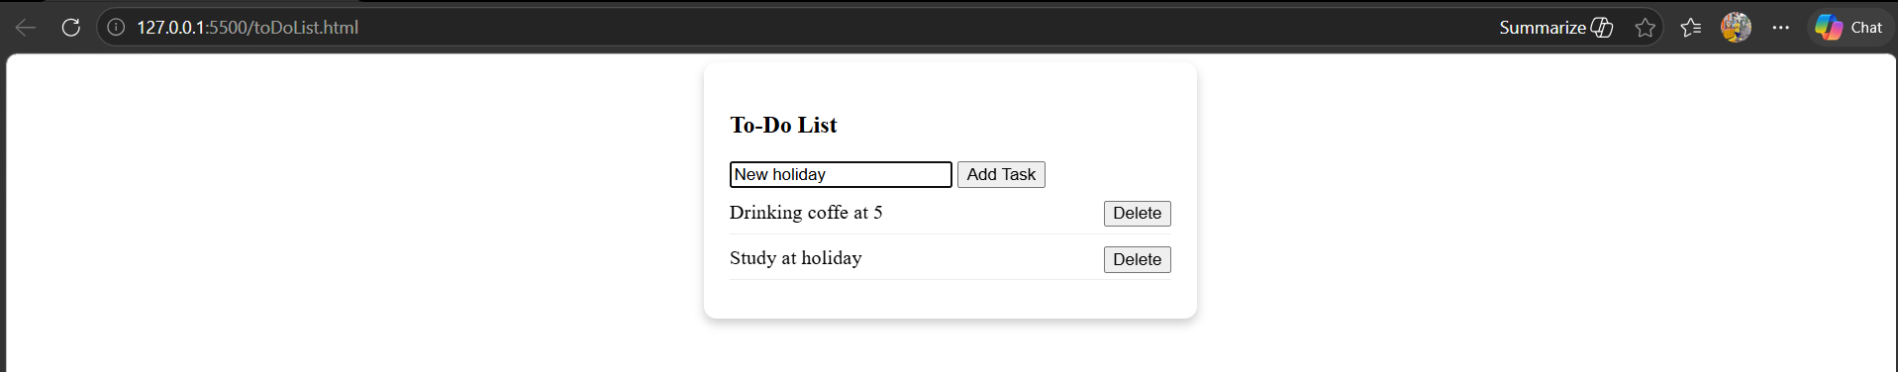

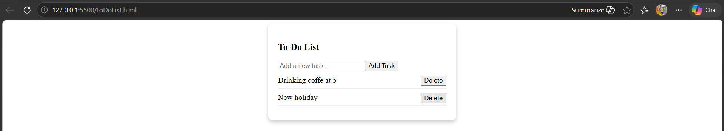

- Create a Student List Manager using HTML, CSS, and JavaScript. Create a form to enter student names. Store the names in an array and display them dynamically in a list. Provide functionality to delete a selected student from the array and update the displayed list accordingly.
<!DOCTYPE html>
<html>
<body>
<h3>Student List Manager </h3>
<input type="text" id="studentName" placeholder="Enter student name">
<button onclick="addStudent()">Add Student</button>
<ul id="displayList"></ul>

<script>
let students = []; // Array to store names

function addStudent() {
const name = document.getElementById('studentName').value;
if(name) {
students.push(name);
render();
document.getElementById('studentName').value = "";
}
}

function deleteStudent(index) {
students.splice(index, 1); // Delete selected student
render();
}

function render() {
const list = document.getElementById('displayList');
list.innerHTML = "";
students.forEach((s, i) => {
list.innerHTML += `<li>${s} <button onclick="deleteStudent(${i})">Delete</button></li>`;
});
}
</script>
</body>
</html>

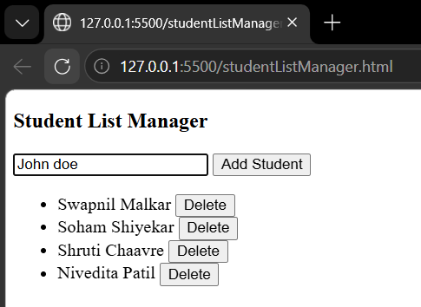
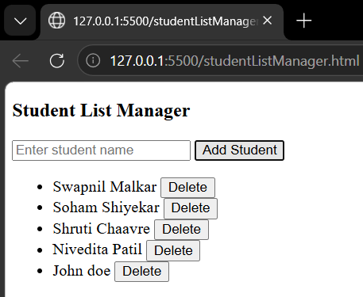
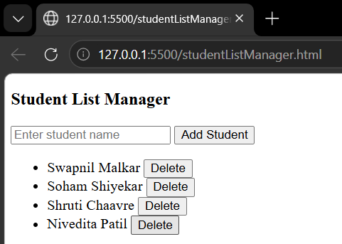

- Create an attractive User Profile Card component using React. The component should display a profile image, user name, designation, short description, and a Follow button. Apply appropriate CSS styling to create a modern UI panel with hover effects and centered layout.
import React from 'react';

const ProfileCard = () => {
const styles = {
container: { display: 'flex', justifyContent: 'center', alignItems: 'center', height: '100vh', backgroundColor: '#f0f2f5' },
card: {
width: '300px', backgroundColor: '#fff', borderRadius: '15px', padding: '20px',
textAlign: 'center', boxShadow: '0 4px 8px rgba(0,0,0,0.1)', transition: '0.3s'
},
image: { width: '100px', height: '100px', borderRadius: '50%', marginBottom: '15px' },
button: { backgroundColor: '#007bff', color: '#fff', border: 'none', padding: '10px 20px', borderRadius: '5px', cursor: 'pointer' }
};

return (
<div style={styles.container}>
<div style={styles.card} onMouseEnter={(e) => e.currentTarget.style.transform = 'scale(1.05)'} onMouseLeave={(e) => e.currentTarget.style.transform = 'scale(1)'}>
<h2>Swapnil Malkar</h2>
<p style={{color: '#777'}}>Software Engineer</p>
<p>Passionate about building modern web apps with React.</p>
<button style={styles.button}>Follow</button>
</div>
</div>
);
};

export default ProfileCard;

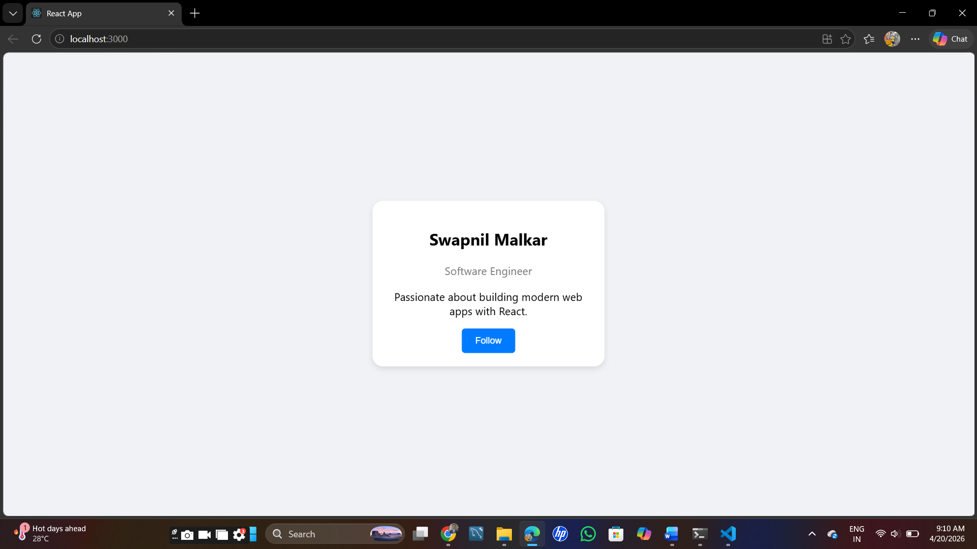

- Create a React application that demonstrates passing data from parent to child using props.
import React from 'react';

const Child = (props) => (
<div style={{ border: '1px solid black', padding: '10px', margin: '10px' }}>
<h3>Child Component</h3>
<p>Received Name: {props.name}</p>
</div>
);

const Parent = () => (
<div style={{ padding: '20px' }}>
<h2>Parent Component</h2>
<Child name="Swapnil" />
</div>
);

export default Parent;
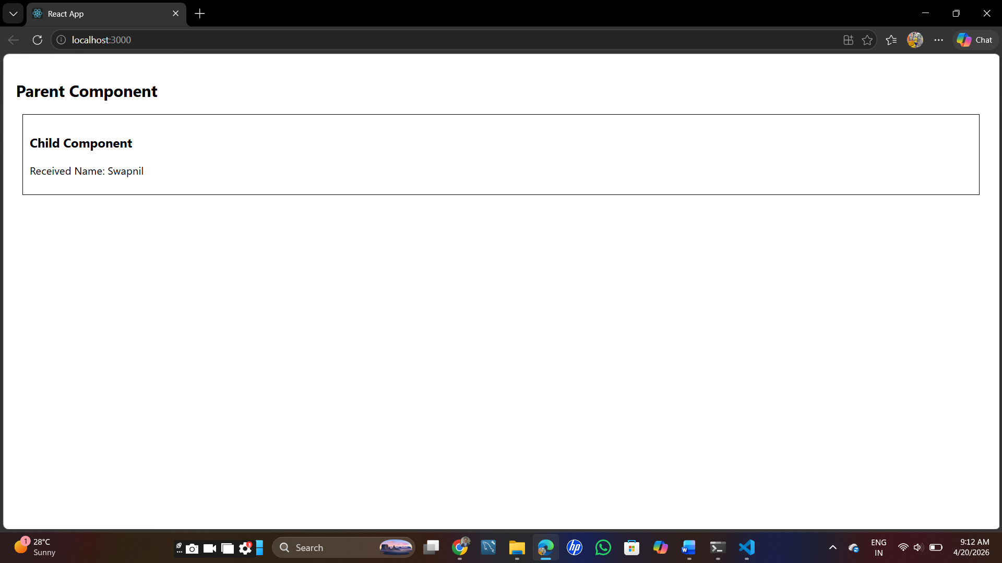

- Create a React form to collect student details and display submitted data using useState

import React, { useState } from 'react';

const StudentForm = () => {
const [name, setName] = useState("");
const [submitted, setSubmitted] = useState("");

const styles = {
box: { padding: '20px', border: '1px solid #ccc', width: '300px' }
};

return (
<div style={styles.box}>
<form onSubmit={(e) => { e.preventDefault(); setSubmitted(name); }}>
<input type="text" value={name} onChange={(e) => setName(e.target.value)} placeholder="Student Name" />
<button type="submit">Submit</button>
</form>
{submitted && <h4>Last Submitted Student: {submitted}</h4>}
</div>
);
};

export default StudentForm;

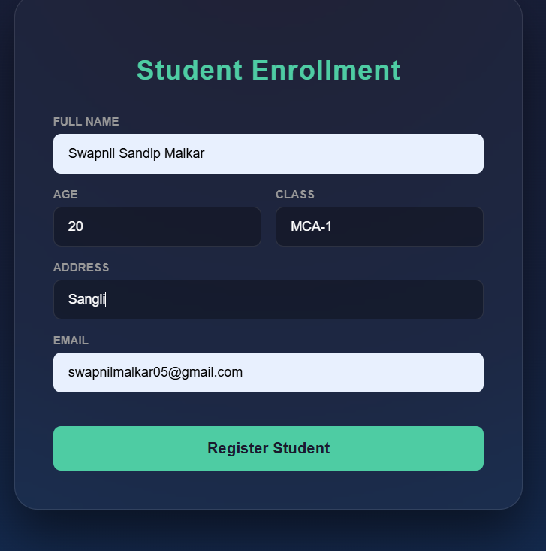

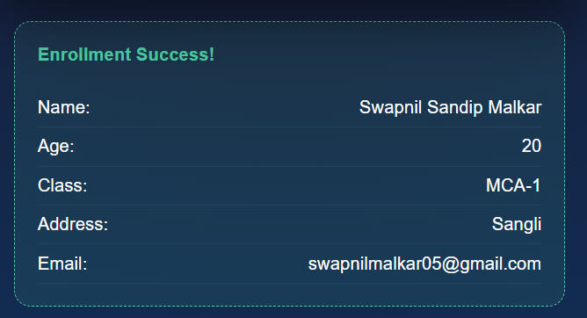

- Implement useEffect hook to fetch data from a dummy API and display it in a list.
import React, { useState, useEffect } from 'react';

const FetchData = () => {
const [items, setItems] = useState([]);

useEffect(() => {
fetch('https://jsonplaceholder.typicode.com/users')
.then(res => res.json())
.then(data => setItems(data));
}, []);

return (
<div style={{ padding: '20px' }}>
<h3>User Directory</h3>
<ul>
{items.map(user => <li key={user.id}>{user.name}</li>)}
</ul>
</div>
);
};

export default FetchData;

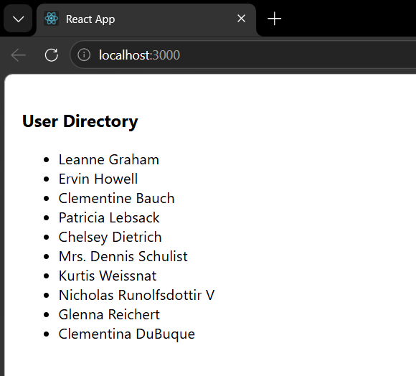

- React form with validation (name, email, password) and display error messages.
import React, { useState } from 'react';

const ValidatedForm = () => {
// State for form fields
const [formData, setFormData] = useState({
name: '',
email: '',
password: ''
});

// State for error messages
const [errors, setErrors] = useState({});

// Internal CSS Styles
const styles = {
container: {
display: 'flex',
justifyContent: 'center',
alignItems: 'center',
minHeight: '100vh',
backgroundColor: '#f4f7f6',
fontFamily: '"Segoe UI", Tahoma, Geneva, Verdana, sans-serif',
},
card: {
backgroundColor: '#ffffff',
padding: '40px',
borderRadius: '12px',
boxShadow: '0 10px 25px rgba(0,0,0,0.1)',
width: '100%',
maxWidth: '400px',
},
title: {
textAlign: 'center',
color: '#333',
marginBottom: '20px',
fontSize: '24px',
},
formGroup: {
marginBottom: '20px',
display: 'flex',
flexDirection: 'column',
},
label: {
marginBottom: '8px',
fontSize: '14px',
fontWeight: '600',
color: '#555',
},
input: {
padding: '12px',
borderRadius: '6px',
border: '1px solid #ddd',
fontSize: '16px',
outline: 'none',
transition: 'border-color 0.3s ease',
},
// Helper for dynamic input border styling
inputError: {
borderColor: '#ff4d4f',
},
errorText: {
color: '#ff4d4f',
fontSize: '12px',
marginTop: '5px',
fontWeight: '500',
},
button: {
width: '100%',
padding: '14px',
backgroundColor: '#4caf50',
color: 'white',
border: 'none',
borderRadius: '6px',
fontSize: '16px',
fontWeight: 'bold',
cursor: 'pointer',
transition: 'background-color 0.3s ease',
marginTop: '10px',
},
buttonHover: {
backgroundColor: '#45a049',
}
};

const validate = () => {
let tempErrors = {};
const emailRegex = /\S+@\S+\.\S+/;

if (!formData.name.trim()) tempErrors.name = "Name is required";
if (!formData.email) {
tempErrors.email = "Email is required";
} else if (!emailRegex.test(formData.email)) {
tempErrors.email = "Invalid email format";
}
if (!formData.password) {
tempErrors.password = "Password is required";
} else if (formData.password.length < 6) {
tempErrors.password = "Password must be at least 6 characters";
}

setErrors(tempErrors);
return Object.keys(tempErrors).length === 0;
};

const handleSubmit = (e) => {
e.preventDefault();
if (validate()) {
alert("Registration Successful!");
console.log("Submitted Data:", formData);
}
};

const handleChange = (e) => {
const { name, value } = e.target;
setFormData({ ...formData, [name]: value });
};

return (
<div style={styles.container}>
<div style={styles.card}>
<h2 style={styles.title}>Register Student</h2>
<form onSubmit={handleSubmit} noValidate>
{/* Name Field */}
<div style={styles.formGroup}>
<label style={styles.label}>Full Name</label>
<input
type="text"
name="name"
placeholder="Enter your name"
style={{
...styles.input,
...(errors.name ? styles.inputError : {})
}}
value={formData.name}
onChange={handleChange}
/>
{errors.name && <span style={styles.errorText}>{errors.name}</span>}
</div>

{/* Email Field */}
<div style={styles.formGroup}>
<label style={styles.label}>Email Address</label>
<input
type="email"
name="email"
placeholder="example@mail.com"
style={{
...styles.input,
...(errors.email ? styles.inputError : {})
}}
value={formData.email}
onChange={handleChange}
/>
{errors.email && <span style={styles.errorText}>{errors.email}</span>}
</div>

{/* Password Field */}
<div style={styles.formGroup}>
<label style={styles.label}>Password</label>
<input
type="password"
name="password"
placeholder="Min. 6 characters"
style={{
...styles.input,
...(errors.password ? styles.inputError : {})
}}
value={formData.password}
onChange={handleChange}
/>
{errors.password && <span style={styles.errorText}>{errors.password}</span>}
</div>

<button
type="submit"
style={styles.button}
onMouseOver={(e) => e.target.style.backgroundColor = styles.buttonHover.backgroundColor}
onMouseOut={(e) => e.target.style.backgroundColor = styles.button.backgroundColor}
>
Submit Registration
</button>
</form>
</div>
</div>
);
};

export default ValidatedForm;

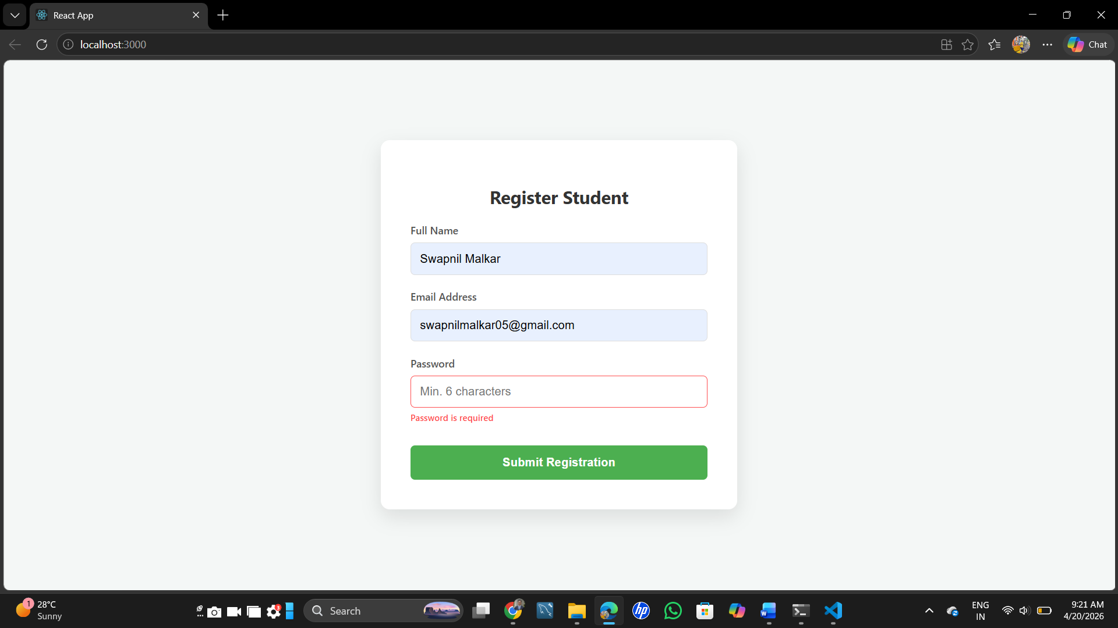

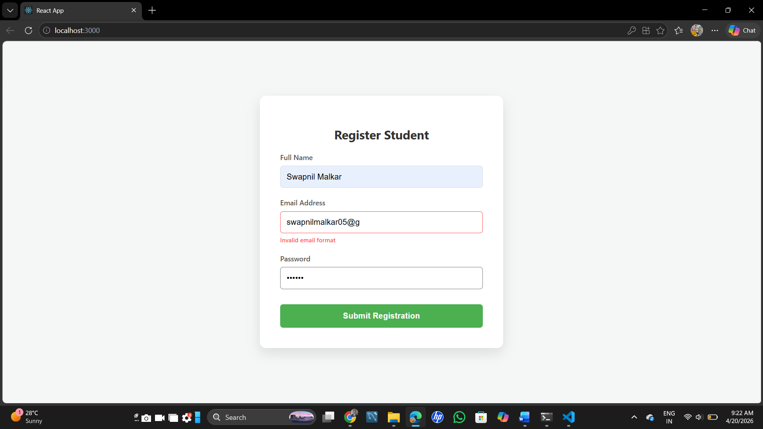

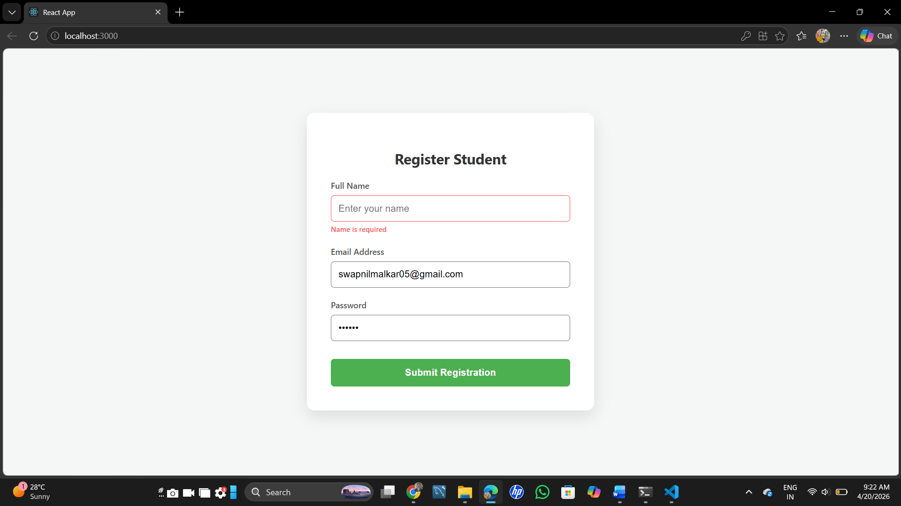

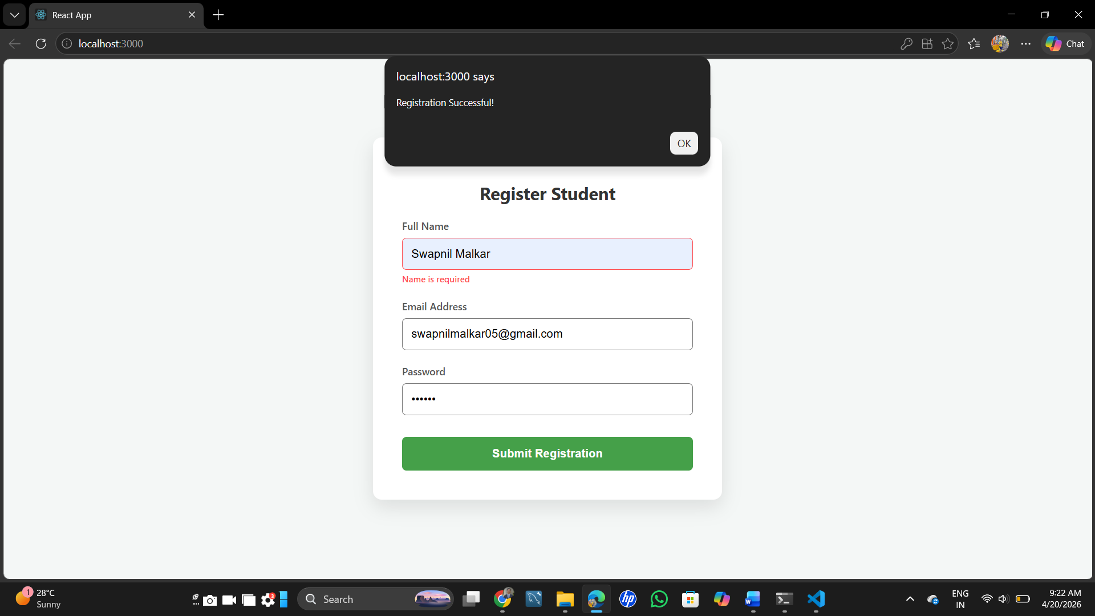

- React component that uses useEffect for lifecycle behavior (e.g., document title update).
import React, { useState, useEffect } from 'react';

const LifecycleComponent = () => {
// State to track the count
const [count, setCount] = useState(0);

// useEffect hook to handle lifecycle behavior (document title update)
useEffect(() => {
document.title = `Count: ${count}`;
console.log("Document title updated to:", count);
}, [count]); // Re-runs whenever the 'count' state changes

// Internal CSS Styles
const styles = {
container: {
display: 'flex',
flexDirection: 'column',
justifyContent: 'center',
alignItems: 'center',
minHeight: '100vh',
backgroundColor: '#eef2f3',
fontFamily: 'Arial, sans-serif',
},
card: {
padding: '30px',
borderRadius: '15px',
backgroundColor: '#ffffff',
boxShadow: '0 8px 20px rgba(0,0,0,0.1)',
textAlign: 'center',
width: '250px',
},
header: {
color: '#333',
fontSize: '18px',
marginBottom: '10px',
},
countDisplay: {
fontSize: '48px',
fontWeight: 'bold',
color: '#007bff',
margin: '20px 0',
},
button: {
padding: '12px 24px',
fontSize: '16px',
backgroundColor: '#007bff',
color: '#fff',
border: 'none',
borderRadius: '8px',
cursor: 'pointer',
transition: 'background-color 0.2s ease',
},
buttonHover: {
backgroundColor: '#0056b3',
},
info: {
marginTop: '15px',
fontSize: '12px',
color: '#666',
}
};

return (
<div style={styles.container}>
<div style={styles.card}>
<h2 style={styles.header}>Counter App</h2>
<p style={styles.info}>Look at the browser tab title!</p>

{/* The count is printed on the screen here */}
<div style={styles.countDisplay}>{count}</div>

<button
style={styles.button}
onClick={() => setCount(count + 1)}
onMouseOver={(e) => e.target.style.backgroundColor = styles.buttonHover.backgroundColor}
onMouseOut={(e) => e.target.style.backgroundColor = styles.button.backgroundColor}
>
Increment Count
</button>
</div>
</div>
);
};

export default LifecycleComponent;
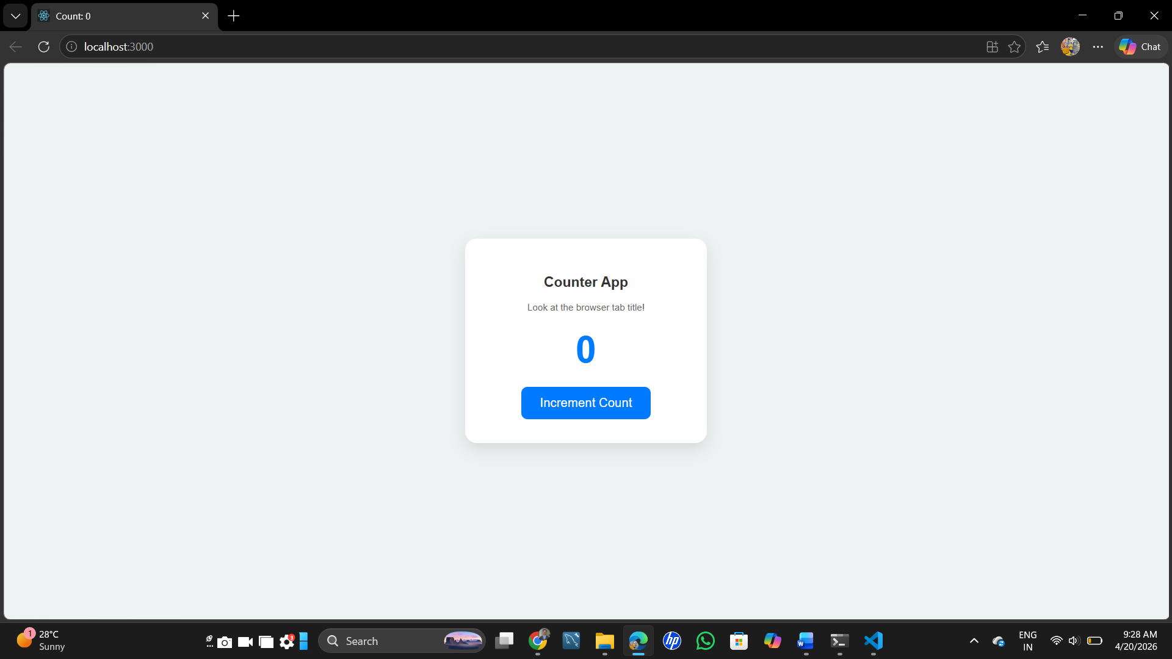

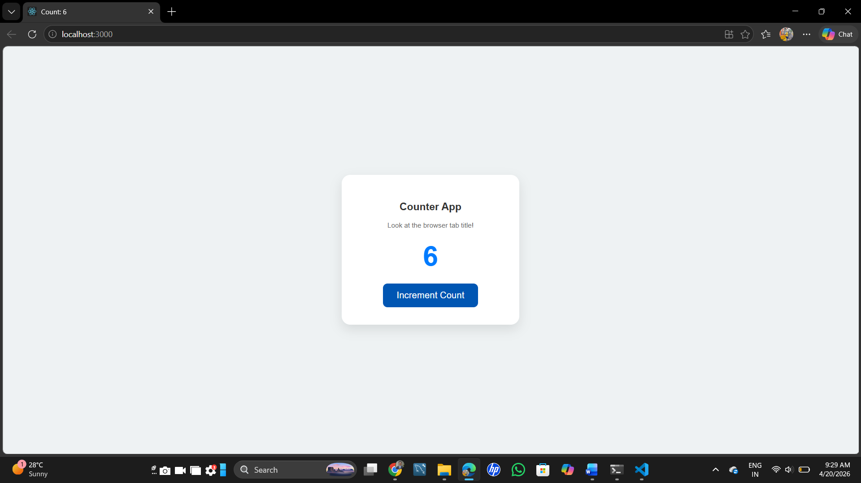

- Create REST API using Express for CRUD operations on user data (in-memory array).
const express = require('express');
const app = express();
const PORT = 5000;

app.use(express.json());

let users = [
{ id: 1, name: "Swapnil Malkar" },
{ id: 2, name: "Vaibhav Patil" }
];

// 1. GET
app.get('/users', (req, res) => {
res.json(users);
});

// 2. POST
app.post('/users', (req, res) => {
const newUser = { id: users.length + 1, name: req.body.name };
users.push(newUser);
res.status(201).json(newUser);
});

// 3. PUT
app.put('/users/:id', (req, res) => {
const id = parseInt(req.params.id);
const user = users.find(u => u.id === id);
if (user) {
user.name = req.body.name;
res.json(user);
} else {
res.status(404).send("User not found");
}
});

// 4. DELETE
app.delete('/users/:id', (req, res) => {
const id = parseInt(req.params.id);
users = users.filter(u => u.id !== id);
res.send(`User with ID ${id} deleted.`);
});

app.listen(PORT, () => {
console.log(`Server running at http://localhost:${PORT}`);
});
GET Method
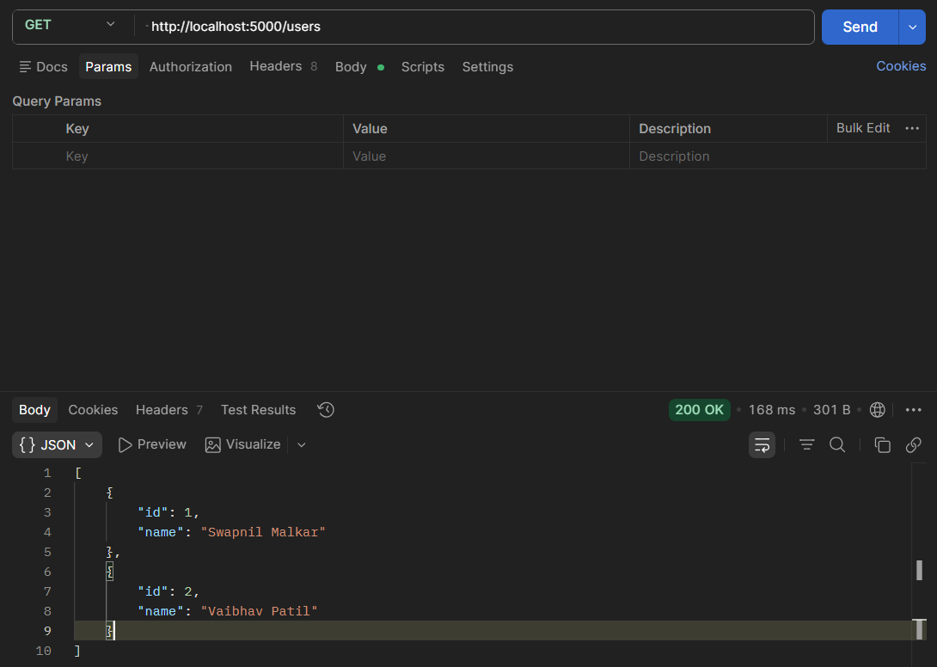

POST Method
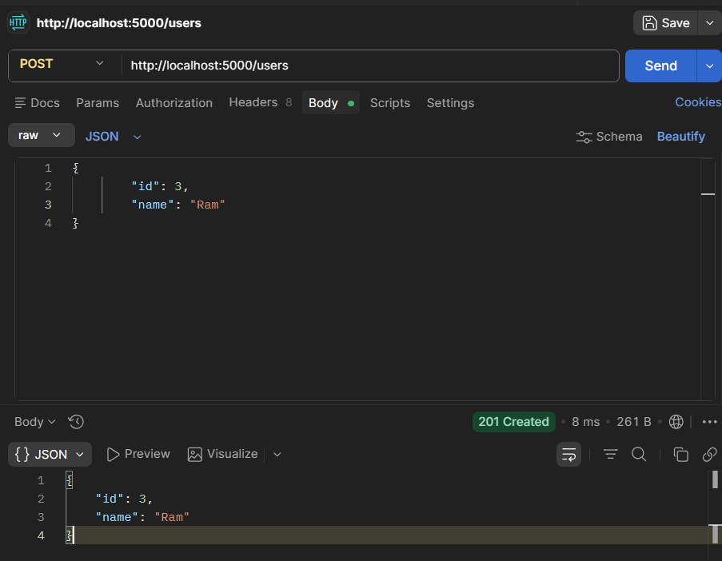

PUT Method Lakshuman Raghuivanshi updated.
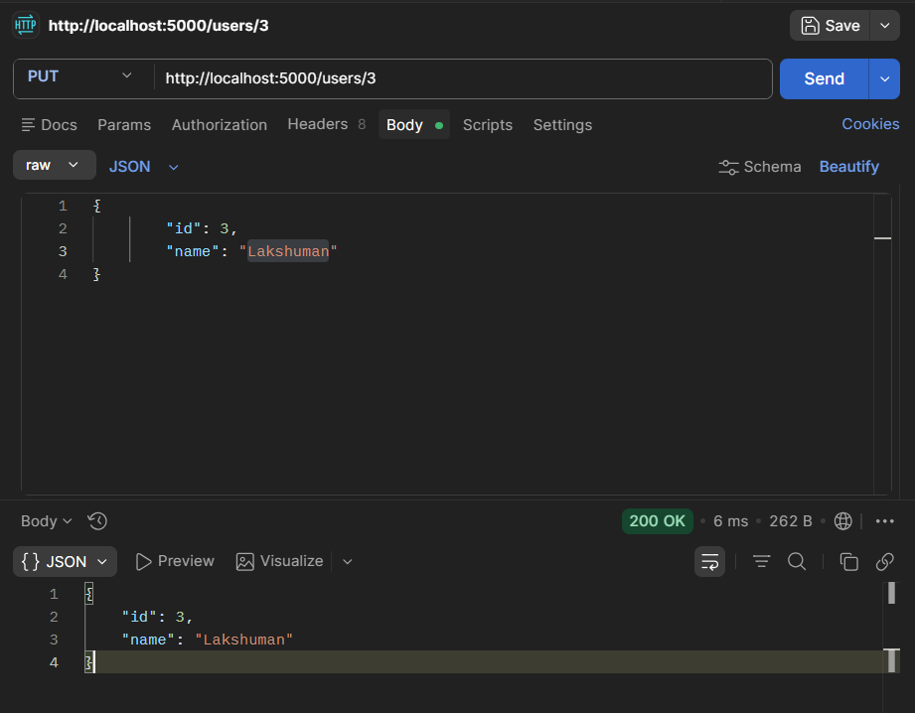

DELETE Method
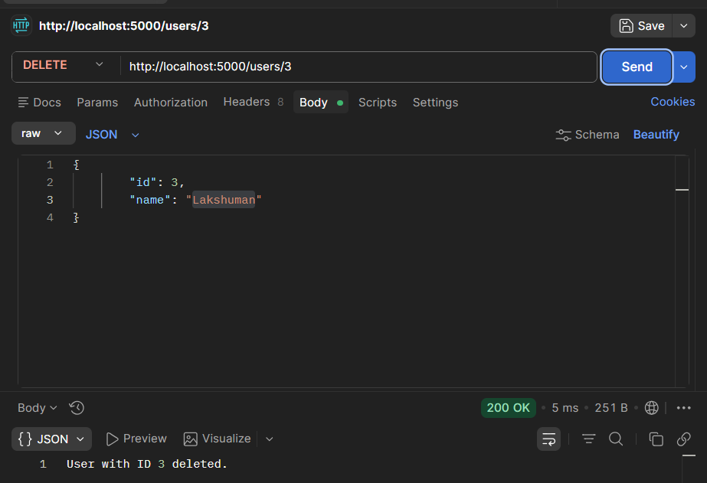

- Implement POST request to accept form data and display response in JSON.
const express = require('express');
const app = express();
const PORT = 4000; // Using a different port to avoid conflicts

// Middleware to parse JSON bodies (for API tools)
app.use(express.json());

// Middleware to parse URL-encoded bodies (for standard HTML forms)
app.use(express.urlencoded({ extended: true }));

// Question 11: POST request to accept data and return JSON
app.post('/submit-form', (req, res) => {
// Extracting data from the request body
const formData = req.body;

console.log("Data received:", formData);

// Sending the response back in JSON format
res.json({
status: "Success",
message: "Form data received successfully",
receivedData: formData
});
});

app.listen(PORT, () => {
console.log(`Question 11 server running at http://localhost:${PORT}`);
});

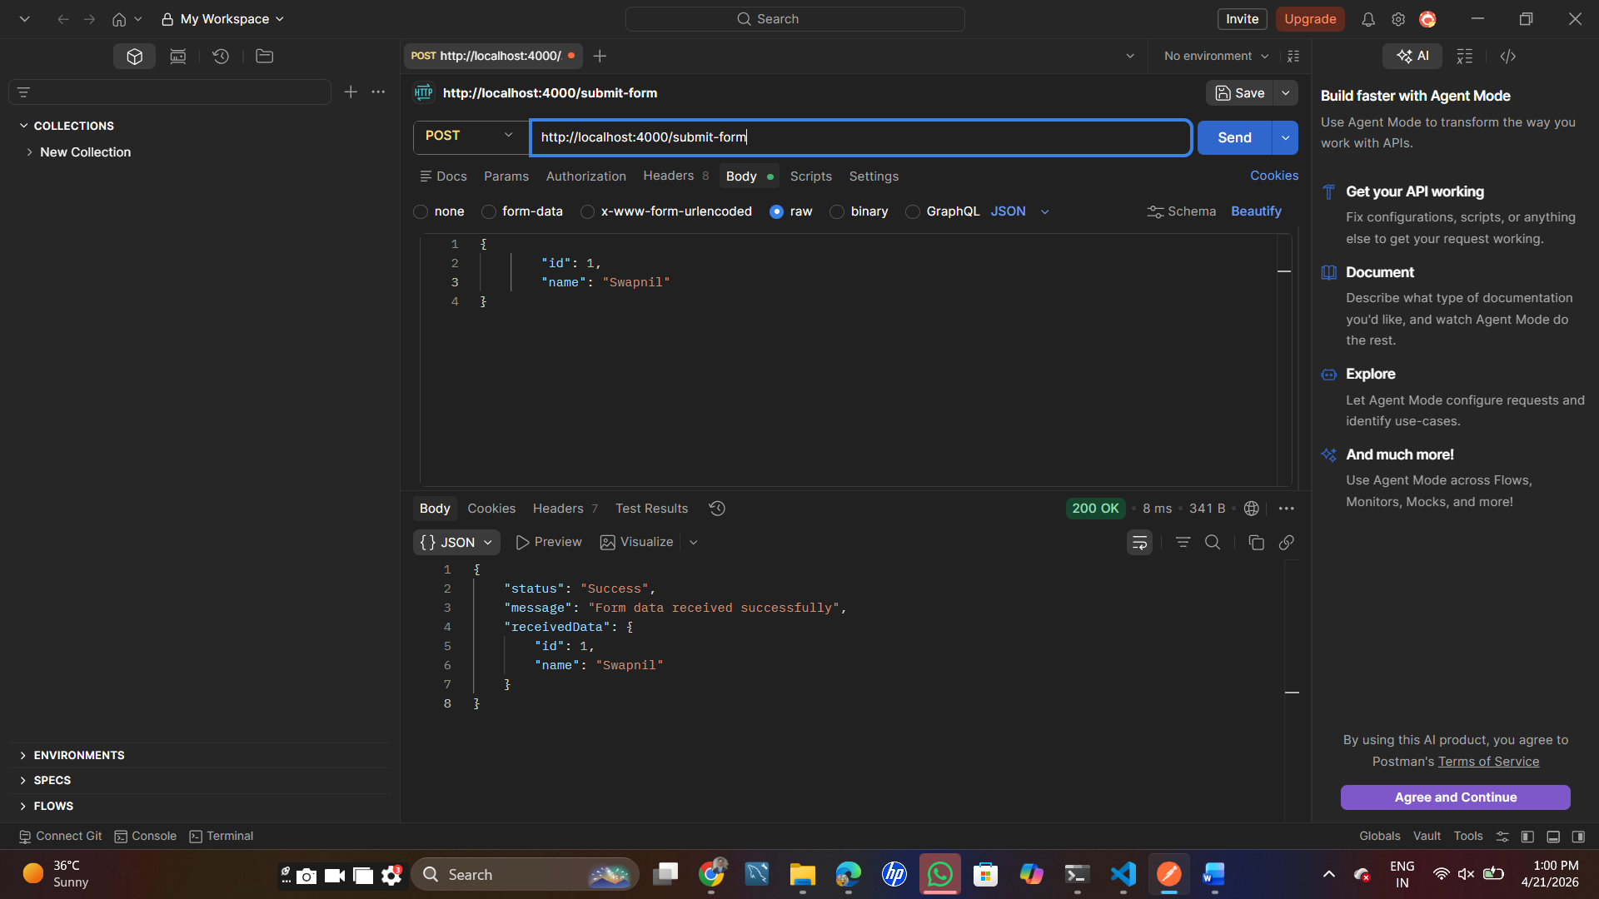

- Create middleware in Express to log request time and URL.
const express = require('express');
const app = express();
const PORT = 3000;

// The Middleware Function
// This function captures the request details as they come in
const requestLogger = (req, res, next) => {
const time = new Date().toLocaleString(); // Capture current time
const url = req.url; // Capture the requested URL
const method = req.method; // Capture the HTTP method (GET, POST, etc.)

console.log(`[${time}] Request Made to: ${url} using ${method} method`);

// CRITICAL: next() tells Express to move to the next function/route.
// Without this, the request will hang and never finish.
next();
};

// Apply the middleware globally so it logs every single request
app.use(requestLogger);

// Sample Routes to test the logger
app.get('/', (req, res) => {
res.send("Check your terminal to see the log for the Home route!");
});

app.get('/about', (req, res) => {
res.send("Check your terminal to see the log for the About route!");
});

app.get('/contact', (req, res) => {
res.send("Check your terminal to see the log for the Contact route!");
});

app.listen(PORT, () => {
console.log(`Question 12 server is running at http://localhost:${PORT}`);
});
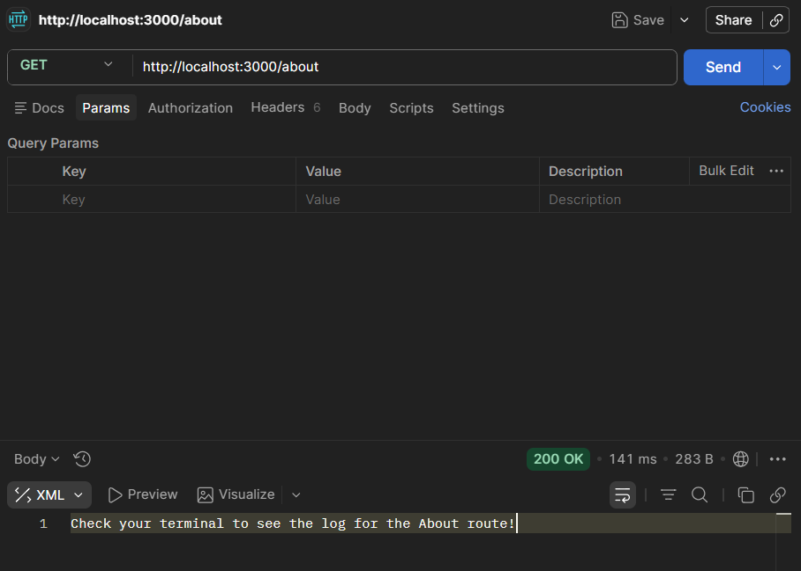

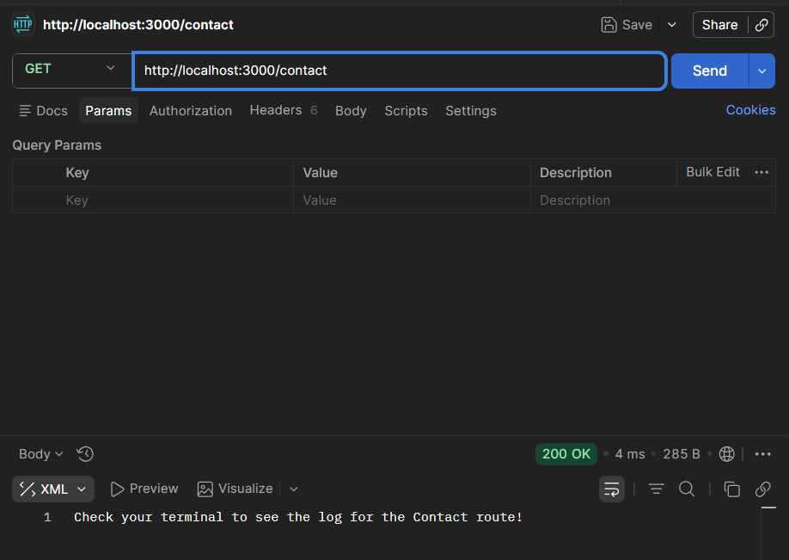

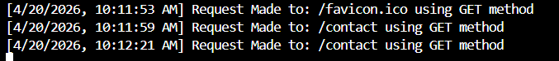

- Develop Express API demonstrating PUT and DELETE operations.
const express = require('express');
const app = express();
const PORT = 3000;

// CRITICAL: This line must come BEFORE your routes
// It tells Express to parse incoming JSON data into req.body
app.use(express.json());

let items = [
{ id: 1, name: "Laptop" },
{ id: 2, name: "Smartphone" }
];

app.get('/items', (req, res) => {
res.json(items);
});

// PUT Operation
app.put('/items/:id', (req, res) => {
const itemId = parseInt(req.params.id);
const item = items.find(i => i.id === itemId);

if (item) {
// If app.use(express.json()) is missing, req.body is undefined
item.name = req.body.name || item.name;
res.json({ message: "Item updated successfully", updatedItem: item });
} else {
res.status(404).json({ message: "Item not found" });
}
});

// DELETE Operation
app.delete('/items/:id', (req, res) => {
const itemId = parseInt(req.params.id);
items = items.filter(i => i.id !== itemId);
res.json({ message: `Item ${itemId} deleted` });
});

app.listen(PORT, () => {
console.log(`Server running at http://localhost:${PORT}`);
});

PUT Operation
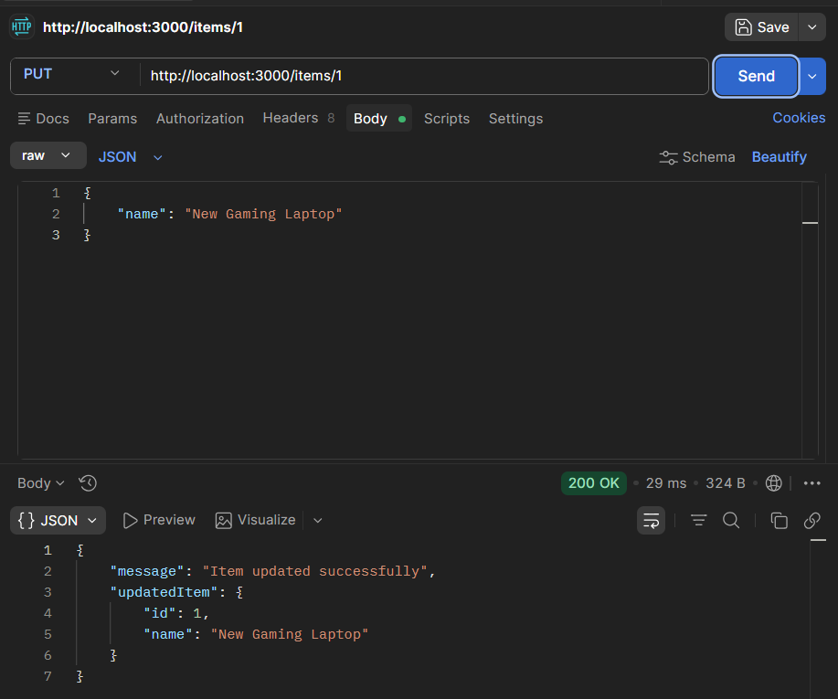

DELETE Operation
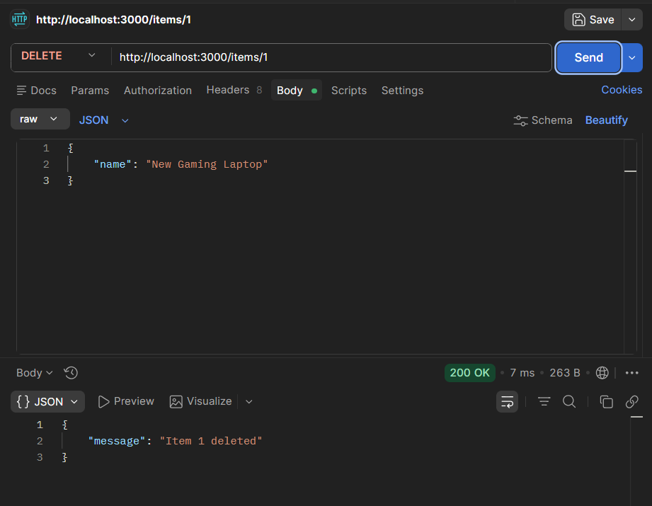

- Develop a User Registration Schema with validation:
a. username (required, minlength 5)
b. password (required, minlength 6)
c. email (required, match email format)
d. createdAt (default date)
e. Test invalid data and show error handling.

const mongoose = require('mongoose');

// 1. Connect to MongoDB (Local instance)
mongoose.connect('mongodb://127.0.0.1:27017/journalDB')
.then(() => console.log("Connected to MongoDB..."))
.catch(err => console.error("Could not connect to MongoDB:", err));

// 2. Define the User Registration Schema
const userSchema = new mongoose.Schema({
username: {
type: String,
required: [true, "Username is required"],
minlength: [5, "Username must be at least 5 characters"]
},
password: {
type: String,
required: [true, "Password is required"],
minlength: [6, "Password must be at least 6 characters"]
},
email: {
type: String,
required: [true, "Email is required"],
match: [/.+\@.+\..+/, "Please enter a valid email format"]
},
createdAt: {
type: Date,
default: Date.now
}
});

// 3. Create the Model
const User = mongoose.model('User', userSchema);

// 4. Test Function: Test invalid data and show error handling
async function testValidation() {
console.log("\n--- Testing Invalid Data ---");

// Attempting to save a user that violates all rules:
// Username < 5, Password < 6, Invalid email format
const invalidUser = new User({
username: "Swapnil Malkar",
password: "111",
email: "wrong-email"
});

try {
await invalidUser.save();
} catch (error) {
// Log individual validation errors
for (let field in error.errors) {
console.log(`Error in ${field}: ${error.errors[field].message}`);
}
}

console.log("\n--- Testing Valid Data ---");
const validUser = new User({
username: "SwapnilMalkar",
password: "securePassword111",
email: "Swapnilmalkar56@gmail.com"
});

try {
const result = await validUser.save();
console.log("Success! User saved to database:", result);
} catch (error) {
console.log("Unexpected error:", error.message);
} finally {
mongoose.disconnect(); // Close connection when done
}
}

testValidation();

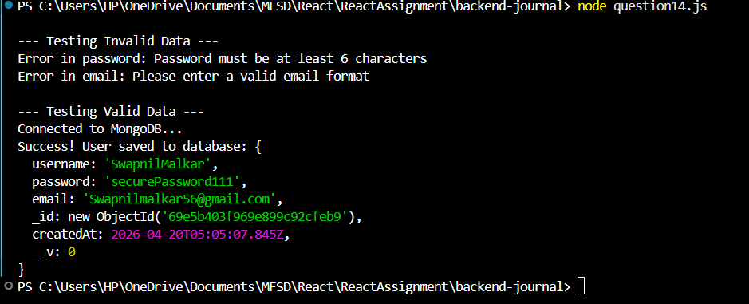

- Create a Product Schema with validation rules:
a. productName (required)
b. price (required, min value 100)
c. category (enum: Electronics, Clothing, Grocery)
d. stock (default 0)
e. Insert valid and invalid records.

const mongoose = require('mongoose');

// 1. Connect to MongoDB
mongoose.connect('mongodb://127.0.0.1:27017/journalDB')
.then(() => console.log("Connected to MongoDB for Product Testing..."))
.catch(err => console.error("Connection error:", err));

// 2. Define the Product Schema
const productSchema = new mongoose.Schema({
productName: {
type: String,
required: [true, "Product name is required"]
},
price: {
type: Number,
required: [true, "Price is required"],
min: [100, "Price must be at least 100"] // Min value constraint
},
category: {
type: String,
// Enum: Only allows specific values
enum: {
values: ['Electronics', 'Clothing', 'Grocery'],
message: '{VALUE} is not a valid category'
}
},
stock: {
type: Number,
default: 0 // Default value
}
});

// 3. Create the Model
const Product = mongoose.model('Product', productSchema);

// 4. Function to Insert Valid and Invalid Records
async function runProductTest() {
console.log("\n--- Testing Invalid Records ---");

// This record will fail because:
// 1. Price is below 100
// 2. Category 'Books' is not in the Enum list
const invalidProduct = new Product({
productName: "Notebook",
price: 50,
category: "Books"
});

try {
await invalidProduct.save();
} catch (error) {
console.log("Validation Failed as expected:");
for (let field in error.errors) {
console.log(`- ${field}: ${error.errors[field].message}`);
}
}

console.log("\n--- Testing Valid Record ---");
const validProduct = new Product({
productName: "Smartphone",
price: 15000,
category: "Electronics",
stock: 10
});

try {
const savedProd = await validProduct.save();
console.log("Success! Product saved:", savedProd);
} catch (error) {
console.log("Error saving valid product:", error.message);
} finally {
mongoose.disconnect();
}
}
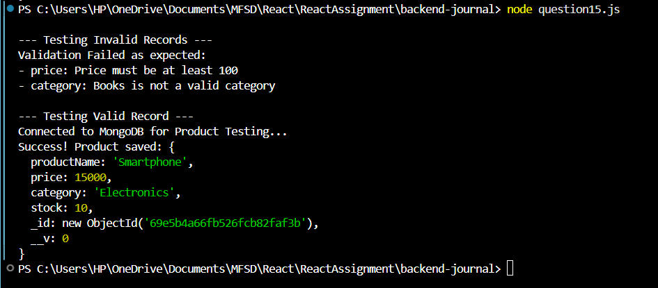
runProductTest()

