**PR 2**

**Logan Nofsinger and Swapnil Pande**

**NOFSINLD and PANDES**

**ME 2160 - 03**

**Description of Design:**

Due​ ​to​ ​the​ ​lack​ ​of​ ​research​ ​of​ ​prosthetic​ ​wrists​ ​compared​ ​to​ ​that​ ​of​ ​terminal​ ​devices,​ ​this proposal​​ ​focus​es on the design ​of​ ​a body-powered prosthetic wrist​ capable of pronation and supination of the terminal device.​ ​The​ ​purpose​ ​of​ ​the​ ​prosthetic​ ​wrist​ ​is​ ​to​ ​augment​ ​the​ ​capabilities​ ​of​ ​terminal​ ​devices​ ​that are​ ​already​ ​commercially​ ​available​ ​by​ ​providing​ ​an​ ​additional​ ​degree​ ​of​ ​freedom.​ ​The wrist is built with a modular design that will interface with a large variety of terminal devices.

Pronation is achieved using a shoulder-mounted harness using a Bowden cable system. The cables wrap around an internal pulley and cause rotation in the shaft with movement of the shoulder. An approximate 4 inch range of motion of the shoulder produces a 180o range fo motion in the wrist. A switch allows the prostheses patient to toggle between an unlocked and locked state. When unlocked, the shoulder harness is linked to the output shaft, allowing the patient to rotate the wrist. When locked, the wrist position is fixed in place and the provides no resistance at the shoulder harness. The switching mechanism uses a spring and guide to lock the wrist in either position.

Several mechanical changes have been made from the original proposal. The original proposal included a clutch and friction pad for the locking and unlocking mechanism. In order to resist a torque of 25 N*m, a force of 6429 lbs needed to be applied to the shaft. This amount of force is unreasonable for the size of the prosthetic wrist and would introduce many complications to allow users to actuate the switch. To circumvent this problem a system of locking gears was introduced and the proposed four-bar-linkage switch was traded for a sliding actuator which pushes a sliding collar to engage either the pulley or the locking gear.

|  |  |
| --- | --- |
| Wrist assembly | Assembly of entire prosthetic. |
| Keyed_shaft | The central shaft. |
| Key | Allows revolving components to rotate the shaft. |
| Support_frame | The frame of the prosthetic built to encase its internal mechanisms and take shear load from the shaft. |
| 6381K409_MULTIPURPOSE SLEEVE BRNG | Bushing used to space components on the shaft. |
| 60355K701_BALL BEARING assembly | Bearings used to hold shaft in place in the support frame. |
| Sliding_collar assembly | Wraps around the shaft and engages the locking gear, pulley, and switch. |
| Lockingshaft | The base of the sliding collar. Has shaft to connect to switch and encases locking gear to arrest motion in central shaft. Ball bearing is press fit onto opposite end. |
| 6383k150_ball_bearing assembly | Ball bearing interface between lockingshaft and shaft_engager |
| Shaft_engager | Press fits onto bearing on lockingshaft. Engages main shaft with key. Is used to push gear into pulley gear-engager to pair motion of shaft with the pulley. |
| 5172T120_HT-LOAD MTL GEAR--20 DEG PRESSURE ANGLE | Press-fit gear on shaft_engager. Connects with pulleylocker. |
| 6325K950_MTL GEAR--14-.5 DEG PRESSURE ANGLE | Press fits on shaft to catch lockingshaft. |
| 3434T150_PULLEY FOR WIRE ROPE | Converts cable movement into radial movement. Spins freely about shaft via bearing. |
| Pulleylocker | Allows pulley to engage the rotating portion of the sliding collar. |
| Slider assembly | The sliding actuator to control position of sliding_collar |
| Slider_base_top | The base of the slider case. Constrains slider movement. |
| Slider_base | Second half of slider case. Broken into two components for ease of assembly. |
| Slider | The actual slider components which connects to the lockingshaft to move the sliding_collar. |
| Hand_interface | Press fits onto the end of the shaft and allows the user to press fit a terminal device onto its end. |

**Section 5:**

Keyed_Shaft: A simple extruded circle with an extruded cut on its side to form the keyway.

Key: Simple extruded shape to fit in the keyway.

Support Frame: An extruded disk was made to serve as the back-plate of the frame. A disk with a hole in the middle to fit the ball bearing was made on the surface of this. This was then repeated about 4 inches away to create the front plate of the prosthetic. An axial beam was made to hold these disks together and patterned radially to encase the components inside. Two hoops were made against these beams for reinforcement and to allow a place to mount the slider assembly.

Sliding Collar Assembly:

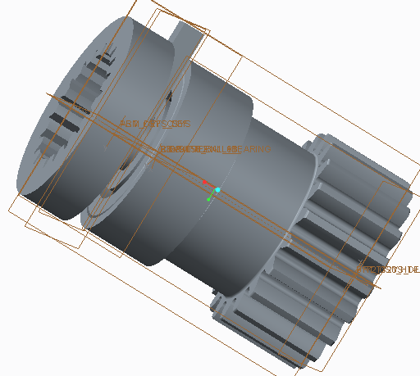

This assembly contains four discrete components: the locking shaft, a ball bearing, the pulley engager, and a gear (shown left to right above). The locking shaft serves as the base of the assembly, upon which the bearing is press fit. The pulley engager is then press fit to the outside of this bearing, allowing it to rotate freely about the non-rotating locking shaft. Finally, the gear is press fit onto the end of the pulley engager to interact with the pulley.

Locking Shaft: A revolve was created about the x-axis and the following sketch was created:

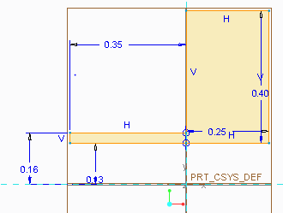

The sketch was revolved 360 degrees around the axis.

A circle of diameter 0.63 inches was cut into the material .1875 inches into the front surface of the part.

An extrusion was created on the outermost front section of the part and the following sketch was created based on the dimensions of the gear.

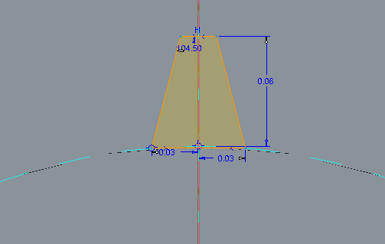

The material was cut through until the surface created by the previous extrusion. The extrusion was patterned around the central axis of the part 20 times to match the teeth of the corresponding gear.

An extrusion was created on the right datum plane. A rectangle was drawn as shown below to interface with the locking switch.

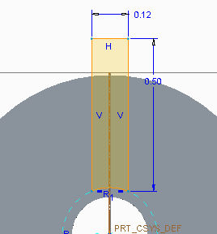

The extrude dimension was set to 0.12 inches.

Shaft Engager:

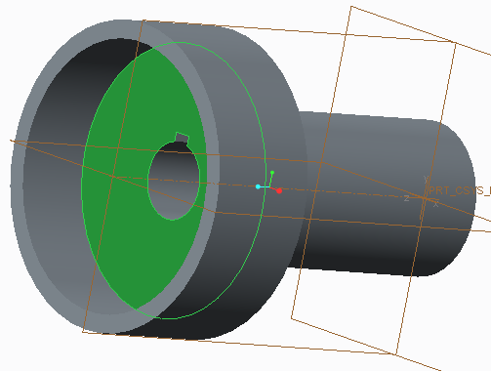

A cylinder with a centered hole for the shaft and key were extruded. A large hole was cut in one end to fit the ball bearing. A circular extruded cut was made on the other end to allow the gear to be press fit on.

Pulley Locker: A sketch was started and a circle of 1.25 inches was extruded 0.75 inches. A second extrusion was created on the top surface of the cylinder. A circle of radius 1.00 inches was cut into the cylinder 0.5 inches. Next, a third sketch was created on the uncut portion of the cylinder as shown in the figure below. The sketch was cut through until the next surface, which was the cut from the previous extrusion. This sketch was patterned about the center axis of the cylinder 20 times to create matching holes for the teeth of the gear. A hole was cut into the center of the part.

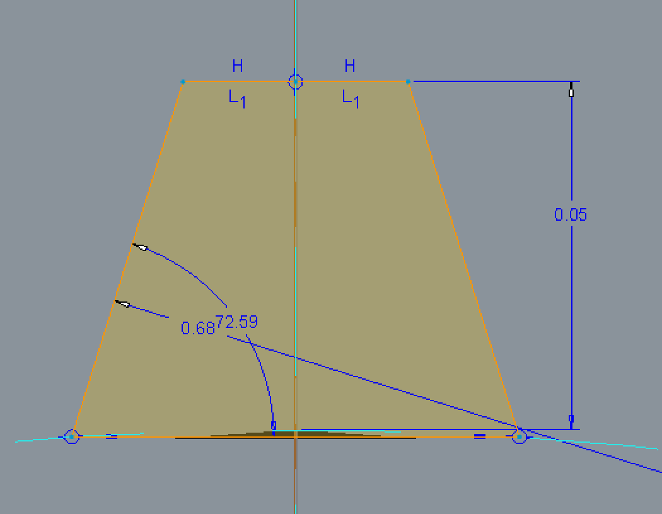

Slider Assembly: The slider base and top are constrained together, forming a box around the slider component. These are designed as separate components to allow the slider to be inserted upon assembly.

Slider Base Top: This component was started as an extruded rectangle. The bottom of this part would constrain the top of the slider as it moves through the base. A horizontal and a vertical extruded rectangular cut were made in the top of the part. The below sketch was cut from the center of the part to allow the slider to rest in its desired positions.

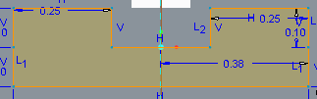

Slider Base: This component was started as an extruded rectangle. Slots were cut into this to allow the slider to slide along the base of the box. Two 1/8 inch holes were made to allow this base to be attached to the support frame.

Slider: The center of the slider is a small extruded rectangle which is built to fit into the track created by the two slider base components. A shaft was extruded on this to allow the user to slide it. The other side of this shaft is press fit into the switch connecter.

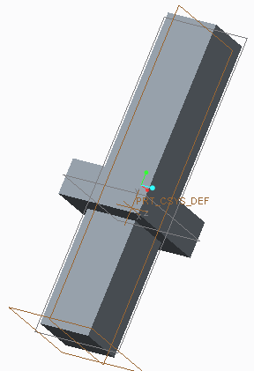

Switch Connector: This is a rectangle with two rectangular extruded holes in opposite ends. One of these ends will hold the slider and the other will hold a spring which pushes against the shaft of the sliding collar. This spring pushes the slider up so that it rests in the desired positions.

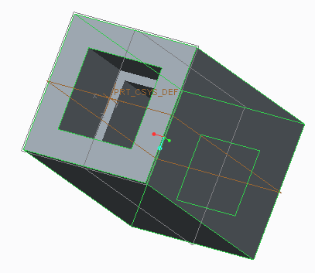

Wrist Assembly: The support structure served as the base of this assembly. Two ball bearings were confined to the front and back of the frame. The shaft was confined to these ball bearings. A bushing, the pulley, the sliding collar assembly, and the locking gear were confined on this shaft. The hand interface was confined on the end of the shaft outside of the support frame. The slider assembly is constrained to the reinforcement hoops on the outside of the support structure. The shaft from the slider assembly connects with the shaft from the sliding collar.