QA Automation — AM Squad
Biweekly Status Briefing · October 01, 2026
Audience: Rajib (Chapter Lead) · Henry (Director) · Persistent Delivery Managers

Prepared by | Swapnil Patil / QA Automation AM Squad
Sprints covered | AMSQUAD Sprints 26.16 closeout + 26.17 (current)
Classification | Internal — Leadership
Companion deck | AM-Squad-Biweekly-Status-Rajib-Henry-Oct01-2026.pptx

Executive Summary
Unite MSC API coding is 100% complete on main (MR !268 / QA-1938; Bruno MR !271). ENVP Epic QA-600 closed. SharePoint KT hub (parent + 11 children) is ready to publish under API Testing Documentation Hub. Performance regression is healthy; Enrollment MSC perf is the last MSC perf gap. API GitLab nightly is still pending DevOps — batch/job/remote mostly ready; need DB files on the server and a named owner (API regression waits on that). Critical support asks: Stage1 MFA disable for offshore (Swapnil is currently the only update path), Stage5/CAT regression takeover (V2+V3 suites running per Brian), and sustaining support for V3 IDP + Universal Enrollment. Jul–Sep TCs added shared with Dhanashree (V2 33/8/39 · V3 10/8/16).
Metric | Value | Notes
Sprint scope | 26.16 closeout → 26.17 | 26.15 · 26.16
GitLab merges | 5 | MSC coding + Bruno on main; V3 profile/bank MRs landing
Sprint 26.16 board items | 180 | Board items across 26.16–26.17
Regression bugs | 9 | Stage1/IDP + financial txn stabilization tracked
MSC in-scope APIs | 76/79 | Coding 100% · SharePoint hub publishing · ENVP QA-600 closed
MSC Mobile 2 | 25/25 | Complete — on main; Bruno migrated
MSC Mobile 1 | 26/26 | Complete — on main; Bruno migrated
MSC Enrollment | ~100% (15/15) | Coding complete — SharePoint publish + Enrollment perf remaining
Delivery vs ETA | ~70% of original ETA | Consistent ahead-of-plan delivery

1. Unite MSC API Automation
Program KB: programs/unite-msc/ · Repository: api-test-automation (GitLab). Delivered in approximately 50% of original ETA using AI-assisted migration and canonical TestNG framework.

Coverage snapshot
Module | Coverage | Status
Mobile 2 | 25/25 endpoints (100%) | Complete — sign-off package ready (QA-1553, QA-1567)
Mobile 1 | 26/26 in-scope operations (100%) | Complete — on main; Bruno migrated
Enrollment | 15/15 core E2E (100%) | Coding complete — SharePoint publish + Enrollment perf remaining

Coding complete. Docs publishing in flight. API nightly blocked on DevOps ownership — not on missing automation design.

Pipeline & environments
- Stage1 healthy — MFA disable for offshore still single-threaded on Swapnil after DB refresh / new accounts
- QC4 / Stage1 hybrid proof continuing
- API GitLab nightly PENDING DevOps — batch/job/remote mostly ready; need DB files copied to server + named owner. API regression not nightly yet. Perf regression already running healthy.
- Hybrid model per Jul 2025 leadership decision — Stage1 is primary until QC4 stabilizes.
- Blocker: no non-IDP plants in QC4 lower environment — need product owner to name test plans.

Pending merge !268
- Title: QA-1938 — Validate E2E coverage & remaining standard-flow gaps (merged)
- Author: Dinesh Kumar · Status: Merged Sep 11 — pipeline green
- Changes: 110 files · Blocker: None — closed
- M1/M2 suite wiring + enrollment gap closures/negatives
- https://gitlab.com/ascensus-gs/products/depot/qa-automation/api-test-automation/-/merge_requests/268

Sprint 26.14–26.15 MSC highlights (Jira)
- MR 255–262 merged — enrollment submit, subsequent E2E, standard enrollment (QA-1404, QA-1939)
- QA-1938 — gap inventory + negatives in MR !265 (Review)
- QA-2039–2047 — sign-off docs, README index, troubleshooting, AI scenario guide
- QA-2048–2053 — legacy-to-TestNG traceability matrix
- QA-1405 — Mobile 2 GitLab nightly delivered; enrollment nightly in wrap-up

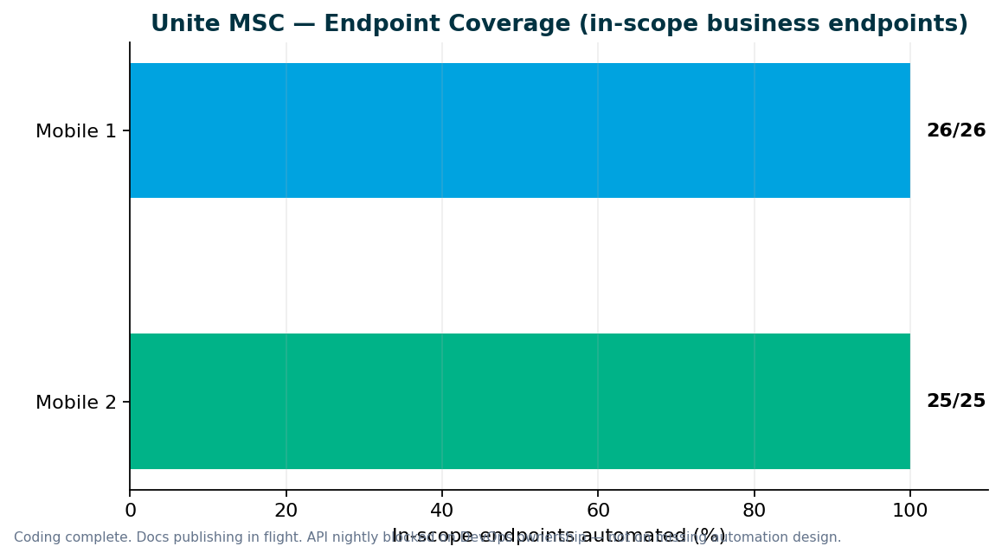

2. V2 & V3 UI Automation
Sprint 26.17 — V2 Stage5/CAT + CSR Actions; V3 IDP/UE + bank/bene; Stage1 MFA support gap. Inventory cleanup ≠ zero work — Aug V2/V3 kept non-zero for stabilize/flaky MRs while MSC/Perf/CAT took capacity.

Sprint 26.14–26.15 highlights
- Sep: Member bank + beneficiary × 4 plans (+16 TCs) — Sunil MR !235
- Jul: WebRereg × 3 plans (+6) plus other UE/reg adds
- V3 IDP + Universal Enrollment still need named sustaining support
- Sep: CSR Actions suite new on Stage1 nightly (+39 methods)
- Stage5/CAT regression suites created and running (Brian request) — Swapnil supporting today
- Jul–Sep V2 TCs added for leadership chart: 33 / 8 / 39

V2 regression gaps (Venkatesh Mallela)
CSR Actions added to Stage1 nightly (+39 methods Sep). Stage5/CAT smoke in active regression. Member→V3 migration continuing. Need Stage5 support handover.

P0 — turn on existing automation
- CSR Actions on Stage1 nightly — landed Sep (+39 methods)
- Stage5/CAT V2 smoke suites running — need sustaining owner
- Member-related cases — migrate to V3 (V2 member IDP obsolete for migrated Direct plans)
- Share adjustment / CSR daily wiring continue
- Enrollment / login / registration retire-or-migrate largely done

P1 — extend coverage
- Contribution / withdrawal / investment stabilization after SEQ_FIN_TXN_ID issues
- Stage5/CAT expansion and green-suite triage

P2 — build new automation
- YTD bucket, financial history, failed transactions — still backlog after P0/P1

V2 → V3 migration — discussion needed
Confirm: member flows permanently on V3 for migrated Direct plans — retire V2 member IDP suites?

Regression bugs (Sprints 26.14–26.15)
Key | Summary | Area | Sprint
QA-2014 | V3 Universal Enrollment — unable to create account | V3 | 26.15
QA-2013 | V3 CSR Member Personal Information validation | V3 | 26.15
QA-1990 | V3 withdrawal voucher invalid | V3 | 26.15
QA-1989 | V2 CSR withdrawal voucher invalid | V2 | 26.15
QA-2199 | SEQ_FIN_TXN_ID null — contrib/withdrawal/investment stabilization | V2 | 26.16

3. Performance Testing
Perf regression healthy · M1/M2 done · Enrollment MSC perf remaining. Performance regression suite already running and healthy — no nightly ask. API GitLab nightly / API regression still pending DevOps ownership.

Deliverables (Sprints 26.14–26.15)
Request | Sprint | Status | Jira
Mobile 2 MSC performance | 26.15–26.16 | Done | Prior MSC M2 perf
Mobile 1 auth / owner-profile / device-push JMeter | 26.16 | Done | QA-2159–2163
Enrollment MSC performance | 26.17 | Remaining — last MSC perf gap | Enrollment MSC perf

Performance governance ask
Two emergency requests in two sprints forced the team to drop planned sprint work. We delivered scripts and baseline results in approximately one week each, but the full standard — KB documentation, Git check-in, test data management, and expanded regression coverage — was not possible under last-minute intake.
- Engage QA Automation when performance requirements are designed — not at deploy approval
- Mandate performance validation for IDP login, enrollment, contributions, and withdrawals before release
- Route cross-team perf requests through standard intake with lead time

4. Capacity & Upcoming Work
MSC program target: SharePoint publish this sprint · API nightly when DevOps owns · Enrollment perf closes MSC perf. Expected: SharePoint hub publish + Enrollment perf · API nightly waits on DevOps.

MSC wrap-up checklist (1 resource)
- MR !268 merged (QA-1938) ✓
- Bruno M1/M2/Enrollment merged (MR !271) ✓
- ENVP Epic QA-600 closed ✓
- SharePoint hub — parent + 11 children (publish in flight)
- qTest manual modules linked ✓
- API GitLab nightly — DevOps owner + DB files on server
- Enrollment performance

Planned reallocation
- Preeti → Enrollment MSC perf (last MSC perf gap)
- Dinesh → SharePoint publish support + qTest; then API suite packaging IF leadership confirms
- Venkatesh → V2 gaps + Stage5 handover candidate discussion
- He / Sunil → V3 IDP + UE coverage; need sustaining owner named
- Swapnil → MFA/Stage5 support until owners named; leadership reporting; SharePoint publish

V2 → V3 migration
Retire obsolete V2 member/login/enrollment as Direct→universal completes; expand daily with existing automation
Stage1 Direct plans on universal — V2 member IDP no longer valid
Lead: Venkatesh Mallela

Incoming: ACS-5678 Atlas (AHA)
- Feature: ACS-5678 — Atlas Traffic Distribution & Load Balancer Rebalancing
- Owner: Brian Danilczyk · Priority: #2 on Michael's list
- Estimate: 2–3 sprints · Dependency: Redis session-management initiative
- Target: October 2026 delivery
- Scope: load/perf/regression validation of traffic distribution after Redis session externalization

5. Support Ownership (critical)
Several production-support duties are currently single-threaded on Swapnil. Need named owners so the squad scales.
Area | Today | Ask
Stage1 MFA / DB update support | Offshore has no Stage1 update access. After DB refresh or new accounts, MFA must be disabled — Swapnil handles all of it. | Arrange Stage1 support (update access or on-call) so MFA disable / account prep is not a single point of failure.
Stage5 / CAT regression | Per Brian’s request, Swapnil has been running Stage5 (CAT) regression. V2 and V3 smoke/regression suites exist and are active. | Name an owner to take over Stage5/CAT regression support for V2 and V3.
V3 IDP + Universal Enrollment | V3 IDP and UE coverage continues (He / Sunil). Sustaining support still informal. | Name sustaining support for V3 IDP + Universal Enrollment (defects, suite health, plan coverage).
API GitLab nightly | Batch/job/remote mostly ready. Waiting on DevOps to copy DB files to server and own the job. | Confirm DevOps owner; complete server DB copy; turn on API nightly. API regression pending until then.
Performance regression | Already running — healthy. | No ask — keep as-is; Enrollment MSC perf is the remaining MSC perf gap.

6. Leadership Asks & Decisions

Support ownership (critical)
- Stage1 MFA / DB update support for offshore — name owner or grant update path (today: Swapnil only)
- Stage5 / CAT regression takeover — V2 + V3 smoke suites running; name sustaining owner
- V3 IDP + Universal Enrollment — name sustaining support owner
- API GitLab nightly — confirm DevOps owner; copy DB files to server; turn on job (setup mostly ready)

Roadmap & capacity
- Confirm post-MSC queue: Atlas (Oct) vs API suite packaging (QA-892) vs V2/V3 + Stage5 support?
- Accept: Performance regression is healthy — no change needed

Unite MSC / API automation
- Accept M1/M2/Enrollment coding complete — remaining = SharePoint publish + Enrollment perf + API nightly
- API regression still pending until GitLab nightly is owned and scheduled
- Name ACM / sustaining reader for MSC SharePoint hub after publish

V2 / V3 / Stage5
- Approve Stage5/CAT as ongoing regression support (not ad hoc Swapnil duty)
- Approve retirement of V2 member IDP for Direct plans now on universal — migrate to V3

Performance
- Enrollment MSC perf is the last MSC perf gap — keep priority
- Perf governance: route requests through intake (not last-minute before deploy)

Owners needed (names TBD on this call)
Area | What we need | Suggested role
Stage1 MFA / DB updates | Offshore MFA disable after refresh / new accounts | Stage1 support / DBA path
Stage5 / CAT regression | Take over V2 + V3 CAT smoke support | QA automation owner
V3 IDP + UE | Sustaining support for defects + suite health | V3 automation owner
API GitLab nightly | Copy DB files · own job · schedule nightly | DevOps + QA contact
Performance regression | Already healthy — no change | Preeti (keep)
MSC SharePoint hub | Sustaining reader after publish | ACM / program lead

Appendix — References
- programs/unite-msc/leadership/2026-08-07-kevin-status-update.md
- programs/unite-msc/leadership/2026-07-17-leadership-update/
- programs/unite-msc/leadership/2026-07-23-scope-alignment/
- programs/leadership-updates/2026-08-am-squad-leadership-update/
- programs/Performance Testing/barcode-syn-443/
- Jira: QA project · AMSQUAD sprints
Generated September 30, 2026.

