QA Automation — AM Squad
Biweekly Status Briefing · September 11, 2026
Audience: Rajib (Chapter Lead) · Henry (Director) · Persistent Delivery Managers

Prepared by | Swapnil Patil / QA Automation AM Squad
Sprints covered | AMSQUAD Sprints 26.14, 26.15 (current), and wrap-up focus
Classification | Internal — Leadership
Companion deck | AM-Squad-Biweekly-Status-Rajib-Henry-Sep11-2026.pptx

Executive Summary
Unite MSC API automation coding is complete on main: Mobile 1 (26/26), Mobile 2 (25/25), and Enrollment (25/28 catalog — 3 partner endpoints deferred). Standard + subsequent E2E flows are on main; MR !265 (QA-1938) adds suite wiring, negatives, and validation gaps — pending Snyk/security gate approval. Sprint 26.15 focus: sign-off documentation (QA-2039–2047), traceability matrix, and Venkatesh V2 regression gap analysis. Post-MSC capacity can pivot to Atlas (Oct) or V2 P0 daily-regression wiring per leadership priority.
Metric | Value | Notes
Sprint scope | 26.14 – 26.15 (current) | 26.14 · 26.15
GitLab merges | 14 | Aug 27 – Sep 10 · api-test-automation repo
Sprint 26.15 board items | 165 | Board items in Sprint 26.15
Regression bugs | 8 | Regression bugs in Sprints 26.14–26.15
MSC in-scope APIs | 76/79 | M1 26 + M2 25 + Enrollment 25/28 (3 partner deferred)
MSC Mobile 2 | 25/25 | Complete — sign-off ready; on main
MSC Mobile 1 | 26/26 | Complete — sign-off ready; suite wiring in MR !265
MSC Enrollment | ~89% (15/15) | Coding complete for MSC E2E — standard + subsequent flows on main; negatives + suite params in MR !265
Delivery vs ETA | ~70% of original ETA | Consistent ahead-of-plan delivery

1. Unite MSC API Automation
Program KB: programs/unite-msc/ · Repository: api-test-automation (GitLab). Delivered in approximately 50% of original ETA using AI-assisted migration and canonical TestNG framework.

Coverage snapshot
Module | Coverage | Status
Mobile 2 | 25/25 endpoints (100%) | Complete — sign-off package ready (QA-1553, QA-1567)
Mobile 1 | 26/26 in-scope operations (100%) | Complete — sign-off ready; suite wiring in MR !265
Enrollment | 15/15 core E2E (89%) | Coding complete for MSC E2E — standard + subsequent flows on main; negatives + suite params in MR !265

Coding/design complete for M1, M2, and enrollment MSC scope. MR !265 finalizes suite wiring + validation gaps. Program close = docs, traceability, sign-off owners.

Pipeline & environments
- IDP + non-IDP paths validated for M1/M2/Enrollment on Stage1
- Hybrid model — integration proof continuing post DB refresh
- Mobile 2 nightly delivered (QA-1405); enrollment nightly in wrap-up
- Hybrid model per Jul 2025 leadership decision — Stage1 is primary until QC4 stabilizes.
- Blocker: no non-IDP plants in QC4 lower environment — need product owner to name test plans.

Pending merge !265
- Title: QA-1938 — Validate E2E coverage & automate remaining standard-flow gaps
- Author: Dinesh Kumar · Status: Open — can merge; pipeline canceled (Snyk/security gate)
- Changes: 110 files · Blocker: Snyk scan / security gate — merge when pipeline green + approval
- M1/M2 suite wiring (integration + regression TestNG XML), enrollment README, gap closures + negatives from QA-1938 subtasks
- https://gitlab.com/ascensus-gs/products/depot/qa-automation/api-test-automation/-/merge_requests/265

Sprint 26.14–26.15 MSC highlights (Jira)
- MR 255–262 merged — enrollment submit, subsequent E2E, standard enrollment (QA-1404, QA-1939)
- QA-1938 — gap inventory + negatives in MR !265 (Review)
- QA-2039–2047 — sign-off docs, README index, troubleshooting, AI scenario guide
- QA-2048–2053 — legacy-to-TestNG traceability matrix
- QA-1405 — Mobile 2 GitLab nightly delivered; enrollment nightly in wrap-up

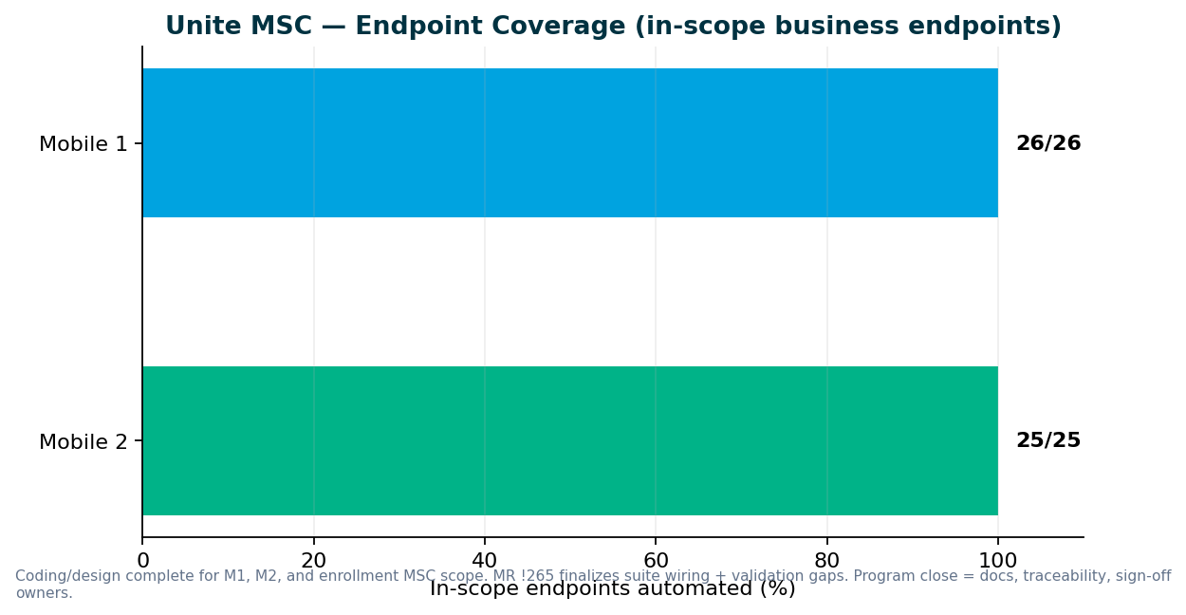

2. V2 & V3 UI Automation
Sprint 26.15 — V2 gap analysis (Venkatesh) + V3 maintenance; MSC wrap-up parallel. V2 focus: wire existing features to daily regression before building new automation.

Sprint 26.14–26.15 highlights
- Universal enrollment account creation failures (QA-2014)
- Member personal information validation flakes (QA-2012, QA-2013)
- V3 is source of truth for migrated plans — invalid contact scenarios may move from V2
- Venkatesh completed V2 regression suite inventory — 8 P0 gaps are 'turn on what we already have'
- Jira epic QA-1943–QA-2010 tracks suite inventory, classification, and adding missing daily coverage
- Active bugs: voucher invalid on withdrawal (QA-1989 V2, QA-1990 V3), PAB enrollment allocation (QA-1988)

V2 regression gaps (Venkatesh Mallela)
Daily regression covers contrib, fees, withdrawals, investments, G100, profile maintenance — but misses reversal, plan transfer/rollover, share adjust/conversion, P&E on core NYD/NYA, and several CSR history screens.

P0 — turn on existing automation
- Reversal — Reversal.feature exists; add @dailyrun to stage1-csr-actions (1–2 scenarios first)
- Plan transfer / rollover — add @dailyrun for Rollover In + Plan Transfer from Partner on Direct/Advisor
- Inter-plan transfer — restore one daily test from Archive (e.g. NYD); confirm traunch valid
- Share adjustment / Conversion — add Direct/Advisor to CSR_ShareAdjustment.feature @dailyrun
- Principal update (P&E) — add one daily row for Direct (CSR_PandE.feature)
- Advisor fee — wire AdvisorFeeEntry if NYA needs advisor-specific fee UI
- Upromise contribution — one @dailyrun on NYD if plan supports
- Rollover from another 529 — one @dailyrun on Advisor if Stage1 data supports

P1 — extend coverage
- stage1-acct-overview — optional ABLE (NYB) balance row
- stage1-csr-acct-maintenance — invalid contact, authorized individual, bank negatives, trusted contact
- stage1-csr-actions — advisor greenscreen fees; optional ABLE contrib/fees
- stage1-enrollments — expand Advisor CSR enrollment if needed
- stage1-transfers — beneficiary transfer on Advisor (and ABLE if supported)
- stage1-ugift — optional Advisor CSR uGift

P2 — build new automation
- YTD bucket adjustment — new feature + Stage1 data
- Financial history — new read-only UI scenario
- Failed transactions — same pattern
- Bank instruction history — separate from BankInformation maintenance
- Aggregation / OFAC history — new CSR screen or defer to compliance
- CSR Information — if distinct screen
- Change beneficiary image — implement commented SharedStepDefs step
- Tell a friend — new automation or defer if retired

V2 → V3 migration — discussion needed
Classify each V2 test retain/migrate/replace/retire (QA-1962) before suite changes — do not retire solely because failing (QA-1963)

Regression bugs (Sprints 26.14–26.15)
Key | Summary | Area | Sprint
QA-2014 | V3 Universal Enrollment — unable to create account | V3 | 26.15
QA-2013 | V3 CSR Member Personal Information validation | V3 | 26.15
QA-1990 | V3 withdrawal voucher invalid on Review and Submit | V3 | 26.15
QA-1989 | V2 CSR withdrawal voucher invalid (MND, NYD, MID, WVD, IND) | V2 | 26.15
QA-1988 | V2 PAB legacy enrollment — allocation field blocks Step 6 | V2 | 26.15

3. Performance Testing
Sprint 26.15 — Mobile 1 perf scripts in progress; contribution JMX delivered. IDP login, legacy login, MSC login baselines in weekday regression

Deliverables (Sprints 26.14–26.15)
Request | Sprint | Status | Jira
MSC contribution full-flow JMX | 26.14 | Delivered | QA-1802
Mobile 1 auth/login JMeter scripts | 26.15 | In progress — NY, NMD, OKD parameterized | QA-1983–QA-1986
Perf governance process + intake template | 26.15 | In progress | QA-1965–QA-1969

Performance governance ask
Two emergency requests in two sprints forced the team to drop planned sprint work. We delivered scripts and baseline results in approximately one week each, but the full standard — KB documentation, Git check-in, test data management, and expanded regression coverage — was not possible under last-minute intake.
- Engage QA Automation when performance requirements are designed — not at deploy approval
- Mandate performance validation for IDP login, enrollment, contributions, and withdrawals before release
- Route cross-team perf requests through standard intake with lead time

4. Capacity & Upcoming Work
MSC program target: Sprint 26.15 close — coding done; sign-off + handoff sprint in progress. Expected: Coding complete — Sunil + docs stories (QA-2039–2047) for sign-off package.

MSC wrap-up checklist (1 resource)
- MR !265 merged (suite wiring + negatives)
- Sign-off Word pack with coverage matrix (QA-2043)
- Traceability matrix legacy → TestNG (QA-2048–2053)
- GitLab enrollment nightly job
- qTest manual cases + Postman→Bruno
- KT + named ACM sustaining owner

Planned reallocation
- Dinesh → MR !265 merge + enrollment negatives/validation (QA-1938)
- Sunil → sign-off docs, qTest, Bruno, coverage matrix (QA-893, QA-2039–2047)
- Venkatesh → V2 regression gap analysis → suite wiring (QA-1943–QA-2010)
- Preeti → M1 perf JMX (QA-1983–1986); enrollment perf after sign-off
- Swapnil → leadership reporting, MR review, roadmap

V2 → V3 migration
Retire obsolete V2 Jenkins cases as plans migrate to V3; expand daily regression with existing automation first
Venkatesh gap analysis shows 8 P0 items need @dailyrun wiring — not new code
Lead: Venkatesh Mallela / Wence

Incoming: ACS-5678 Atlas (AHA)
- Feature: ACS-5678 — Atlas Traffic Distribution & Load Balancer Rebalancing
- Owner: Brian Danilczyk · Priority: #2 on Michael's list
- Estimate: 2–3 sprints · Dependency: Redis session-management initiative
- Target: October 2026 delivery
- Scope: load/perf/regression validation of traffic distribution after Redis session externalization

5. Leadership Asks & Decisions

Roadmap & capacity
- MSC coding is done — confirm sign-off sprint + sustaining owner (ACM) this week
- Post-MSC queue: Atlas (Oct) vs V2 P0 daily regression vs V3 expansion?
- Approve merge of MR !265 once Snyk gate clears

Unite MSC / API automation
- Formal sign-off for M1 (26/26), M2 (25/25), Enrollment (25/28 MSC scope)
- Accept 3 deferred partner endpoints (submit, Upromise, OAuth) as out of scope
- Name sign-off contacts for pipeline and perf baselines

V2 regression (Jenkins)
- Approve P0 daily regression additions from Venkatesh gap analysis (8 items — mostly @dailyrun wiring)
- Confirm plan-migration rules before retiring legacy direct-plan cases (QA-1961–1964)
- Prioritize P0 turn-on vs P2 new-screen builds for Q4 capacity

V3 universal platform (GitLab)
- IDP enrollment account creation failures (QA-2014) — product/env owner?
- Invalid contact / security-question scenarios — confirm V3 ownership vs V2 maintenance

Performance & stress testing
- M1 perf scripts in progress (QA-1983–1986) — confirm NY/NMD/OKD priority
- Approve perf intake template + SDLC gate (QA-1965–1969)

Pipeline & environments
- Enrollment GitLab nightly — schedule in wrap-up sprint
- QC4 integration proof — env stability + non-IDP plant contacts

Sign-off owners needed (names TBD from leadership)
Area | What we need | Suggested role
Mobile 2 API | Green signal for 25/25 endpoint coverage | MSC API SME / product owner
Mobile 1 API | Accept 26/26 in-scope endpoints (suite-tier routing) | MSC API SME
MSC Pipeline | Approve GitLab nightly + ENVP integration | DevOps + program lead
Performance baselines | Accept IDP/MSC perf thresholds | Platform / perf SME
Non-IDP test plans | Name plans for QC4 lower env | Product / plan configuration owner

Appendix — References
- programs/unite-msc/leadership/2026-08-07-kevin-status-update.md
- programs/unite-msc/leadership/2026-07-17-leadership-update/
- programs/unite-msc/leadership/2026-07-23-scope-alignment/
- programs/leadership-updates/2026-08-am-squad-leadership-update/
- programs/Performance Testing/barcode-syn-443/
- Jira: QA project · AMSQUAD sprints
Generated September 11, 2026.

