AUTOMATION BUG LIFECYCLE
QA Automation Operating Standard
Version July 24, 2026
Applicable to all QA Automation teams and programs
Single source of truth: qa-automation-kb repository

1. Purpose & Scope
This standard defines how QA Automation responds when regression or release tests fail. It applies to any team running V2 (Jenkins) or V3 (GitLab) suites, API automation, or performance regression — not tied to a single program or client.
The workflow integrates: (1) triage per 04_EXECUTION/TRIAGE_RULES.md and FLAKINESS_PLAYBOOK.md, (2) evidence collection in 10_IMPORTS_RAW/regression_reports/, (3) Cursor Prompt H from 00_SYSTEM/PROMPTS.md, (4) leadership-approved communication templates from Confluence Bug Handling exports, and (5) GitLab Project Manager for change-set investigation.

2. Triage — Bug or Not?
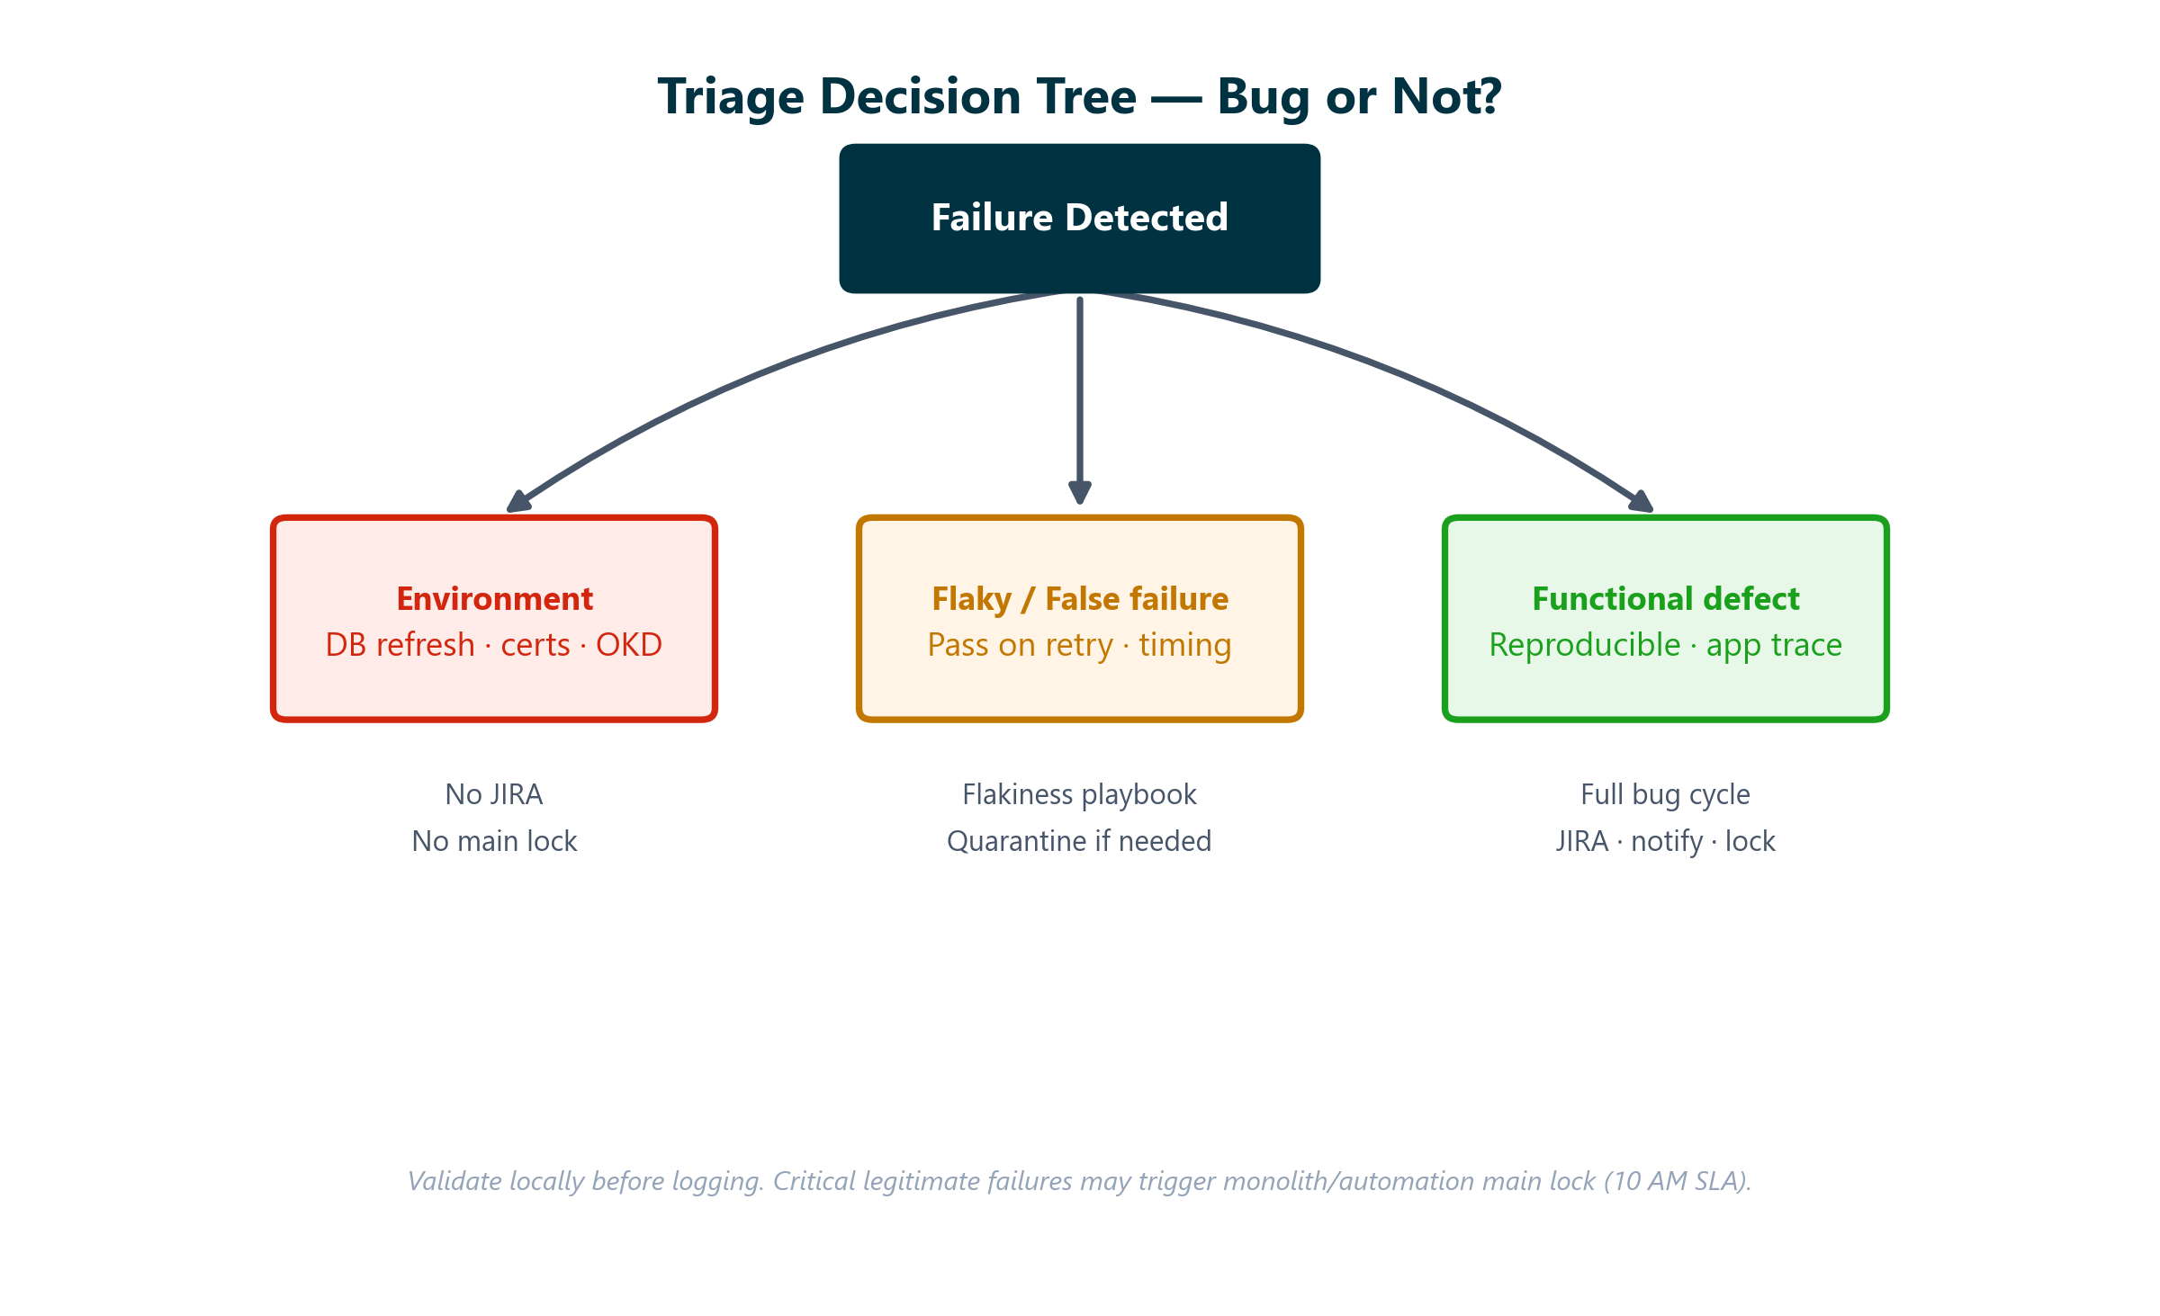
Classification | Signals | Action | JIRA?
Environment | DB restricted, certs/helm, OKD down, env-only | Escalate infra | No
Flaky / false failure | Pass on retry; timing; locator; TR flip same day | Flakiness playbook | No
Automation script | Test logic, wait, data setup | Fix locally in automation repo | Optional
Functional defect | Reproducible; manual repro; app stack trace | Full bug cycle | Yes

3. End-to-End Workflow
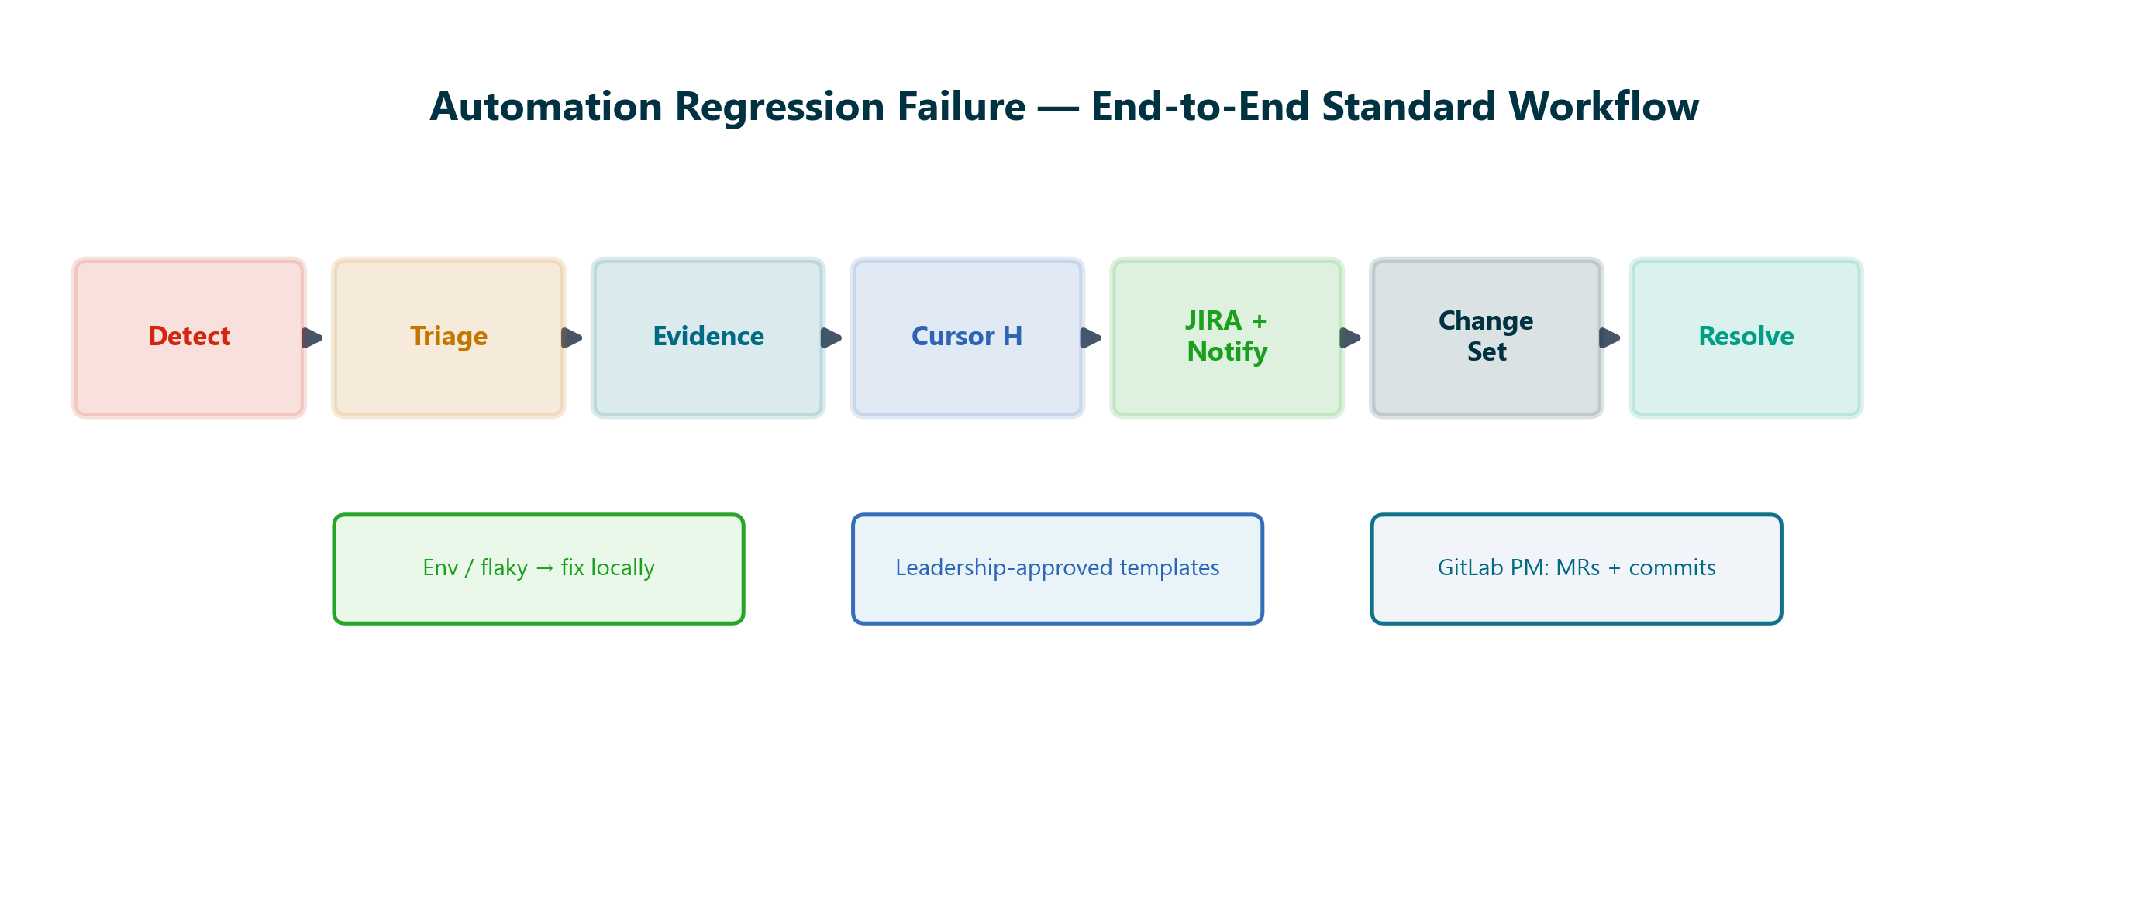
Step | Activity | Standard reference
1 | Detect: V2 Jenkins or V3 GitLab regression reports failure. Record last green run timestamp. | 04_EXECUTION/DAILY_REGRESSION.md
2 | Triage: Classify per Section 2. Rerun locally. Check environment health (04_EXECUTION/DAILY_REGRESSION.md). | FLAKINESS_PLAYBOOK.md
3 | Evidence: Folder: 10_IMPORTS_RAW/regression_reports/[MMDDYYYY]/ — screenshots, logs, test data. | BUG_REPORTING_PROCESS.md
4 | Cursor H: 00_SYSTEM/PROMPTS.md section H → JIRA block + email + Teams in one .md file. | 00_SYSTEM/PROMPTS.md
5 | JIRA + Notify: QA board ticket. Leadership-approved To/Cc. Critical legit → lock main (10 AM SLA). | Confluence Bug Handling PDFs
6 | Change set: GitLab Project Manager: MRs + commits between last pass and failure. | GitLab Project Manager
7 | Resolve: Fix verified → JIRA closed with RCA → resolution email → unlock main. | 1b Resolution PDF

4. Evidence Folder Structure
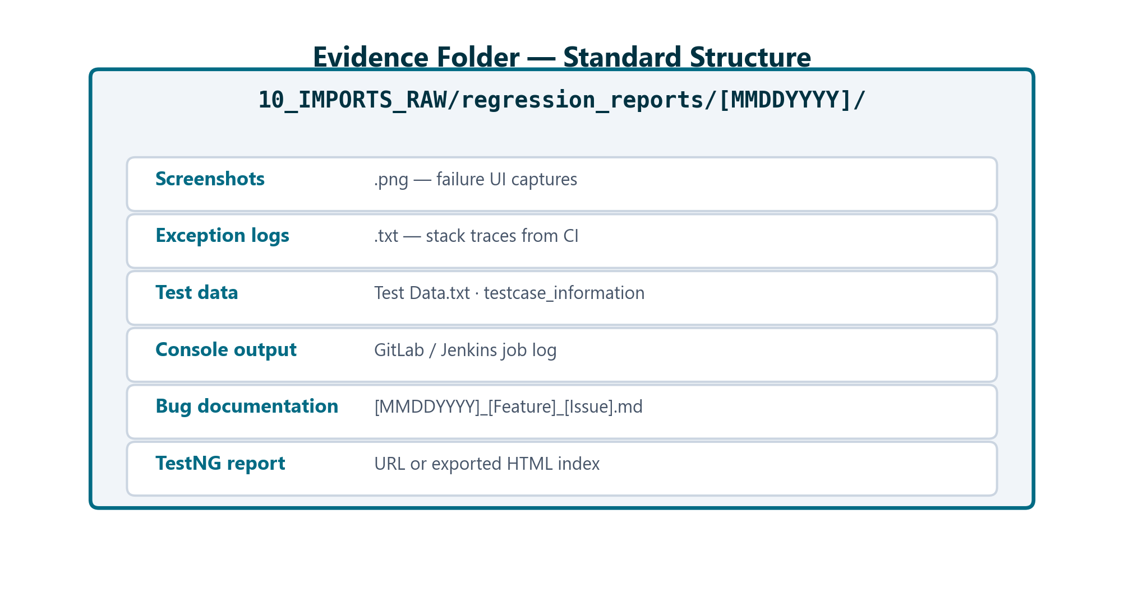
Naming: [MMDDYYYY]_[FeatureName]_[IssueType].md — see BUG_REPORTING_PROCESS.md.

5. Cursor Prompt H Deliverables
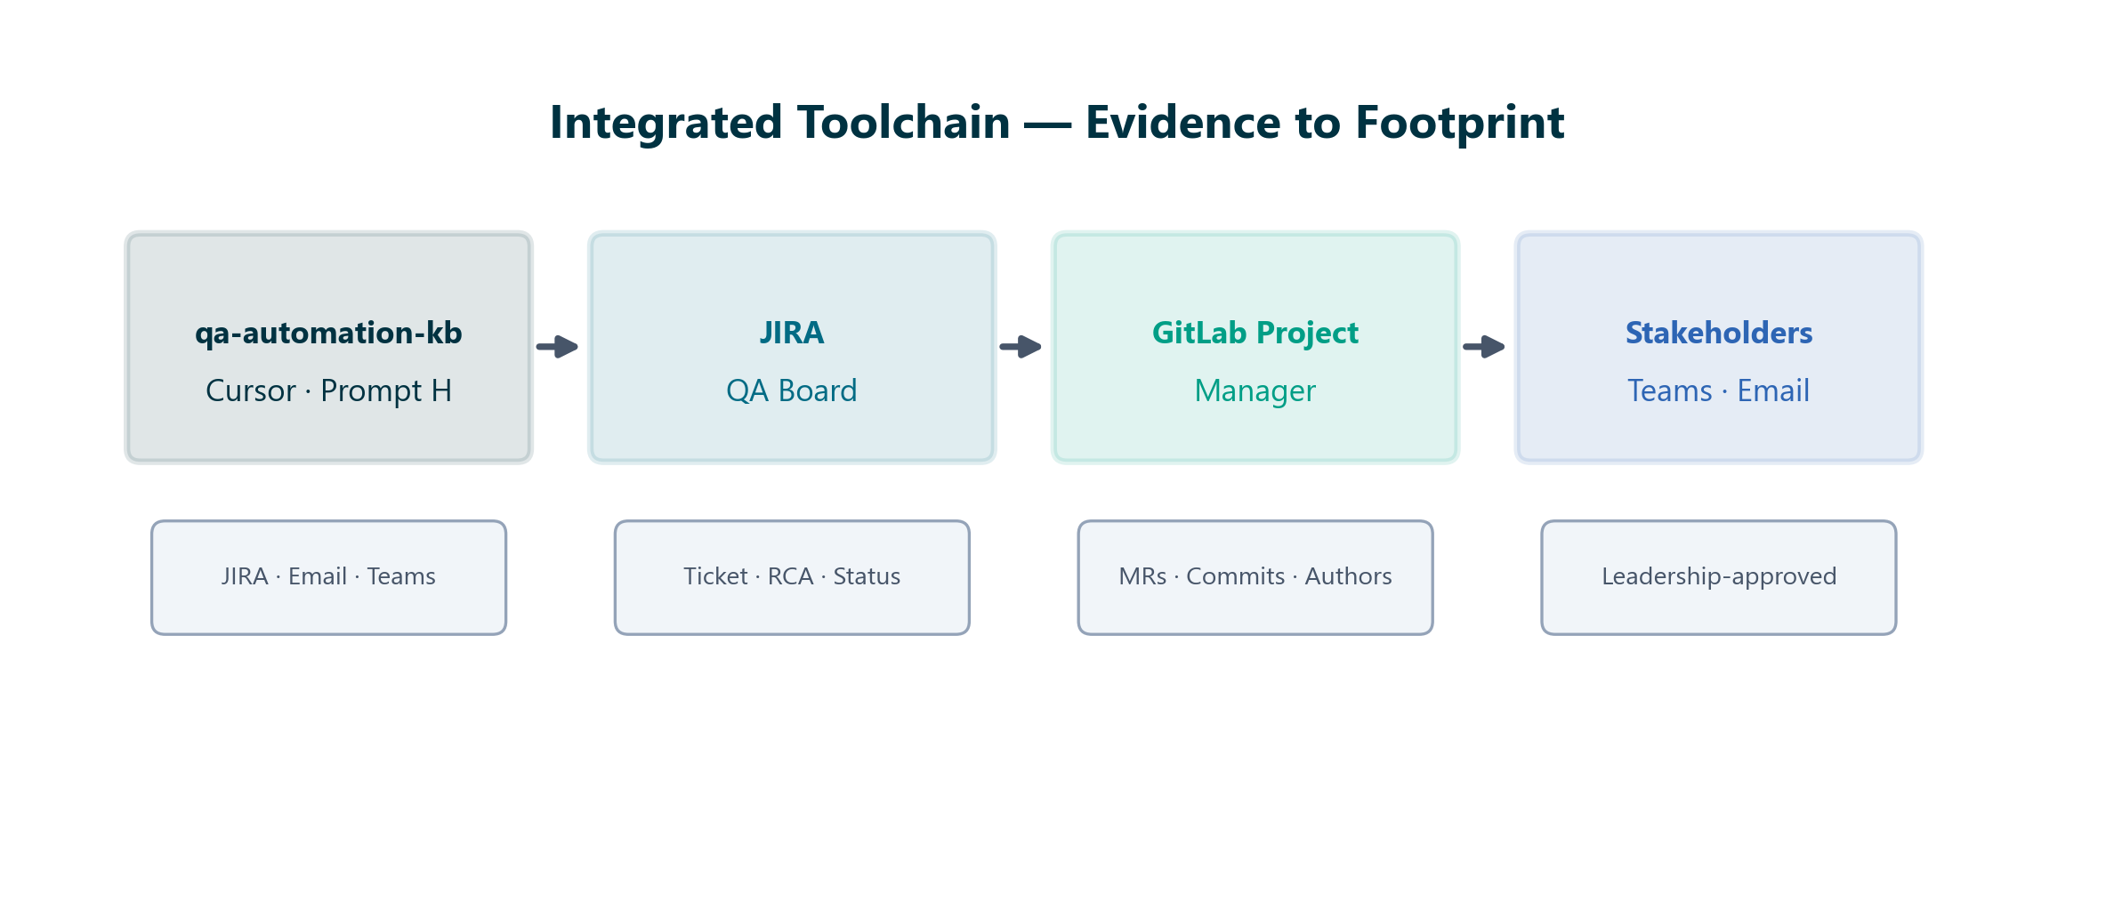
Teams and email templates produced by Prompt H follow formats approved by leadership and senior QA resources. Use standard To/Cc lists — do not improvise distribution or structure.

6. GitLab Project Manager — Change Set
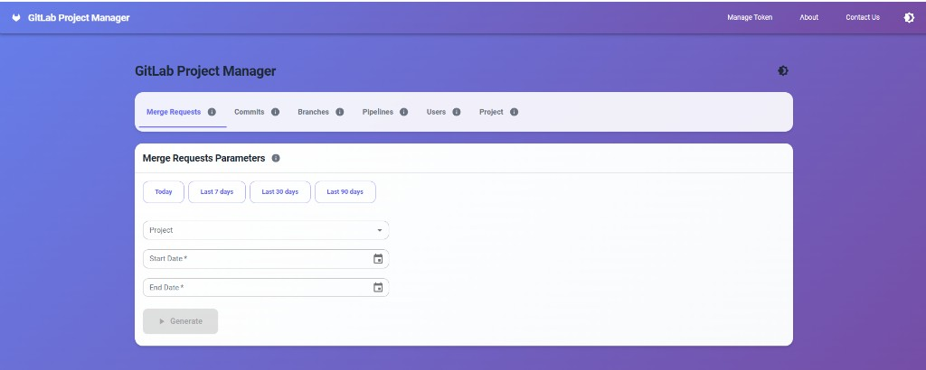
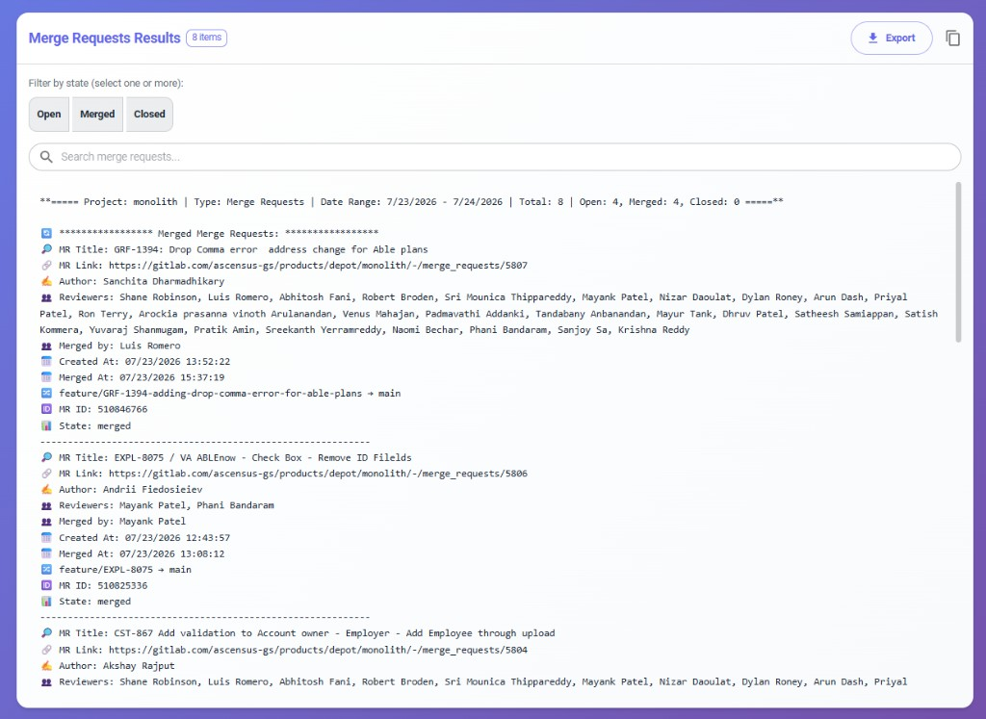
Sample output: Merge Requests for monolith — date range, authors, merged by, branches
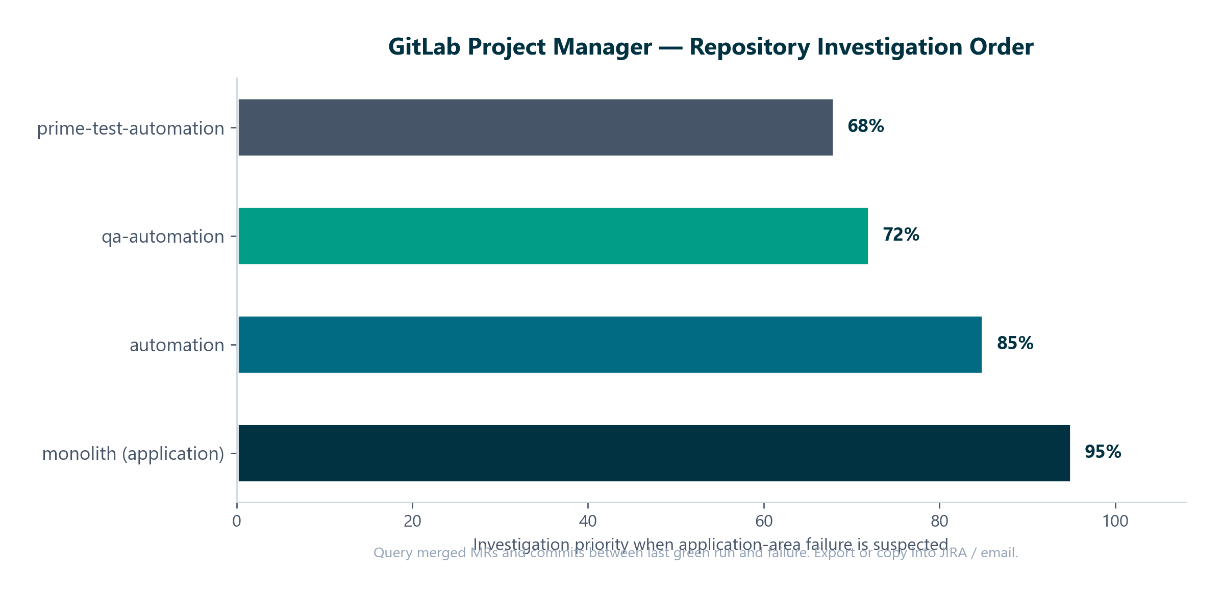
- Utility: C:\Development\Workspace\GitlabInfoProjUI (separate repo; read-only GitLab API)
- Tabs: Merge Requests · Commits · Branches · Pipelines · Users · Project
- Filter Merged MRs; note Author, Merged by, source → target branch, Merged At (EST)
- Export CSV/Excel or copy formatted report into JIRA / email Change Set section

7. Defect Lifecycle & Branch Locking
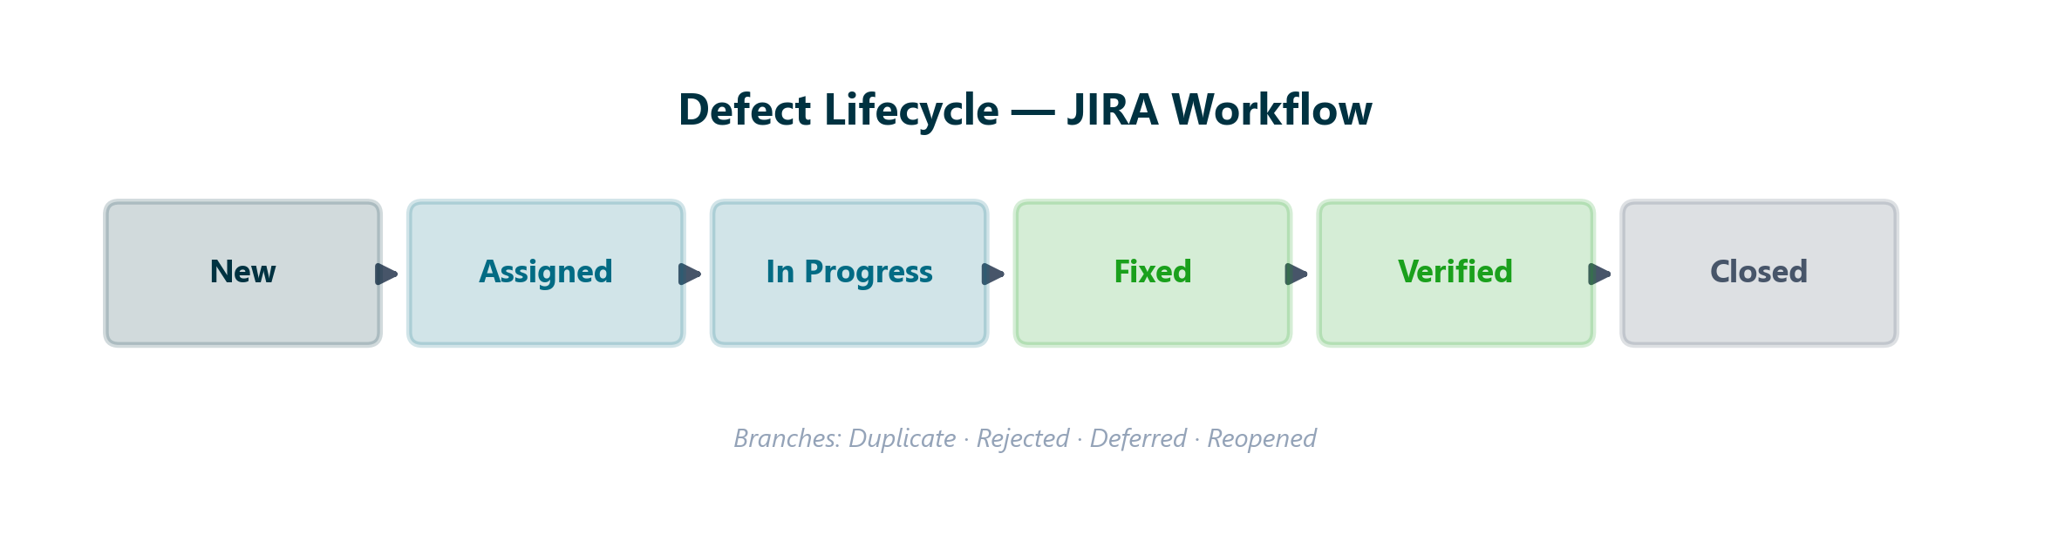
Full reference: 04_EXECUTION/DEFECT_LIFECYCLE.md, 04_EXECUTION/TRIAGE_RULES.md
Lock monolith/main + automation/main only for critical, legitimate defects — not env/data/flaky.

8. Multi-Failure Rollup
- Group by feature/plan — not one JIRA per test method
- Failure matrix with root-cause hints per traunch/plan
- Umbrella ticket + linked children when appropriate
- Reference: 10_IMPORTS_RAW/regression_reports/04202026/04202026_DailyRegression_PipelineFailureRollup.md

9. Repository Cross-References
Topic | Path in qa-automation-kb
Prompt H | 00_SYSTEM/PROMPTS.md
Role & constraints | 00_SYSTEM/ROLE.md, CONSTRAINTS.md
Glossary (triage, flakiness, RCA) | 00_SYSTEM/GLOSSARY.md
Bug reporting SOP | 10_IMPORTS_RAW/regression_reports/BUG_REPORTING_PROCESS.md
Repetitive tasks guide | 05_ONBOARDING/HOW_TO_REPETITIVE_TASKS.md
Defect lifecycle | 04_EXECUTION/DEFECT_LIFECYCLE.md
Triage rules | 04_EXECUTION/TRIAGE_RULES.md
Flakiness playbook | 04_EXECUTION/FLAKINESS_PLAYBOOK.md
RCA process | 04_EXECUTION/RCA_PROCESS.md
JIRA template | 06_TEMPLATES/JIRA_TICKET_TEMPLATE.md
Confluence exports | 10_IMPORTS_RAW/confluence_exports/Bug Handling/

