ENROLLMENT API AUTOMATION
Formal sign-off and handover
STATUS: COMPLETE (defined scope)
September 24, 2026 · QA Automation (AMSQUAD) · QA-893
Classification: Internal — handover to engineering and support

1. Document control
Title | Enrollment API Automation — Sign-Off
Version | 1.0
Date | September 24, 2026
Jira | QA-893 / QA-2043
Determination | COMPLETE — defined happy path + subsequent scope

2. Executive summary
25 of 28 catalog endpoints automated (89.3%). Current regression/integration XML runs 17 ordered classes for OK Direct, New York, and NM Direct. Three partner rows are deferred.

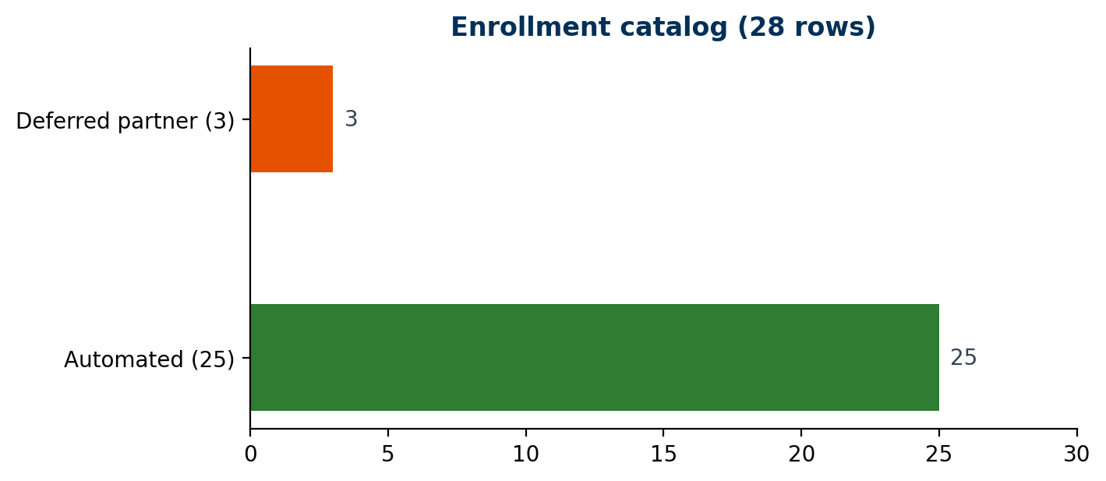

3. KPIs
Catalog / automated / deferred | 28 / 25 / 3
Test classes | 23 + EnrollmentBaseTest
@Test methods | 25
Suite XML plants | okdirect, newyork, nmdirect
Enrollment nightly | Not verified in current GitLab CI

4. Endpoint register
ID | Method | Path | Area | Class | Status | Plants
ENR-01 | GET | /enrollmentapi/health/liveness | Smoke | EnrollmentPingRequestTest | Done | okdirect
ENR-02 | GET | /enrollmentapi/v1/ping | Smoke | EnrollmentPingRequestTest | Done | okdirect
ENR-03 | GET | /enrollmentapi/v1/certificate | Smoke | EnrollmentCertificateRequestTest | Done | okdirect
ENR-04 | GET | /enrollmentapi/v1/usstates | Smoke | EnrollmentUsStatesRequestTest | Done | okdirect
ENR-05 | GET | /enrollmentapi/v1/country | Smoke | EnrollmentCountryRequestTest | Done | okdirect
ENR-06 | GET | /enrollmentapi/v1/plans | Smoke | EnrollmentPlansRequestTest | Done | okdirect
ENR-07 | GET | /enrollmentapi/v1/plans/{planId} | Smoke | EnrollmentPlansRequestTest | Done | okdirect
ENR-08 | GET | /enrollmentapi/v1/content | Wizard | EnrollmentContentRequestTest | Done | okdirect+newyork+nmdirect
ENR-09 | POST | /mobile1api/v1/mobilemembersession | Optional | MobileMemberSessionRequestTest | Done (smoke group) | okdirect
ENR-10 | POST | .../enrollmentstarted | Wizard | EnrollmentStartedRequestTest | Done | okdirect+newyork+nmdirect
ENR-11 | POST | .../prospects | Wizard | ProspectRequestTest | Done | okdirect+newyork+nmdirect
ENR-12 | POST | .../owner-entered | Wizard | OwnerEnteredTests | Done | okdirect+newyork+nmdirect
ENR-13 | POST | .../owner-address-entered | Wizard | OwnerAddressEnteredRequestTest | Done | okdirect+newyork+nmdirect
ENR-14 | POST | .../beneficiary-entered | Wizard | BeneficiaryEnteredTests | Done | okdirect+newyork+nmdirect
ENR-15 | POST | .../verify/routingnumber | Wizard | VerifyBankRoutingNumberRequestTest | Done | okdirect+newyork+nmdirect
ENR-16 | POST | .../bank-entered | Wizard | BankEnteredRequestTests | Done | okdirect+newyork+nmdirect
ENR-17 | POST | .../recurring-contribution-entered | Wizard | RecurringContributionEnteredRequestTest | Done | okdirect+newyork+nmdirect
ENR-18 | POST | .../enrollmentallocationfunds/get | Wizard | AllocationFundRequestTest | Done | okdirect+newyork+nmdirect
ENR-19 | POST | .../allocations-entered | Wizard | AllocationsEnteredRequestTests | Done | okdirect+newyork+nmdirect
ENR-20 | POST | .../review-confirm-entered | Wizard | ReviewConfirmEnteredRequestTest | Done | okdirect+newyork+nmdirect
ENR-21 | GET | .../subsequentenrollment/banks | Subsequent | SubsequentEnrollmentBanksRequestTest | Done | okdirect+newyork+nmdirect
ENR-22 | POST | .../subsequent.../beneficiary-entered | Subsequent | SubsequentBeneficiaryEnteredRequestTest | Done | okdirect+newyork+nmdirect
ENR-23 | POST | .../subsequent.../bank-entered | Subsequent | SubsequentEnrollmentBankEnteredRequestTest | Done | okdirect+newyork+nmdirect
ENR-24 | POST | .../subsequent.../recurring-contribution | Subsequent | SubsequentEnrollmentRecurringContributionRequestTest | Done | okdirect+newyork+nmdirect
ENR-25 | POST | .../subsequent.../review-confirm-entered | Subsequent | SubsequentEnrollmentReviewConfirmEnteredRequestTest | Done | okdirect+newyork+nmdirect
ENR-26 | POST | .../enrollments/submit | Partner | — | Deferred QA-1808 | —
ENR-27 | GET | .../upromiseaccount | Partner | — | Deferred QA-1807 | —
ENR-28 | POST | .../oauth/token | Partner | — | Deferred | —

5. Exclusions
Item | Reason
POST /enrollments/submit | QA-1808 partner
GET /upromiseaccount | QA-1807
POST /oauth/token | Not MSC E2E
Negatives | Enhancement for receiving team
GitLab nightly | Follow-up story

6. Approvals
Names are blank until leadership assigns ACM / sign-off contacts.
Role | Name | Signature | Date
QA Automation Lead
Program / ACM
Engineering
Support / Operations

