QA Automation — AM Squad
Biweekly Status Briefing · August 14, 2026
Audience: Rajib (Chapter Lead) · Henry (Director) · Persistent Delivery Managers

Prepared by | Swapnil Patil / QA Automation AM Squad
Sprints covered | AMSQUAD Sprints 26.11, 26.12, and 26.13 (current)
Classification | Internal — Leadership
Companion deck | AM-Squad-Biweekly-Status-Rajib-Henry-Aug2026.pptx

Executive Summary
The AM Squad continues parallel delivery across Unite MSC API automation, V2/V3 UI regression, performance testing, and pipeline/standards work. This briefing covers Sprints 26.11, 26.12, and 26.13 (current) only — not Apr–Aug historical totals. Mobile 1 and Mobile 2 are 100% of in-scope business endpoints (26 + 25); enrollment is ~30% with first API slices in Sprint 26.13. The team expects to close the MSC program by end of Sprint 26.13 and will have 1–2 resources available for new priorities — but we need a two-quarter roadmap and sign-off owners to plan effectively.
Metric | Value | Notes
Sprint scope | 26.11 – 26.13 | 26.11 · 26.12 · 26.13
GitLab merges | 28 | Jul 8 – Aug 10 · 3 automation repos
Sprint 26.13 board items | 152 | Board items in Sprint 26.13
Regression bugs | 5 | Regression bugs since Sprint 26.11
MSC in-scope APIs | 51/51 | M1 26 + M2 25 · 100% automated
MSC Mobile 2 | 25/25 | Complete — ready for leadership sign-off
MSC Mobile 1 | 26/26 | Complete — all in-scope endpoints coded and suite-routed
MSC Enrollment | ~30% | In progress — framework designed; first API vertical slices in Sprint 26.13 (QA-1595–1603)
Delivery vs ETA | ~70% of original ETA | Consistent ahead-of-plan delivery

1. Unite MSC API Automation
Program KB: programs/unite-msc/ · Repository: api-test-automation (GitLab). Delivered in approximately 50% of original ETA using AI-assisted migration and canonical TestNG framework.

Coverage snapshot
Module | Coverage | Status
Mobile 2 | 25/25 endpoints (100%) | Complete — sign-off package ready (QA-1553, QA-1567)
Mobile 1 | 26/26 in-scope operations (100%) | Complete — all in-scope endpoints coded and suite-routed
Enrollment | ~30% | Framework + first API slices in Sprint 26.13 (QA-1595–1603)

100% = all in-scope business endpoints automated. Destructive/functional endpoints run in smoke or integration suites — not duplicated in master regression.

Pipeline & environments
- IDP + non-IDP paths validated for Mobile 1 and Mobile 2 on Stage1
- Unstable — hybrid model; pipeline design complete, QC4 proof pending stability
- Mobile 2 GitLab nightly job in flight (QA-1405, QA-1544–1549)
- Hybrid model per Jul 2025 leadership decision — Stage1 is primary until QC4 stabilizes.
- Blocker: no non-IDP plants in QC4 lower environment — need product owner to name test plans.

Sprint 26.13 MSC highlights (Jira)
- QA-1595–1603 — Enrollment API automation vertical slices (health, plans, prospect, wizard steps)
- QA-1405 / QA-1544–1549 — Mobile 2 GitLab nightly regression job and runbook
- QA-1668–1671 — Mobile 1/2 coverage validation and sign-off prep
- QA-1627–1631 — Enrollment prospect happy-path integration spike

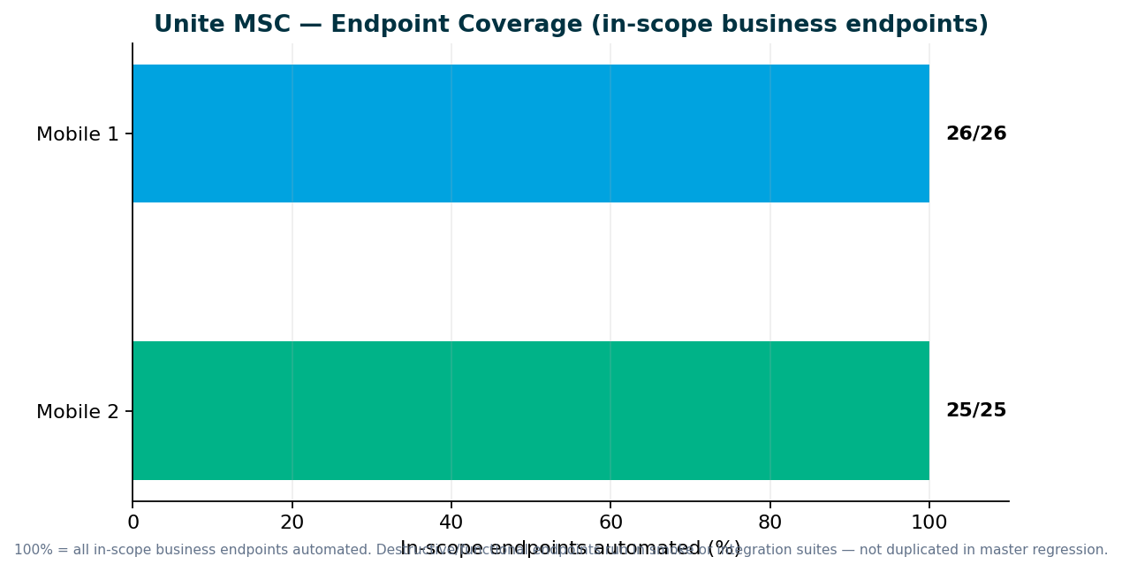

2. V2 & V3 UI Automation
Sprints 26.11–26.13 — maintenance and stabilization, not greenfield expansion. Small test-case adds for regression stability — not reporting Apr–Aug inventory totals.

Sprint 26.11–26.13 highlights
- Web registration stabilization, entity flows, flaky-test fixes (QA-1462, QA-1366)
- V3 is the long-term source of truth on GitLab as direct plans migrate off V2
- CSR maintenance modules; legacy enrollment cases under sunset review
- Plans migrating legacy → universal platform — need decision on which Jenkins suites to retire

V2 → V3 migration — discussion needed
Which plan types stay on V2 Jenkins vs move to V3 GitLab? When do we retire duplicate enrollment coverage?

Regression bugs (Sprints 26.11–26.13)
Key | Summary | Area | Sprint
QA-1694 | V3 IDP Login regression failure | V3 | 26.13
QA-1691 | V3 Universal Enrollment IDP Login failure | V3 | 26.13
QA-1693 | Perf IDP login resources JMX fix | Perf | 26.13
QA-1520 | V3 Member Personal Information validation | V3 | 26.12
QA-1519 | V3 Member Personal Information validation | V3 | 26.12

3. Performance Testing
Deliverables in Sprints 26.11–26.13 only. IDP login, legacy login, MSC login baselines in weekday regression; MSC endurance suite (QA-1229)

Deliverables (Sprints 26.11–26.13)
Request | Sprint | Status | Jira
Barcode SYN-443 (Synergy return-mail API) | 26.12 | Delivered — baselines at 30/45/60 SPM; sign-off comms in flight | QA-1550, QA-1463
Jahia / IDP server patch — post-login banner perf | 26.12–26.13 | Delivered — pre/post patch BlazeMeter comparison on Stage1 | QA-1593, QA-1647, QA-1690
IDP login regression JMX resource fix | 26.13 | Delivered — IDP_login_resources.jmx corrected for nightly suite | QA-1693

Performance governance ask
Two emergency requests in two sprints forced the team to drop planned sprint work. We delivered scripts and baseline results in approximately one week each, but the full standard — KB documentation, Git check-in, test data management, and expanded regression coverage — was not possible under last-minute intake.
- Engage QA Automation when performance requirements are designed — not at deploy approval
- Mandate performance validation for IDP login, enrollment, contributions, and withdrawals before release
- Route cross-team perf requests through standard intake with lead time

4. Capacity & Upcoming Work
MSC program target: End of Sprint 26.13 — MSC program sign-off + 1-resource maintenance mode. Expected: 1–2 resources free after Sprint 26.13 MSC sign-off.

Planned reallocation
- Dinesh → Enrollment completion
- Sunil → MSC manual test case package + qTest
- Wence/Venkatesh → V2→V3 migration track

V2 → V3 migration
Retire V2 enrollment from Jenkins; migrate CSR enrollment flows to V3 on GitLab
Direct plans migrated to V3; reduce Jenkins footprint as legacy becomes obsolete
Lead: Wence / Venkatesh (when MSC capacity frees)

Incoming: ACS-5678 Atlas (AHA)
- Feature: ACS-5678 — Atlas Traffic Distribution & Load Balancer Rebalancing (QA Automation)
- Owner: Brian Danilczyk · Priority: #2 on Michael's list
- Estimate: 2–3 sprints · Dependency: Redis session-management initiative
- Target: Q4 2026 — pre peak-season
- Scope: load/perf/regression validation of traffic distribution after Redis session externalization

5. Leadership Asks & Decisions

Roadmap & capacity
- Publish a 2-quarter automation roadmap — we will provide ETAs once priorities are confirmed
- Confirm post-MSC priorities: ACS-5678 Atlas vs V2 sunset vs V3 expansion vs other AHA items from Brian
- Team consistently delivers within ~70% of stated ETA — need confirmed priorities to plan Q4 epics

Unite MSC / API automation
- Name sign-off owners for Mobile 1, Mobile 2, pipeline, and perf baselines
- Accept M1 (26/26) and M2 (25/25) as 100% of in-scope business endpoints — suite-tier routing is intentional
- Identify non-IDP plan contacts for lower environments (QC4 has no non-IDP plants today)

V2 regression (Jenkins)
- As plans migrate legacy → universal platform, which V2 Jenkins suites should we retire?
- CSR enrollment sunset timing — align retirement with plan migration schedule
- Should obsolete legacy-only test cases be removed now or maintained until full migration?

V3 universal platform (GitLab)
- Confirm V3 as source of truth for migrated plans — what expansion areas are priority after MSC?
- IDP login regression ownership — recent failures QA-1694, QA-1691 need product/env alignment

Performance & stress testing
- Route performance requests through SDLC intake — not last-minute before deploy
- Mandate performance validation for IDP login, enrollment, contributions, withdrawals before release
- Name sign-off owners for IDP/MSC perf baselines and emergency exception process

Pipeline & environments
- Approve GitLab nightly MSC regression job (QA-1405, QA-1544–1549)
- QC4 hybrid model — need env stability and non-IDP test-plan owners before proof sign-off
- Confirm Stage1-as-primary until QC4 stabilizes (Jul 2025 hybrid decision)

Sign-off owners needed (names TBD from leadership)
Area | What we need | Suggested role
Mobile 2 API | Green signal for 25/25 endpoint coverage | MSC API SME / product owner
Mobile 1 API | Accept 26/26 in-scope endpoints (suite-tier routing) | MSC API SME
MSC Pipeline | Approve GitLab nightly + ENVP integration | DevOps + program lead
Performance baselines | Accept IDP/MSC perf thresholds | Platform / perf SME
Non-IDP test plans | Name plans for QC4 lower env | Product / plan configuration owner

Appendix — References
- programs/unite-msc/leadership/2026-08-07-kevin-status-update.md
- programs/unite-msc/leadership/2026-07-17-leadership-update/
- programs/unite-msc/leadership/2026-07-23-scope-alignment/
- programs/leadership-updates/2026-08-am-squad-leadership-update/
- programs/Performance Testing/barcode-syn-443/
- Jira: QA project · AMSQUAD sprints
Generated August 13, 2026.

