QA Automation — AM Squad
Biweekly Status Briefing · August 14, 2026
Audience: Rajib (Chapter Lead) · Henry (Director) · Persistent Delivery Managers

Prepared by | Swapnil Patil / QA Automation AM Squad
Sprints covered | AMSQUAD Sprint 26.11 (7/08 – 7/21) · AMSQUAD Sprint 26.12 (7/22 – 8/04)
Classification | Internal — Leadership
Companion deck | AM-Squad-Biweekly-Status-Rajib-Henry-Aug2026.pptx

Executive Summary
The AM Squad continues parallel delivery across Unite MSC API automation, V2/V3 UI regression, performance testing, and pipeline/standards work. The last two sprints (26.11 and 26.12) were MSC-heavy with enrollment kickoff and two emergency performance requests. Mobile 2 is complete; Mobile 1 is ~86%; enrollment is ~30% with framework design done. The team expects to close the MSC program by end of next sprint and will have 1–2 resources available for new priorities — but we need a two-quarter roadmap and sign-off owners to plan effectively.
Metric | Value | Notes
GitLab merges (Apr–Aug) | 121 | 3 automation repositories
Jira story points | 545 | Sprints 26.04–26.12
Work items closed | 245 | Stories, tasks, spikes
Automation bugs logged | 20 | Regression triage
MSC Mobile 2 | 25/25 | Complete — ready for sign-off
MSC Mobile 1 | ~25/29 | Core complete — master suite + gap closure
MSC Enrollment | ~30% | In progress — framework designed; automation underway
Delivery vs ETA | ~70% of original ETA | Consistent ahead-of-plan delivery

1. Unite MSC API Automation
Program KB: programs/unite-msc/ · Repository: api-test-automation (GitLab). Delivered in approximately 50% of original ETA using AI-assisted migration and canonical TestNG framework.

Coverage snapshot
Module | Coverage | Status
Mobile 2 | 25/25 endpoints (100%) | Complete — sign-off package ready (QA-1553, QA-1567)
Mobile 1 | ~25/29 core categories (~86%) | Master suite wiring + ~4 endpoint gaps
Enrollment | ~30% | Framework + Postman + SQL ready; automation in flight (QA-995, QA-1507, QA-1542)

Pipeline & environments
- IDP + non-IDP M1/M2 regression validated on Stage1
- Unstable — hybrid model; pipeline design complete, QC4 proof pending stability
- DevOps integration in progress (QA-1569 / QA-1552)
- Hybrid model per Jul 2025 leadership decision — Stage1 is primary until QC4 stabilizes.
- Blocker: no non-IDP plants in QC4 lower environment — need product owner to name test plans.

Sprint 26.12 MSC highlights (Jira)
- QA-1553 — Mobile 2 validation, coverage matrix, L1–L4 evidence, sign-off package
- QA-1551 — Cross-team alignment and leadership reporting
- QA-1552 — DevOps ENVP / GitLab pipeline integration
- QA-1569 — DevOps follow-up for Mobile 2 GitLab nightly job
- QA-995 / QA-1507 — Enrollment asset inventory and migration spike
- QA-1542 — QC4 proof for enrollment SQL-backed scenario selection

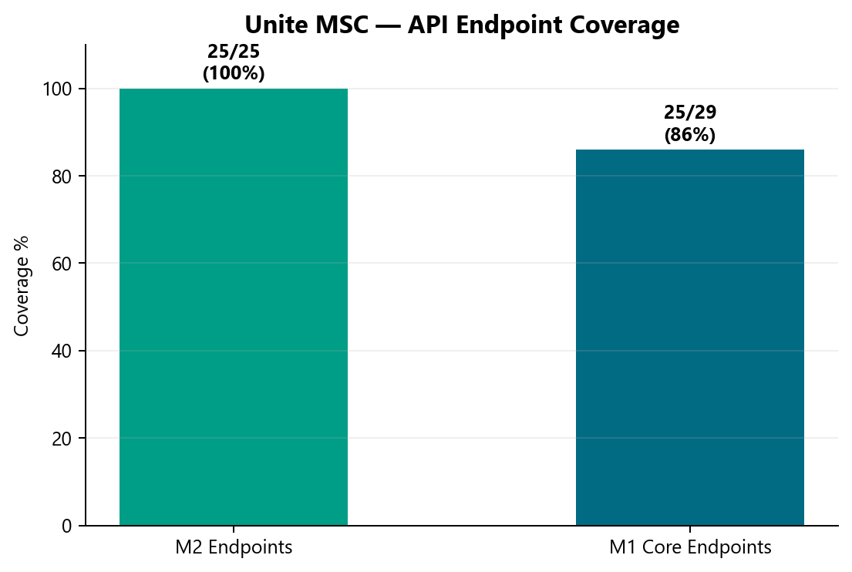

2. V2 & V3 UI Automation
V2 Stage1 nightly: 592 test methods (Jenkins). V3 Stage1 nightly: 442 test methods (GitLab). Stage1 nightly snapshots only — built since Q2 2025; excludes smoke/Stage 2/5.

Sprint 26.11–26.12 highlights
- V3: web registration stabilization (QA-1462), withdrawal flaky fixes (QA-1366), entity flows
- V2: CSR maintenance modules; CSR Actions +33 scenarios queued for nightly expansion
- Daily regression triage: V2 + V3 + Perf (QA-1338 series)

Recent automation bugs (30 days)
Key | Summary | Area
QA-1694 | V3 IDP Login regression failure | V3
QA-1691 | V3 Universal Enrollment IDP Login failure | V3
QA-1693 | Perf IDP login resources JMX fix | Perf
QA-1520 | V3 Member Personal Information validation | V3

3. Performance Testing
Inventory: 72 base transaction flows expand to 323 plan-expanded test cases across 4 Jenkins scenario definitions.

Emergency deliveries (last 2 sprints)
Request | Timeline | Status | Jira
Barcode SYN-443 (Synergy) | ~1 week | Delivered — baselines at 30/45/60 SPM; sign-off comms in flight | QA-1550 series
Jahia / IDP server patch validation | ~1 week (in flight) | Priti — JMeter post-login banner perf; pre/post patch comparison | QA-1593, QA-1605

Performance governance ask
Two emergency requests in two sprints forced the team to drop planned sprint work. We delivered scripts and baseline results in approximately one week each, but the full standard — KB documentation, Git check-in, test data management, and expanded regression coverage — was not possible under last-minute intake.
- Engage QA Automation when performance requirements are designed — not at deploy approval
- Mandate performance validation for IDP login, enrollment, contributions, and withdrawals before release
- Route cross-team perf requests through standard intake with lead time

4. Capacity & Upcoming Work
MSC program target: End of next sprint — MSC program sign-off + 1-resource maintenance mode. Expected: 1–2 resources free from next sprint onward.

Planned reallocation
- Dinesh → Enrollment completion
- Sunil → MSC manual test case package + qTest
- Wence/Venkatesh → V2→V3 migration track

V2 → V3 migration
Retire V2 enrollment from Jenkins; migrate CSR enrollment flows to V3 on GitLab
Direct plans migrated to V3; reduce Jenkins footprint
Lead: Wence / Venkatesh (when MSC capacity frees)

Incoming: ACS-5678 Atlas (AHA)
- Feature: ACS-5678 — Atlas Traffic Distribution & Load Balancer Rebalancing (QA Automation)
- Owner: Brian Danilczyk · Priority: #2 on Michael's list
- Estimate: 2–3 sprints · Dependency: Redis session-management initiative
- Target: Q4 2026 — pre peak-season
- Scope: load/perf/regression validation of traffic distribution after Redis session externalization

5. Leadership Asks & Decisions
- 1. Publish a 2-quarter automation roadmap — we will provide ETAs once priorities are confirmed
- 2. Route performance requests through SDLC intake — not last-minute before deploy
- 3. Mandate performance validation for high-priority flows (IDP login, enrollment, contributions, withdrawals) before release
- 4. Name sign-off owners for Mobile 1, Mobile 2, pipeline, and perf baselines
- 5. Identify non-IDP plan contacts for lower environments (QC4 has no non-IDP plants today)
- 6. Confirm post-MSC priorities: ACS-5678 Atlas vs V2 sunset vs V3 expansion vs AHA from Brian

Sign-off owners needed (names TBD from leadership)
Area | What we need | Suggested role
Mobile 2 API | Green signal for 25/25 endpoint coverage | MSC API SME / product owner
Mobile 1 API | Accept ~25/29 core + master suite plan | MSC API SME
MSC Pipeline | Approve GitLab nightly + ENVP integration | DevOps + program lead
Performance baselines | Accept IDP/MSC perf thresholds | Platform / perf SME
Non-IDP test plans | Name plans for QC4 lower env | Product / plan configuration owner

Appendix — References
- programs/unite-msc/leadership/2026-08-07-kevin-status-update.md
- programs/unite-msc/leadership/2026-07-17-leadership-update/
- programs/unite-msc/leadership/2026-07-23-scope-alignment/
- programs/leadership-updates/2026-08-am-squad-leadership-update/
- programs/Performance Testing/barcode-syn-443/
- Jira: QA project · AMSQUAD sprints
Generated August 13, 2026.

