QA Automation — AM Squad
Biweekly Status Briefing · August 28, 2026
Audience: Rajib (Chapter Lead) · Henry (Director) · Persistent Delivery Managers

Prepared by | Swapnil Patil / QA Automation AM Squad
Sprints covered | AMSQUAD Sprints 26.13, 26.14, and 26.14 (current)
Classification | Internal — Leadership
Companion deck | AM-Squad-Biweekly-Status-Rajib-Henry-Aug28-2026.pptx

Executive Summary
The AM Squad continues parallel delivery across Unite MSC API automation, V2/V3 UI regression, performance testing, and pipeline/standards work. This briefing covers Sprints 26.13 and 26.14 (current). Mobile 1 and Mobile 2 are 100% of in-scope business endpoints (26 + 25) and ready for sign-off. Enrollment core E2E is ~95% (19/20 endpoints coded; 17 TestNG classes). Submit (review-confirm-entered) is the remaining coding step — target end Sprint 26.14. Coding complete is not program closed: one resource stays ~1 sprint on documentation, qTest, Bruno handover, and sign-off packaging while the main squad pivots to Atlas or V2/V3 backlog.
Metric | Value | Notes
Sprint scope | 26.13 – 26.14 | 26.13 · 26.14
GitLab merges | 34 | Aug 5 – Aug 26 · 3 automation repos
Sprint 26.14 board items | 148 | Board items in Sprint 26.14
Regression bugs | 6 | Regression bugs since Sprint 26.13
MSC in-scope APIs | 51/51 + enrollment 95% | M1 26 + M2 25 complete · Enrollment core E2E 19/20
MSC Mobile 2 | 25/25 | Complete — sign-off ready
MSC Mobile 1 | 26/26 | Complete — sign-off ready
MSC Enrollment | ~95% (19/20) | Core E2E nearly complete — submit (review-confirm-entered) in flight; partner/subsequent flows deferred to next sprint (research)
Delivery vs ETA | ~70% of original ETA | Consistent ahead-of-plan delivery

1. Unite MSC API Automation
Program KB: programs/unite-msc/ · Repository: api-test-automation (GitLab). Delivered in approximately 50% of original ETA using AI-assisted migration and canonical TestNG framework.

Coverage snapshot
Module | Coverage | Status
Mobile 2 | 25/25 endpoints (100%) | Complete — sign-off package ready (QA-1553, QA-1567)
Mobile 1 | 26/26 in-scope operations (100%) | Complete — sign-off ready
Enrollment | 19/20 core E2E (95%) | Core E2E nearly complete — submit (review-confirm-entered) in flight; partner/subsequent flows deferred to next sprint (research)

100% = all in-scope business endpoints automated. Enrollment 95% = core happy-path E2E (19/20); 5 partner/subsequent catalog endpoints deferred with research.

Pipeline & environments
- IDP + non-IDP paths validated for Mobile 1 and Mobile 2 on Stage1
- Hybrid model; DB refresh completed — integration proof continuing
- Mobile 2 GitLab nightly job delivered (QA-1405)
- Hybrid model per Jul 2025 leadership decision — Stage1 is primary until QC4 stabilizes.
- Blocker: no non-IDP plants in QC4 lower environment — need product owner to name test plans.

Sprint 26.13–26.14 MSC highlights (Jira)
- QA-1786–1789 — Enrollment optional helpers: mobile login, enrollment started, recurring contribution, allocation funds
- QA-1775–1776, QA-1602–1603 — Wizard steps: owner address, content, allocations, verify routing
- QA-1405 — Mobile 2 GitLab nightly regression job delivered
- QA-1668–1671 — Mobile 1/2 coverage validation and sign-off prep complete
- QA-1604 / QA-1810 — Submit (review-confirm-entered) — in flight end Sprint 26.14
- DB refresh: test data + SQL stabilized for Stage1/QC4 enrollment runs (Aug 2026)

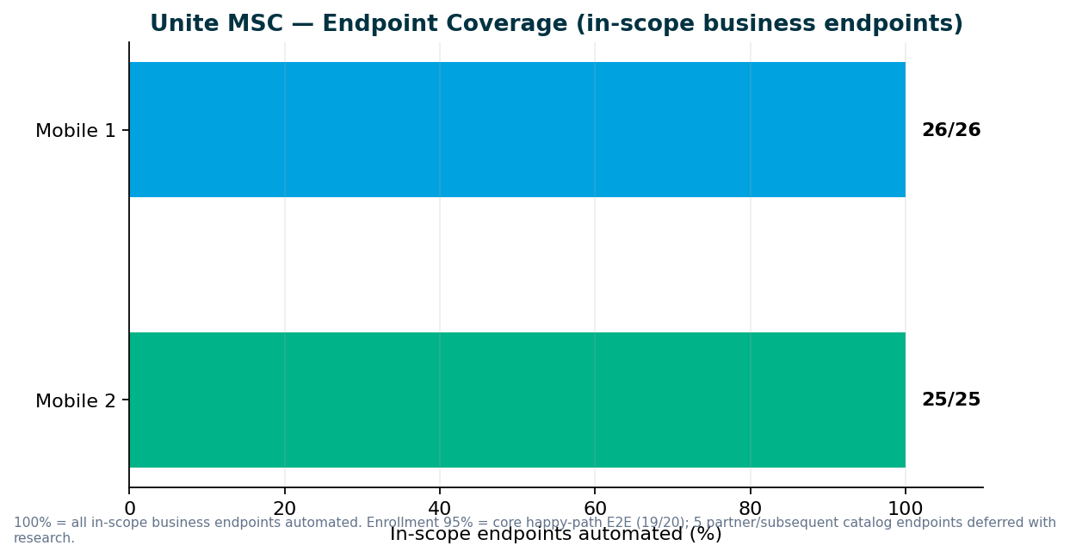

2. V2 & V3 UI Automation
Sprints 26.13–26.14 — maintenance and stabilization; capacity shifting to MSC close-out + new priorities. Small test-case adds for regression stability — team can resume V2/V3 expansion as MSC coding completes.

Sprint 26.11–26.13 highlights
- Web registration stabilization, entity flows, flaky-test fixes
- V3 is the long-term source of truth on GitLab as direct plans migrate off V2
- IDP login regression flakes — product/env alignment ongoing
- CSR maintenance modules; legacy enrollment cases under sunset review
- QA-1275: V2 cases removed/updated for plans migrated Non-IDP → IDP
- Plans migrating legacy → universal platform — need decision on which Jenkins suites to retire

V2 → V3 migration — discussion needed
Which plan types stay on V2 Jenkins vs move to V3 GitLab? When do we retire duplicate enrollment coverage?

Regression bugs (Sprints 26.11–26.13)
Key | Summary | Area | Sprint
QA-1820 | V2 IDP-impacted legacy cases — Stage1 daily regression stabilization | V2 | 26.14
QA-1694 | V3 IDP Login regression failure | V3 | 26.13
QA-1691 | V3 Universal Enrollment IDP Login failure | V3 | 26.13
QA-1520 | V3 Member Personal Information validation | V3 | 26.12
QA-1519 | V3 Member Personal Information validation | V3 | 26.12

3. Performance Testing
Sprints 26.13–26.14 — one resource (Preeti); slightly behind plan due to IDP + emergency barcode work. IDP login, legacy login baselines in weekday regression; MSC endurance suite in repo — scheduling after M1/enrollment perf scripts

Deliverables (Sprints 26.11–26.13)
Request | Sprint | Status | Jira
MSC IDP Login BlazeMeter analysis | 26.13 | Delivered — QA-1429 | QA-1429
Unite MSC Contribution full-flow JMX | 26.14 | In progress — QA-1802 | QA-1802
MSC Mobile 1 + Enrollment perf scenarios | 26.15 | Planned — Preeti; after API E2E stable | QA-1229

Performance governance ask
Two emergency requests in two sprints forced the team to drop planned sprint work. We delivered scripts and baseline results in approximately one week each, but the full standard — KB documentation, Git check-in, test data management, and expanded regression coverage — was not possible under last-minute intake.
- Engage QA Automation when performance requirements are designed — not at deploy approval
- Mandate performance validation for IDP login, enrollment, contributions, and withdrawals before release
- Route cross-team perf requests through standard intake with lead time

4. Capacity & Upcoming Work
MSC program target: Enrollment coding end Sprint 26.14 · program close-out ~1 sprint with 1 dedicated resource. Expected: 1 resource ~1 sprint after enrollment coding (docs, qTest, Bruno, KT, sign-off) — NOT full squad exit.

MSC wrap-up checklist (1 resource)
- Documentation & KB runbooks (onboarding, nightly job ops, reporting)
- Coverage metrics matrix (M1/M2/enrollment endpoint Excel vs Java)
- qTest manual cases from Postman E2E
- Postman → Bruno collection handover
- GitLab enrollment nightly job
- KT session + sign-off package to named ACM / sustaining owner

Planned reallocation
- Sunil → MSC wrap-up: manual qTest cases, Postman→Bruno, coverage matrix, handover docs
- Dinesh / dev → enrollment submit + Stage1 E2E validation (end Sprint 26.14)
- Preeti → perf: MSC contribution JMX (26.14); M1 + enrollment perf next sprint
- Main squad (3.5) → ACS-5678 Atlas intake OR V2/V3/API backlog per leadership priority
- Swapnil → roadmap, sign-off coordination, leadership reporting

V2 → V3 migration
Retire V2 enrollment from Jenkins; migrate CSR enrollment flows to V3 on GitLab
Direct plans migrated to V3; reduce Jenkins footprint as legacy becomes obsolete
Lead: Wence / Venkatesh (when MSC wrap-up completes)

Incoming: ACS-5678 Atlas (AHA)
- Feature: ACS-5678 — Atlas Traffic Distribution & Load Balancer Rebalancing (QA Automation)
- Owner: Brian Danilczyk · Priority: #2 on Michael's list
- Estimate: 2–3 sprints · Dependency: Redis session-management initiative
- Target: October 2026 delivery
- Scope: load/perf/regression validation of traffic distribution after Redis session externalization

5. Leadership Asks & Decisions

Roadmap & capacity
- Confirm post-MSC priority queue: ACS-5678 Atlas (Oct delivery) vs V2 sunset vs V3 expansion
- Acknowledge 1-resource MSC wrap-up sprint — coding complete ≠ program closed
- Name sustaining owner (ACM) and sign-off contacts for M1, M2, enrollment, pipeline, perf

Unite MSC / API automation
- Accept M1 (26/26) and M2 (25/25) as 100% in-scope — ready for formal sign-off
- Enrollment: 95% core E2E — submit step target end Sprint 26.14; partner flows next sprint
- Approve handoff of API automation assets to named sustaining team

V2 regression (Jenkins)
- Which V2 Jenkins suites retire as plans migrate to universal platform?
- CSR enrollment sunset timing — align with plan migration schedule

V3 universal platform (GitLab)
- Confirm V3 as source of truth for migrated plans — expansion priority after MSC?
- IDP login regression ownership — recent failures need product/env alignment

Performance & stress testing
- Route performance requests through SDLC intake — team slightly behind due to emergency work
- Preeti: M1 + enrollment perf scripts planned next sprint after API E2E stable
- We continue owning nightly + perf regression unless leadership redirects to sustaining team

Pipeline & environments
- Mobile 2 GitLab nightly delivered (QA-1405) — enrollment nightly to follow in wrap-up sprint
- DB refresh complete — QC4 integration proof can proceed
- Confirm Stage1-as-primary until QC4 fully stable

Sign-off owners needed (names TBD from leadership)
Area | What we need | Suggested role
Mobile 2 API | Green signal for 25/25 endpoint coverage | MSC API SME / product owner
Mobile 1 API | Accept 26/26 in-scope endpoints (suite-tier routing) | MSC API SME
MSC Pipeline | Approve GitLab nightly + ENVP integration | DevOps + program lead
Performance baselines | Accept IDP/MSC perf thresholds | Platform / perf SME
Non-IDP test plans | Name plans for QC4 lower env | Product / plan configuration owner

Appendix — References
- programs/unite-msc/leadership/2026-08-07-kevin-status-update.md
- programs/unite-msc/leadership/2026-07-17-leadership-update/
- programs/unite-msc/leadership/2026-07-23-scope-alignment/
- programs/leadership-updates/2026-08-am-squad-leadership-update/
- programs/Performance Testing/barcode-syn-443/
- Jira: QA project · AMSQUAD sprints
Generated August 27, 2026.

