QA Automation — AM Squad Leadership Update
April – August 2026

Prepared by | QA Automation — AM Squad
Reporting period | April – August 2026
Version | August 2026
Classification | Internal — Leadership distribution

Contents
Executive Summary 3
1. Delivery Velocity 4
GitLab Merges by Repository 4
Monthly Automation Delivery 5
2. Jira Sprint Delivery 5
Story Points by Sprint 6
Automation Bugs by Sprint 6
Sprint detail 7
3. V2 Legacy UI Automation 7
V2 Test Methods by Module 7
4. V3 Universal Platform 8
V3 Test Methods by Module 8
5. API / Unite MSC 9
MSC Endpoint Coverage 9
API Module Breakdown 10
6. Performance Testing 10
Performance Flows vs Expanded Cases 11
7. Portfolio Value & Investment 11
Investment Allocation 12
Release Automation Impact 13
Appendix A — Data Confidence 14
Appendix B — Roadmap & Leadership Asks 14
Appendix C — References 14

Executive Summary
The QA Automation AM Squad delivers across six parallel channels — V2 Legacy UI, V3 Universal Platform, API/Unite MSC, performance testing, pipeline/CI, and department standards. This briefing covers Apr–Aug 2026 delivery within a ~12-month team build (squad formed Q2 2025).
- 121 GitLab merges to main across three automation repositories (peak Jun–Jul MSC sprint)
- 545 Jira story points · 245 work items · 20 automation bugs logged
- Stage1 nightly inventory: V2 592 + V3 442 methods (built since Q2 2025; excludes smoke/Stage 2/5/integrations); perf 323 plan-expanded cases
- Unite MSC rescued — M2 25/25 endpoints, M1 ~25/29 core (~50% ETA savings)
- ~80% release validation automated (17 FTE → 2 FTE equivalent)
Metric | Value | Context
GitLab merges to main | 121 | Apr–Aug 2026 · 3 repositories
Jira story points delivered | 545 | AMSQUAD Sprints 26.04–26.12
Automation bugs discovered | 20 | Logged via regression triage
V2 Stage1 nightly methods | 592 | Jenkins nightly · Aug 4 · ~12 mo build
V3 Stage1 nightly methods | 442 | GitLab CI nightly · Aug 4 snapshot
Performance test cases | 323 | 83 base flows × plan matrix
MSC Mobile 2 / M1 core | 25/25 · ~25/29 | api-test-automation
Period delivery (Apr–Aug) | 1212 | Estimated new coverage
Release automation | ~80% | 17 FTE → 2 FTE equivalent

592 V2 and 442 V3 are Stage1 nightly snapshots only — accumulated since Q2 2025, not built in Apr–Aug alone. Smoke (Stage 2/5), integrations, and +33 CSR Actions are additional coverage and are not added to these totals.

1. Delivery Velocity
GitLab merge activity measures code delivery throughput. Monthly automation delivery measures estimated new test coverage closed in each month — these are separate metrics and should not be combined.

GitLab Merges by Repository
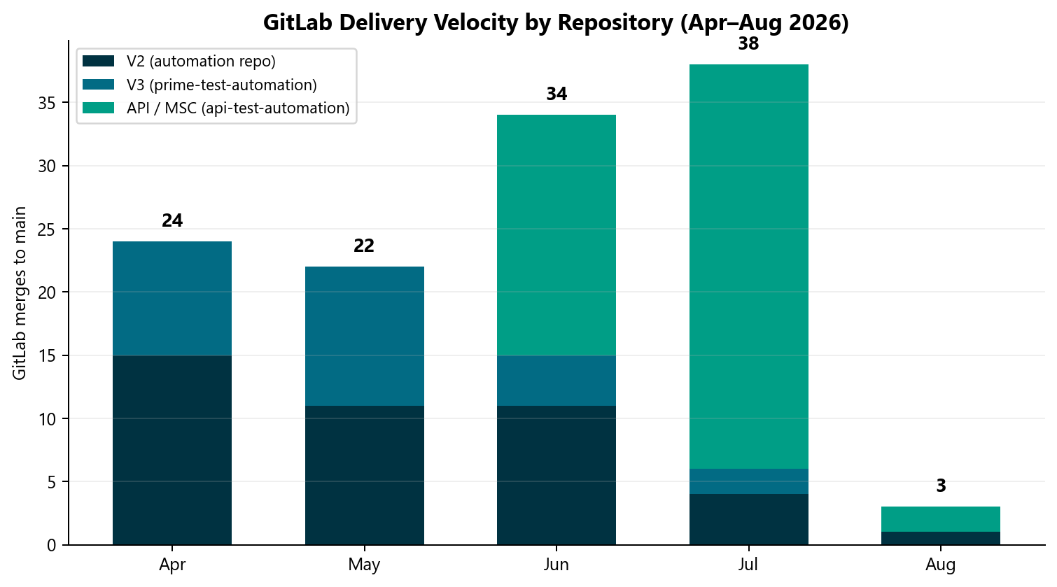
Source: GitLab MR export · Apr 1 – Aug 4, 2026 · Total 121 merges

Key takeaways
- 121 merges to main; July peak at 38 merges during MSC API sprint
- Repositories: automation (V2), prime-test-automation (V3), api-test-automation (MSC)
- Merge count is a delivery-velocity metric — not the same as test case inventory

Monthly Automation Delivery
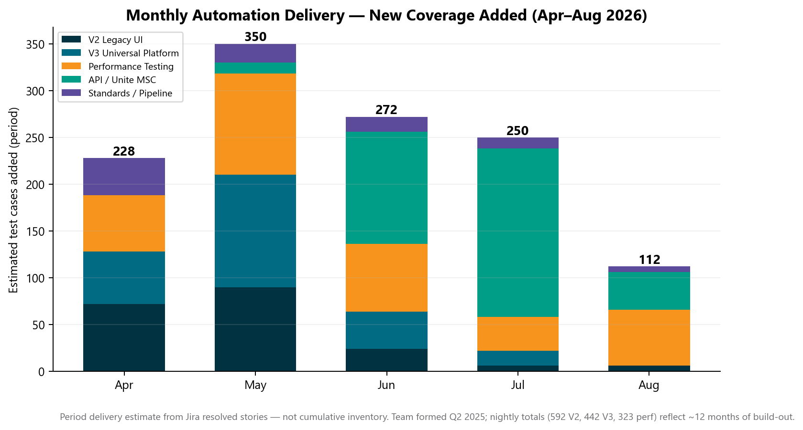
Source: Jira AMSQUAD Sprints 26.04–26.12 · ~1212 est. cases Apr–Aug

Key takeaways
- Period delivery estimate — not cumulative nightly inventory
- Counts include multi-plan, multi-environment, and positive/negative permutations
- Pre-April foundation is in nightly totals; this chart shows when work landed

2. Jira Sprint Delivery
Across AMSQUAD Sprints 26.04–26.12 the squad closed 245 work items (545 story points) and logged 20 automation-discovered defects.

Story Points by Sprint
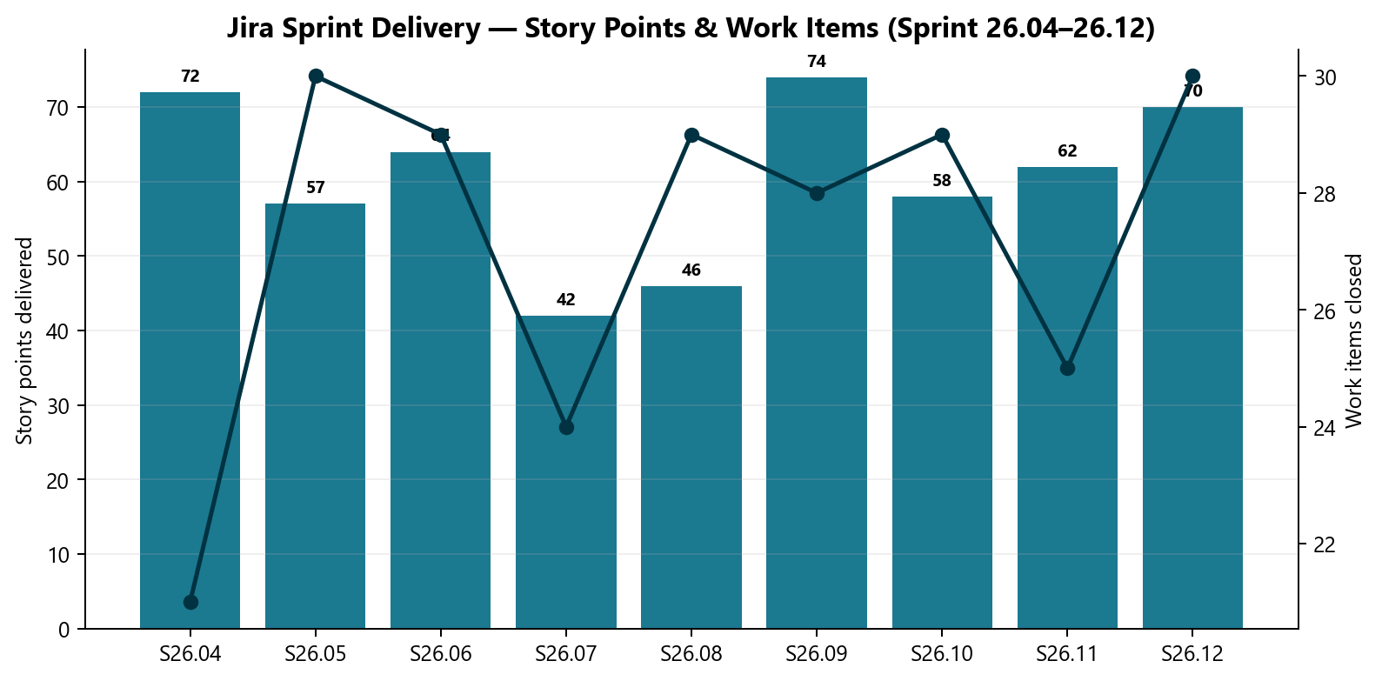
Source: Jira AMSQUAD export

Key takeaways
- Sustained sprint delivery across reporting window
- Story points track committed work closed

Automation Bugs by Sprint
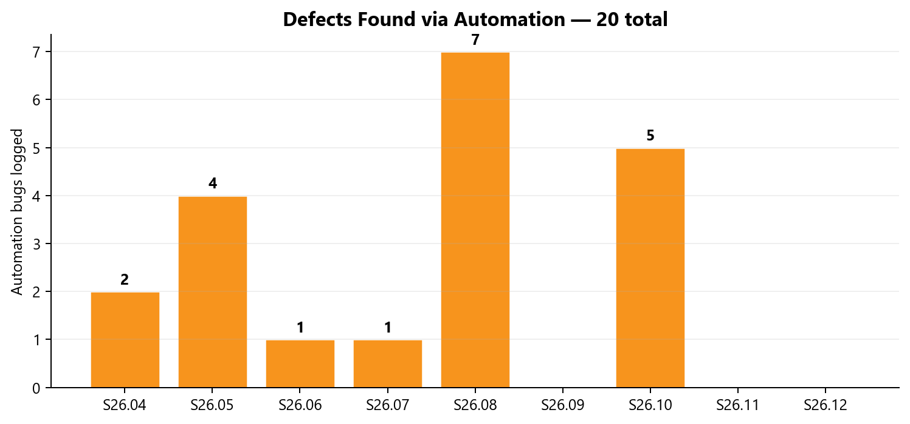
Source: Jira AMSQUAD export
Key takeaways
- Defects found via nightly regression triage
- Fed into automation bug lifecycle standard

Sprint detail
Sprint | Work Items | Stories | Spikes | Bugs | SP
26.04 | 21 | 18 | 1 | 2 | 72
26.05 | 30 | 22 | 3 | 4 | 57
26.06 | 29 | 26 | 1 | 1 | 64
26.07 | 24 | 17 | 5 | 1 | 42
26.08 | 29 | 19 | 2 | 7 | 46
26.09 | 28 | 26 | 1 | 0 | 74
26.10 | 29 | 22 | 1 | 5 | 58
26.11 | 25 | 24 | 0 | 0 | 62
26.12 | 30 | 27 | 1 | 0 | 70

3. V2 Legacy UI Automation
V2 Jenkins Stage1 nightly snapshot: 592 test methods across 12 modules (Aug 4, 2026). This count reflects the primary Mon–Fri nightly job only — built since Q2 2025, not delivered in Apr–Aug alone.
Not included in 592: Stage 5 smoke, Stage 2 smoke, on-demand fast smoke, and +33 CSR Actions scenarios (built — pending Jenkins nightly wire). Empower also runs as a separate dedicated nightly job.

V2 Test Methods by Module
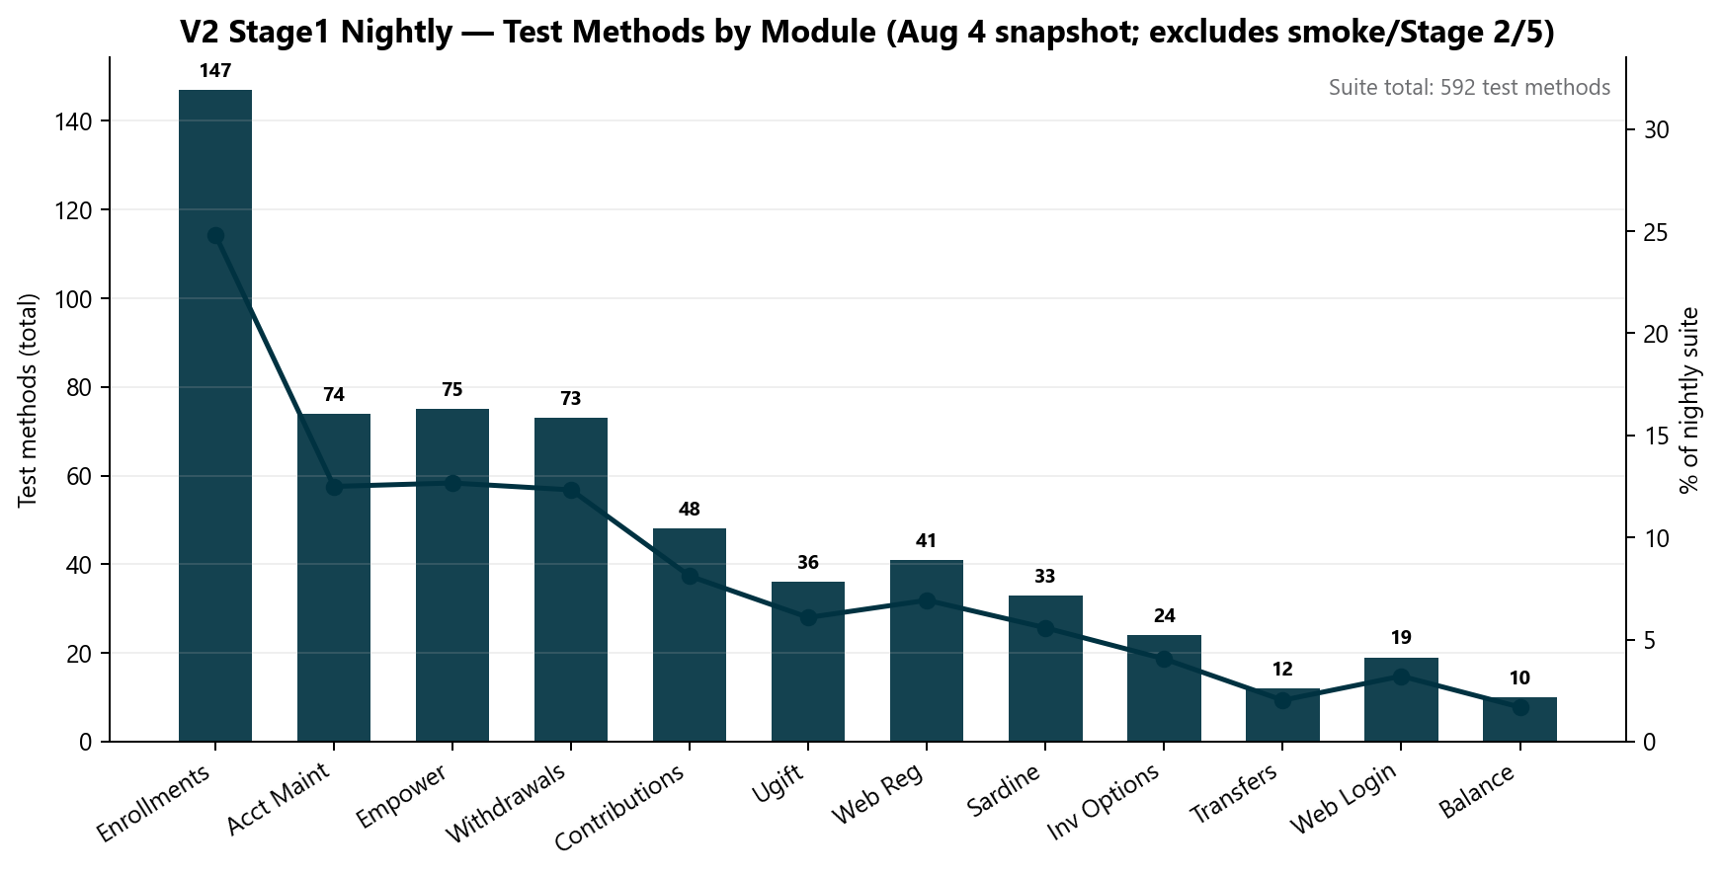
Source: Jenkins STAGE1-Daily-Unite-Prime-Regression · Aug 4, 2026 snapshot

Key takeaways
- 592 total methods — Stage1 primary nightly only
- Enrollments largest module (scenario × plan matrix)
- CSR maintenance modules added Apr–Jul on earlier foundation
- +33 CSR Actions scenarios — next expansion (not yet in nightly job)

4. V3 Universal Platform
V3 GitLab Stage1 nightly snapshot: 442 test methods (Aug 4, 2026). Framework, CI/CD pipelines, and suites were built since Q2 2025 — Apr–Aug is acceleration, not greenfield.
Not included in 442: Stage 5 smoke suites (UE + IDP), integration XML profiles, and Entity suites still expanding on a separate GitLab track. Universal Enrollment (303) reflects enrollment scenarios multiplied across plan/traunch permutations — not 303 unique manual scripts.

V3 Test Methods by Module
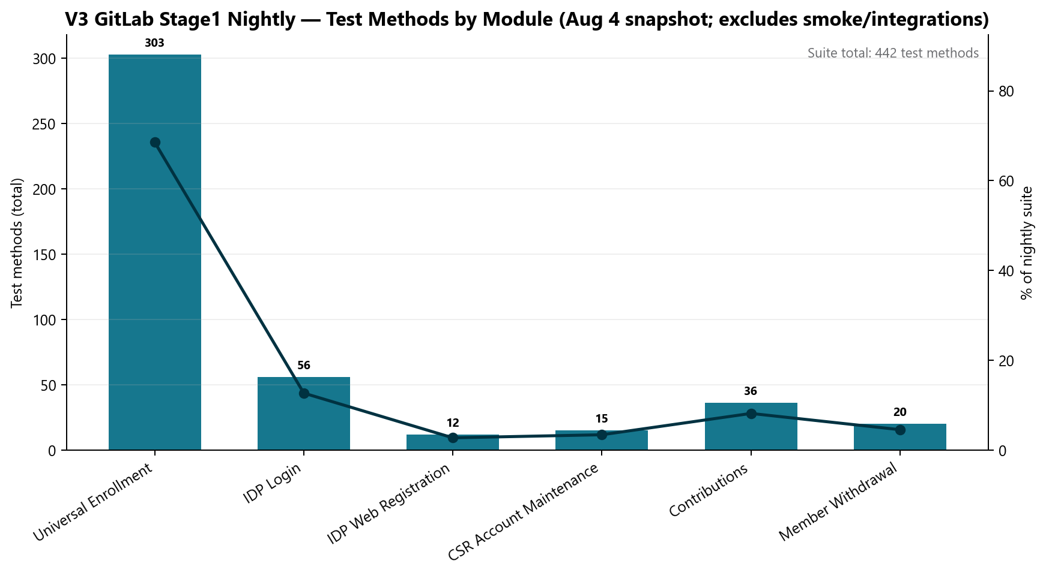
Source: GitLab scheduled_regression_job · Aug 4, 2026 snapshot

Key takeaways
- 442 total methods across UE, IDP Login, Web Registration, CSR, Contributions, Withdrawals
- Entity platform suites expanding on a separate GitLab track
- GitLab CI scheduled regression operational

Module | Test Methods | Notes
Universal Enrollment | 303 | Largest module — multi-plan enrollment matrix
IDP Login | 56 | Functional coverage
IDP Web Registration | 12 | Functional coverage
CSR Account Maintenance | 15 | Functional coverage
Contributions | 36 | Functional coverage
Member Withdrawal | 20 | Functional coverage

5. API / Unite MSC
Mobile 2 API automation is complete at 25/25 endpoints. Mobile 1 is at ~25/29 core endpoints. Delivered in approximately half the original ETA using AI-assisted migration.

MSC Endpoint Coverage
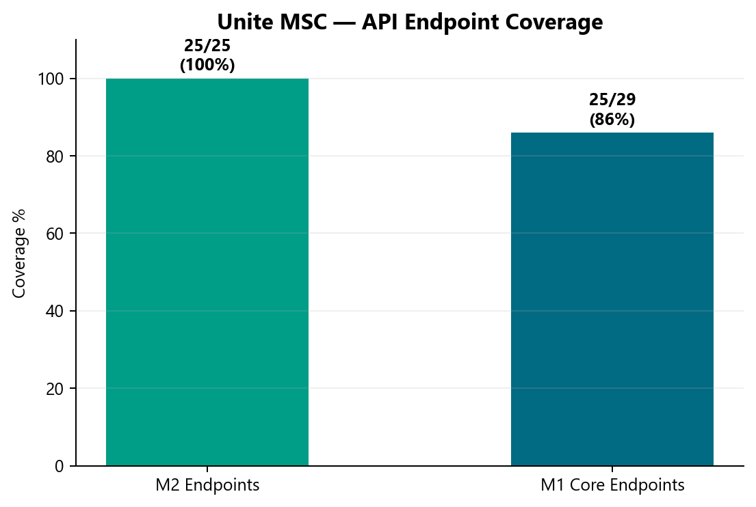
Source: api-test-automation repo inventory

Key takeaways
- M2 25/25 · M1 ~25/29
- P0: GitLab nightly scheduling (QA-1405)

API Module Breakdown
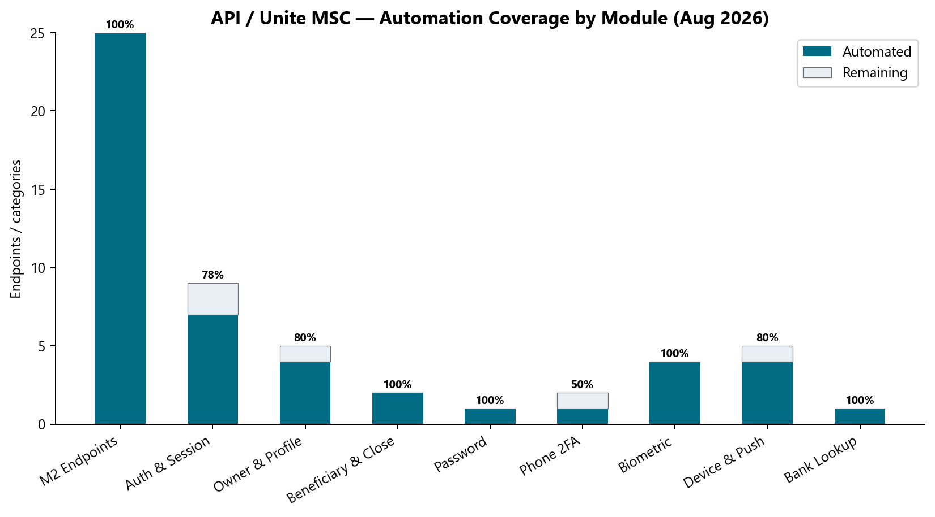
Source: api-test-automation repo inventory

Key takeaways
- Auth, profile, biometric, device, bank categories
- M1 master suite in progress

6. Performance Testing
Performance inventory: 72 base transaction flows expand to 323 test cases when multiplied across plan permutations (e.g. IDP × 7 plans). Four Jenkins scenarios schedule these runs.

Performance Flows vs Expanded Cases
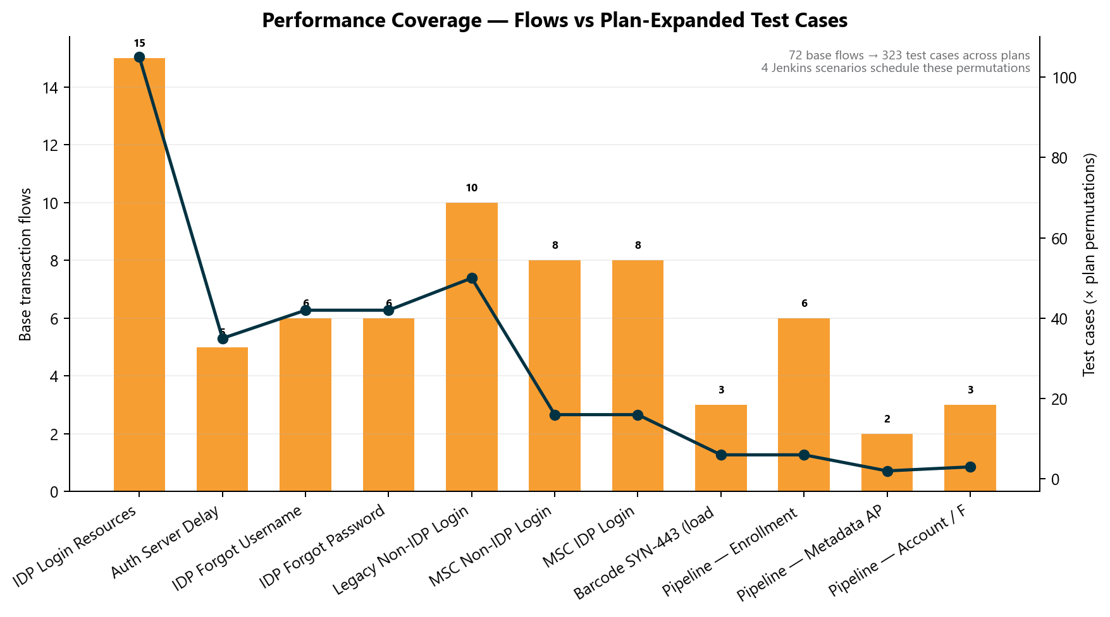
Source: Perf inventory model · Jenkins + BlazeMeter

Key takeaways
- 72 base flows → 323 plan-expanded test cases
- IDP login: 15 transaction labels × 7 plans = 105 cases alone
- Barcode SYN-443 emergency cycle delivered in ~1 week

7. Portfolio Value & Investment
- Framework architecture and canonical repo structure (API, perf, UI)
- AI-accelerated documentation, Postman collections, and TestNG boilerplate
- qTest master suite design and automation bug lifecycle standard
- Pipeline/DevOps co-design and cross-team emergency support

Investment Allocation
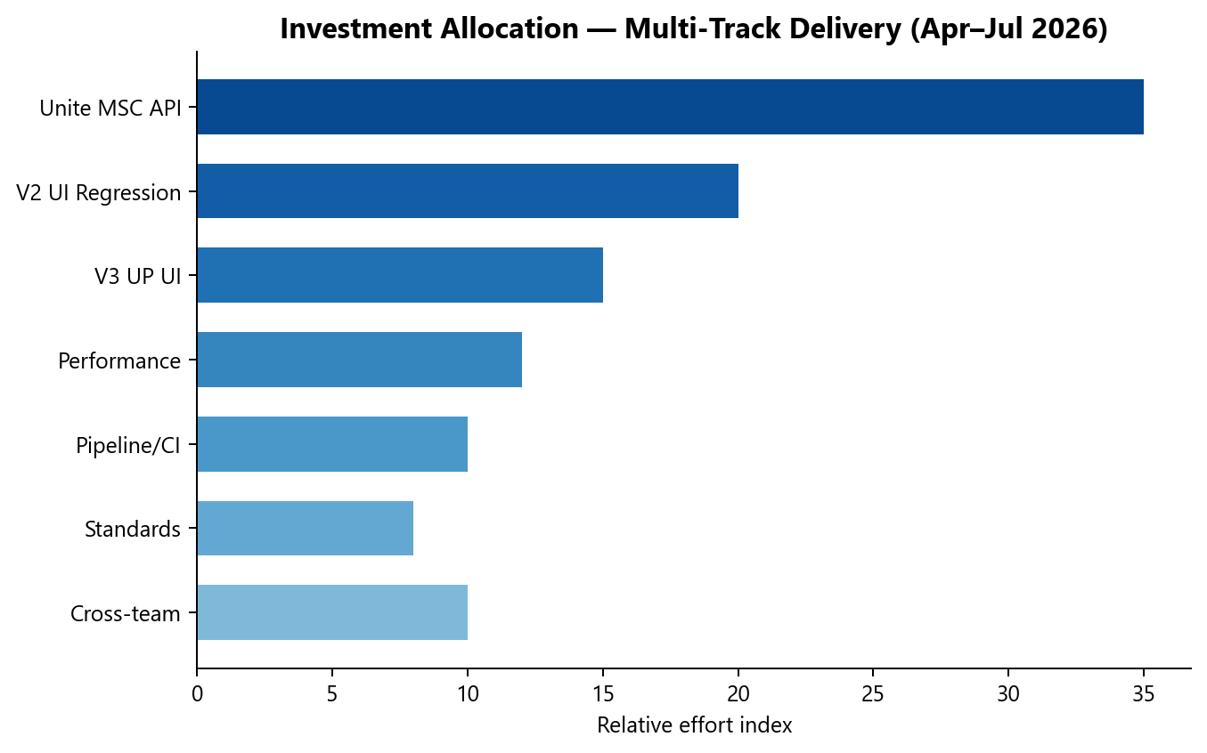
Squad effort estimate Apr–Jul 2026

Key takeaways
- MSC API 35%
- V2 UI 20%
- V3 UP 15%
- Perf 12%

Release Automation Impact
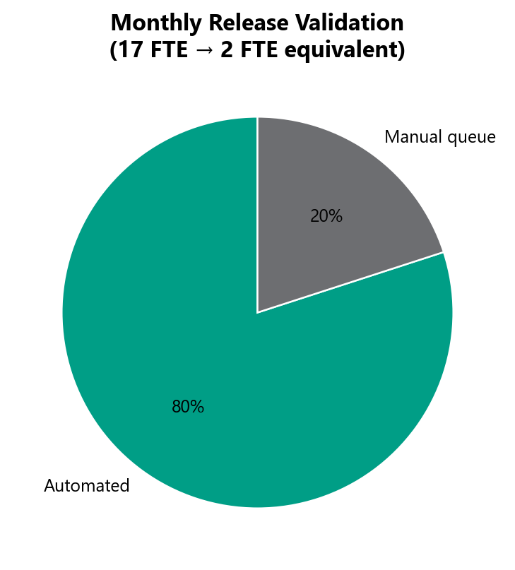
Release validation model

Key takeaways
- ~80% automated
- 17 FTE → 2 FTE equivalent

Appendix A — Data Confidence
Monthly chart = new coverage delivered in each month (period velocity). Scorecard = Stage1 nightly inventory snapshot (~12 mo since Q2 2025; excludes smoke/Stage 2/5/integrations).
- 592 V2 + 442 V3 = Stage1 nightly snapshots (Aug 4) — built since Q2 2025, not in Apr–Aug alone.
- Excludes smoke (Stage 2/5), integration suites, and +33 CSR Actions pending wire — more coverage exists.
- We are NOT claiming 1,212 + 592 + 442 — period delivery vs inventory are different metrics.
- ~1,212 estimated new coverage in Apr–Aug from 225 Jira stories; nightly totals include pre-April foundation.
- Apr–Aug shows acceleration (MSC API sprint Jun–Jul), not greenfield from zero.

Appendix B — Roadmap & Leadership Asks
- Mobile 2 GitLab nightly (QA-1405)
- Mobile 1 master suite completion
- MSC enrollment API automation
- CSR Actions nightly expansion
- Automated monthly dashboard
Leadership asks: (1) engage AM Squad at SDLC start for roadmap visibility; (2) administrative capacity to free technical lead for architecture and AI tooling.

Appendix C — References
- Jira — QA Automation project: https://ascensuscollegesavings.atlassian.net/jira/software/projects/QA
- GitLab — api-test-automation: https://gitlab.com/ascensus-gs/products/depot/qa-automation/api-test-automation
- GitLab — unite-test-automation (V2): https://gitlab.com/ascensus-gs/products/depot/qa-automation/automation
- GitLab — prime-test-automation (V3): https://gitlab.com/ascensus-gs/products/depot/qa-automation/prime-test-automation
- qTest — Automation Unite: https://ascensus.qtestnet.com
- Jenkins — QA performance & nightly regression: jenkinsqant1 (internal QA Jenkins)
Generated August 10, 2026.

