MOBILE 1 API AUTOMATION
Formal Sign-Off & Handover Package
STATUS: COMPLETE
Sign-off date: August 13, 2026
Prepared by: QA Automation (AMSQUAD)
Classification: Internal — Handover to Engineering & Support

Document Control
Document title | Mobile 1 API Automation — Sign-Off & Handover
Version | 2.0 — Final
Sign-off date | August 13, 2026
Evidence baseline | main @ August 2026
Automation repo | ascensus-gs/products/depot/qa-automation/api-test-automation
Knowledge base | qa-automation-kb/programs/unite-msc/api-test-automation
Endpoints automated | 26
Sign-off determination | COMPLETE

1. Executive Summary
Mobile 1 API automation is COMPLETE: 26 endpoint operations automated with 27 TestNG test methods across module regression and smoke suites.
Canonical TestNG automation replaces legacy unite-mobile1 Cucumber/WAR tests. Coverage spans authentication, profile, beneficiary, bank info, biometric, device/push tokens, phone authentication, password change, CSR-as-member, IDP token flows, and member session operations. Shared auth uses MobileServerClient via MobileBaseRequestTest and SQL fixture get.mobile.auth.user.
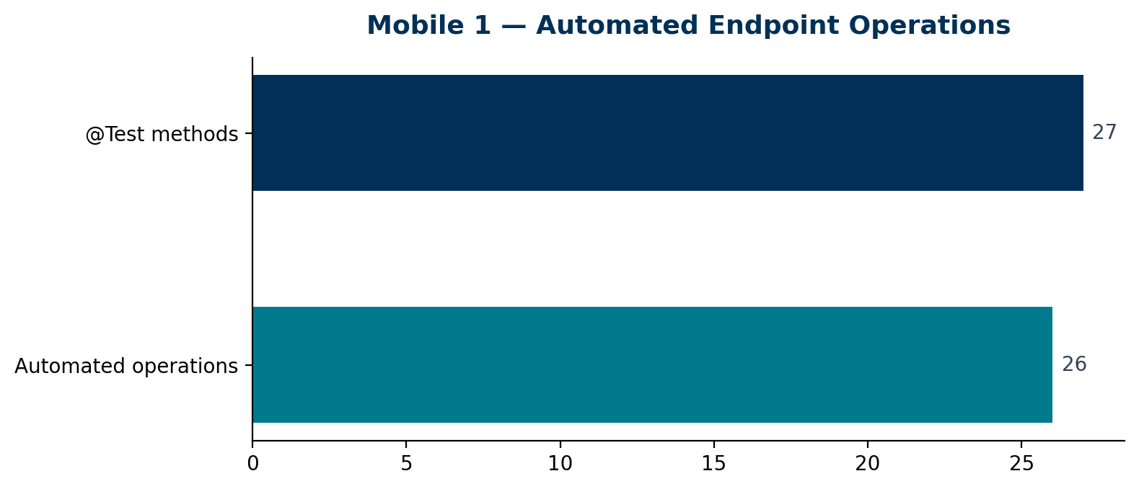
Endpoint operations automated | 26
TestNG @Test methods | 27
Module regression suite XMLs | 15+
Maven profiles | 30+
Validation layers delivered | L1–L4 (lean)
Sign-off determination | COMPLETE

2. Migration Summary
- Legacy source: unite-mobile1 Cucumber features + Postman MSC Mobile Endpoints collection
- New location: api-test-automation/mobile/mobile1/
- Pattern: MobileBaseRequestTest + POJO convertToPOJO + module/integration/regression suite XML
- Auth consolidated to jsonapi-auth MobileServerClient (INFI-8078)
- Destructive flows isolated to mobile1-smoke (password, owner PUT, close account, biometric DELETE)
- IDP flows (nmdirect): idptokenexchange + mobilememberidptoken — QC4 may return 401 on automation JWT

3. Code Coverage & Test Metrics
Note: JaCoCo line coverage applies to framework Java sources, not API endpoint coverage. Endpoint coverage is measured as automated business endpoints / in-scope denominator.
Metric | Value | Notes
Endpoint operations | 26 | Distinct HTTP method + path pairs with canonical tests
Test methods | 27 | Includes multi-branding legs in auth regression
Module suites passing (QC4) | See evidence/regression-runs/ | Per-profile CSV Jul 2026
SQL validation (L5) | Deferred | No guessed DB queries — api-validation KB for future
JaCoCo (framework code) | N/A this package | Endpoint coverage is primary sign-off metric

4. Endpoint Register (Full Mapping)
ID | Method | Path | Area | Test Class | Migration | Master | Notes
M1-01 | POST | /mobile1api/v1/mobilemembersession | Authentication | Mobile1AuthenticationTest | migrated | Y | Auth foundation — 3 test legs (OKD session, OKD username, NMD session)
M1-02 | GET | /mobile1api/v1/mobilememberusername | Authentication | MobileMemberUsernameGetRequestTest | migrated | Y | Runs in mobile1-auth-regression
M1-03 | GET | /mobile1api/v1/mobileowner | Profile | MobileOwnerRequestTest | migrated | Y
M1-04 | GET | /mobile1api/v1/mobileOwnerMenu | Profile | MobileOwnerMenuRequestTest | migrated | Y
M1-05 | GET | /mobile1api/v1/mobileprofilemenu | Profile | MobileProfileMenuRequestTest | migrated | Y
M1-06 | PUT | /mobile1api/v1/mobileowner | Profile | MobileOwnerPutRequestTest | migrated | N | Destructive — smoke suite
M1-07 | GET | /mobile1api/v1/mobilebeneficiaryByExt/{ext} | Beneficiary | MobileBeneficiaryByExtRequestTest | migrated | Y | OKD only in suites
M1-08 | POST | /mobile1api/v1/mobilecloseaccount/{ext} | Beneficiary | MobileCloseAccountPostRequestTest | migrated | Y | preClosureCheck=true
M1-09 | POST | /mobile1api/v1/mobilecloseaccount/{ext} | Beneficiary | MobileActualCloseAccountPostRequestTest | migrated | N | Smoke — NMD only
M1-10 | GET | /mobile1api/v1/mobilebankinfobyroutingnum/{routingNum} | Bank Info | MobileBankInfoByRoutingNumRequestTest | migrated | Y
M1-11 | POST | /mobile1api/v1/mobilememberbiometric | Biometric | MobileMemberBiometricPostRequestTest | migrated | Y
M1-12 | GET | /mobile1api/v1/mobilememberbiometric | Biometric | MobileMemberBiometricGetRequestTest | migrated | Y
M1-13 | DELETE | /mobile1api/v1/mobilememberbiometric | Biometric | MobileMemberBiometricDeleteRequestTest | migrated | N | Smoke only
M1-14 | POST | /mobile1api/v1/requestPhoneNumberAuthentication | Phone Auth | MobileRequestPhoneNumberAuthenticationPostRequestTest | migrated | Y | May trigger SMS outside QC4
M1-15 | POST | /mobile1api/v1/mobilememberdevices | Device | MobileMemberDeviceRequestTest | migrated | Y | 5 tests in class
M1-16 | POST | /mobile1api/v1/mobilememberpushnotificationtokens | Device | MobileMemberDeviceRequestTest | migrated | Y
M1-17 | PUT | /mobile1api/v1/mobilememberpushnotificationtokens | Device | MobileMemberDeviceRequestTest | migrated | Y
M1-18 | GET | /mobile1api/v1/mobilememberpushnotificationtokens/deviceuuid/{deviceUuid} | Device | MobileMemberDeviceRequestTest | migrated | Y
M1-19 | GET | /mobile1api/v1/mobilememberdevices | Device | MobileMemberDeviceRequestTest | migrated | Y
M1-20 | PATCH | /mobile1api/v1/mobilemembers | Password | MobileChangePasswordRequestTest | migrated | N | Uses JSON user id 2
M1-21 | POST | /mobile1api/v1/mobilecsrasmembersession | CSR | MobileCsrAsMemberSessionRequestTest | migrated | Y | INVALID_CREDENTIALS without real token
M1-22 | POST | /mobile1api/v1/idptokenexchange | IDP | MobileIdpTokenExchangeRequestTest | migrated | Y | NMD IDP branding
M1-23 | POST | /mobile1api/v1/mobilememberidptoken | IDP | MobileMemberIdpTokenRequestTest | migrated | Y | QC4 often 401 on automation JWT
M1-24 | GET | /mobile1api/v1/mobilemembersession/{id} | Session | MobileMemberSessionByIdRequestTest | migrated | N | Smoke — SQL user 1
M1-25 | POST | /mobile1api/v1/mobilemembersession/validateBiometricToken | Session | MobileMemberSessionValidateBiometricTokenRequestTest | migrated | N | Functional group
M1-26 | POST | /mobile1api/v1/mobilemembersessionpin | Session | MobileMemberSessionPinRequestTest | migrated | Y | No GET in legacy API

5. How to Run & Troubleshoot
- Parent: mvn -f mobile/pom.xml clean install -DskipTests
- Auth regression: mvn -f mobile/mobile1/pom.xml clean test "-Pacceptance-qc4,mobile1-auth-regression" "-Denvironment.properties=qc4.properties"
- Module example: mvn -f mobile/mobile1/pom.xml clean test "-Pmobile1-memberdevice-regression" "-Denvironment.properties=qc4.properties"
- Smoke (destructive): mvn -f mobile/mobile1/pom.xml clean test "-Pmobile1-smoke" "-Denvironment.properties=qc4.properties"
- Report: mobile/mobile1/target/mobile-ms-report/index.html (module suites with listener)
- Troubleshooting: qa-automation-kb/.../docs/02-daily-usage/04-troubleshooting.md

6. Known Limitations
- CSR-as-member requires optional -Dcsr-as-member-jwt-token for HTTP 200 with real session
- IDP mobilememberidptoken: use -Didp-jwt-token= for live 200 on QC4
- Phone authentication may trigger SMS — pin verification out of scope
- L5 SQL API–DB reconciliation deferred to api-validation program

7. Sign-Off Approval
Mobile 1 API Automation API automation is COMPLETE for the defined scope effective August 13, 2026.
Role | Name | Signature | Date
QA Automation Lead
Program Lead / SME
Engineering Lead
Support / Operations

