MOBILE 2 API AUTOMATION
Formal Sign-Off & Handover Package
STATUS: COMPLETE
Sign-off date: August 13, 2026
Prepared by: QA Automation (AMSQUAD)
Classification: Internal — Handover to Engineering & Support

Document Control
Document title | Mobile 2 API Automation — Sign-Off & Handover
Version | 2.0 — Final
Sign-off date | August 13, 2026
Evidence baseline | main @ August 2026
Automation repo | ascensus-gs/products/depot/qa-automation/api-test-automation
Knowledge base | qa-automation-kb/programs/unite-msc/api-test-automation
Endpoints automated | 24
Sign-off determination | COMPLETE

1. Executive Summary
Mobile 2 API automation is COMPLETE: 24 of 25 documented business endpoints (96.0%). One harness endpoint excluded by design.
Migration from unite-mobile2 Cucumber WAR to lean TestNG suites. Master regression runs OKD (okdirect) and NYD (newyork) brandings. Dashboard intentionally simplified from 8-test regression to lean baseline. 26 TestNG methods across 19+ RequestTest classes.
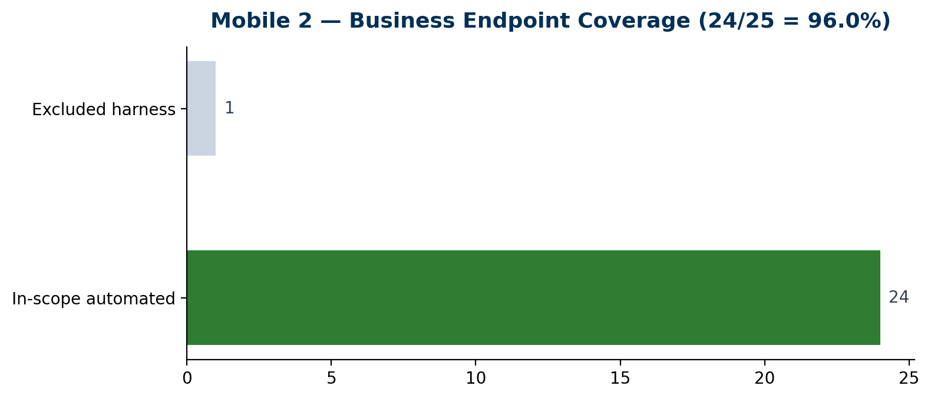
Documented business endpoints | 25
Automated (in-scope) | 24
Coverage percentage | 96.0%
Master regression tests | ~40 (OKD + NYD legs)
Validation layers | L1–L4 lean
Sign-off determination | COMPLETE

2. Migration Summary
- Legacy: unite-mobile2 Cucumber + Postman unite-mobile2 collection
- Canonical: api-test-automation/mobile/mobile2/
- Prerequisite: mvn -f mobile/mobile1/pom.xml install -DskipTests before mobile2 runs
- Master suite: mobile-ms-master-regression — all stable endpoints OKD + NYD
- Destructive: Banks PUT/DELETE and Contribution DELETE excluded from master by design
- Excluded: GET mobilemembers/{planId}/{username} — acceptance harness only

3. Code Coverage & Test Metrics
Note: JaCoCo line coverage applies to framework Java sources, not API endpoint coverage. Endpoint coverage is measured as automated business endpoints / in-scope denominator.
Metric | Value | Notes
Business endpoints (denominator) | 25 | Dinesh Mobile2.xlsx / program scope
Automated in-scope | 24 | Excludes M2-20 harness
QC4 module profiles pass | 20/22 | Contribution profiles had 5 failures Jul 2026 — see evidence logs
Master regression | 40 tests expected | okdirect + newyork branding legs
L5 SQL validation | Deferred | api-validation/mappings YAML exists for future

4. Endpoint Register (Full Mapping)
ID | Method | Path | Area | Test Class | Migration | Master | Notes
M2-01 | GET | /mobile2api/v1/mobileactivity/{ext} | Activity | MobileActivityRequestTest | migrated-simplified | Y | Master regression
M2-02 | GET | /mobile2api/v1/mobiletransactionhistory/{ext} | Transactions | MobileTransactionHistoryRequestTest | migrated-simplified | Y
M2-03 | GET | /mobile2api/v1/investments/{ext} | Investment | MobileInvestmentRequestTest | migrated-simplified | Y
M2-04 | GET | /mobile2api/v1/mobilebanks | Banks | MobileBanksRequestTest | migrated | Y | OKD only
M2-05 | GET | /mobile2api/v1/mobilebanks/{id} | Banks | MobileBanksRequestTest | migrated | Y
M2-06 | POST | /mobile2api/v1/mobilebanks | Banks | MobileBanksRequestTest | migrated | Y
M2-07 | PUT | /mobile2api/v1/mobilebanks | Banks | MobileBanksRequestTest | migrated | N | Excluded from master
M2-08 | DELETE | /mobile2api/v1/mobilebanks | Banks | MobileBanksRequestTest | migrated | N | Excluded from master
M2-09 | GET | /mobile2api/v1/content | Content | MobileContentRequestTest | migrated-simplified | Y
M2-10 | GET | /mobile2api/v1/plans | Plans | MobilePlansRequestTest | migrated | Y
M2-11 | GET | /mobile2api/v1/plans/{id} | Plans | MobilePlansRequestTest | migrated | Y
M2-12 | GET | /mobile2api/v1/mobilecontribution | Contribution | MobileContributionRequestTest | migrated | Y
M2-13 | GET | /mobile2api/v1/mobilecontributioncheck | Contribution | MobileContributionCheckRequestTest | migrated | Y
M2-14 | GET | /mobile2api/v1/mobilecontribution/{ext}/{id} | Contribution | MobileContributionDetailRequestTest | migrated | Y | Stage1 fixture caveat
M2-15 | POST | /mobile2api/v1/mobilecontribution | Contribution | MobileContributionPostRequestTest | migrated | Y
M2-16 | PUT | /mobile2api/v1/mobilecontribution/{ext}/{id} | Contribution | MobileContributionPutRequestTest | migrated | Y
M2-17 | DELETE | /mobile2api/v1/mobilecontribution/{ext}/{id} | Contribution | MobileContributionDeleteRequestTest | migrated | N | OKD module only; not master
M2-18 | GET | /mobile2api/v1/mobiledashboard | Dashboard | MobileDashboardRequestTest | migrated-simplified | Y | Reference case study
M2-19 | GET | /mobile2api/v1/mobileytdsummary/{ext} | Dashboard | MobileYtdSummaryRequestTest | migrated | N | Master + smoke
M2-20 | GET | /mobile2api/v1/mobilemembers/{planId}/{username} | Harness | MobileMembersRequestTest | excluded | N | Out of business numerator
M2-21 | GET | /mobile2api/v1/mobilebalancetrend/{ext} | Balance | MobileBalanceTrendRequestTest | migrated-simplified | Y
M2-22 | GET | /mobile2api/v1/mobileperformance/{ext} | Performance | MobilePerformanceRequestTest | migrated-simplified | Y
M2-23 | GET | /mobile2api/v1/mobilestackup/{planId} | Stackup | MobileStackupRequestTest | migrated-simplified | N | Duplicate class in 2 packages
M2-24 | GET | /mobile2api/v1/mobileugift | UGift | MobileUgiftRequestTest | migrated | Y
M2-25 | PATCH | /mobile2api/v1/mobileugift/{ext} | UGift | MobileUgiftRequestTest | migrated | Y

5. How to Run & Troubleshoot
- mvn -f mobile/mobile1/pom.xml install -DskipTests # always first
- mvn -f mobile/mobile2/pom.xml test "-Pmobile-ms-master-regression,acceptance-qc4" "-Dmobile.ms.report.environment=QC4"
- Stage1: add acceptance-stage1 + <COMPUTERNAME>.properties host file
- Batch QC4: programs/unite-msc/api-test-automation/scripts/run-qc4-all-suites.ps1
- Nexus/GitHub: docs/04-pipelines/02-github-actions-nexus-pipeline.md

6. Known Limitations
- Contribution module: 5 failing legs in Jul 2026 QC4 batch — investigate fixture/data
- Stage1 contribution detail/PUT may 401 without fixture refresh
- Banks module: okdirect only — not run under NMD/NYD in master
- Dashboard lean test defers 6 of 8 legacy assertion groups — documented in dashboard coverage matrix

7. Sign-Off Approval
Mobile 2 API Automation API automation is COMPLETE for the defined scope effective August 13, 2026.
Role | Name | Signature | Date
QA Automation Lead
Program Lead / SME
Engineering Lead
Support / Operations

