UNITE MSC
Automation Scope Alignment
July 23, 2026
Audience: Rajib, Henry
Prepared by: QA Automation (AMSQUAD)
Follow-up to Jul 17 bi-weekly leadership sync

1. Meeting Purpose
Align with Rajib and Henry on Unite MSC automation scope — especially SQL validation depth, environment strategy (QC4 vs Stage 1), and what constitutes 'complete' for Mobile 2 and Mobile 1.
Henry raised that SQL API–DB validation could significantly expand scope. This document separates what is delivered today (L1–L4) from optional enhancement work (L5), and proposes a hybrid environment approach while QC4 remains unstable.
- Decisions needed today:
- Confirm L1–L4 as the Mobile 2 sign-off bar (no L5 required for 'complete')
- If L5 is desired — choose pilot (dashboard) vs full program
- Confirm hybrid Stage 1 strategy for functional + performance evidence
- Identify SMEs for sign-off and production-like performance criteria
- Confirm strategic direction and reusability expectations for MSC API automation

2. Program Status — Updated Jul 23
Mobile 2 is COMPLETE at 24/25 (96.0%) business endpoints. Mobile 1 is IN PROGRESS at 6/27 (22.2%).
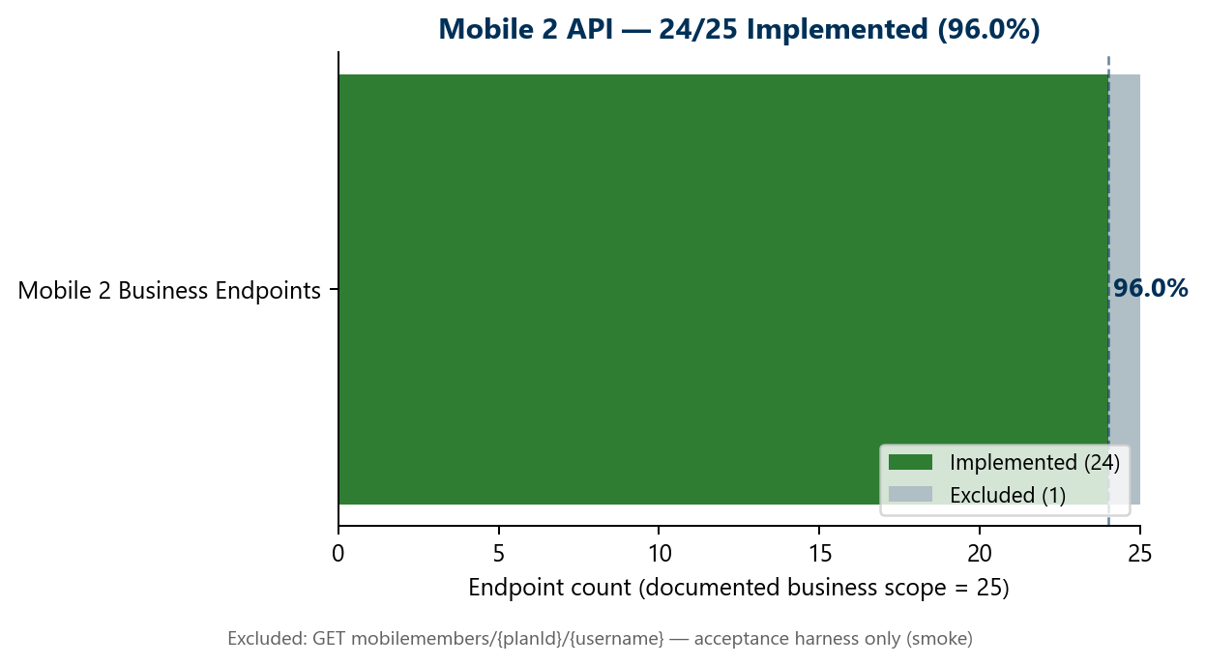
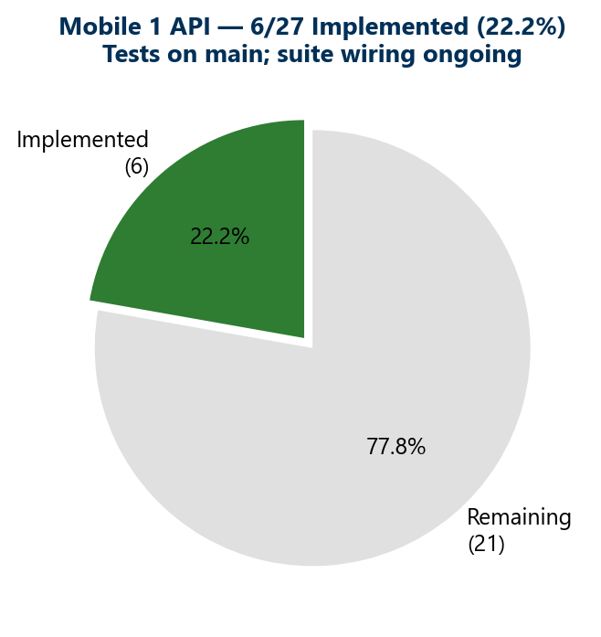
Track | Implemented | Scope | Status
Mobile 2 API | 24/25 | 96.0% | COMPLETE — sign-off path
Mobile 1 API | 6/27 | 22.2% | IN PROGRESS — tests on main
Performance (MSC) | 1 flow live | Stage 1 | Expanding — Stage 1 only
Pipeline (GHA) | Dashboard slice | — | Module suites in progress
Counting rule: Endpoint is 'implemented' when canonical test class exists on main — even if not yet wired to master regression suite (weekly hygiene adds suite links).

3. API Validation — Scope Clarification
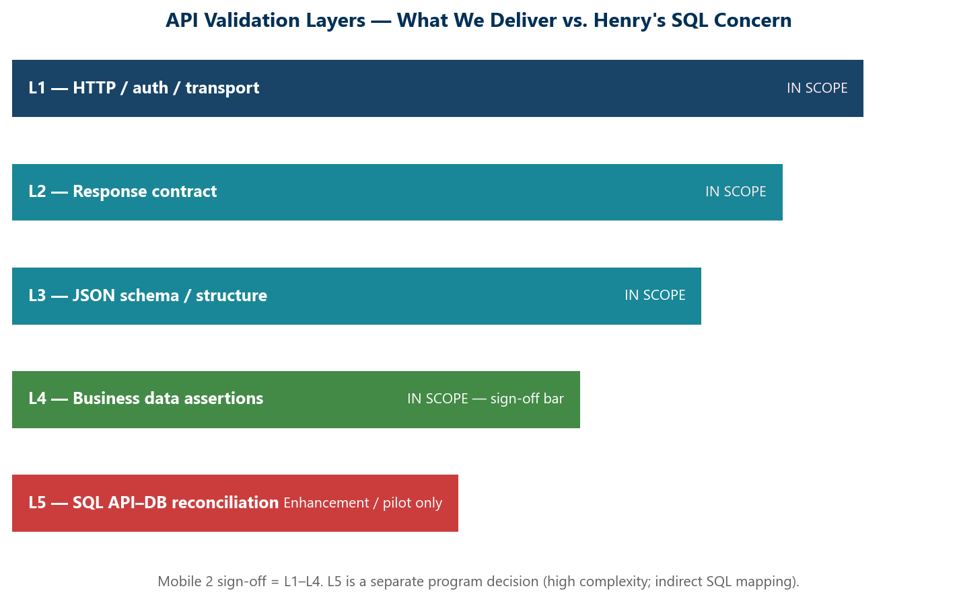
Layer | What it validates | Mobile 2 status | Sign-off?
L1 HTTP / Auth | Status codes, session/token, transport errors | Delivered | Yes
L2 Response contract | Content-type, JSON parse, error payloads | Delivered | Yes
L3 Schema / structure | JSON schema, required fields, types | Delivered | Yes
L4 Business assertions | Field values, business rules, branding | Delivered | Yes
L5 SQL API–DB | JDBC compare to API JSON via field maps | Not delivered | Decision needed

Why L5 SQL is complex for Unite MSC
- Mobile APIs are BFF-layer — data is assembled from multiple SQL sources, not 1:1 endpoint-to-query
- Developers (Mizar, Luis) confirmed indirect mapping is difficult even for app team
- Computed fields (totalBalance, displayInStackup, regType display names) require BFF logic replication
- Some fields are on-prem only or external (CMS content) — no SQL compare possible
- L5 is valuable as a pilot/enhancement — but it is a separate multi-sprint program, not a sign-off blocker
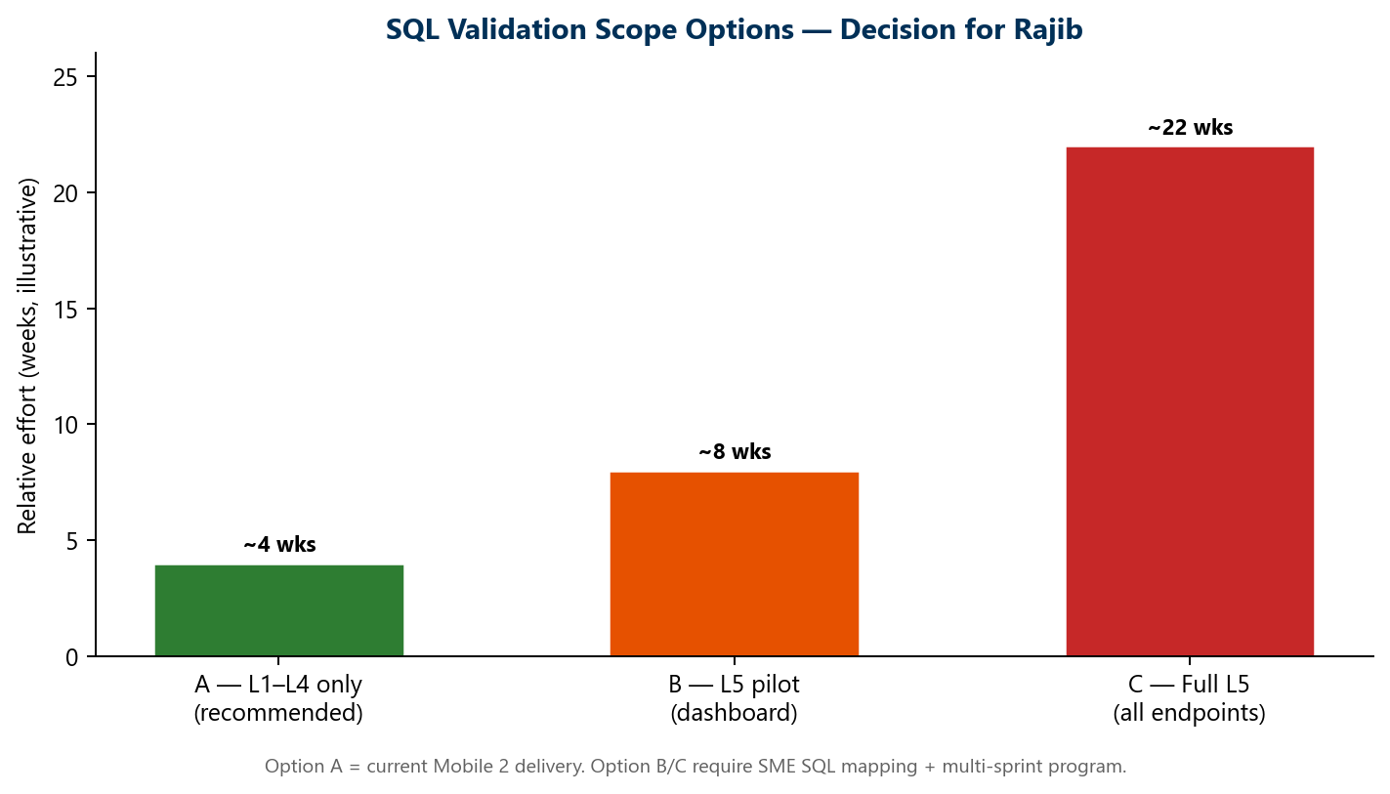

4. Hybrid Environment Strategy
QC4 is currently unstable due to team dependencies (OKD disabled during Stage 1 migration). We use Stage 1 as the primary execution environment for design, test, sign-off, and performance.
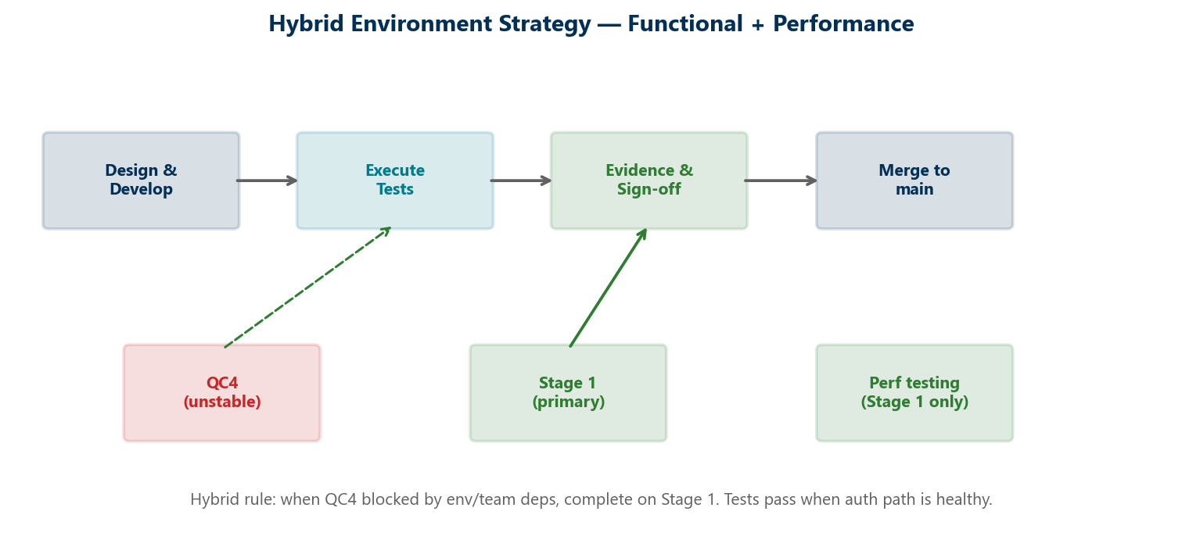
Environment | Functional tests | Performance | Notes
QC4 | When stable | Not primary | Some OKD failures env-specific; NMD paths work
Stage 1 | Primary | Primary (Priti) | Verified Jul 22 — tests pass when auth healthy
Stage 5 / 2 | Future | TBD | Framework supports via Maven profiles
Production-like load | N/A | Stage 1 | 25-user baseline; SME criteria pending

5. Mobile 2 — Delivery Summary
All 24 business endpoints have canonical TestNG tests on main. 1 harness endpoint excluded by design.
Framework: Canonical TestNG — shared auth, HTML reports, OKD/NMD branding, module + master suites
Dashboard: mobiledashboard + mobileytdsummary — complete
Banks: List, GET-by-id, POST on master; PUT/DELETE smoke-only (destructive)
Contribution: 6 endpoints; DELETE module-only; detail/PUT Stage 1 fixture known
Content / Plans / Activity / Investment / Balance / UGift: Complete on master regression
Excluded: GET mobilemembers/{planId}/{username} — acceptance harness (smoke only)
Evidence: Stage 1 execution verified Jul 22; QC4 re-run when env stable

6. Mobile 1 — Delivered So Far
Endpoint | Test class | Status
POST mobilemembersession | Mobile1AuthenticationTest | Complete — auth foundation
GET mobileowner | MobileOwnerRequestTest | Implemented on main
GET mobileOwnerMenu | MobileOwnerMenuRequestTest | Implemented on main
GET mobileprofilemenu | MobileProfileMenuRequestTest | Implemented on main
GET mobilebeneficiaryByExt/{ext} | MobileBeneficiaryByExtRequestTest | Implemented on main
GET mobilebankinfobyroutingnum/{routingNum} | MobileBankInfoByRoutingNumRequestTest | Implemented on main

7. Performance Testing — Stage 1 Approach
- Priti directed to Stage 1 only — stable, production-like load possible
- Regulations + DoD established from scratch; nightly Jenkins regression live (weekdays)
- Baseline: 25 users; BlazeMeter reports; SME input needed for production-like criteria
- Henry offered to help identify owner for performance success criteria
- Expansion: Dashboard → Contribution → Banks → Activity flows

8. Decisions & Next Steps
# | Decision / Action | Owner
1 | Confirm L1–L4 as Mobile 2 sign-off bar (no L5 required) | Rajib / Henry
2 | If L5 desired — approve pilot scope (dashboard only) or defer | Rajib
3 | Approve hybrid Stage 1 strategy while QC4 unstable | Rajib / Henry
4 | Identify SMEs for Mobile 2 sign-off + perf criteria | Henry / Rajib
5 | Confirm MSC automation strategic direction & reusability | Rajib

Appendix — Jul 17 Open Questions Carried Forward
- Value and reusability of United MSC API automation
- SQL validation depth and approach
- SME input for performance metrics and success criteria
- SME identification for sign-off
- Framework focus pending Rajib input

