MOBILE 2 API AUTOMATION
Formal Sign-Off Certificate
STATUS: COMPLETE
Unite MSC — Mobile 2 API Test Automation
July 23, 2026
Prepared by: QA Automation (AMSQUAD)
Classification: Internal

Document Control
Document title | Mobile 2 API Automation — Sign-Off Certificate
Version | 1.0 — Final
Sign-off date | July 23, 2026
Program | Unite MSC Mobile 2 API Automation
Evidence baseline | Commit cee0de9 on main branch
Prior baseline | July 14, 2026 — 22/25 endpoints (88%) @ 7ccaf46
Status | COMPLETE — 24/25 business endpoints (96%)

1. Executive Summary
Mobile 2 API automation is COMPLETE for the defined business scope: 24 of 25 documented business endpoints (96.0%) have canonical automated tests on the main branch.
This sign-off certifies delivery of the Mobile 2 canonical TestNG automation framework, endpoint test coverage, master and module regression suites, OKD/NMD branding support, and API validation through Layer 4 (business data assertions). One harness-only endpoint is intentionally excluded from the business automation numerator.
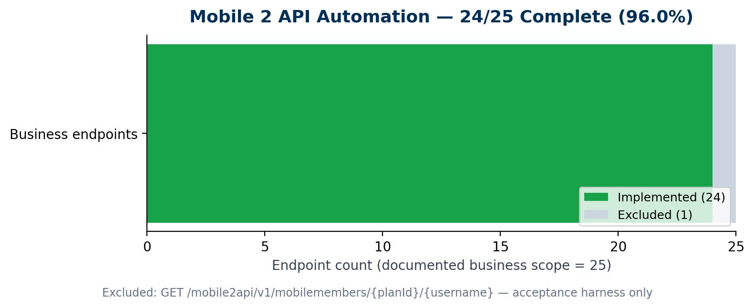
Documented business endpoints | 25
Automated (business scope) | 24
Coverage percentage | 96.0%
Excluded (by design) | 1 — acceptance harness endpoint
Sign-off determination | COMPLETE

2. Scope Definition
- In scope: All documented Mobile 2 business API endpoints under /mobile2api/v1 (denominator = 25).
- Automation type: Canonical TestNG API tests with HTTP, schema, and business assertions (L1–L4).
- Branding: OKD (okdirect) and NMD (nmdirect / newyork) session paths supported.
- Environments: QC4 and Stage 1 via Maven acceptance profiles.
- Out of scope for this sign-off: SQL API–DB reconciliation (L5), Enrollment API, Mobile 1 business endpoints.

Excluded endpoint (intentional)
GET /mobile2api/v1/mobilemembers/{planId}/{username} — Acceptance/harness helper used for member lookup in test flows. Smoke test exists but endpoint is excluded from the business automation numerator by approved scope definition.

3. Sign-Off Criteria — All Met
# | Criterion | Status
1 | Canonical TestNG framework on main branch | MET
2 | 24/25 business endpoints have automated tests | MET
3 | Master regression suite wires stable endpoints (OKD + NMD) | MET
4 | L1–L4 API validation (HTTP, contract, schema, business assertions) | MET
5 | Module regression suites per functional area | MET
6 | HTML test reporting and Maven profile execution | MET
7 | Dashboard + YTD summary endpoints automated | MET
8 | Documented exclusions and destructive-test placement | MET

4. Endpoint Register
ID | Method | Path | Area | Status | Regression placement
M2-01 | GET | /mobile2api/v1/mobileactivity/{ext} | Activity | Complete | Master regression
M2-02 | GET | /mobile2api/v1/mobiletransactionhistory/{ext} | Transactions | Complete | Master regression
M2-03 | GET | /mobile2api/v1/investments/{ext} | Investment | Complete | Master regression
M2-04 | GET | /mobile2api/v1/mobilebanks | Banks | Complete | Master regression
M2-05 | GET | /mobile2api/v1/mobilebanks/{id} | Banks | Complete | Master regression
M2-06 | POST | /mobile2api/v1/mobilebanks | Banks | Complete | Master regression
M2-07 | PUT | /mobile2api/v1/mobilebanks | Banks | Complete | Smoke / module only (destructive)
M2-08 | DELETE | /mobile2api/v1/mobilebanks | Banks | Complete | Smoke / module only (destructive)
M2-09 | GET | /mobile2api/v1/content | Content | Complete | Master regression
M2-10 | GET | /mobile2api/v1/plans | Plans | Complete | Master regression
M2-11 | GET | /mobile2api/v1/plans/{id} | Plans | Complete | Master regression
M2-12 | GET | /mobile2api/v1/mobilecontribution | Contribution | Complete | Master regression
M2-13 | GET | /mobile2api/v1/mobilecontributioncheck | Contribution | Complete | Master regression
M2-14 | GET | /mobile2api/v1/mobilecontribution/{ext}/{id} | Contribution | Complete | Master regression; Stage 1 fixture note
M2-15 | POST | /mobile2api/v1/mobilecontribution | Contribution | Complete | Master regression
M2-16 | PUT | /mobile2api/v1/mobilecontribution/{ext}/{id} | Contribution | Complete | Master regression; Stage 1 fixture note
M2-17 | DELETE | /mobile2api/v1/mobilecontribution/{ext}/{id} | Contribution | Complete | Module only (destructive)
M2-18 | GET | /mobile2api/v1/mobiledashboard | Dashboard | Complete | Master regression
M2-19 | GET | /mobile2api/v1/mobileytdsummary/{ext} | Dashboard | Complete | Master + smoke regression
M2-20 | GET | /mobile2api/v1/mobilemembers/{planId}/{username} | Harness | Excluded | Acceptance harness — out of business scope
M2-21 | GET | /mobile2api/v1/mobilebalancetrend/{ext} | Balance | Complete | Master regression
M2-22 | GET | /mobile2api/v1/mobileperformance/{ext} | Performance | Complete | Master regression
M2-23 | GET | /mobile2api/v1/mobilestackup/{planId} | Stackup | Complete | Master regression
M2-24 | GET | /mobile2api/v1/mobileugift | UGift | Complete | Master regression
M2-25 | PATCH | /mobile2api/v1/mobileugift/{ext} | UGift | Complete | Master regression

5. Validation Standard Delivered
Layer | Description | Delivered
L1 — HTTP / Auth | Status codes, session tokens, transport and auth errors | Yes
L2 — Response contract | Content-type, JSON parsing, error payloads | Yes
L3 — Schema / structure | JSON schema validation, required fields, types | Yes
L4 — Business assertions | Field values, business rules, branding-specific checks | Yes
L5 — SQL API–DB | JDBC reconciliation against API JSON | Out of scope

6. Framework & Program Deliverables
- Migration from legacy Cucumber to canonical TestNG framework
- Shared authentication module with dynamic SQL credential loading (OKD + NMD)
- 19 Mobile 2 RequestTest classes covering all business functional areas
- 25 TestNG suite XML definitions and 30+ Maven execution profiles
- Master regression suite (OKD + NMD branding runs)
- Module regression suites per area (activity, banks, contribution, dashboard, etc.)
- Smoke suite for destructive operations (PUT/DELETE banks) and harness endpoints
- HTML reporting integration for test execution evidence
- Dashboard automation including YTD summary endpoint
- Custom reporting design for leadership and program metrics
- GitHub Actions pipeline — Dashboard vertical slice validated
- Performance regression foundation on Stage 1 (separate track)

7. Environment & Execution Evidence
Hybrid environment approach: Stage 1 is the primary execution environment for sign-off evidence while QC4 has team dependencies. Tests pass when authentication path is healthy.
Environment | Status | Notes
Stage 1 | Primary evidence | Execution verified July 22, 2026 — NMD paths confirmed
QC4 | Secondary | Re-run when environment stable; some OKD failures are env-specific
OKD branding | Supported | okdirect session path in master suite
NMD branding | Supported | nmdirect / newyork session path in master suite

Prior baseline progression
July 14, 2026 baseline: 22 of 25 endpoints (88%) verified at commit 7ccaf46. Subsequent delivery added YTD summary and Banks GET-by-id endpoints, bringing coverage to 24/25 (96.0%) at commit cee0de9.

8. Known Limitations (Documented — Not Sign-Off Blockers)
Item | Description
Destructive tests | PUT/DELETE banks and DELETE contribution run in smoke/module suites only — excluded from master by design
Contribution detail/PUT | Stage 1 env-specific test-data fixture may return 401; QC4 fixture available
Harness endpoint | mobilemembers excluded from business numerator — smoke coverage only
GitLab nightly job | Recurring scheduled regression — follow-up DevOps item (QA-1405)

9. Explicitly Out of Scope
- L5 SQL API–DB reconciliation (separate enhancement program if leadership approves)
- Mobile 1 API business endpoint migration (active program — separate sign-off)
- Enrollment API automation (future multi-sprint program)
- Full GitLab nightly Mobile 2 regression scheduling (follow-up item)

10. Sign-Off Approval
Mobile 2 API automation is hereby marked COMPLETE for the defined business scope (24/25 endpoints, 96.0%) effective July 23, 2026.

Role | Name | Signature | Date
QA Automation Lead
Program Lead / SME
Engineering Lead
Leadership Approval

Certification statement: The undersigned confirm that Mobile 2 API automation meets the sign-off criteria defined in Section 3, with documented exclusions in Sections 2 and 8, and validation through Layer 4 as the approved completion standard.

