UNITE MSC
Automation Scope Alignment
July 23, 2026
Audience: Leadership
Prepared by: QA Automation (AMSQUAD)
Follow-up to Jul 17 bi-weekly leadership sync

Table of Contents
- 1. Meeting Purpose
- 2. Program Status
- 3. API Validation — Scope Clarification
- 4. SQL Validation — Discussion Topic
- 5. Hybrid Environment Strategy
- 6. Mobile 2 — Delivery Summary
- 7. Mobile 1 — Delivered So Far
- 8. Performance Testing — Stage 1 Approach
- 9. Decisions & Next Steps
- Appendix A — SQL Scope Options (discussion reference)
- Appendix B — Jul 17 Open Questions

1. Meeting Purpose
Align leadership on Unite MSC automation scope — especially SQL validation depth, environment strategy (QC4 vs Stage 1), and what constitutes 'complete' for Mobile 2 and Mobile 1.
The Jul 17 bi-weekly raised that SQL API–DB validation could significantly expand scope. This document separates what is delivered today (L1–L4) from optional enhancement work (L5), and documents the hybrid environment approach while QC4 remains unstable.

Decisions needed
- Confirm L1–L4 as the Mobile 2 sign-off bar (no L5 required for 'complete')
- If L5 is desired — choose pilot (dashboard) vs full program vs defer
- Confirm hybrid Stage 1 strategy for functional + performance evidence
- Identify SMEs for sign-off and production-like performance criteria
- Confirm strategic direction and reusability expectations for MSC API automation

2. Program Status — Updated Jul 23
Mobile 2 is COMPLETE at 24/25 (96.0%) business endpoints. Mobile 1 is IN PROGRESS at 6/27 (22.2%).
Mobile 2 | Mobile 1 | Sign-off bar | Primary environment
24/25 (96.0%) | 6/27 (22.2%) | L1–L4 | Stage 1

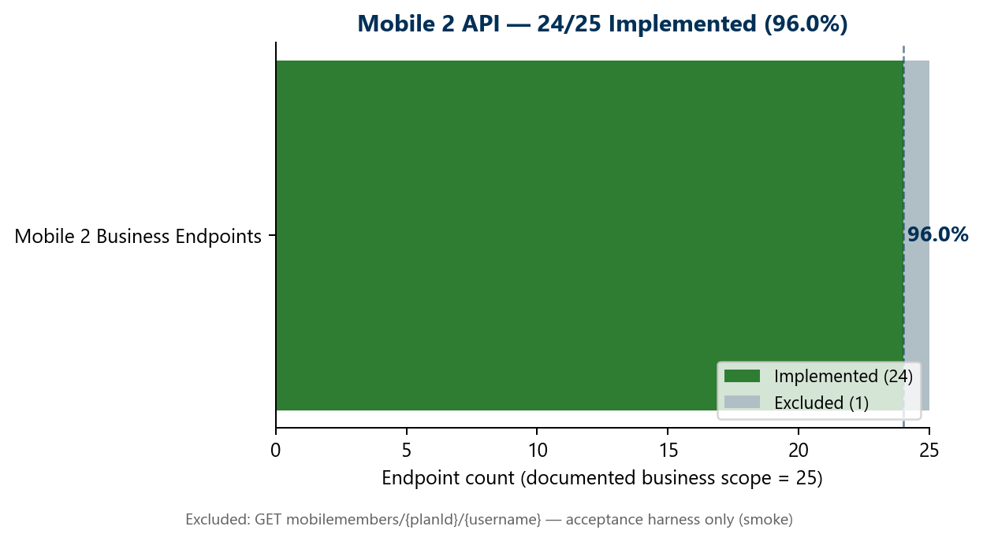
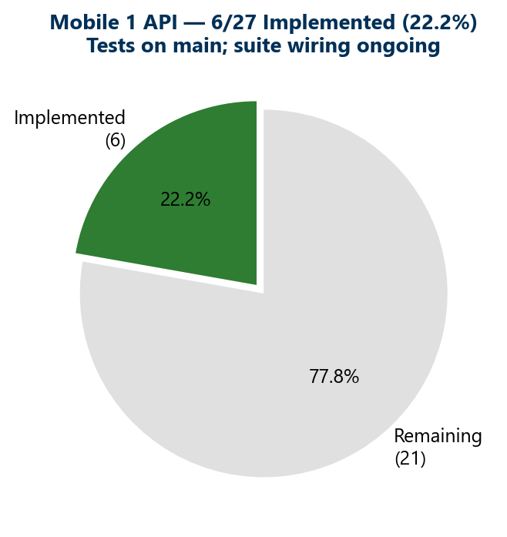
Track | Implemented | Scope | Status
Mobile 2 API | 24/25 | 96.0% | COMPLETE — sign-off path
Mobile 1 API | 6/27 | 22.2% | IN PROGRESS — tests on main
Performance (MSC) | 1 flow live | Stage 1 | Expanding — Stage 1 only
Pipeline (GHA) | Dashboard slice | — | Module suites in progress
Counting rule: Endpoint is 'implemented' when canonical test class exists on main — even if not yet wired to master regression suite (weekly hygiene adds suite links).

3. API Validation — Scope Clarification
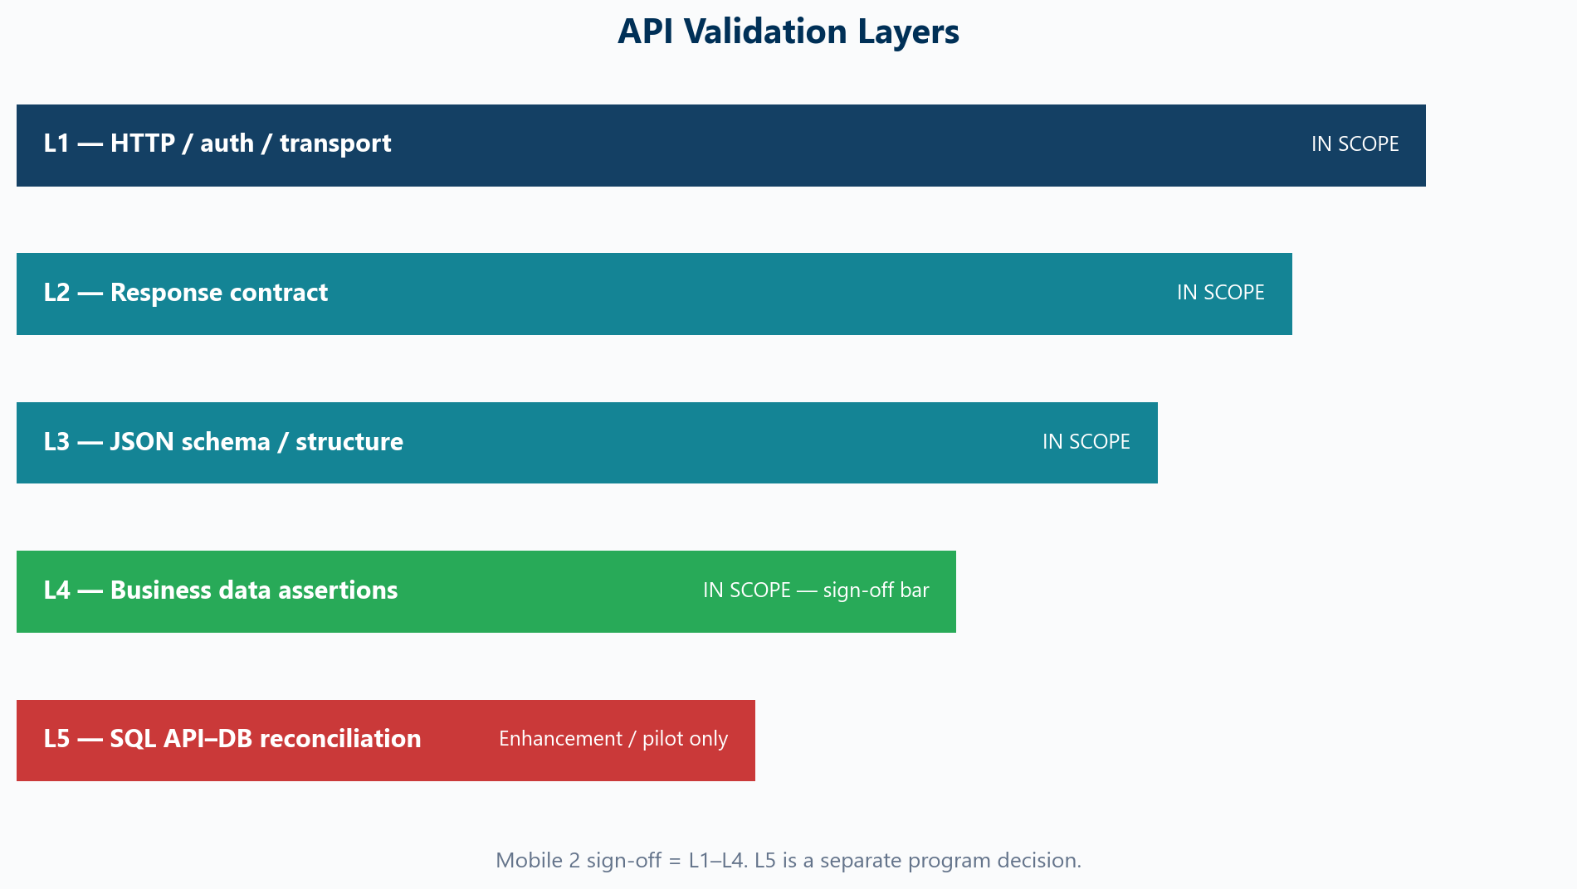
Layer | What it validates | Mobile 2 status | Sign-off?
L1 HTTP / Auth | Status codes, session/token, transport errors | Delivered | Yes
L2 Response contract | Content-type, JSON parse, error payloads | Delivered | Yes
L3 Schema / structure | JSON schema, required fields, types | Delivered | Yes
L4 Business assertions | Field values, business rules, branding | Delivered | Yes
L5 SQL API–DB | JDBC compare to API JSON via field maps | Not delivered | Decision needed

Why L5 SQL is complex for Unite MSC
- Mobile APIs are BFF-layer — data is assembled from multiple SQL sources, not 1:1 endpoint-to-query
- Application team also confirmed indirect mapping is difficult
- Computed fields (totalBalance, displayInStackup, regType display names) require BFF logic replication
- Some fields are on-prem only or external (CMS content) — no SQL compare possible
- L5 is valuable as a pilot/enhancement — but it is a separate multi-sprint program, not a sign-off blocker

4. SQL Validation — Discussion Topic
Scope options chart is retained as Appendix A for verbal discussion — it is not included in the presentation deck.
- Current delivery: HTTP + schema + business assertions (L1–L4)
- L5 SQL API–DB compare = JDBC queries mapped to API JSON fields
- Unite MSC BFF layer makes 1:1 SQL mapping very difficult
- Development team also struggles with indirect SQL-to-endpoint mapping
- Recommendation: L5 as optional pilot — NOT a Mobile 2 blocker
- Leadership to decide: defer L5, pilot on dashboard only, or approve full L5 program

5. Hybrid Environment Strategy
QC4 is currently unstable due to team dependencies (OKD disabled during Stage 1 migration). We use Stage 1 as the primary execution environment for design, test, sign-off, and performance.
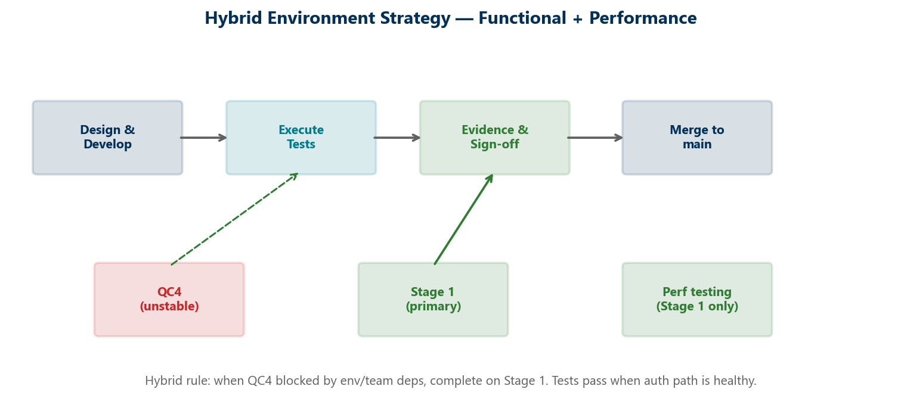
Environment | Functional tests | Performance | Notes
QC4 | When stable | Not primary | Some OKD failures env-specific; NMD paths work
Stage 1 | Primary | Primary | Verified Jul 22 — tests pass when auth healthy
Stage 5 / 2 | Future | TBD | Framework supports via Maven profiles
Production-like load | N/A | Stage 1 | 25-user baseline; SME criteria pending

6. Mobile 2 — Delivery Summary
All 24 business endpoints have canonical TestNG tests on main. 1 harness endpoint excluded by design.
Framework: Canonical TestNG — shared auth, HTML reports, OKD/NMD branding, module + master suites
Dashboard: mobiledashboard + mobileytdsummary — complete
Banks: List, GET-by-id, POST on master; PUT/DELETE smoke-only (destructive)
Contribution: 6 endpoints; DELETE module-only; detail/PUT Stage 1 fixture known
Content / Plans / Activity / Investment / Balance / UGift: Complete on master regression
Excluded: GET mobilemembers/{planId}/{username} — acceptance harness (smoke only)
Evidence: Stage 1 execution verified Jul 22; QC4 re-run when env stable

7. Mobile 1 — Delivered So Far
Endpoint | Test class | Status
POST mobilemembersession | Mobile1AuthenticationTest | Complete — auth foundation
GET mobileowner | MobileOwnerRequestTest | Implemented on main
GET mobileOwnerMenu | MobileOwnerMenuRequestTest | Implemented on main
GET mobileprofilemenu | MobileProfileMenuRequestTest | Implemented on main
GET mobilebeneficiaryByExt/{ext} | MobileBeneficiaryByExtRequestTest | Implemented on main
GET mobilebankinfobyroutingnum/{routingNum} | MobileBankInfoByRoutingNumRequestTest | Implemented on main
Remaining: 21 endpoints in active migration.

8. Performance Testing — Stage 1 Approach
- Stage 1 only — stable, production-like load possible
- Regulations + DoD established from scratch; nightly Jenkins regression live (weekdays)
- Baseline: 25 users; BlazeMeter reports
- SME input needed for production-like success criteria
- Expansion path: Dashboard → Contribution → Banks → Activity flows

9. Decisions & Next Steps
# | Decision / Action | Owner
1 | Confirm L1–L4 as Mobile 2 sign-off bar (no L5 required) | Leadership
2 | If L5 desired — approve pilot scope (dashboard only) or defer | Leadership
3 | Approve hybrid Stage 1 strategy while QC4 unstable | Leadership
4 | Identify SMEs for Mobile 2 sign-off + perf criteria | Program SMEs
5 | Confirm MSC automation strategic direction & reusability | Leadership

Appendix A — SQL Scope Options (Discussion Reference)
This chart supports verbal discussion only. It is not included in the presentation deck.
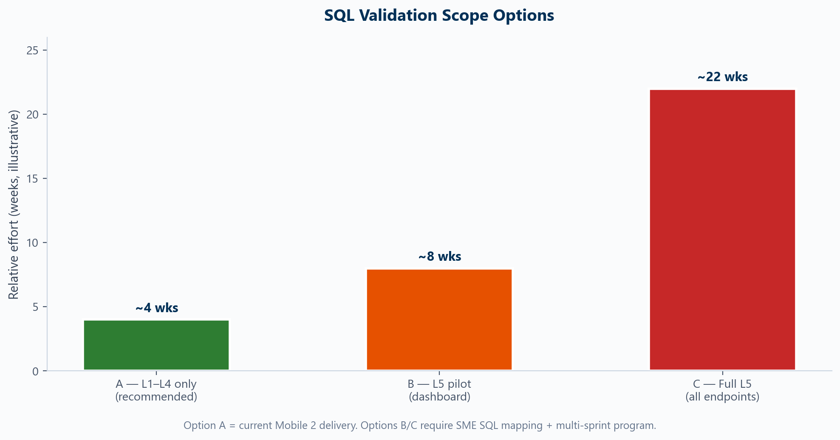
Option | Scope | Relative effort
A (recommended) | L1–L4 only — current Mobile 2 delivery | ~4 weeks
B | L5 pilot — dashboard endpoint only | ~8 weeks
C | Full L5 — all endpoints | ~22 weeks

Appendix B — Jul 17 Open Questions Carried Forward
- Value and reusability of United MSC API automation
- SQL validation depth and approach
- SME input for performance metrics and success criteria
- SME identification for sign-off
- Framework focus and strategic direction

