UNITE MSC
Automation Program — Leadership Update

July 17, 2026
Audience: Rajiv/Rajib, Henry, Kevin
Prepared by: QA Automation (AMSQUAD)
Classification: Internal — Leadership

Table of Contents
- 1. Executive Summary
- 2. Program Metrics at a Glance
- 3. Mobile 2 — Sign-Off Readiness
- 4. Mobile 1 — Active Sprint Focus
- 5. Pipeline & CI/CD Workflow
- 6. Performance Regression
- 7. V2/V3 UI Automation
- 8. Team Contributions & Kudos
- 9. Risks & Dependencies
- 10. Leadership Asks
- 11. Roadmap
- Appendix — Sources & TBD Items

1. Executive Summary
The Unite MSC automation program has moved from fragmented legacy Cucumber into a reusable, scalable canonical framework across Mobile APIs, UI regression, performance testing, and pipeline readiness.
Mobile 2 API: Baseline functionally complete — ready for formal sign-off pending MR merge and refreshed QC4/Stage 1 evidence.
Mobile 1 API: Active sprint focus — authentication foundation complete on main.
IDP coverage: New capability in canonical framework (not in legacy baseline).
Performance: Foundation established — MSC non-IDP Jenkins job live.
Pipeline: GHA Dashboard slice complete; GitLab nightly not yet created.

2. Program Metrics at a Glance
Verified metrics are cited with source date; projected values require re-run (see Appendix).
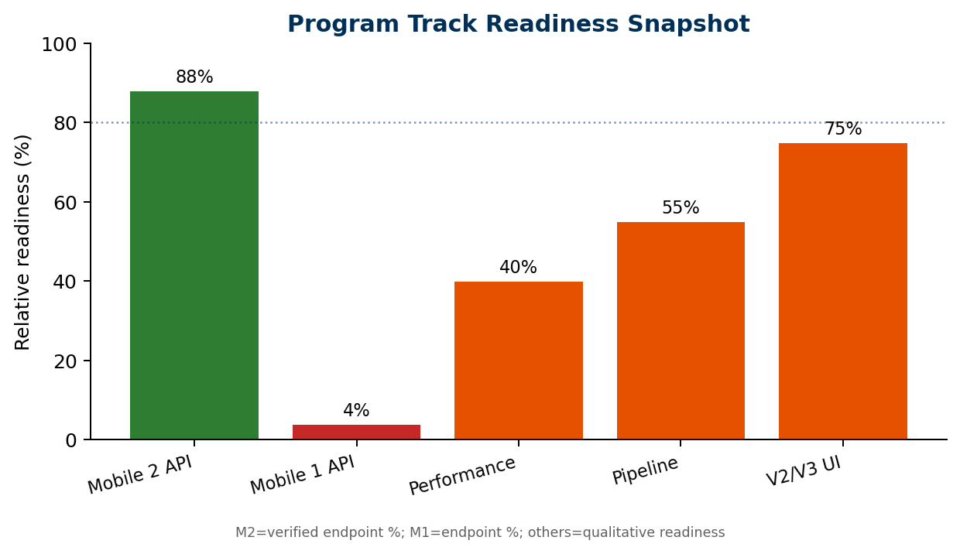
Track | Status | RAG
Mobile 2 API | 88% endpoints verified — sign-off path | 88% endpoints verified — sign-off path
Mobile 1 API | Auth done — business migration in sprint | Auth done — business migration in sprint
Performance | Jenkins foundation — flows expanding | Jenkins foundation — flows expanding
Pipeline | GHA slice done — nightly pending | GHA slice done — nightly pending
V2/V3 UI | Nightly stable — daily triage continues | Nightly stable — daily triage continues
Enrollment API | Next major program — multi-sprint | Next major program — multi-sprint

3. Mobile 2 — Sign-Off Readiness
READY FOR REVIEW — Conditional sign-off per sign-off package (2026-07-14).
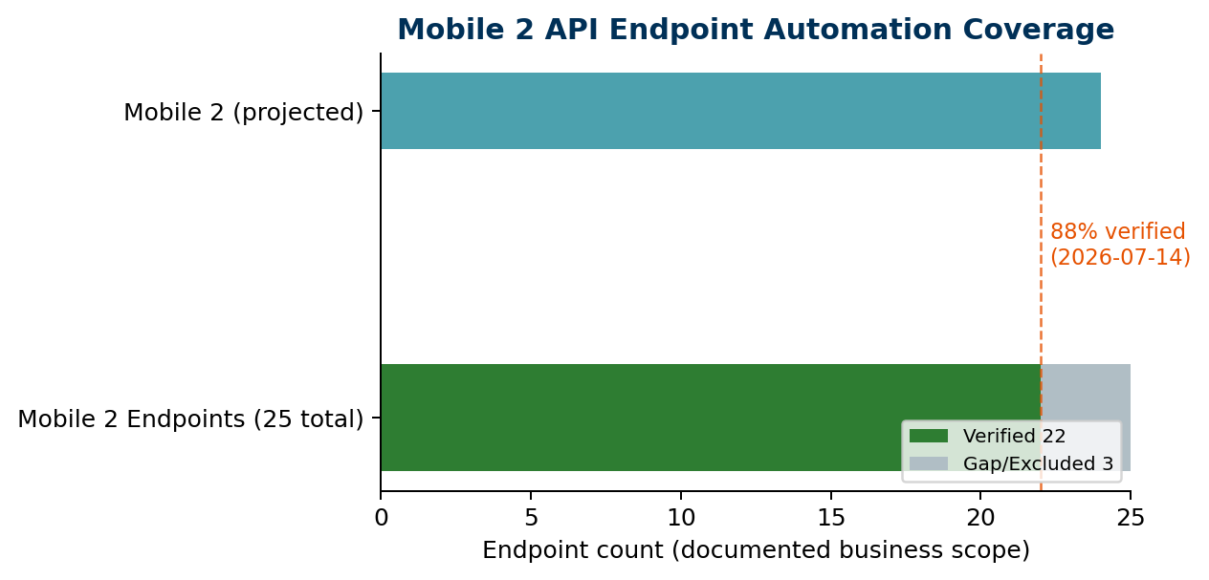

Verified Scorecard (2026-07-14, commit 7ccaf46)
Metric | Value
Documented in-scope endpoints | 25
Automated endpoints | 22
Coverage percentage | 88.0%
Master regression runs (OKD + NMD) | 34
Stage 1 master pass rate | 36 / 40
Legacy migration | ~95%
Postman parity | ~96%
Source: 17-mobile2-api-automation-signoff.md

Functional Area Status
Area | Status | Notes
Activity, Transactions, Investment | Complete | Master wired
Banks | Near complete | GET-by-id added post sign-off — verify
Content & Plans | Complete | —
Contribution (6 endpoints) | Partial | Stage 1 fixture — env-specific 401
Dashboard | Near complete | YTD added post sign-off — verify
Balance / Performance / Stackup | Complete | —
UGift | Complete | —

Sign-Off Path
- Merge pending MRs to main
- Re-run QC4 + Stage 1 master regression
- Resolve Stage 1 contribution test-data fixture
- Leadership formal approval

4. Mobile 1 — Active Sprint Focus
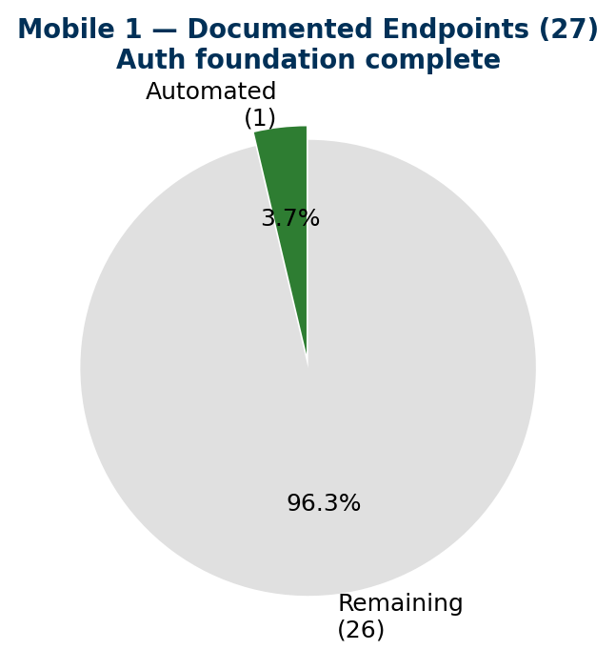

Current State (documented scope)
Metric | Value
Documented business endpoints | 27
Automated | 1 (POST mobilemembersession)
Coverage | 3.7%
Auth foundation (OKD + NMD) | Complete

Sprint 26.11 Goals
- This sprint: Mobile 1 non-IDP baseline (owner, profile, dashboard, beneficiary)
- Next sprint: Mobile 1 IDP compatibility and hardening
- Target: M1 + M2 complete for non-IDP and IDP by end of next sprint (data permitting)

5. Pipeline & CI/CD Workflow
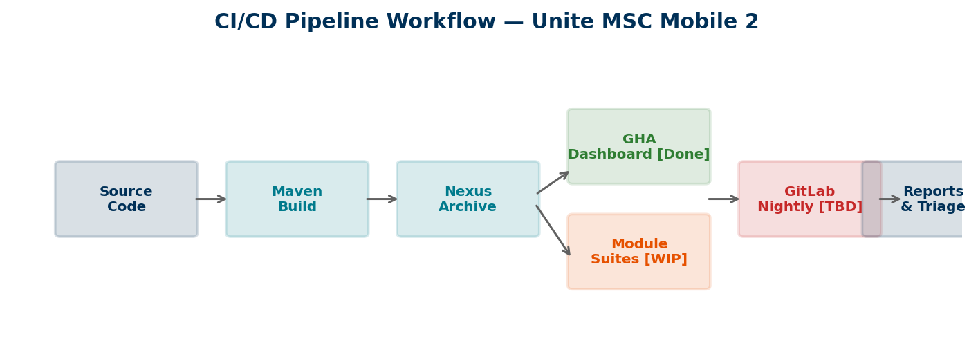
Component | Status | RAG
GitHub Actions — Dashboard vertical slice | Complete (Chaitanya) | Complete (Chaitanya)
Nexus archive packaging | Working | Working
Mobile 2 module pipeline expansion | In progress | In progress
GitLab nightly Mobile 2 regression | Story needed — DevOps | Story needed — DevOps
Master integration / regression suite | Available | Available

6. Performance Regression

Performance Metrics
Metric | Value
MSC scenarios in Jenkins | 1 (non-IDP login → Dashboard)
MSC scenarios in repo | ≥ 2 JMX files
Scheduled MSC nightly | No — ad hoc only
IDP UP suite (related) | Scheduled weekdays ~3 AM
QA-1229 (non-IDP Jenkins) | Done — 2026-07-02
QA-1228 (IDP MSC login) | In progress
Kudos — Priti Choudhary ramped quickly in a complex authentication/performance area and delivered the MSC non-IDP Jenkins foundation despite limited initial domain context.
Next targets: Contribution → Banks → Activity → Mobile 1 (after clean manual validations).

7. V2/V3 UI Automation

UI Regression Status
Metric | Value
Nightly regression | Stable (per program operations)
Morning validation effort | ~15–20 min when clean
V2 UP-scoped inventory | 268 scenarios (Jun 2026 assessment)
V3 UP-scoped inventory | 379 scenarios (Jun 2026 assessment)
Current nightly pass rate | TBD — requires qTest/Jenkins export

8. Team Contributions & Kudos
Team Member | Primary Focus | Key Delivery
Swapnil Patil | Program, master suite, KB | Auth SQL, sign-off pack, pipeline guides
Dinesh Kumar | Dashboard, plans, YTD | Plans MR, Ugift, YTD summary
Venkatesh Mallela | Contribution, balance | Contribution CRUD, performance
Sunil Godiyal | Banks, investments, TH | Banks suite, GET-by-id
Priti Choudhary | Performance | MSC Jenkins job QA-1229

9. Risks & Dependencies
Risk | Severity | Impact
GitLab nightly not created | High | Manual regression burden on team
Test data gaps (Stage 1/5/2) | Medium | Env-flexible framework blocked by data
Enrollment encryption complexity | Medium | Multi-sprint schedule risk
Contribution Stage 1 fixture | Medium | Env-specific 401 on detail/PUT
Reporting cadence load | Medium | Needs BA/Scrum support

10. Leadership Asks
1. Approve DevOps story: GitLab nightly Mobile 2 regression (QC4 first, Stage 1 parameterized)
2. Confirm Mobile 2 baseline can move to formal sign-off after refreshed evidence run
3. Confirm Mobile 1 as active sprint priority
4. Support pipeline scheduling and environment / test-data readiness
5. Structured backlog intake for new API and performance requests
6. 30–40% BA/Scrum/admin support for documentation, Jira hygiene, SME coordination, and weekly metrics

11. Roadmap
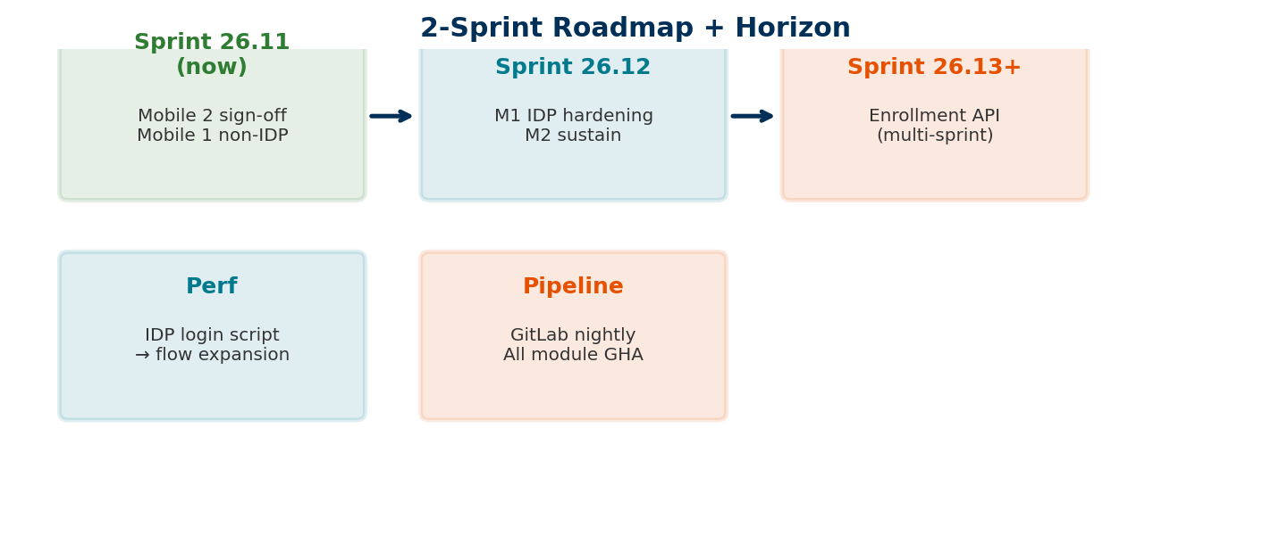

Enrollment API — Next Horizon
- Higher complexity than Mobile 1/2 — encryption/decryption
- Requires test-data creation utility and MFA-disabled account handling
- Expected duration: more than one sprint
- Will support dynamic account creation for future regression

Appendix — Sources & TBD Items

Source References
- api-test-automation/.../17-mobile2-api-automation-signoff.md
- api-test-automation/.../16-mobile2-coverage-matrix.md
- api-test-automation/.../03-document-postman-coverage-matrix.md
- qa-automation-kb/.../unite-msc-performance-testing-tracker.md
- api-test-automation/.../17-MOBILE2-NEXUS-GITHUB-ACTIONS-PIPELINE.md
- qa-automation-kb/leadership-updates/unite-msc/2026-07-17-leadership-update/

TBD — Requires Verification Before Next Meeting
- Fresh QC4 master regression run (run-qc4-all-suites.ps1)
- Fresh Stage 1 master regression run (run-stage1-all-suites.ps1)
- Updated endpoint count after YTD + Banks GET-by-id merge
- GitLab open MR list and pipeline status
- V2/V3 nightly pass rate from qTest/Jenkins
Document generated from verified program artifacts. Do not cite projected Mobile 2 coverage ≥96% until matrix refresh and regression run complete.

