QA Automation — AM Squad
Biweekly Status Briefing · September 25, 2026
Audience: Rajib (Chapter Lead) · Henry (Director) · Persistent Delivery Managers

Prepared by | Swapnil Patil / QA Automation AM Squad
Sprints covered | AMSQUAD Sprints 26.15 and 26.16 (current)
Classification | Internal — Leadership
Companion deck | AM-Squad-Biweekly-Status-Rajib-Henry-Sep25-2026.pptx

Executive Summary
Unite MSC API coding is 100% complete on main (MR !268 / QA-1938 merged; Bruno collections MR !271 merged). Sprint 26.16 wrap-up: SharePoint KT pack, qTest manual cases, QC4 E2E proof. Only Enrollment performance remains after wrap-up. Preeti finishes Mobile 1 perf by Sep 26; Mobile 2 perf done; Jenkins API perf jobs ready but not nightly-scheduled. Venkatesh nearly done with V2 enroll/login/registration retire-or-migrate; member flows move to V3 as Direct plans are on universal. He is expanding V3 IDP profile coverage after illness. Leadership decision needed: assign Dinesh to package remaining universal APIs into regression/integration/nightly suites (QA-892) vs Atlas vs continued V2/V3 gap work.
Metric | Value | Notes
Sprint scope | 26.15 – 26.16 (current) | 26.15 · 26.16
GitLab merges | 5 | Sep 11 – Sep 21 · api-test-automation (incl. QA-1938 + Bruno)
Sprint 26.16 board items | 180 | Board items in Sprint 26.16
Regression bugs | 9 | Known Stage1/IDP bugs tracked across 26.15–26.16
MSC in-scope APIs | 76/79 | M1+M2+Enrollment coding 100% · wrap-up in flight
MSC Mobile 2 | 25/25 | Complete — on main; Bruno migrated
MSC Mobile 1 | 26/26 | Complete — on main; Bruno migrated
MSC Enrollment | ~100% (15/15) | Automation coding complete — wrap-up (SharePoint, qTest, QC4) by end Sprint 26.16
Delivery vs ETA | ~70% of original ETA | Consistent ahead-of-plan delivery

1. Unite MSC API Automation
Program KB: programs/unite-msc/ · Repository: api-test-automation (GitLab). Delivered in approximately 50% of original ETA using AI-assisted migration and canonical TestNG framework.

Coverage snapshot
Module | Coverage | Status
Mobile 2 | 25/25 endpoints (100%) | Complete — sign-off package ready (QA-1553, QA-1567)
Mobile 1 | 26/26 in-scope operations (100%) | Complete — on main; Bruno migrated
Enrollment | 15/15 core E2E (100%) | Automation coding complete — wrap-up (SharePoint, qTest, QC4) by end Sprint 26.16

Coding/design complete. Wrap-up = SharePoint, qTest, Bruno usage docs, QC4 proof. Only Enrollment API performance remains after that.

Pipeline & environments
- Stage1 health recovered post DB refresh — V2/V3 stable
- QC4 E2E proof in sprint (QA-2086 series)
- Mobile 2 nightly delivered; enrollment nightly + API suite packaging = leadership decision
- Hybrid model per Jul 2025 leadership decision — Stage1 is primary until QC4 stabilizes.
- Blocker: no non-IDP plants in QC4 lower environment — need product owner to name test plans.

Pending merge !268
- Title: QA-1938 — Validate E2E coverage & remaining standard-flow gaps (merged)
- Author: Dinesh Kumar · Status: Merged Sep 11 — pipeline green
- Changes: 110 files · Blocker: None — closed
- M1/M2 suite wiring + enrollment gap closures/negatives
- https://gitlab.com/ascensus-gs/products/depot/qa-automation/api-test-automation/-/merge_requests/268

Sprint 26.14–26.15 MSC highlights (Jira)
- MR 255–262 merged — enrollment submit, subsequent E2E, standard enrollment (QA-1404, QA-1939)
- QA-1938 — gap inventory + negatives in MR !265 (Review)
- QA-2039–2047 — sign-off docs, README index, troubleshooting, AI scenario guide
- QA-2048–2053 — legacy-to-TestNG traceability matrix
- QA-1405 — Mobile 2 GitLab nightly delivered; enrollment nightly in wrap-up

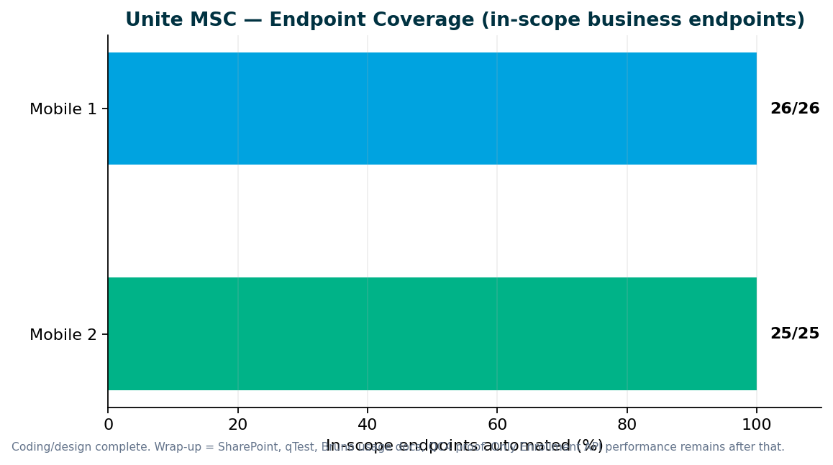

2. V2 & V3 UI Automation
Sprint 26.16 — V2 migration + V3 IDP profile expansion; Stage1 recovered. V2 and V3 both stable — focus is gap closure and plan-migration alignment, not greenfield volume.

Sprint 26.14–26.15 highlights
- He: IDP profile issues fixed; adding missing profile coverage for IDP plans
- V3 stable again after Stage1 DB-refresh disturbance
- Member personal information E2E investigation continues (QA-1845)
- Venkatesh: enrollment/login/registration retire-or-migrate nearly complete
- Member IDP cases moving to V3 — Direct plans on universal platform in Stage1
- CSR actions + share adjustment daily regression wiring this sprint

V2 regression gaps (Venkatesh Mallela)
Enrollment/login/registration classification nearly done. Member flows must move to V3 as Direct→universal migration broke V2 member IDP. P0 CSR wiring (share adjust, csr-actions daily) underway. More V2 areas land by end of sprint.

P0 — turn on existing automation
- Enrollment / login / registration — fix, retire, or migrate to V3 (almost done)
- Member-related cases — migrate to V3 (V2 member IDP obsolete for migrated Direct plans)
- stage1-csr-actions.xml → Jenkins daily (QA-2187, QA-2197)
- Share adjustment credit/debit/conversion scenarios (QA-2143–2148)
- Remove obsolete web login from V2 Jenkins where retired (QA-2186)

P1 — extend coverage
- Additional gaps designed but not yet on daily — wiring through end of Sprint 26.16
- Contribution / withdrawal / investment stabilization after Stage1 SEQ_FIN_TXN_ID issues (QA-2199–2203)

P2 — build new automation
- YTD bucket, financial history, failed transactions — still backlog after P0/P1

V2 → V3 migration — discussion needed
Confirm: member flows permanently on V3 for migrated Direct plans — retire V2 member IDP suites?

Regression bugs (Sprints 26.14–26.15)
Key | Summary | Area | Sprint
QA-2014 | V3 Universal Enrollment — unable to create account | V3 | 26.15
QA-2013 | V3 CSR Member Personal Information validation | V3 | 26.15
QA-1990 | V3 withdrawal voucher invalid | V3 | 26.15
QA-1989 | V2 CSR withdrawal voucher invalid | V2 | 26.15
QA-2199 | SEQ_FIN_TXN_ID null — contrib/withdrawal/investment stabilization | V2 | 26.16

3. Performance Testing
Sprint 26.16 — Mobile 2 done · Mobile 1 done by Sep 26 · Enrollment next. Jenkins API perf jobs created and ready — need leadership/ops OK to schedule nightly

Deliverables (Sprints 26.14–26.15)
Request | Sprint | Status | Jira
Mobile 2 MSC performance | 26.15–26.16 | Done | Prior MSC M2 perf
Mobile 1 auth / owner-profile / device-push JMeter | 26.16 | Done by tomorrow (Sep 26) | QA-2159–2163, QA-2160 Done
Enrollment MSC performance + nightly schedule | 26.16–26.17 | Remaining — Jenkins jobs ready, nightly schedule pending | Schedule API perf jobs

Performance governance ask
Two emergency requests in two sprints forced the team to drop planned sprint work. We delivered scripts and baseline results in approximately one week each, but the full standard — KB documentation, Git check-in, test data management, and expanded regression coverage — was not possible under last-minute intake.
- Engage QA Automation when performance requirements are designed — not at deploy approval
- Mandate performance validation for IDP login, enrollment, contributions, and withdrawals before release
- Route cross-team perf requests through standard intake with lead time

4. Capacity & Upcoming Work
MSC program target: End Sprint 26.16 — MSC automation + docs 100%; Enrollment perf follows. Expected: End Sprint 26.16 — SharePoint + qTest + QC4; then Dinesh available for suite packaging or Atlas.

MSC wrap-up checklist (1 resource)
- MR !268 merged (QA-1938) ✓
- Bruno M1/M2/Enrollment merged (MR !271) ✓
- SharePoint handoff pages (QA-2084)
- qTest manual cases M1/M2/Enrollment (QA-2101–2108)
- QC4 E2E proof (QA-2086)
- Enrollment performance + Jenkins nightly schedule

Planned reallocation
- Preeti → finish M1 perf (tomorrow) → Enrollment MSC perf + nightly schedule
- Dinesh → MSC wrap-up (Bruno done; qTest + SharePoint + QC4) then API suite packaging IF leadership confirms
- Venkatesh → V2 enroll/login/reg finish + member→V3 + CSR daily gaps
- He → V3 IDP profile coverage expansion
- Swapnil → SharePoint KT pack, leadership reporting, roadmap

V2 → V3 migration
Retire obsolete V2 member/login/enrollment as Direct→universal completes; expand daily with existing automation
Stage1 Direct plans on universal — V2 member IDP no longer valid
Lead: Venkatesh Mallela

Incoming: ACS-5678 Atlas (AHA)
- Feature: ACS-5678 — Atlas Traffic Distribution & Load Balancer Rebalancing
- Owner: Brian Danilczyk · Priority: #2 on Michael's list
- Estimate: 2–3 sprints · Dependency: Redis session-management initiative
- Target: October 2026 delivery
- Scope: load/perf/regression validation of traffic distribution after Redis session externalization

5. Leadership Asks & Decisions

Roadmap & capacity
- Confirm post-MSC queue: Atlas (Oct) vs API suite packaging (QA-892) vs V2/V3 gap expansion?
- MSC wrap-up completes end Sprint 26.16 — Dinesh free for next API project after that

Unite MSC / API automation
- Accept M1/M2/Enrollment coding as complete — wrap-up is docs/qTest/SharePoint/QC4
- Confirm: assign Dinesh to wire remaining universal endpoints into regression + integration + nightly suites (QA-892)?
- Name ACM / sustaining owner for MSC API assets on SharePoint

V2 regression (Jenkins)
- Approve retirement of V2 member IDP for Direct plans now on universal — migrate to V3
- Confirm P0 daily wiring (csr-actions, share adjust) before P2 new-screen builds

V3 universal platform (GitLab)
- V3 IDP profile expansion underway — confirm IDP plan coverage priority
- Member personal information / enrollment defects — product/env owners for lingering Stage1 issues?

Performance & stress testing
- Approve scheduling API/MSC perf Jenkins jobs for nightly (jobs ready, not scheduled)
- Enrollment MSC perf is the last MSC perf gap after M1 lands tomorrow

Pipeline & environments
- Stage1 health recovered — acknowledge cross-team fix for DB refresh / IDP instability
- QC4 E2E proof this sprint — confirm non-IDP plant contacts if still needed

Sign-off owners needed (names TBD from leadership)
Area | What we need | Suggested role
Mobile 2 API | Green signal for 25/25 endpoint coverage | MSC API SME / product owner
Mobile 1 API | Accept 26/26 in-scope endpoints (suite-tier routing) | MSC API SME
MSC Pipeline | Approve GitLab nightly + ENVP integration | DevOps + program lead
Performance baselines | Accept IDP/MSC perf thresholds | Platform / perf SME
Non-IDP test plans | Name plans for QC4 lower env | Product / plan configuration owner

Appendix — References
- programs/unite-msc/leadership/2026-08-07-kevin-status-update.md
- programs/unite-msc/leadership/2026-07-17-leadership-update/
- programs/unite-msc/leadership/2026-07-23-scope-alignment/
- programs/leadership-updates/2026-08-am-squad-leadership-update/
- programs/Performance Testing/barcode-syn-443/
- Jira: QA project · AMSQUAD sprints
Generated September 24, 2026.

