**API Testing At A Glance**

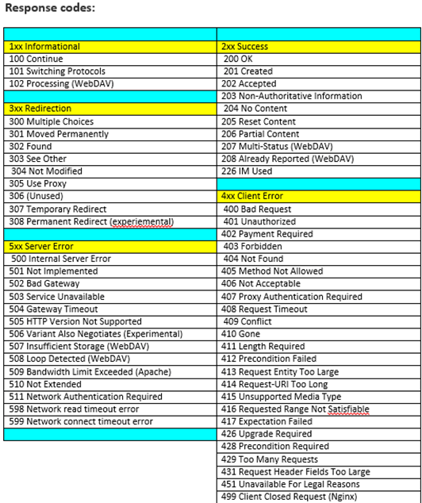

**EndPoint –** BaseURI+Resource+Parameters