**Working with AutoIT In Selenium**

**What Is AutoIT V3 And Why We Need It In Selenium WebDriver**

As you know, It Is very hard to **automate windows popup dialog** box like file upload dialog, file download and save dialog, windows authentication dialog etc In **selenium webdriver** because It Is designed to automate web applications. Surly there are few work around to do all these things In **selenium webdriver** but do not have any strong and stable feature using which we can do all these things easily. In this section, We will learn something about **Auto IT automation** and Its usage with webdriver.

**What Is AutoIT V3?**

We can say, **Auto IT Is Automation tool** using which we can automate windows GUI. It Is freeware automation tool. Best use of auto It Is to simulate mouse and keyboard events like keystroke, mouse movement, working with windows native popup dialog etc. It Is mostly used for automating desktop applications.

**Why AutoIT V3?**

Main reasons behind using auto IT are as bellow.

* **Open Source Tool :**It Is freeware automation tool with many features.
* **Easy to download and Install** - It Is very easy to Install Auto IT. You can download .exe file from It official website.
* **Easy to learn and use** - It uses very simple scripting language. Anyone can understand Its different methods and functions very easily. In help section of Auto IT, Each function Is described with detailed description and example.
* **Simulates keystrokes and mouse events** - This Is the main reason behind using It. It Is very stable with keystrokes and mouse movement events.
* **Standalone compile and execution** - It has built In feature to compile script and generate .exe executable file. You not need any extra add-on to do all these things.
* **Easy to handle windows elements** : It Is very easy to handle windows elements like dialog, popup, buttons, text box and all other elements.

**Why Need AutoIT V3 With Selenium WebDriver?**

Many web applications contains forms with file uploading feature, Some times you need to test file downloading feature, Sometimes you need to handle windows authentication popups. Sometimes It Is not possible or I can say hard to handle all these things using only selenium webdriver. To handle all these situations easily, We can use AutoIT generated .exe file with selenium webdriver. Because AutoIT handles all these things very easily.

**How To Download And Install Auto IT Step By Step**

As I described In [**PREVIOUS POST**](http://www.software-testing-tutorials-automation.com/2014/12/what-is-autoit-v3-and-why-we-need-it-in.html), Auto IT Is opensource automation tool and can help us to handle windows element In our selenium webdriver test cases. We need AutoIT and AutoIT script editor to write test scripts.

**Steps To Download AutoIT**

You can **download AutoIT** from Its official website. [**Click Here**](https://www.autoitscript.com/site/autoit/downloads/) to go AutoIT to download page. On that page, Click on Download AutoIt button as shown In bellow given Image. It will start downloading "**autoit-v3-setup.exe**" file.

[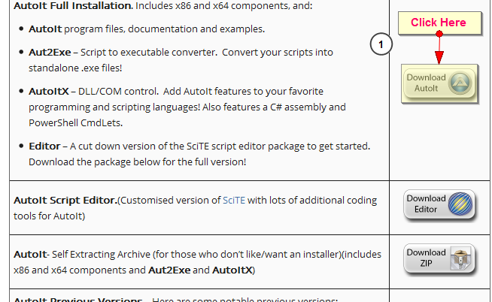](http://2.bp.blogspot.com/-Mce5P45N09E/VIwllU23mUI/AAAAAAAABOE/BvyRuxTZF-I/s1600/Download%2BAutoIT.png)

**Steps To Download AutoIT Script Editor**

To download AutoIT Script editor, Go to same [**Downloading Page**](https://www.autoitscript.com/site/autoit/downloads/) and click on Download editor button as shown In bellow Image. It will download file with name "**SciTE4AutoIt3.exe**".

[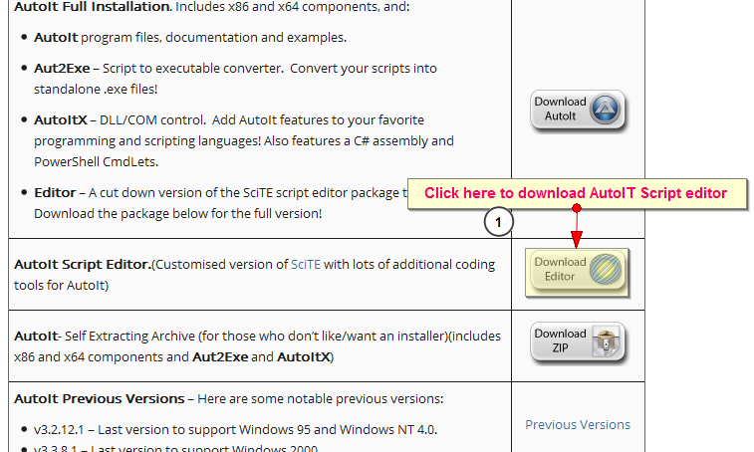](http://2.bp.blogspot.com/-jDOMB3b7sTU/VIwlrIgjXwI/AAAAAAAABOM/xs8PC1uqqXk/s1600/Download%2BAutoIT%2BScript%2BEditor.png)

**Installing AutoIT**

You need to **Install AutoIT** first and then you can Install AutoIT Script editor. To Install AutoIT, Double click on "**autoit-v3-setup.exe**" file. It will open Installation dialog as shown In bellow Image.

[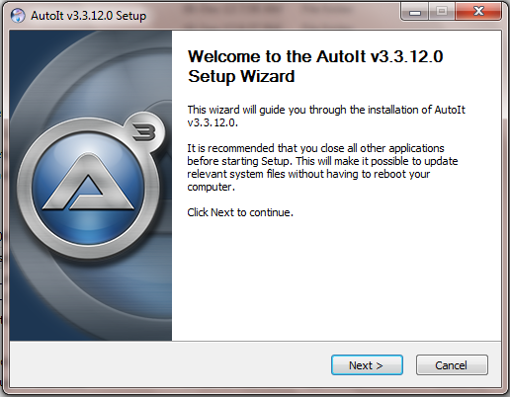](http://3.bp.blogspot.com/-H3Kt2pUZp7I/VIwocK5Xg8I/AAAAAAAABOY/xeHe3NmILbs/s1600/Install%2BAutoIT.png)

Click on Next button and follow the Installation guide by keeping default settings as It Is. On completion of Installation, You can see AutoIT In your **Start menu -> All Programs** options as shown In bellow Image.

[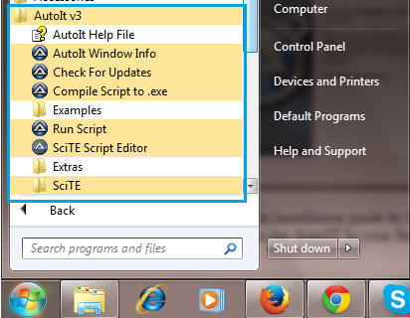](http://4.bp.blogspot.com/-stX4zhK1Q-w/VIwp-OdziCI/AAAAAAAABOk/jjvEBh5DXQQ/s1600/AutoIT%2BInstalled.png)

**Install AutoIT Script Editor**  
AutoIT script editor which Is Installed with AutoIT Is Lite version as shown In bellow Image.

[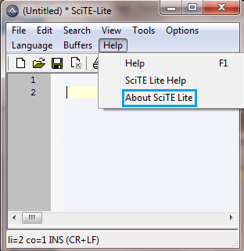](http://2.bp.blogspot.com/-0l1zm3vq74Q/VIwupLmWFaI/AAAAAAAABO4/R9g25VAcYyA/s1600/autoit%2Blite.png)

To get full editor version, You need to Install It separately. To Install AutoIT script editor, Double click on "**SciTE4AutoIt3.exe**" source file. It will open Installation dialog as shown In bellow Image.

[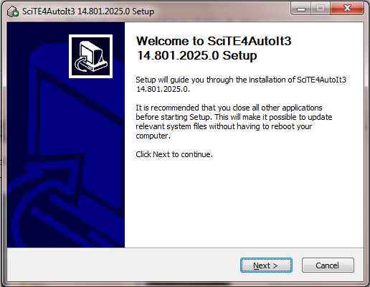](http://3.bp.blogspot.com/-zGlEZUSZmQA/VIwq2XQcd1I/AAAAAAAABOs/RHvxBVumnXM/s1600/Install%2BAutoIT%2BScript%2BEditor.png)

Follow script editor Installation guide by keeping default settings as It Is. At the end of Installation, You will see AutoIT Installed In **Start -> All Programs** as shown In bellow Image.

[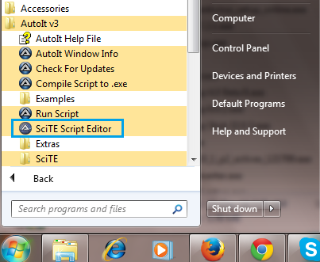](http://3.bp.blogspot.com/-9Pp2Thmqsio/VIwvZyn8YVI/AAAAAAAABPA/tYOzH6ZxCdw/s1600/AutoIT%2Bscript%2Beditor%2BInstalled.png)

Now you can open editor and verify Its version. It will looks like bellow.

[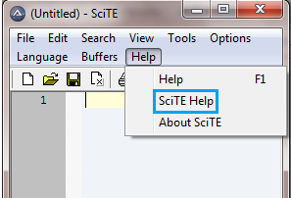](http://1.bp.blogspot.com/-nNIM-h6G1mc/VIwwKRwKuYI/AAAAAAAABPM/eHvPmkU2cFQ/s1600/autoit%2Bfull.png)

# Create Script In AutoIt To Upload File

Before creating and running **file upload script In AutoIT**, You must be aware about what Is AutoIT and how to Install It. I have already described about **AutoIT** In [**THIS POST**](http://www.software-testing-tutorials-automation.com/2014/12/what-is-autoit-v3-and-why-we-need-it-in.html) and how to **download and Install** It In [**THIS POST**](http://www.software-testing-tutorials-automation.com/2014/12/how-to-download-and-install-auto-it.html). Now let us learn how to create script In AutoIT to upload file using **selenium webdriver**.

In this section, We will learn how to create and run AutoIt script stand alone. Next post will describe you how to Integrate AutoIT script with selenium webdriver.

**Identify objects properties of File Upload dialog**

First of all you need to Identify objects of file upload dialog. Navigate to [**THIS PAGE**](http://only-testing-blog.blogspot.in/2014/01/textbox.html) where you will find file uploading functionality. Click on Browse button. It will open file uploading dialog as shown In bellow Image.

[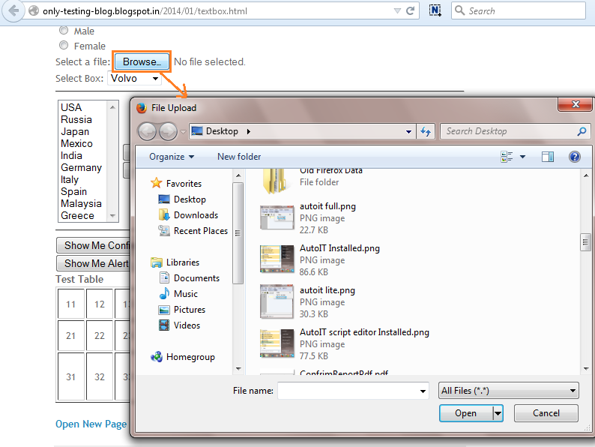](http://3.bp.blogspot.com/-tSdf5SJD_Ek/VIxC_Tx5IRI/AAAAAAAABPc/HQI_dEzQnag/s1600/file%2Buploading%2Busing%2BautoIt.png)

To Identify objects of dialog, AutoIt has Windows Info tool. You can open It from **Start -> All Programs -> AutoIt V3 -> AutoIt Windows Info**.

[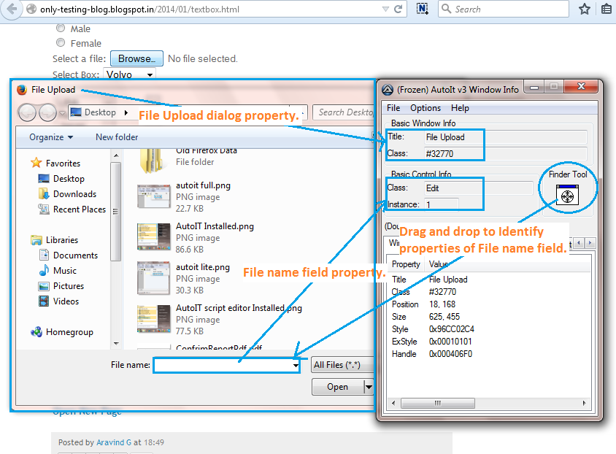](http://1.bp.blogspot.com/-JTHHk_qEMBg/VIxHkPrX9WI/AAAAAAAABPo/L96WHeruowA/s1600/Identify%2Bobject%2Bproperties%2Busing%2BautoIT.png)

To Identify object properties of Upload dialog, Simply drag and drop "**Finder Tool**" from AutoIT v3 windows Info tool to "**File name**" field as shown In above Image. It will automatically Identify object properties of File Upload dialog and File name field. Same way you can Identify properties of any object of any dialog. We will use that object property In auto It script. In this example, Our object properties are as bellow.

* **File upload dialog** : Title = File Upload, Class = #32770
* **File name field** : Edit1 (Class + Instance combination)
* **Open button** : Button1 (Class + Instance combination)

**Write AutoIt script to select file In dialog**

File "**Test.txt**" (which I wants to upload) Is located at **E:\AutoIT** location. To write file upload script, you need to use SciTE Script Editor. Open script editor from **Start -> All Programs -> AutoIt V3 -> SciTE Script Editor** and write bellow given script In to It and save It as "**Script To Upload File.au3**". Script explanation Is given with each line.  
  
**Note**: Test.txt file should be located at "E:\AutoIT" folder.

**; It will wait for 8 seconds to appear File Upload dialog.**

**; Used Title property of File upload dialog window.**

WinWait("File Upload","",8)

**; Set control focus to File name Input box of File Upload dialog.**

**; Used Class property of File upload dialog window and Class+Instance property for File name Input box.**

ControlFocus("[CLASS:#32770]","","Edit1")

Sleep(3000)

**; Set the name of file In File name Edit1 field.**

**; "Test.txt" file Is located In AutoIT folder of E drive. So we have to provide full path like E:\AutoIT\Test.txt.**

ControlSetText("[CLASS:#32770]", "", "Edit1", "E:\AutoIT\Test.txt")

Sleep(3000)

**; Click on the Open button of File Upload dialog.**

ControlClick("[CLASS:#32770]", "","Button1");

In above script, We have used total five different AutoIT commands. Explanation Is as bellow.

* **WinWait**: Used to wait for given time to appear targeted dialog window.
* **ControlFocus**: Set the focus on targeted dialog window.
* **Sleep**: Wait for given time.
* **ControlSetText**: Write text In targeted Input text field of dialog.
* **ControlClick**: Click on targeted button of win. dialog.

Your script will looks like bellow In AutoIt editor.

[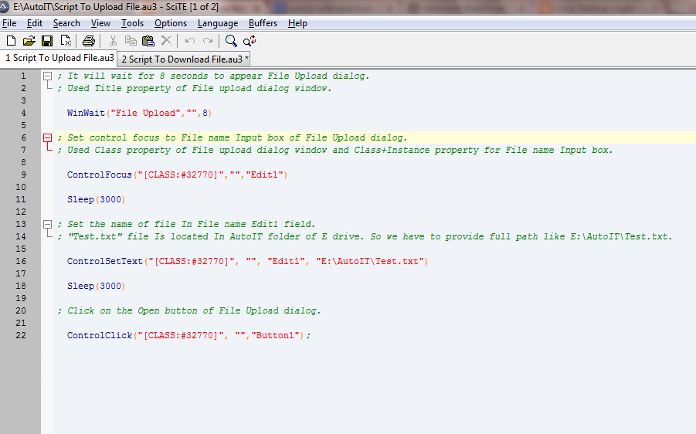](http://4.bp.blogspot.com/-91c5x7suB9k/VI0g7G4Nn_I/AAAAAAAABQI/EOiSYdmbFBY/s1600/AutoIT%2Bscript%2Bto%2Bupload%2Bfile.png)

**Convert script In executable format**

To run this script, We need to convert It In executable .exe format. It Is very simple because AutoIT has built In function to convert script In .exe format.

To convert script,

* Simply go to the folder where "**Script To Upload File.au3**" file Is stored.
* Right click on file and select **Compile Script** as shown In bellow Image. It will create "**Script To Upload File.exe**" file In same folder.

[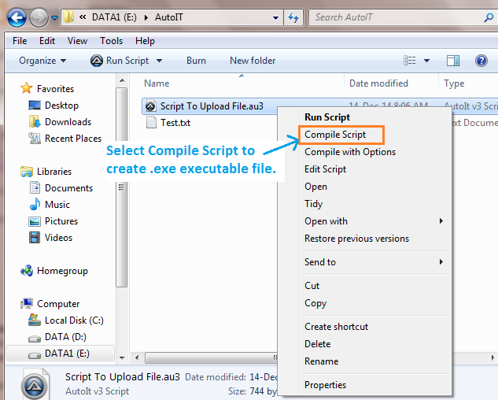](http://3.bp.blogspot.com/--GfqS93rfIM/VI0Fd1hWDVI/AAAAAAAABP4/xCBlewDCBUw/s1600/create%2Bexecutable%2Bfile.png)  
[**CLICK HERE**](https://drive.google.com/file/d/0B6vnknygMB3ILXRfaGtmOTRFMDg/view?usp=sharing) to download ready made "**Script To Upload File.au3**" and "**Script To Upload File.exe**" files of AutoIt.

**Test AutoIt script**

Now you can test script to verify Is It working fine or not.

To test script,

* **File Upload** dialog should be opened. Go to [**THIS TEST PAGE**](http://only-testing-blog.blogspot.in/2014/01/textbox.html) In Firefox browser and click on "Browse" button to open **File Upload** dialog.
* Double click on "**Script To Upload File.exe**" file to execute script and observe actions on **File Upload** dialog. It will enter file path In File name field of dialog and then click on Open button automatically.

# Upload File In Selenium WebDriver Using AutoIt

As you know, **File uploading** Is very hard In **selenium webdriver** because It Is not able to handle file uploading dialog. So we will use **AutoIT**with selenium webdriver to upload file In web applications. We have already created AutoIt script **(Script To Upload File.exe)** In previous post which can select file from **File Upload** dialog. We will learn how to Integrate that AutoIt script with selenium webdriver In this section.

In java, It Is very easy to execute any executable file. We can run any executable script file using **Runtime.getRuntime().exec("File Path")** method. We will use this java method In our selenium webdriver test script to handle file upload dialog.

So now final selenium webdriver with AutoIt Integration test script Is as bellow.  
  
**Note**: "**Script To Upload File.exe**" and "**Test.txt**" files should be located at "E:\\AutoIT" folder.

package AutoIt;

import java.io.IOException;

import java.util.concurrent.TimeUnit;

import org.openqa.selenium.By;

import org.openqa.selenium.WebDriver;

import org.openqa.selenium.firefox.FirefoxDriver;

import org.testng.annotations.BeforeTest;

import org.testng.annotations.Test;

public class AutoIt_Test {

WebDriver driver;

@BeforeTest

public void setup() throws Exception {

driver =new FirefoxDriver();

driver.manage().window().maximize();

driver.manage().timeouts().implicitlyWait(10, TimeUnit.SECONDS);

driver.get("http://only-testing-blog.blogspot.in/2014/01/textbox.html");

}

@Test

public void testCaseOne_Test_One() throws IOException, InterruptedException {

**//Click on browse button.**

driver.findElement(By.name("img")).click();

**//To execute autoIt script .exe file which Is located at E:\\AutoIT\\ location.**

Runtime.getRuntime().exec("E:\\AutoIT\\Script To Upload File.exe");

}

}

Run above script In eclipse.

* It will click on browser button to open File Upload dialog using selenium webdriver.
* Then **Runtime.getRuntime().exec("E:\\AutoIT\\Script To Upload File.exe");** syntax will execute AutoIt generated "**Script To Upload File.exe**" file. It will select file and click on open button of File Upload dialog.

On completion of script, you will see that Test.txt file Is uploaded as shown In bellow given Image.

[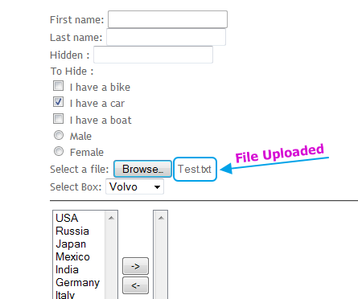](http://3.bp.blogspot.com/-x5GvaXcgv6Q/VI1i7xM9VzI/AAAAAAAABQ4/v-z60O3V5_M/s1600/file%2Buploaded%2Busing%2Bautoit.png)

# Downloading File Using AutoIt In Selenium WebDriver

**Downloading file** using **selenium webdriver** Is also tricky task. I have already described how to handle **file download** functionality In **selenium webdriver** by creating custom firefox profile In [**THIS POST**](http://www.software-testing-tutorials-automation.com/2014/05/how-to-download-different-files-using.html). It Is really very long task. At place of using custom profile approach, We can use **AutoIt**script with selenium webdriver to **download file** from any web page.

You will find different test files download links on [**THIS PAGE**](http://only-testing-blog.blogspot.in/2014/05/login.html)which we will use to learn how to download file using AutoIt In selenium webdriver. We have to perform bellow given steps to create selenium webdriver + AutoIt script.

**Identify objects properties of file download and save dialog**

In Firefox browser, Go to [**THIS PAGE**](http://only-testing-blog.blogspot.in/2014/05/login.html) and click on "**Download Text File**" link. It will open Save file dialog with Open with and Save File radio options.

Now you can Identify save file dialog properties using AutoIt Window Info tool as described In [**THIS POST**](http://www.software-testing-tutorials-automation.com/2014/12/create-script-in-autoit-to-upload-file.html). In this case you will get only dialog's property (Title and class) using AutoIt Window Info tool as shown In bellow Image. It Is not able to retrieve property of Save File radio option and OK button. So we have to use some alternative method In our AutoIt script to select Save File radio option and click OK button.

[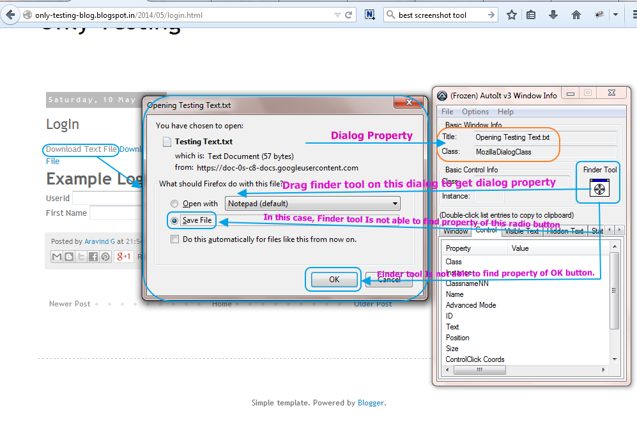](http://1.bp.blogspot.com/-gEdvxGHbM84/VI07u4cPvvI/AAAAAAAABQY/9lxtqP65QAE/s1600/Identify%2Bdialog%2Bproperty%2Bto%2BUpload%2Bfile%2Busing%2Bautoit.png)  
So we have only dialog property In this case as bellow.

* **File Save dialog** : Title = Opening Testing Text.txt, Class = MozillaDialogClass

We will use class property In our script to select dialog.

**Write AutoIt script to save file**

If you see In above Image, **Save File** option has shortcut to select It. We can select It using **ALT + S** keyboard shortcut keys. Also focus Is set by default on OK button. So we can press **ENTER**key to select OK. We can do both these Keystroke action In AutoIt very easily using Send() command as shown In bellow script.

**; wait for 8 seconds to appear download and save dialog. Used class property of download dialog.**

WinWait("[CLASS:#MozillaDialogClass]","",8)

**; Perform keyboard ALT key down + s + ALT key Up action to select Save File Radio button using keyboard sortcut.**

Send("{ALTDOWN}s{ALTUP}")

**; Wait for 3 seconds**

Sleep(3000)

**; Press Keyboard ENTER button.**

Send("{ENTER}")

Save above script In "**Script To Download File.au3**" format at "**E:\AutoIT**" location. Above script will perform bellow give actions.

1. wait for 8 seconds to appear file saving dialog.
2. Press ALT down + s + ALT up key to select Save File radio.
3. Press Enter key to select OK button.

**Convert script In executable format**  
  
Now you can create executable file of above script as described In [**THIS POST**](http://www.software-testing-tutorials-automation.com/2014/12/create-script-in-autoit-to-upload-file.html). After conversion, you will get executable file "**Script To Download File.exe**".  
  
[**CLICK HERE**](https://drive.google.com/file/d/0B6vnknygMB3IeVYzSjdyY0I5VmM/view?usp=sharing) to download ready made "**Script To Download File.au3**" and "**Script To Download File.exe**" files of AutoIt.

**Integrate AutoIt script with selenium webdriver to download file**

As described In **THIS POST**, We will use java Runtime.getRuntime().exec(); method to execute AutoIt script In selenium webdriver.

So our Selenium webdriver + AutoIt script to download file from web page Is as bellow.

**Note**: "**Script To Download File.exe**" file should be located at E:\\AutoIT folder.

package AutoIt;

import java.io.IOException;

import java.util.concurrent.TimeUnit;

import org.openqa.selenium.By;

import org.openqa.selenium.WebDriver;

import org.openqa.selenium.firefox.FirefoxDriver;

import org.testng.annotations.BeforeTest;

import org.testng.annotations.Test;

public class AutoIt_Test {

WebDriver driver;

@BeforeTest

public void setup() throws Exception {

driver =new FirefoxDriver();

driver.manage().window().maximize();

driver.manage().timeouts().implicitlyWait(10, TimeUnit.SECONDS);

driver.get("http://only-testing-blog.blogspot.in/2014/05/login.html");

}

@Test

public void testCaseOne_Test_One() throws IOException, InterruptedException {

**//Click on Download Text File link to download file.**

driver.findElement(By.xpath("//a[contains(.,'Download Text File')]")).click();

**//Execute Script To Download File.exe file to run AutoIt script. File location = E:\\AutoIT\\**

Runtime.getRuntime().exec("E:\\AutoIT\\Script To Download File.exe");

}

}

Now If you run above script, It will download Text file automatically. At the end of script execution, file will be downloaded as shown In bellow Image.

[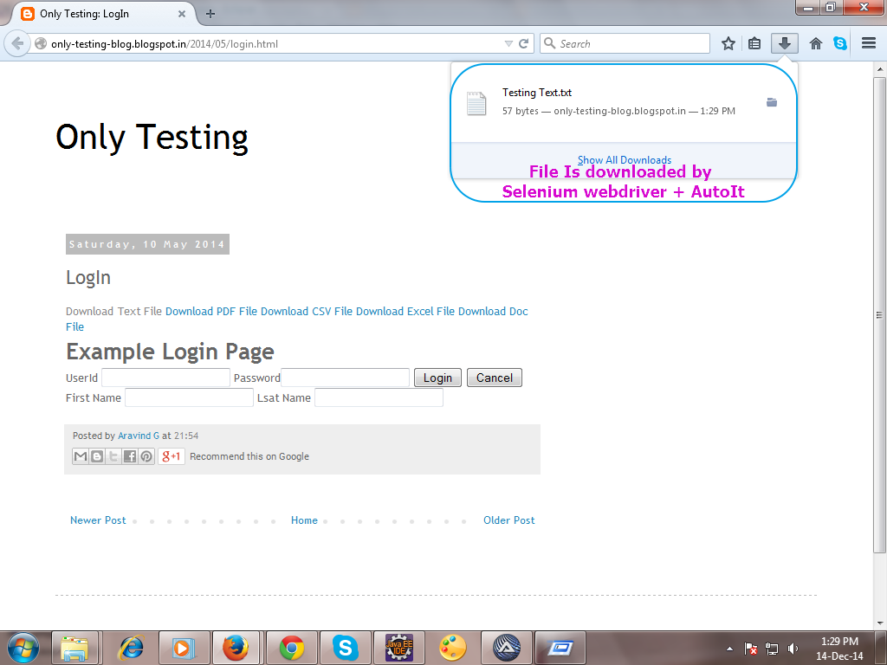](http://1.bp.blogspot.com/-c7ULn214I6Y/VI1EHAm4vdI/AAAAAAAABQo/CBKdUKc6JDo/s1600/Download%2Bfile%2Busing%2Bselenium%2Bwebdriver%2B%2B%2BAutoIt.png)