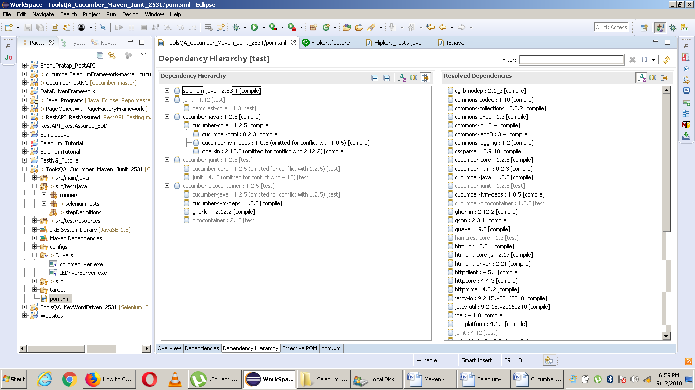

<dependencies>

<!-- https://mvnrepository.com/artifact/org.seleniumhq.selenium/selenium-java -->

<dependency>

<groupId>org.seleniumhq.selenium</groupId>

<artifactId>selenium-java</artifactId>

<version>2.53.1</version>

</dependency>

<!-- https://mvnrepository.com/artifact/junit/junit -->

<dependency>

<groupId>junit</groupId>

<artifactId>junit</artifactId>

<version>4.12</version>

<scope>test</scope>

</dependency>

<!-- https://mvnrepository.com/artifact/info.cukes/cucumber-java -->

<dependency>

<groupId>info.cukes</groupId>

<artifactId>cucumber-java</artifactId>

<version>1.2.5</version>

</dependency>

<!-- https://mvnrepository.com/artifact/info.cukes/cucumber-junit -->

<dependency>

<groupId>info.cukes</groupId>

<artifactId>cucumber-junit</artifactId>

<version>1.2.5</version>

<scope>test</scope>

</dependency>

<dependency>

<groupId>info.cukes</groupId>

<artifactId>cucumber-picocontainer</artifactId>

<version>1.2.5</version>

<scope>test</scope>

</dependency>

</dependencies>

<build>

<plugins>

<plugin>

<groupId>org.apache.maven.plugins</groupId>

<artifactId>maven-compiler-plugin</artifactId>

<version>3.7.0</version>

<configuration>

<source>1.8</source>

<target>1.8</target>

<encoding>UTF-8</encoding>

</configuration>

</plugin>

</plugins>

</build>

\*\*\*\*\*\*\*\*\*\*\*\*\*\*\*\*\*\*\*\*\*\*\*\*\*\*\*\*\*\*\*\*\*\*\*\*\*\*\*\*\*\*\*\*\*\*\*\*\*\*\*\*\*\*\*\*\*\*\*\*\*\*\*\*

package cucumberTest;

import org.junit.runner.RunWith;

import cucumber.api.CucumberOptions;

import cucumber.api.junit.Cucumber;

@RunWith(Cucumber.class)

@CucumberOptions(

features = "Feature"

,glue={"stepDefinition"}

)

public class TestRunner {

}

\*\*\*\*\*\*\*\*\*\*\*\*\*\*\*\*\*\*\*\*\*\*\*\*\*\*\*\*\*\*\*\*\*\*\*\*\*\*\*\*\*\*\*\*\*\*\*\*\*\*\*\*\*\*\*\*\*\*\*\*\*\*\*\*



