**Git At a Glance**

**Working Copy -> Staging Area -> Repository**

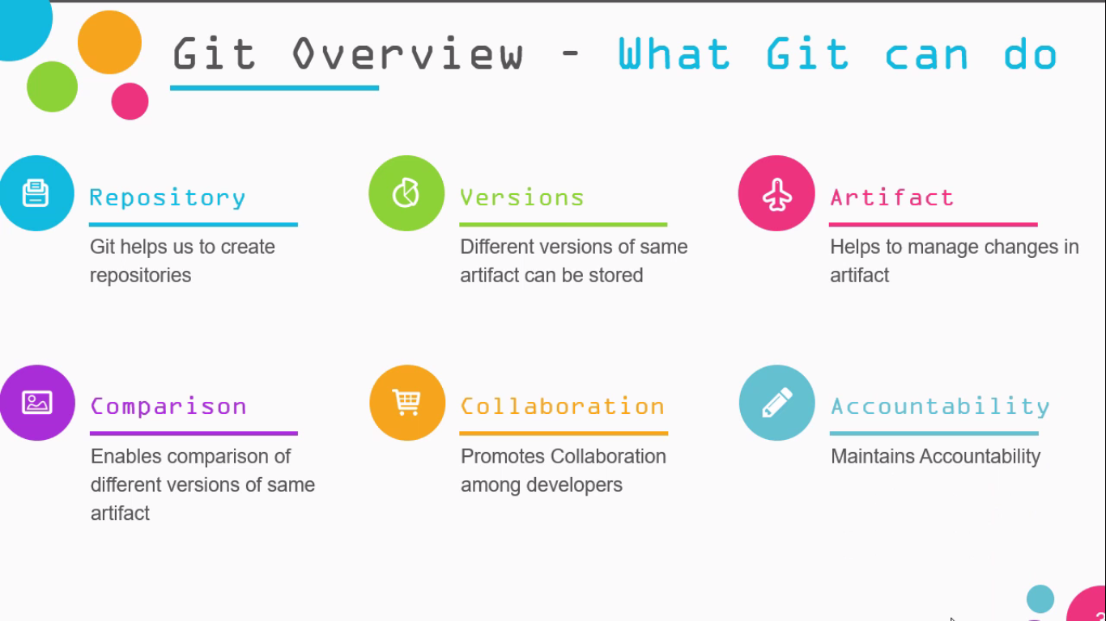

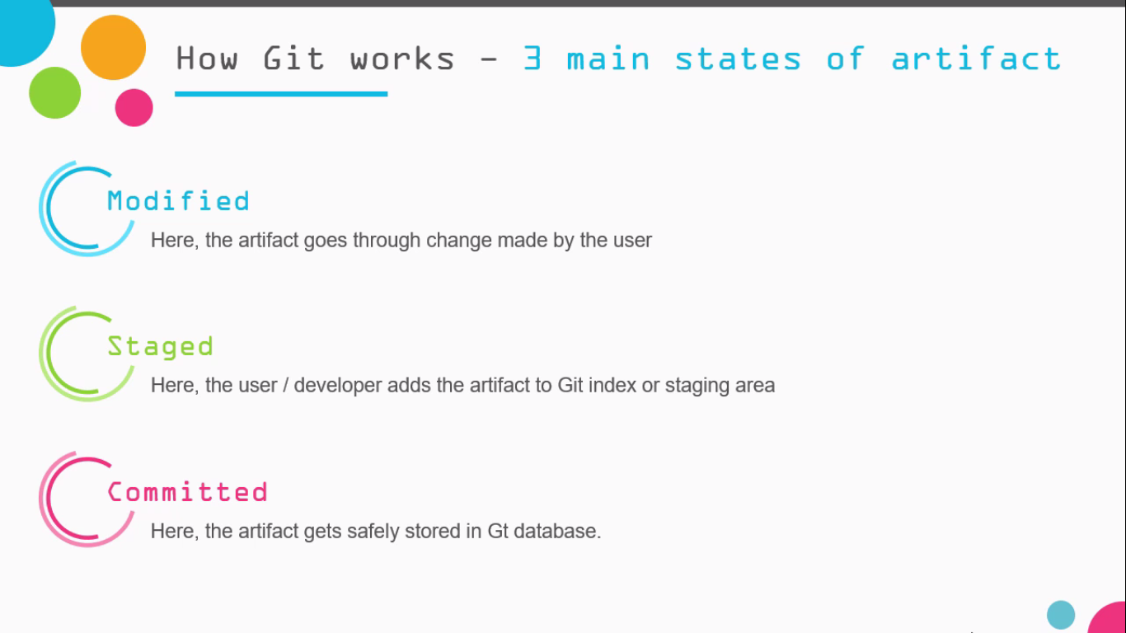

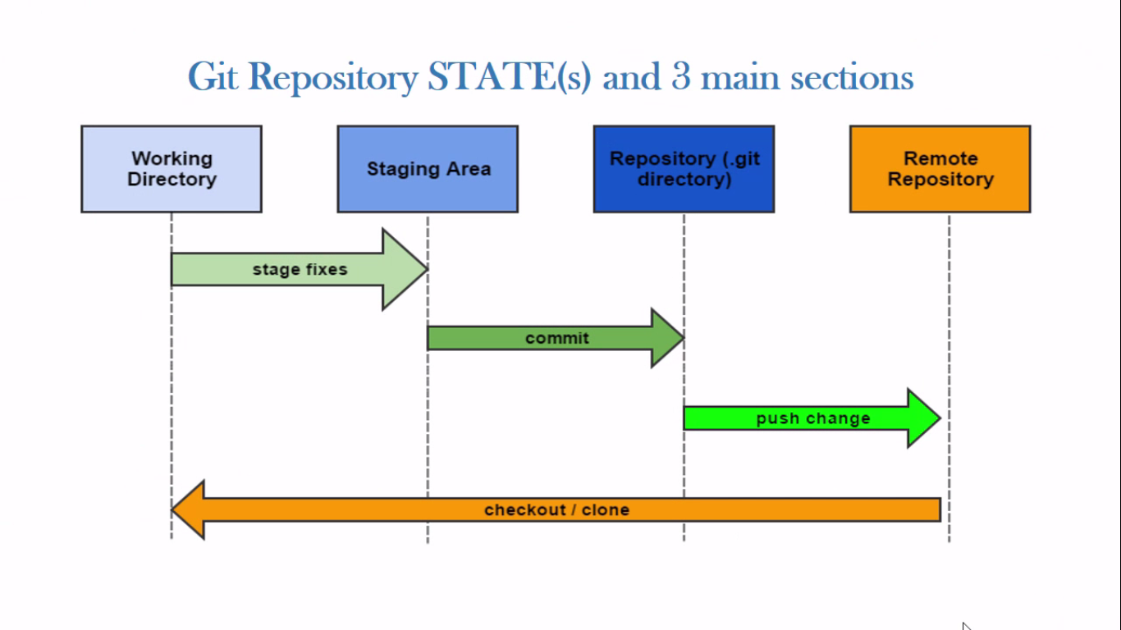

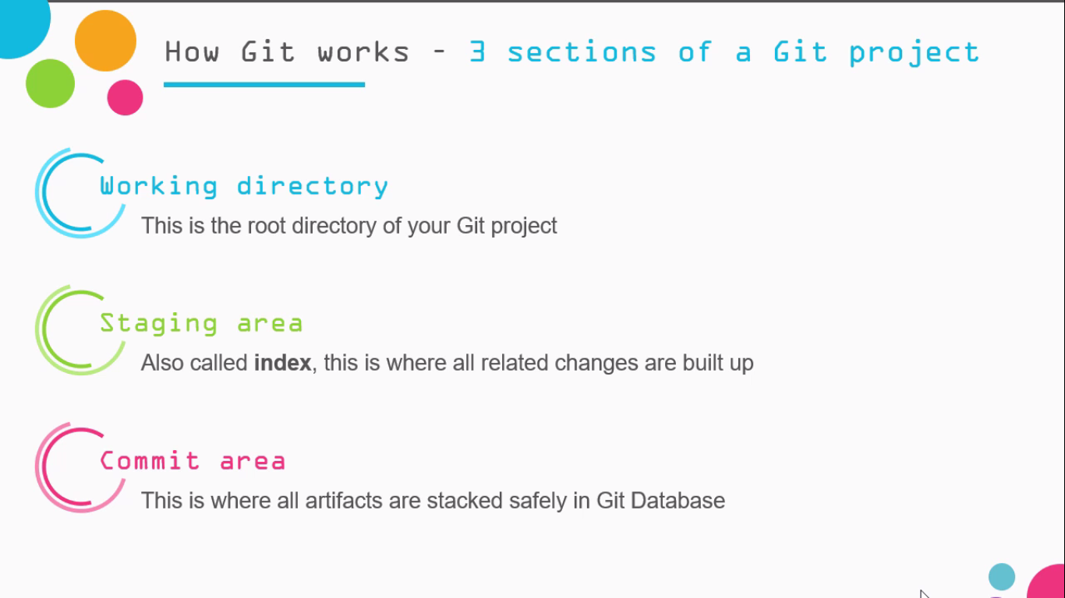

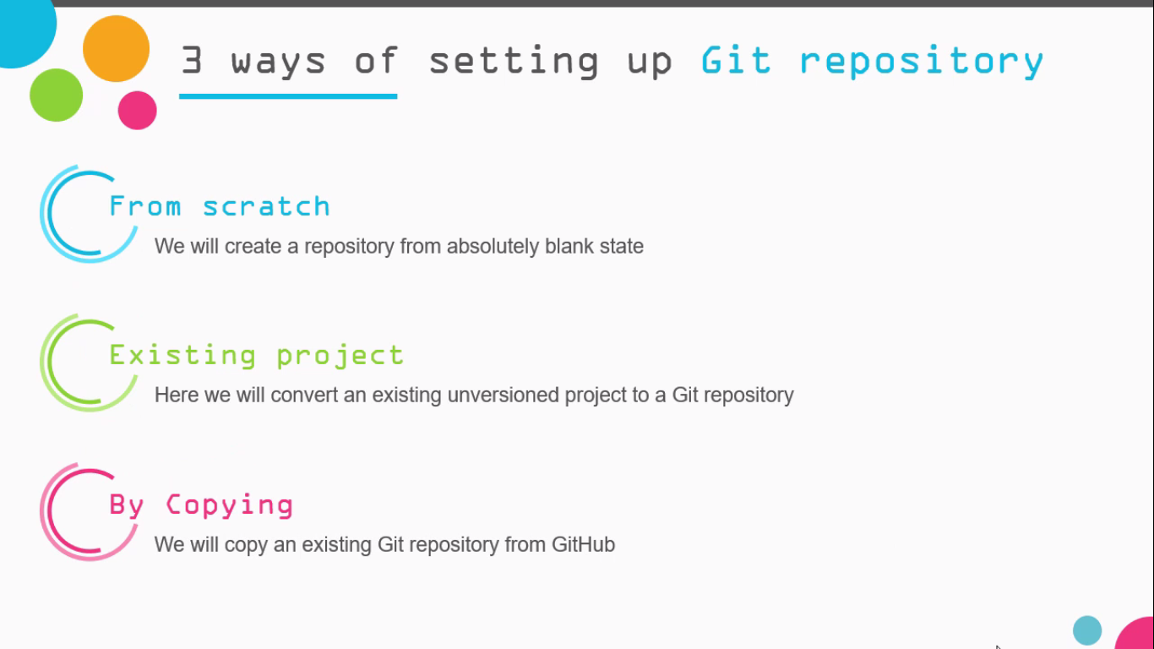

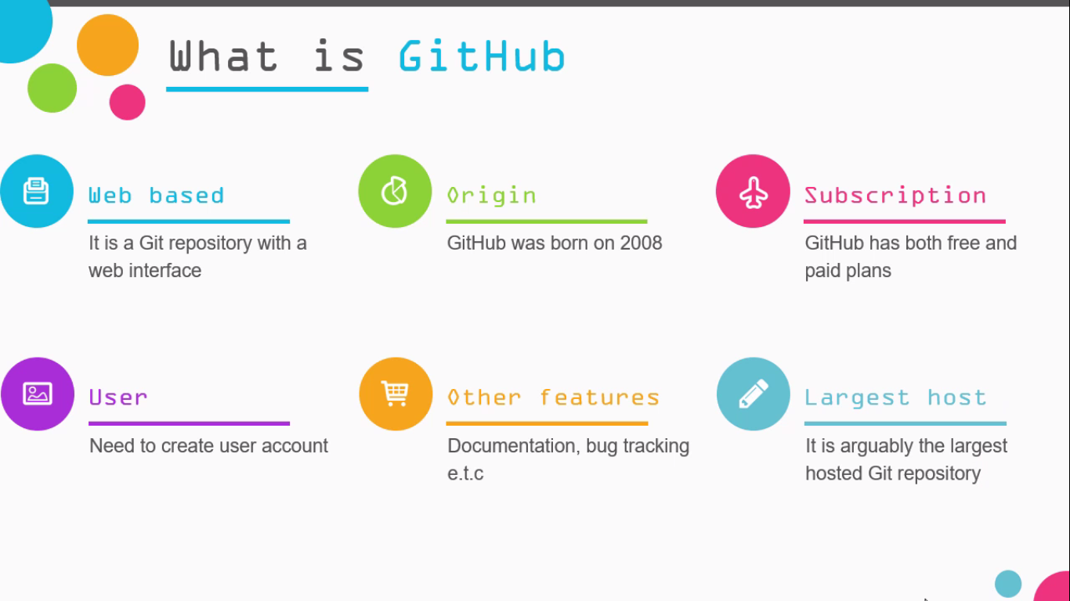

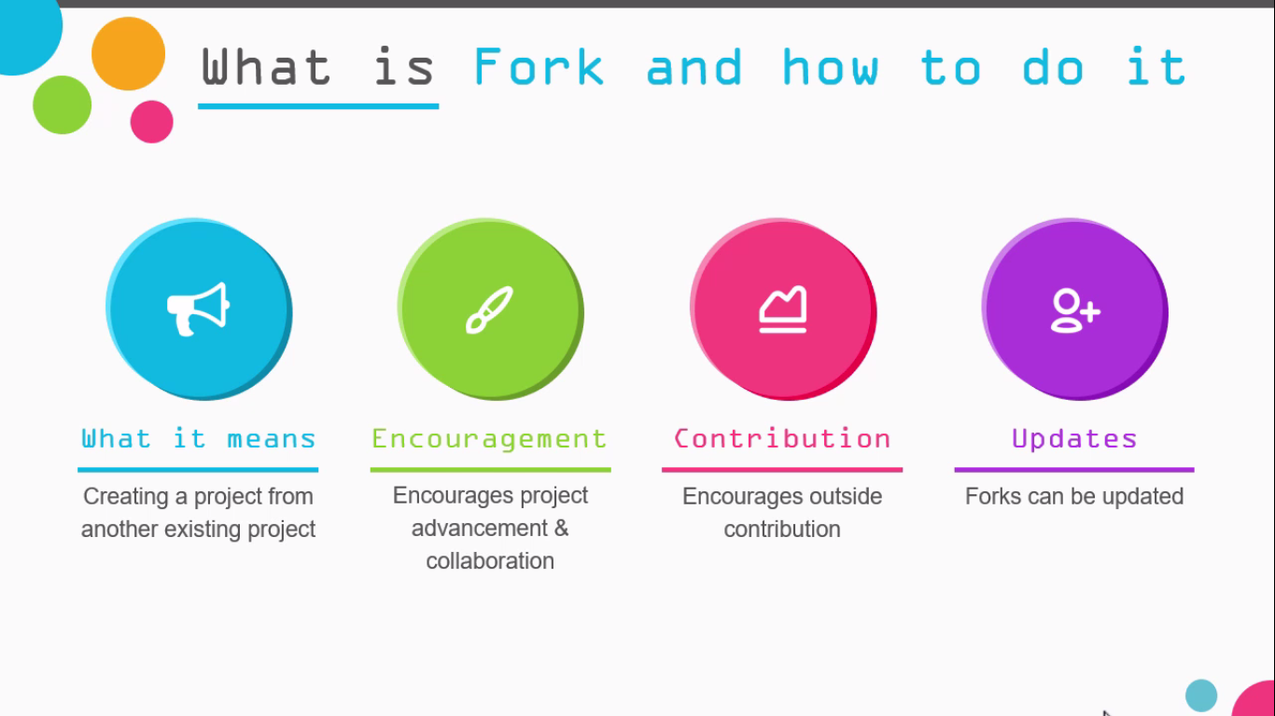

**git --version**

To check git installed and check its version

**git config --list / git config user.email**

List all the config properties / List User.email

**git config --global user.name “SwapnilPorwal”**

**git config --global user.email “SwapnilPorwal2013@gmail.com”**

Set user.name and user.email

**git help <command>**

To get help for given command

**git init**

Initialize the repository

**git status**

To get the status of Working Copy and Stage Area

**git status -s**

?? – file is not tracked

A – file is added to staging

Red M – commited file is modified

Green M – commited file is added

D – file deleted

**git add .**

To add all the modified files present in working directory to stage

**git add “Git-GitHub At a Glance.docx”**

Adding the new file or changes for particular file in working directory to stage

**git rm --cached<filename>**

To unstage the file from staging to working

**git commit -m “This is our First Commit”**

Commit with a message

**git commit -am”Commit”**

To add and commit from working copy to repo

**git commit --amend -m”***”**

To update last commit

**git log**

View Commit History

**git log --oneline**

View Commit histoey in one line

**git log --author=”SwapnilPorwal”**

View Commit History for particular User

**git log <filename>**

View commit history of particular file

**git log <since>..<until> --oneline**

View commit between range

**git log -n <limit>**

git log -n 3 will display only 3 commits

**git diff**

Shows differences in Working Copy and Repo

**git diff --staged**

Compare Staging area and Repo

**git rm “Sample.txt”**

Delete file from Repo and working Copy

**git mv “OldFileName” “NewFileName”**

Rename file

**git checkout -- <filename>**

To Discard changes in working Directory

Take something Repo and make it your copy

**git reset HEAD “FileName”**

Remove file from staging area

**git checkout “CommitNo” -- “fileName”**

Rollback to previous commit for “fileName” and “CommitNo” and bring to stage

**git remote add Origin**

Make a name for remote repository – Origin

**git push -u Origin master**

Push to master

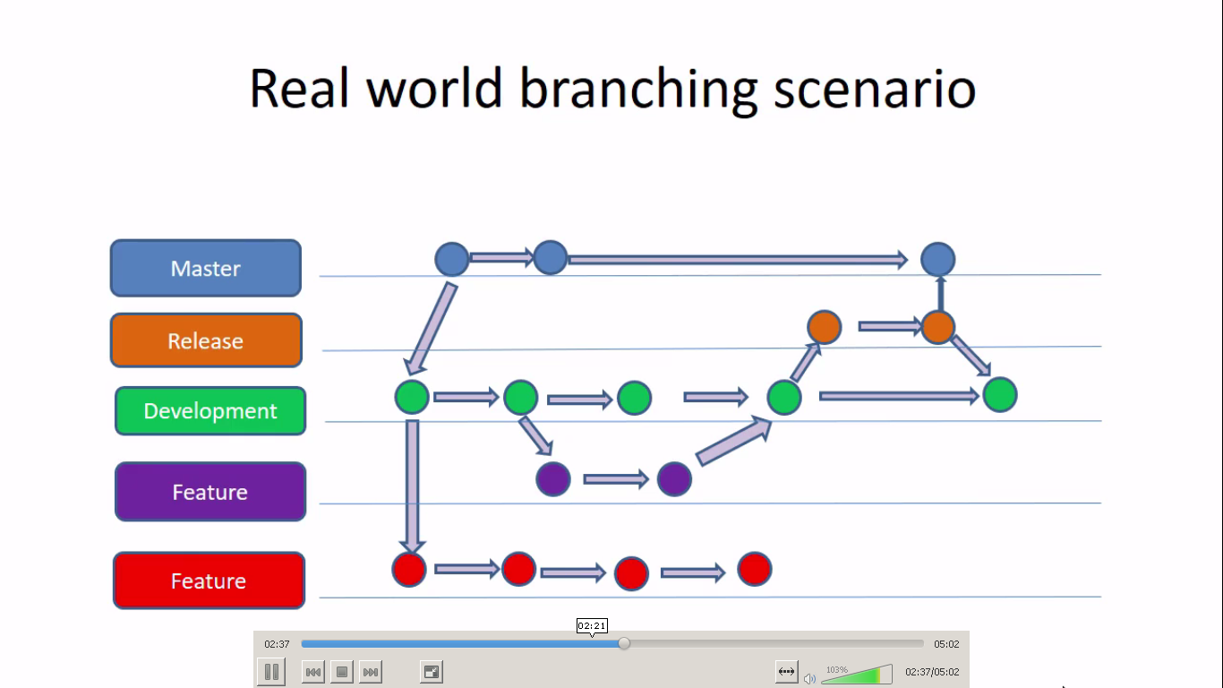

**git branch <branch name>**

Create’s a new branch

**git checkout <branch name>**

Switched to branch ‘branch name’

**git checkout master**

Switched to master branch

**git merge ‘branch name’**

Merges ‘branch name’ with master branch

**git branch -d ‘branch name’**

Deleted branch ‘branch name’

**git clone <GitHub Url>**

Clone the project from GitHub

**git revert HEAD**

Reverts back to previous commit