**How to handle browser (chrome) notifications in Selenium?**

[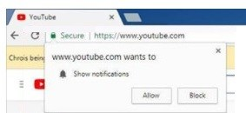](https://i0.wp.com/www.softwaretestingmaterial.com/wp-content/uploads/2017/04/Notification-Popup.jpg?ssl=1)

In Chrome, we can use ChromeOptions as shown below.

|  |  |
| --- | --- |
| 1  2  3 | ChromeOptions options = new ChromeOptions();  options.addArguments("disable-infobars");  WebDriver driver = new ChromeDriver(options); |