Question1. Write a function that stutters a word as if someone is struggling to read it. The first two letters are repeated twice with an ellipsis ... and space after each, and then the word is pronounced with a question mark ?.

**Examples**

stutter("incredible") ➞ "in... in... incredible?"

stutter("enthusiastic") ➞ "en... en... enthusiastic?"

stutter("outstanding") ➞ "ou... ou... outstanding?"

Hint :- Assume all input is in lower case and at least two characters long.

Ans. def stutterWord():

in_string = input('Enter the Word :')

out_string = in_string.replace(in_string[0:2],((in_string[0:2]+'... ')*2)+ in_string[0:2]) +'?'

print(f'{in_string} ➞ {out_string}')

for i in range(3):

stutterWord()

Question 2.Create a function that takes an angle in radians and returns the corresponding angle in degrees rounded to one decimal place.

### Examples

radians_to_degrees(1) ➞ 57.3

radians_to_degrees(20) ➞ 1145.9

radians_to_degrees(50) ➞ 2864.8

Ans. import math

def radianToDegree():

in_num = int(input('Enter the angle in Radians: '))

out_num = (180/math.pi)*in_num

print(f'{in_num} radian(s) ➞ {out_num:.1f} degrees')

for x in range(3):

radianToDegree()

Question 3. In this challenge, establish if a given integer num is a Curzon number. If 1 plus 2 elevated to num is exactly divisible by 1 plus 2 multiplied by num, then num is a Curzon number.

Given a non-negative integer num, implement a function that returns True if num is a Curzon number, or False otherwise.

### Examples

is_curzon(5) ➞ True

# 2 ** 5 + 1 = 33

# 2 * 5 + 1 = 11

# 33 is a multiple of 11

is_curzon(10) ➞ False

# 2 ** 10 + 1 = 1025

# 2 * 10 + 1 = 21

# 1025 is not a multiple of 21

is_curzon(14) ➞ True

# 2 ** 14 + 1 = 16385

# 2 * 14 + 1 = 29

# 16385 is a multiple of 29

Ans. def checkCurzon():

in_num = int(input("Enter a number: "))

if (pow(2,in_num)+1)%((2*in_num)+1) == 0:

print(f'{in_num} is a Curzon Number')

else:

print(f'{in_num} is Not a Curzon Number')

for x in range(4):

checkCurzon()

Question 4.Given the side length x find the area of a hexagon.

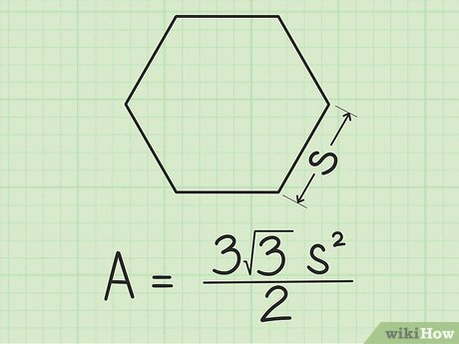

### Examples

area_of_hexagon(1) ➞ 2.6

area_of_hexagon(2) ➞ 10.4

area_of_hexagon(3) ➞ 23.4

Ans. import math

def areaOfHexagon():

in_num = int(input('Enter the side length of a Hexagon: '))

out_num = ((3*math.sqrt(3))/2)*(pow(in_num,2))

print(f'Area for Hexagon of sidelength {in_num} ➞ {out_num:.1f}')

for x in range(3):

areaOfHexagon()

Question 5. Create a function that returns a base-2 (binary) representation of a base-10 (decimal) string number. To convert is simple: ((2) means base-2 and (10) means base-10) 010101001(2) = 1 + 8 + 32 + 128.

Going from right to left, the value of the most right bit is 1, now from that every bit to the left will be x2 the value, value of an 8 bit binary numbers are (256, 128, 64, 32, 16, 8, 4, 2, 1).

### Examples

binary(1) ➞ "1"

# 1*1 = 1

binary(5) ➞ "101"

# 1*1 + 1*4 = 5

binary(10) ➞ "1010"

# 1*2 + 1*8 = 10

Ans. def getBinary():

in_num = int(input("Enter a Number: "))

out_num = bin(in_num).replace('0b','')

print(f'Binary of {in_num} ➞ {out_num}')

for x in range(3):

getBinary()