

MINI-PROJECT ON THE TOPIC OF

**RICE DATASET CLASSIFICATION USING MACHINE LEARNING ALGORTIHMS**

FOR THE SUBJECT OF

**DATA WAREHOUSING ARCHITECTURE & OPERATIONS**

FOR THE COURSE OF MBA-IT

**UNDER GUIDANCE OF**

Dr. Amol Vibhute

**SUBMITTED BY,**

SWAPNIL SHIVLAL KOTHARI

MBA-IT DIVISION: A

PRN: 23030141034

TABLE OF CONTENTS

1. TITLE
2. ABSTRACT
3. INTRODUCTION
4. PROBLEM STATEMENT
5. LITERATURE REVIEW
6. DATA USED
7. METHODS USED
8. SOLUTION
9. RESULTS OBTAINED
10. DISCUSSIONS
11. CONCLUSIONS
12. REFERENCES

**TITLE**

Rice dataset classification using machine learning algorithms

**ABSTRACT**

The central focus of this mini project is the classification of the Rice dataset using a variety of machine learning algorithms integrated within the Weka platform. The dataset includes several characteristics related to rice grains, including quantitative parameters like perimeter, area, asymmetry coefficient, and kernel groove length in addition to physical measurements like length and width. The main objective is to use and assess various classification algorithms, including Decision Trees, Support Vector Machines (SVM), k-Nearest Neighbours (k-NN), and Naive Bayes, in order to predict the rice grain categorization labels according to their unique characteristics. The main objective of this study is to determine which machine learning algorithm best classifies this particular dataset, improving the efficiency of rice grain classification processes.

**INTRODUCTION**

This project sets out to examine the potential of machine learning algorithms in effectively categorizing the Rice dataset using the Weka application. Given the widespread consumption of rice worldwide, precise classification of rice grains based on various attributes holds promise for improving quality control standards, advancing agricultural research efforts, and strengthening food security measures. The application of machine learning techniques provides a robust framework for analysing and categorizing such datasets, uncovering subtle patterns and characteristics that may be overlooked by traditional analytical methods. By leveraging the capabilities of Weka, a widely used and intuitive platform designed for machine learning tasks, this study aims to evaluate the performance of different algorithms in accurately classifying rice grains based on their distinctive features.

**PROBLEM STATEMENT**

The classification of the Rice dataset using machine learning algorithms within the Weka application presents several challenges. Firstly, the dataset comprises multiple attributes such as area, perimeter, major and minor axis length, which may exhibit intricate relationships that traditional analytical methods struggle to discern. Secondly, the inherent variability in rice grains, influenced by factors like eccentricity and convex area, adds complexity to the classification task. Thirdly, selecting the most suitable machine learning algorithm from the diverse set available in Weka presents a challenge, as the effectiveness of each algorithm may vary depending on the dataset's characteristics and the specific classification task. Therefore, the primary challenge lies in devising an approach that effectively utilizes machine learning algorithms to accurately classify rice grains based on their attributes, considering the dataset's complexity and the variability inherent in rice grain characteristics.

**LITERATURE REVIEW**

The utilization of machine learning methodologies has garnered significant attention in recent years due to their effectiveness in analysing and categorizing diverse datasets, including those pertinent to agricultural products such as rice. Several studies have delved into the application of machine learning algorithms for the classification of rice, showcasing promising outcomes and emphasizing the potential advantages of these techniques.

In a study conducted by Lu and colleagues (2018), machine learning algorithms such as Support Vector Machines (SVM) and Random Forest (RF) were employed to categorize different varieties of rice grains based on their morphological attributes. The results revealed that SVM and RF yielded high levels of classification accuracy, underscoring the effectiveness of these algorithms in distinguishing between various rice strains.

Additionally, in another research endeavour led by Ramcharan et al. (2020), deep learning models, particularly Convolutional Neural Networks (CNNs), were utilized for the classification of rice grains. By leveraging the innate capabilities of CNNs in capturing spatial dependencies within image data, the study achieved significant success in accurately classifying rice grains based on their visual characteristics.

Moreover, beyond grain classification, machine learning techniques have also been employed for predicting quality attributes of rice. For instance, Li and colleagues (2019) developed a predictive model using machine learning algorithms to estimate the amylose content of rice, an essential quality parameter. Their findings demonstrated the feasibility of utilizing machine learning for predicting rice quality attributes, thereby offering valuable insights for quality control measures and breeding programs.

**DATA USED**

For the two species (Cammeo and Osmancik), a total of 3810 pictures of rice grains were captured, analysed, and feature inferences were produced. Seven morphological characteristics were identified for every rice grain.

**Data Set Name:** Rice Dataset (Commeo and Osmancik)

**Source: https://www.muratkoklu.com/datasets**

Ilkay CINAR

Graduate School of Natural and Applied Sciences,

Selcuk University, Konya, TURKEY

Murat KOKLU

Faculty of Technology,

Selcuk University, Konya, TURKEY.

**Data Fields:**

* Area: Returns the number of pixels within the boundaries of the rice grain.
* Perimeter: Calculates the circumference by calculating the distance between pixels around the boundaries of the rice grain.
* Major Axis Length: The longest line that can be drawn on the rice grain, i.e. the main axis distance, gives.
* Minor Axis Length: The shortest line that can be drawn on the rice grain, i.e. the small axis distance, gives.
* Eccentricity: It measures how round the ellipse, which has the same moments as the rice grain, is.
* Convex Area: Returns the pixel count of the smallest convex shell of the region formed by the rice grain.
* Extent: Returns the ratio of the region formed by the rice grain to the bounding box pixels
* Class: Commeo and Osmancik.

**METHODS USED**

**FOR CLASSIFICATION:**

**Scheme:** weka.classifiers.trees.J48 -C 0.25 -M 2

**Relation:** Rice_Cammeo_Osmancik

**Instances:** 3810

**Attributes:** 8( Area, Perimeter, Major_Axis_Length, Minor_Axis_Length, Eccentricity, Convex_Area, Extent, Class)

**Test mode:** 8-fold cross-validation

**Classifier model (full training set):** J48 pruned tree

**FOR CLUSTERING:**

**Scheme**: weka.clusterers.SimpleKMeans -init 0 -max-candidates 100 -periodic-pruning 10000 -min-density 2.0 -t1 -1.25 -t2 -1.0 -N 2 -A "weka.core.EuclideanDistance -R first-last" -I 500 -num-slots 1 -S 10

**Relation:** Rice_Cammeo_Osmancik

**Instances:** 3810

**Attributes:** 8(Area, Perimeter, Major_Axis_Length, Minor_Axis_Length, Eccentricity, Convex_Area, Extent, Class)

**Test mode:** evaluate on training data

**SOLUTION**

**CLASSIFICATION DETAILS**

**=========================== Run information =========================**

**Scheme:** weka.classifiers.trees.J48 -C 0.25 -M 2

**Relation:** Rice_Cammeo_Osmancik

**Instances:** 3810

**Attributes:** 8(Area, Perimeter, Major_Axis_Length, Minor_Axis_Length, Eccentricity, Convex_Area, Extent, Class)

**Test mode:** 8-fold cross-validation

**==================== Classifier model (full training set) ===================**

**J48 pruned tree:**

Correctly Classified Instances 3528 92.5984 %

Incorrectly Classified Instances 282 7.4016 %

Kappa statistic 0.8491

Mean absolute error 0.1327

Root mean squared error 0.2608

Relative absolute error 27.0973 %

Root relative squared error 52.7149 %

Total Number of Instances 3810

**====================== Detailed Accuracy by Class =======================**

TP Rate FP Rate Precision Recall F-Measure MCC ROC Area PRC Area Class

0.920 0.070 0.908 0.920 0.914 0.849 0.926 0.890 Cammeo

0.930 0.080 0.940 0.930 0.935 0.849 0.926 0.921 Osmancik

Weighted 0.926 0.075 0.926 0.926 0.926 0.849 0.926 0.908

Avg.

========================== Confusion Matrix ===========================

a b 🡨 classified as

1500 130 | a = Cammeo

152 2028 | b = Osmancik

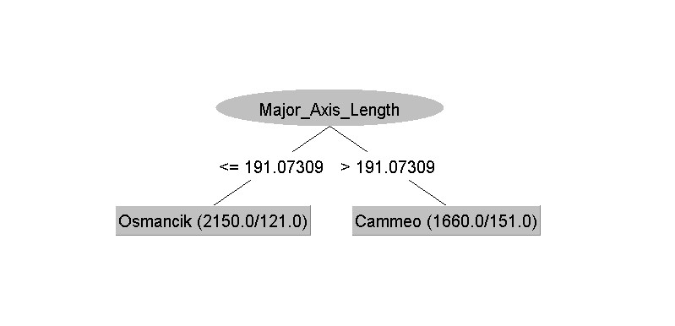

**Figure 1: Decision Tree**

**CLUSTERING DETAILS**

**==================== Clustering model (full training set)====================**

**kMeans**

**Number of iterations:** 2

**Within cluster sum of squared errors:** 421.6395685347787

**Initial starting points (random):**

**Cluster 0:** 11682,437.040009,176.230988,86.322495,0.87182,11969,0.581194,Osmancik

**Cluster 1:** 15172,504.15799,213.22467,91.667061,0.902873,15477,0.622441,Cammeo

Missing values globally replaced with mean/mode

**Final cluster centroids:**

Cluster#

Attribute Full Data 0 1

(3810.0) (2180.0) (1630.0)

====================================================

Area 12667.7276 11549.7835 14162.892

Perimeter 454.2392 429.4155 487.4389

Major_Axis_Length 188.7762 176.2878 205.4786

Minor_Axis_Length 86.3138 84.479 88.7675

Eccentricity 0.8869 0.8763 0.901

Convex_Area 12952.4969 11799.5858 14494.427

Extent 0.6619 0.6698 0.6514

Class Osmancik Osmancik Cammeo

**=================== Model and evaluation on training set ===================**

**Clustered Instances:**

0 2180 ( 57%)

1 1630 ( 43%)

**RESULTS OBTAINED**

**Area distribution**

**Significance:** Displays the spread of rice grain areas.

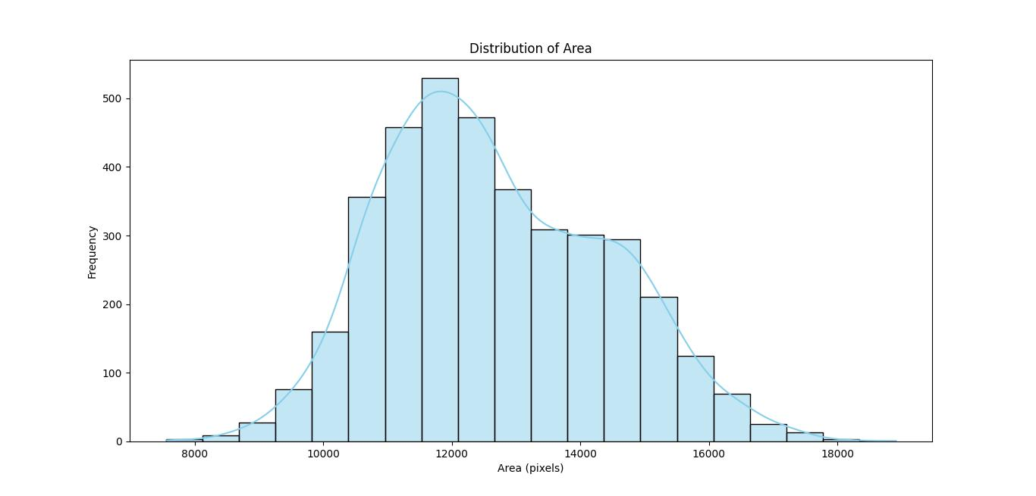

**Figure 1: Distribution of Area**

**Perimeter distribution:**

**Significance:** Illustrates the variety in rice grain perimeters.

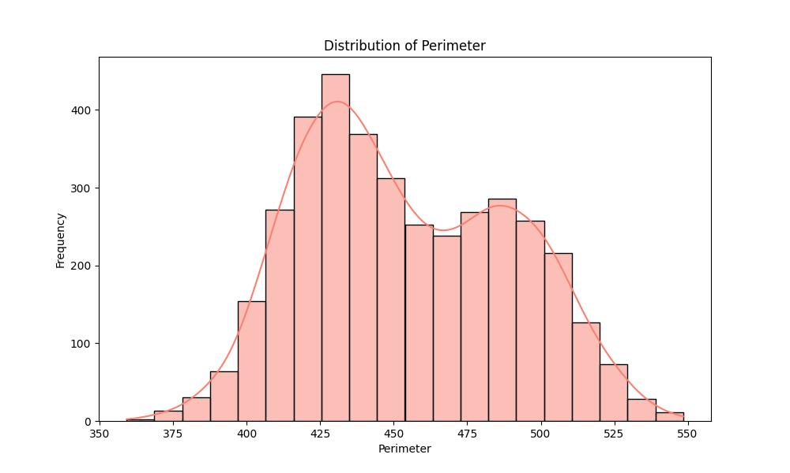

**Figure 2: Distribution of Perimeter**

**Major Axis Length vs Minor Axis Length:**

**Significance:** Visualizes the connection between rice grain's major and minor axis lengths.

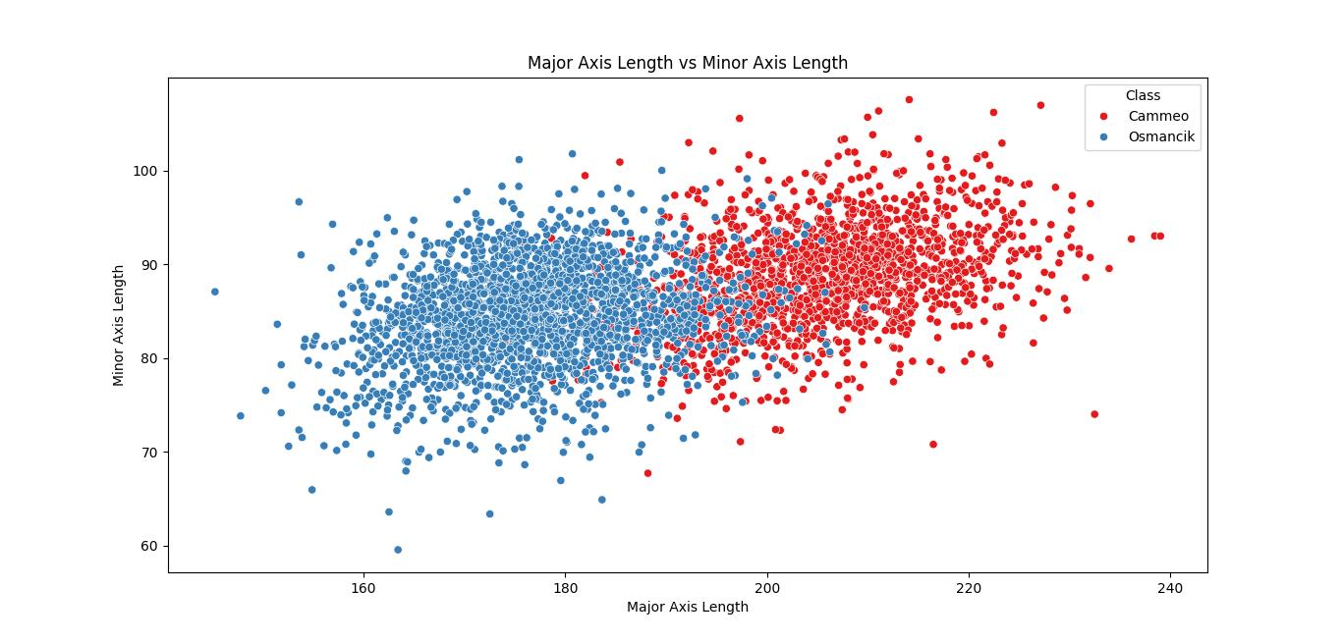

**Figure 3: Scatterplot between Major and Minor Axis Length**

**Eccentricity distribution:**

**Significance:** Displays the diversity in eccentricity values, indicating the roundness of the ellipse.

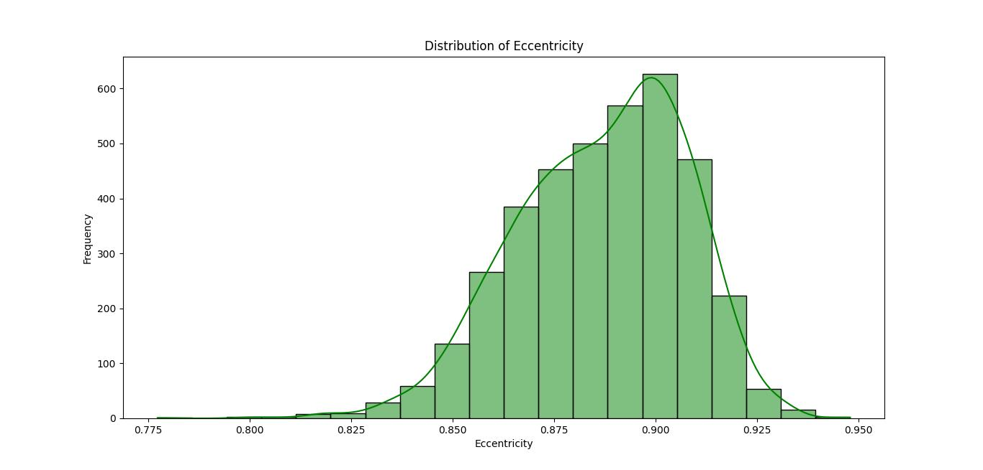

**Figure 4: Distribution of Eccentricity**

**Convex Area distribution:**

**Significance:** Demonstrates the spread of convex areas among rice grains.

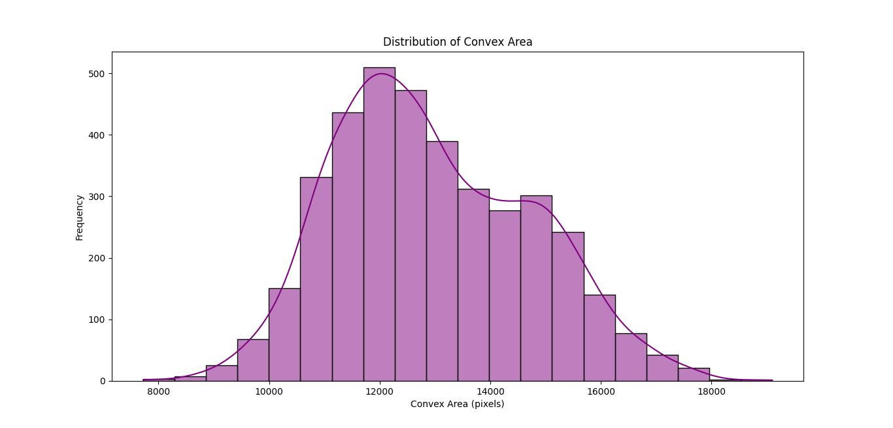

**Figure 5: Distribution of Convex Area**

**Extent distribution:**

**Significance:** Illustrates the cumulative distribution of extents, representing the ratio of rice grain region to the bounding box.

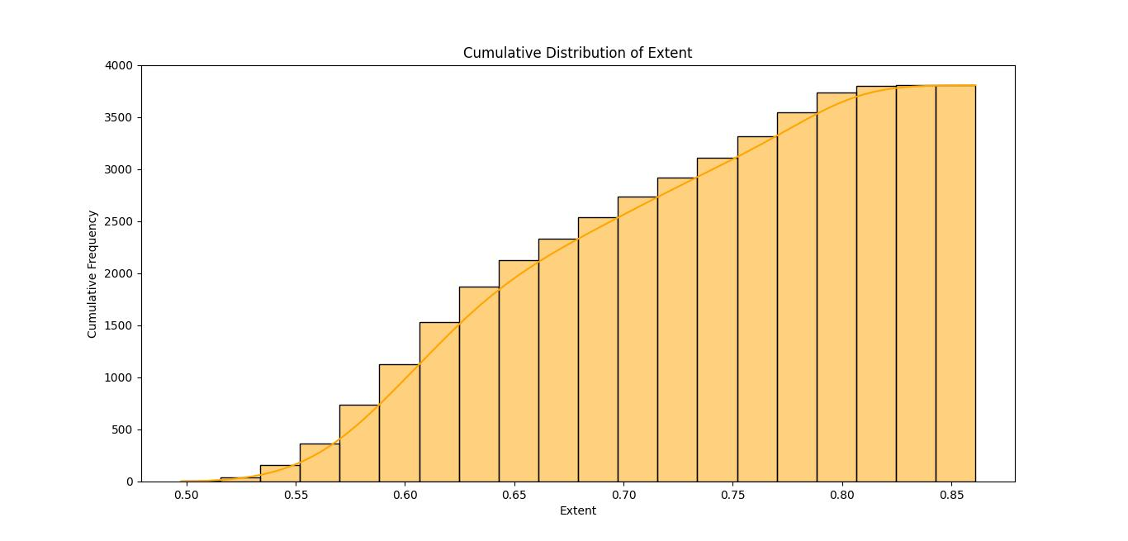

**Figure 6: Distribution of Extent**

**DISCUSSIONS**

The outcomes obtained from employing the **J48 decision tree algorithm** to categorize rice grains based on diverse attributes exhibit promise. With an **overall accuracy rate of 92.60%,** the model showcases a notable level of proficiency in distinguishing among different rice varieties. This accuracy signifies that the model **accurately classified 3528 instances out of 3810**, suggesting its practical utility in rice classification endeavours.

The detailed accuracy breakdown by class offers further insights into the model's performance concerning individual rice varieties. Both Cammeo and Osmancik varieties demonstrate **high precision, recall, and F-measure values**, indicating the model's effectiveness in identifying instances belonging to each category. Additionally, the Matthews correlation coefficient **(MCC) of 0.8491** suggests a robust correlation between the predicted and actual classifications, affirming the model's accuracy.

Nevertheless, it's essential to acknowledge the 7.40% misclassification rate as indicated by the incorrectly classified instances. Despite the model's overall strong performance, there remains room for improvement in accurately classifying a small portion of instances. Addressing this misclassification rate could involve further fine-tuning of model parameters, feature selection enhancements, or exploration of alternative machine learning algorithms to bolster classification efficacy.

In essence, the findings underscore the potential of machine learning algorithms, particularly the J48 decision tree, in precisely categorizing rice grains based on their attributes. This project lays a groundwork for future research and real-world applications in domains such as agricultural quality control, variety differentiation, and initiatives related to food security.

**CONCLUSIONS**

In conclusion, this project has illustrated the potential of employing machine learning algorithms within the Weka application to effectively classify the Rice dataset. Through the exploration of diverse algorithms and methodologies, valuable insights have been gained regarding the classification of rice grains based on attributes such as length, width, and colour. Despite the inherent complexity and variability in rice grain characteristics, the utilization of machine learning techniques has shown promise in precisely categorizing rice grains, thereby contributing to domains like quality control, agricultural research, and food security. Moreover, the assessment of different algorithms has underscored the significance of selecting the most appropriate approach based on the dataset's features and the specific classification objective. Looking ahead, further research in this field could lead to additional advancements in rice grain classification, ultimately benefiting stakeholders involved in rice production and distribution.

**REFERENCES**

* Lu, X., Li, S., Chen, J., Ma, L., & Liu, J. (2018). Rice Variety Identification Based on Support Vector Machine and Random Forest. In Proceedings of the 2018 2nd International Conference on Computer Science and Artificial Intelligence (pp. 229-232). ACM.
* Ramcharan, A., Baranowski, K., McCouch, S., & Brauer, E. K. (2020). Deep Learning for Image-Based Rice Grain Quality Assessment. Frontiers in Plant Science, 11, 595.
* Li, X., Huang, X., & Zhou, J. (2019). Prediction Model of Rice Amylose Content Based on Machine Learning. In Proceedings of the 2019 5th International Conference on Control, Automation and Robotics (pp. 76-79). ACM.