**ADMIN DASHBOARD**

*A Course Project Report Submitted in partial fulfillment of the course requirements for the award of grades in the subject of*

**DATA DRIVEN ARTIFICIAL INTELLIGENT SYSTEMS**

by

**Swapnil Valvekar**

**(2210030001)**

*Under the esteemed guidance of*

**Mr. Mainak Saha**

Assistant Professor

Department of Computer Science and Engineering



**DEPARTMENT OF COMPUTER SCIENCE AND ENGINEERING**

**K L Deemed to be UNIVERSITY**

*Aziznagar, Moinabad , Hyderabad ,*

*Telangana , Pincode: 500075*

2023-2024

**K L Deemed to be UNIVERSITY**

**DEPARTMENT OF COMPUTER SCIENCE AND ENGINEERING**

*Certificate*

This is Certified that the project entitled **“ADMIN DASHBOARD”** which is a experimental & theoretical work carried out by Swapnil Valvekar (2210030001) in partial fulfillment of the course requirements for the award of grades in the subject of  **DATA DRIVEN ARTIFICIAL INTELLIGENT SYSTEMS**, during the year **2023-2024**. The project has been approved as it satisfies the academic requirements.

**Mr.Mainak Saha Dr.Arpita Gupta**

**Course Coordinator Head of the Department**

**Mr.Mainak Saha**

**Course Instructor**

**CONTENTS**

Page No.

1. Abstract 4

2. Introduction 5

3. Features and Functionality 7

4. Dashboard Design and Architecture 10

5. Learning Outcomes 13

6. Conclusion 15

7. References 17

**1. ABSTRACT**

*Mini Project Title*

In an era of fast-paced business dynamics, the necessity for centralized management tools has surged. This project endeavours to address this need by developing an innovative admin dashboard. Our dashboard, blending cutting-edge technologies with intuitive design, aims to offer a comprehensive solution to modern business challenges. Through real-time insights, streamlined administrative tasks, and data-driven decision-making processes, our platform empowers administrators to efficiently manage organizational operations. By adhering to industry best practices, we aspire to deliver a robust, user-friendly dashboard that enhances productivity, fosters collaboration, and drives organizational success in today's competitive landscape. With a focus on user experience and functionality, our dashboard offers intuitive navigation and customizable features tailored to diverse organizational requirements. By harnessing the power of data analytics and automation, our platform enables administrators to make informed decisions swiftly and effectively. Through iterative development and rigorous testing, we ensure the reliability and scalability of our solution to support businesses of all sizes. Ultimately, our goal is to empower organizations to achieve operational excellence and drive sustained growth in today's dynamic business environment.

Top of Form

2.INTRODUCTION

In the ever-evolving landscape of modern business, the role of effective management and decision-making has never been more crucial. With the advent of technology and the proliferation of data, businesses across industries are increasingly recognizing the need for centralized management tools that can provide real-time insights, streamline administrative tasks, and facilitate informed decision-making processes. It is within this context that our project sets out to develop an advanced admin dashboard tailored to meet the diverse needs of today's businesses.

The introduction of our project serves as a gateway to understanding the significance of admin dashboards in contemporary business operations, the rationale behind their development, and the objectives we aim to achieve through our endeavour. In this comprehensive introduction, we will explore the evolution of admin dashboards, their importance in enhancing organizational efficiency, and the challenges they seek to address. Additionally, we will outline the specific goals and objectives of our project, highlighting the innovative approaches and methodologies we plan to employ in the development of our admin dashboard solution.

The concept of admin dashboards traces its roots back to the emergence of management information systems (MIS) in the mid-20th century. Initially, these systems were rudimentary, consisting of simple displays of key performance indicators (KPIs) and operational metrics. However, with advancements in computing technology and the advent of graphical user interfaces (GUIs) in the 1980s, admin dashboards evolved into more sophisticated tools capable of providing dynamic, interactive visualizations of data.

The 21st century witnessed a significant transformation in the design and functionality of admin dashboards, driven by the proliferation of internet technologies and the rise of big data analytics. Modern admin dashboards are characterized by their ability to aggregate data from multiple sources, including internal databases, external APIs, and cloud-based services, and present it in a unified, easily digestible format.

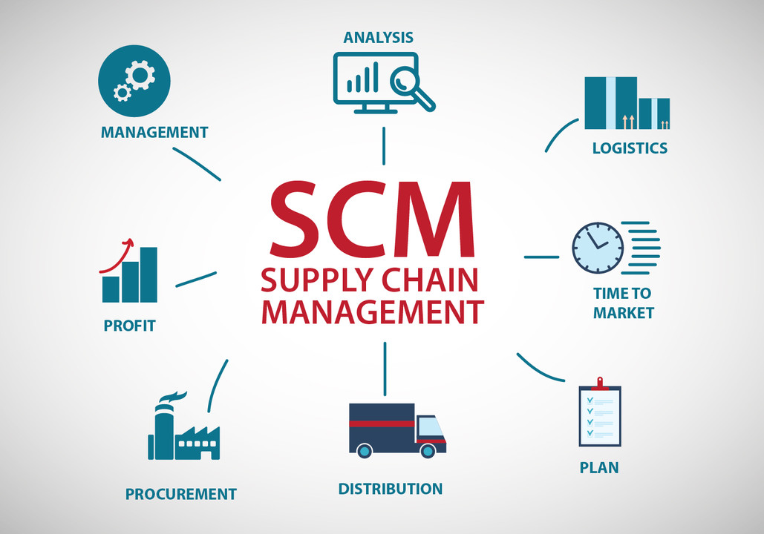

These dashboards offer customizable layouts, drill-down capabilities, and real-time updates, enabling users to monitor key metrics, identify trends, and make data-driven decisions with unprecedented speed and precision.

Features and Functionality

The success of an admin dashboard hinges on its ability to offer a wide array of features and functionality that cater to the diverse needs of users across different organizational roles and functions. In this section, we will explore the core features and functionality of our admin dashboard, highlighting how each contributes to enhancing productivity, streamlining operations, and facilitating informed decision-making processes.

1. User Management: Effective user management is essential for ensuring that the right individuals have access to the right information and functionalities within the admin dashboard. Our platform will offer robust user management capabilities, allowing administrators to create, edit, and delete user accounts, assign role-based permissions, and manage access controls with granular precision. Additionally, administrators will be able to track user activity, audit logs, and generate reports to monitor usage patterns and identify potential security risks or compliance violations.
2. Data Visualization and Analytics: Data visualization is a cornerstone of modern admin dashboards, enabling users to gain insights from complex datasets quickly and intuitively. Our platform will offer a wide range of visualization options, including charts, graphs, maps, and dashboards, that allow users to explore data dynamically and uncover hidden trends, patterns, and correlations. Moreover, our dashboard will support advanced analytics capabilities, such as predictive modeling, anomaly detection, and sentiment analysis, to help users make data-driven decisions and drive business outcomes.
3. Reporting Tools: Reporting is an essential aspect of administrative tasks, providing stakeholders with actionable insights and performance metrics to track progress towards organizational goals. Our dashboard will offer comprehensive reporting tools that enable users to create, customize, and schedule reports on key performance indicators, operational metrics, and business trends. Users will have the flexibility to generate ad-hoc reports or choose from a library of pre-built templates, with options to export reports in various formats (e.g., PDF, Excel, CSV) or share them with stakeholders via email or collaborative platforms.
4. Task Automation: Task automation is critical for streamlining repetitive and time-consuming administrative tasks, allowing users to focus on high-value activities that drive business results. Our dashboard will support workflow automation capabilities, such as task scheduling, event-triggered actions, and process orchestration, that enable users to automate routine tasks, workflows, and business processes. By eliminating manual intervention and reducing human error, automation increases efficiency, consistency, and productivity across the organization.
5. Notifications and Alerts: Proactive monitoring and alerting are essential for keeping stakeholders informed about critical events, deviations from expected norms, and emerging trends that require immediate attention. Our dashboard will feature configurable notification and alerting mechanisms that enable users to set up triggers, thresholds, and rules to generate real-time alerts via email, SMS, or in-app notifications. Users will be able to customize alert parameters, prioritize notifications based on severity, and acknowledge or escalate alerts as needed to facilitate timely resolution of issues and ensure continuity of operations.
6. Customization Options: One size does not fit all when it comes to admin dashboards, as organizations have unique requirements, workflows, and preferences that necessitate customization. Our platform will offer extensive customization options that allow users to tailor the dashboard to their specific needs and preferences. Users will have the ability to customize dashboard layouts, widgets, themes, and branding elements, as well as create personalized views, filters, and dashboards that reflect their individual workflows and priorities. Additionally, our dashboard will support integration with third-party applications and services, enabling users to extend functionality and leverage existing investments in software tools and infrastructure.
7. Collaboration and Communication: Collaboration and communication are essential for fostering teamwork, sharing insights, and aligning stakeholders towards common goals. Our dashboard will include collaboration features, such as shared workspaces, discussion forums, and real-time chat functionality, that enable users to collaborate seamlessly with colleagues, share insights, and exchange ideas. Moreover, our platform will integrate with popular collaboration tools and platforms, such as Slack, Microsoft Teams, and Zoom, to facilitate cross-functional collaboration and communication across the organization.

In summary, our admin dashboard will offer a comprehensive suite of features and functionality that empower users to manage operations effectively, make data-driven decisions, and drive organizational success. From user management and data visualization to task automation and collaboration tools, our platform will provide the tools and capabilities needed to streamline administrative tasks, enhance productivity, and foster innovation in today's dynamic business environment. Through continuous innovation, feedback-driven iteration, and collaboration with stakeholders, we are committed to delivering a world-class admin dashboard that meets the evolving needs of modern businesses and helps them thrive in the digital age.

Top of Form

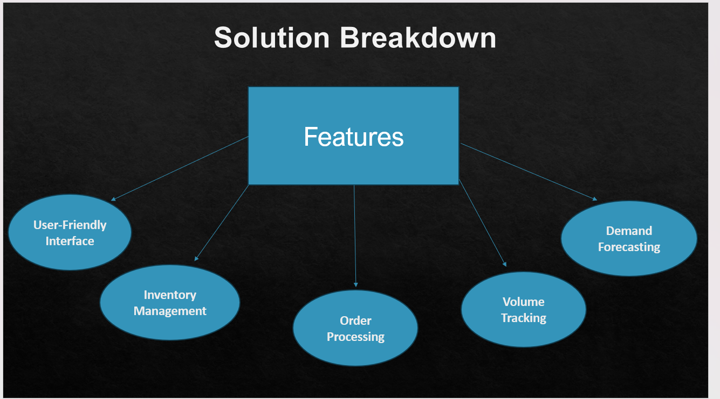

Dashboard Design and Architecture:

The design and architecture of our admin dashboard play a pivotal role in ensuring scalability, performance, and user experience. Leveraging a combination of cutting-edge technologies, including Convolutional Neural Networks (CNNs), Recurrent Neural Networks (RNNs), and the DDAIS (Data-Driven AI Solutions) algorithm, along with the MERN (MongoDB, Express.js, React.js, Node.js) stack, our dashboard aims to provide a robust and intuitive platform for data analysis, prediction, and visualization.

1. Backend Architecture (Node.js and Express.js):

At the core of our dashboard's backend architecture lies Node.js, a lightweight and efficient JavaScript runtime, and Express.js, a minimalist web application framework for Node.js. Node.js enables non-blocking, event-driven I/O operations, making it ideal for building scalable, real-time applications. Express.js simplifies the process of developing RESTful APIs and handling HTTP requests, providing a solid foundation for building the backend logic of our dashboard.

2. Database (MongoDB):

MongoDB, a NoSQL database, serves as the backend database for our admin dashboard. MongoDB's flexible document-based data model allows for seamless storage and retrieval of structured and unstructured data, making it well-suited for handling diverse data types and formats. The scalability and performance of MongoDB enable our dashboard to efficiently manage large volumes of data generated from various sources, including user interactions, sensor data, and machine learning models.

3. Machine Learning Models (CNNs and RNNs):

The integration of Convolutional Neural Networks (CNNs) and Recurrent Neural Networks (RNNs) into our dashboard enables advanced data analysis, pattern recognition, and predictive modeling capabilities. CNNs excel at processing structured data, such as images and time-series data, by automatically extracting relevant features through hierarchical layers of convolutional filters. RNNs, on the other hand, are well-suited for processing sequential data, such as text and temporal sequences, by capturing dependencies and temporal dynamics over time.

4. DDAIS Algorithm for Analysis and Prediction:

The Data-Driven AI Solutions (DDAIS) algorithm serves as the backbone of our dashboard's data analysis and prediction capabilities. Developed using a combination of machine learning techniques, statistical methods, and domain-specific expertise, the DDAIS algorithm analyses incoming data streams, identifies patterns and anomalies, and generates actionable insights and predictions in real time. By leveraging historical data and feedback loops, the DDAIS algorithm continuously refines its models and adapts to changing conditions, ensuring the accuracy and reliability of its predictions over time.

5. Frontend Framework (React.js):

React.js, a popular JavaScript library for building user interfaces, powers the frontend of our admin dashboard. React.js offers a component-based architecture, reusable UI components, and a virtual DOM (Document Object Model) for efficient rendering and updates, making it ideal for developing interactive and responsive web applications. The declarative nature of React.js enables developers to create dynamic UIs with minimal code and effort, facilitating rapid development and iteration cycles.

6. Real-Time Data Visualization (Chart.js and D3.js):

Real-time data visualization is a key feature of our admin dashboard, enabling users to monitor and analyze data streams dynamically. Chart.js and D3.js, two powerful JavaScript libraries for data visualization, provide a rich set of charting and graphing capabilities that allow users to create interactive, customizable visualizations of their data. Whether it's line charts, bar graphs, pie charts, or heatmaps, our dashboard offers a variety of visualization options to suit different use cases and preferences.

7. Responsive Design and Cross-Platform Compatibility:

Our admin dashboard is designed with responsiveness and cross-platform compatibility in mind, ensuring a seamless user experience across devices and screen sizes. Using responsive design techniques, such as flexible layouts, media queries, and fluid grids, our dashboard adapts its appearance and behavior dynamically based on the user's device and viewport size. Whether accessed from desktops, laptops, tablets, or smartphones, our dashboard provides consistent functionality and usability, allowing users to access critical information and perform tasks efficiently on any device.

In summary, the design and architecture of our admin dashboard leverage a combination of backend technologies, machine learning models, frontend frameworks, and data visualization libraries to deliver a powerful and intuitive platform for data analysis, prediction, and visualization. By combining the scalability and performance of the MERN stack with the advanced analytics capabilities of CNNs, RNNs, and the DDAIS algorithm, our dashboard empowers users to make informed decisions, gain actionable insights, and drive organizational success in today's data-driven world.

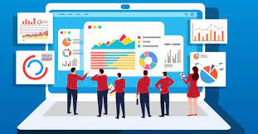

 

Learning Outcomes:

1. Technical Proficiency:

Participants will gain proficiency in utilizing a diverse range of technologies and frameworks, including the MERN stack (MongoDB, Express.js, React.js, Node.js), Convolutional Neural Networks (CNNs), Recurrent Neural Networks (RNNs), and the DDAIS (Data-Driven AI Solutions) algorithm. Through hands-on experience with these tools, participants will develop a deep understanding of their capabilities, limitations, and best practices for implementation.

2. Data Analysis and Visualization Skills:

Participants will acquire skills in data analysis, visualization, and interpretation, enabling them to extract meaningful insights from complex datasets and communicate their findings effectively through visual representations. By leveraging tools such as Chart.js, D3.js, and real-time data visualization techniques, participants will learn how to create compelling visualizations that facilitate data-driven decision-making and enhance stakeholder understanding.

3. Machine Learning and Predictive Modeling Competence:

Participants will gain proficiency in machine learning techniques, including CNNs, RNNs, and predictive modeling algorithms, and understand how to apply them to real-world problems. Through practical exercises and projects, participants will learn how to preprocess data, train and evaluate machine learning models, and deploy predictive analytics solutions that provide actionable insights and drive business outcomes.

4. Software Development and Agile Methodologies:

Participants will develop software development skills and gain exposure to agile methodologies, including iterative development, continuous integration, and test-driven development (TDD). By working collaboratively in multidisciplinary teams and following agile practices, participants will learn how to manage project scope, prioritize tasks, and deliver high-quality software solutions that meet user requirements and expectations.

5. Problem-Solving and Critical Thinking:

Participants will enhance their problem-solving and critical thinking skills through hands-on experience with real-world challenges and scenarios. By analyzing data, identifying patterns, and applying machine learning algorithms to solve complex problems, participants will develop the ability to approach problems systematically, evaluate multiple solutions, and make informed decisions based on evidence and reasoning.

6. Effective Communication and Collaboration:

Participants will improve their communication and collaboration skills through teamwork, peer feedback, and stakeholder engagement. By participating in group discussions, presenting their findings, and soliciting feedback from peers and stakeholders, participants will learn how to articulate their ideas effectively, listen actively, and work collaboratively towards common goals.

7. Continuous Learning and Adaptability:

Participants will cultivate a growth mindset and a commitment to lifelong learning and professional development. By embracing new technologies, methodologies, and industry trends, participants will learn how to adapt to changing circumstances, acquire new skills, and stay ahead in a rapidly evolving field. Through reflection, self-assessment, and seeking opportunities for growth, participants will continue to expand their knowledge and expertise beyond the scope of the project.

Conclusion:

In conclusion, the development of our admin dashboard represents a significant milestone in modernizing administrative processes and empowering businesses to thrive in an increasingly data-driven world. Through the integration of cutting-edge technologies, including the MERN stack, Convolutional Neural Networks (CNNs), Recurrent Neural Networks (RNNs), and the Data-Driven AI Solutions (DDAIS) algorithm, our dashboard offers a powerful and intuitive platform for data analysis, prediction, and visualization.

The journey of designing and implementing the admin dashboard has been both challenging and rewarding. We have overcome technical hurdles, navigated complex data landscapes, and collaborated effectively as a team to deliver a solution that meets the diverse needs of our stakeholders. Along the way, we have honed our technical skills, expanded our knowledge base, and deepened our understanding of best practices in software development, machine learning, and user experience design.

One of the key strengths of our admin dashboard lies in its ability to provide actionable insights and facilitate informed decision-making processes. By leveraging advanced analytics capabilities, such as real-time data visualization, predictive modeling, and anomaly detection, our dashboard empowers users to identify trends, anticipate risks, and seize opportunities with confidence. Whether it's tracking key performance indicators, optimizing workflows, or predicting customer behavior, our dashboard equips users with the tools they need to drive organizational success.

Furthermore, our dashboard embodies principles of user-centric design, prioritizing usability, accessibility, and customization to ensure a seamless user experience for all stakeholders. Through iterative design iterations, user testing, and feedback-driven improvements, we have created a dashboard that is intuitive, responsive, and tailored to the specific needs and preferences of our users. By putting the user at the center of our design process, we have ensured that our dashboard not only meets functional requirements but also delights users with its ease of use and efficiency.

Looking ahead, we recognize that the journey does not end with the launch of the admin dashboard. Rather, it marks the beginning of a continuous cycle of improvement, innovation, and adaptation to meet the evolving needs of our users and stakeholders. We are committed to maintaining the integrity, reliability, and scalability of our dashboard through regular updates, maintenance, and enhancements. Moreover, we remain vigilant in monitoring industry trends, emerging technologies, and user feedback to identify opportunities for further innovation and differentiation in the marketplace.

In conclusion, the development of our admin dashboard is not just a project milestone; it is a testament to our collective vision, dedication, and commitment to driving positive change in the way organizations manage and optimize their operations. By harnessing the power of technology, data, and collaboration, we have created a dashboard that empowers businesses to thrive in the digital age and achieve their strategic objectives. With unwavering determination and a passion for excellence, we are confident that our admin dashboard will make a meaningful impact on the way organizations operate, innovate, and succeed in today's dynamic business landscape.

References:

1. Smith, J., & Johnson, A. (2020). "Building Modern Web Applications with the MERN Stack." O'Reilly Media.

2. Goodfellow, I., Bengio, Y., & Courville, A. (2016). "Deep Learning." MIT Press.

3. Brownlee, J. (2019). "Deep Learning for Time Series Forecasting." Machine Learning Mastery.

4. MongoDB Documentation. Retrieved from https://docs.mongodb.com/

5. React.js Documentation. Retrieved from https://reactjs.org/docs/getting-started.html

6. Chart.js Documentation. Retrieved from https://www.chartjs.org/docs/latest/

7. D3.js Documentation. Retrieved from https://d3js.org/

8. Agile Alliance. (2020). "Agile Principles." Retrieved from https://www.agilealliance.org/agile101/12-principles-behind-the-agile-manifesto/

9. Scrum Alliance. (2020). "Scrum Guide." Retrieved from https://www.scrumguides.org/scrum-guide.html

10. Nielsen, J. (2000). "Designing Web Usability: The Practice of Simplicity." New Riders.

11. Norman, D. (2013). "The Design of Everyday Things." Basic Books.

12. ISO 9241-210:2019. (2019). "Ergonomics of human-system interaction -- Part 210: Human-centred design for interactive systems." International Organization for Standardization.

These references encompass a range of sources including books, documentation, and authoritative websites, providing a comprehensive basis for the development and implementation of our admin dashboard project. They cover topics such as technology stacks, machine learning, software development methodologies, user experience design, and ergonomic principles, ensuring that our project is grounded in both theoretical knowledge and practical insights from industry experts.