End-to-End Data Architecture
SharePoint → Azure Data Factory → Azure Databricks → PostgreSQL → Next.js
Purpose: describe the proposed end-to-end flow from source files through ingestion, data processing, serving, and dashboard consumption. This document covers only stages 1–5 shown in the architecture; the detailed KPI example and lower-level sample SQL/model panels are intentionally excluded.

Architecture Overview
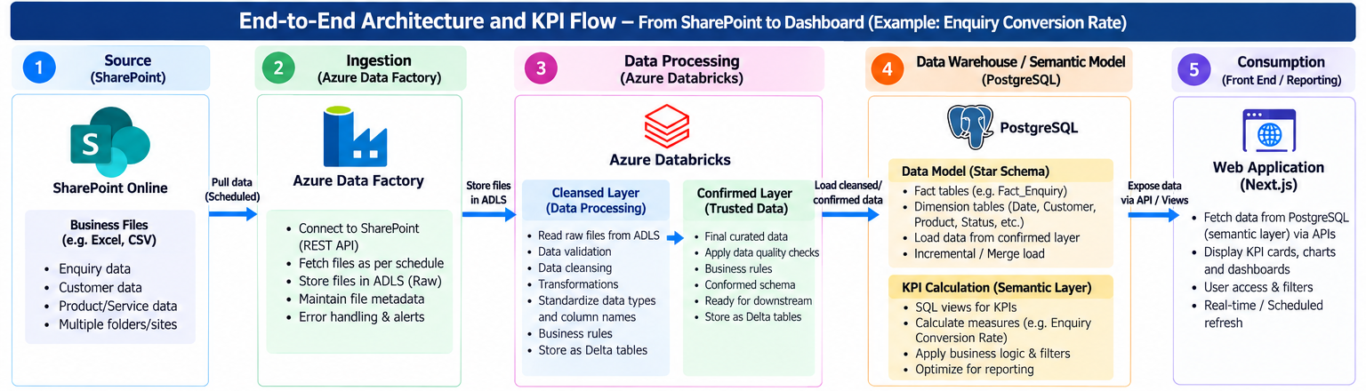
Scope note: pipeline results and monitoring cover ADF ingestion, Databricks processing, and PostgreSQL loading only. Access management in this document focuses on PostgreSQL.
Figure 1. High-level architecture and shared controls (stages 1–5).

1. Source — SharePoint Online
SharePoint Online is the source system for business files. Files may be maintained across multiple folders or sites and can include Excel and CSV files containing enquiry, customer, product, or service data.

Key responsibilities
- Confirm source sites, folders, file types, naming conventions, and business ownership.
- Agree the expected columns, required fields, refresh frequency, and handling of late or revised files.
- Provide the access mechanism and permissions required by the ingestion service.

2. Ingestion — Azure Data Factory (ADF)
ADF orchestrates scheduled extraction from SharePoint and lands source files in Azure Data Lake Storage (ADLS) in a raw/landing area. The raw copy preserves the received file for traceability and potential reprocessing.

Key responsibilities
- Connect to SharePoint through an approved API/authentication method.
- Retrieve files according to the agreed schedule and folder scope.
- Store files in ADLS with a consistent folder and naming strategy.
- Capture file metadata such as source path, file name, modified timestamp, ingestion timestamp, and run status.
- Log ingestion results, failures, retry outcomes, and alerts according to the agreed operational process.

3. Data Processing — Azure Databricks
Databricks reads the landed files, validates and transforms the data, and stores the results as Delta tables. Processing is split into two logical layers so that data quality and trust are explicit.

3.1 Cleansed layer
- Read raw files from ADLS and validate file structure and required columns.
- Standardize column names and data types; normalize dates, codes, and text where agreed.
- Handle duplicates, nulls, invalid records, and other data-quality conditions using documented rules.
- Record rejected records and validation outcomes for troubleshooting.
- Persist the cleansed output as Delta tables.

3.2 Confirmed layer
- Apply approved business rules and cross-record checks.
- Conform schemas and reference values across files or source entities.
- Publish trusted, curated datasets for downstream reporting.
- Persist confirmed outputs as Delta tables and make them available for warehouse loading.

4. Data Warehouse / Semantic Serving — PostgreSQL
PostgreSQL receives the confirmed data from Databricks and provides a structured, query-friendly serving layer for the application. The proposed model uses a star-schema approach where appropriate.

Key responsibilities
- Create fact tables for measurable business events and dimension tables for descriptive context.
- Define primary/foreign keys, grain, relationships, and consistent business definitions.
- Load data from the confirmed layer using an agreed incremental or merge/upsert strategy.
- Create SQL views or reporting tables that expose the approved measures and filters to the API.
- Tune indexes, queries, and data types for expected dashboard usage.
Design note: business relationships and metric definitions should be documented and agreed before implementation. The detailed semantic model and individual KPI formulas can be reviewed as a separate activity.

5. Consumption — Web Application (Next.js)
The Next.js front end displays dashboard components using data returned by a backend API. The API queries approved PostgreSQL views or serving tables rather than connecting the browser directly to the database.

Key responsibilities
- Expose secured API endpoints for KPI values, trends, and breakdowns.
- Fetch data from PostgreSQL through the backend service and return a stable response format.
- Display KPI cards, charts, tables, date ranges, and agreed business filters.
- Apply authentication and authorization so users see only permitted data.
- Support the agreed refresh approach (scheduled refresh or near-real-time querying, depending on requirements).

End-to-End Flow Summary
- Business files are maintained in SharePoint Online.
- ADF retrieves the files and lands a raw copy in ADLS.
- Databricks validates and transforms the data into Cleansed and Confirmed Delta layers.
- Confirmed data is loaded into PostgreSQL for fact/dimension tables and reporting views.
- The Next.js application calls secured APIs to retrieve and display dashboard data. For this document, operational result capture and monitoring stop at PostgreSQL; the web/API layer is not included in the monitoring scope.

PostgreSQL Access Management — Required Controls
- Create separate roles for administrators, data loaders/service identities, read-only reporting users, and support users where needed.
- Grant only the required database, schema, table, and view permissions; avoid broad ownership or superuser access for application identities.
- Use a managed secret store for credentials and define credential rotation and revocation procedures.
- Restrict network connectivity to approved clients/services and enable database auditing/logging where supported.
- Review access periodically and remove permissions when users or services no longer require them.

