**Function**

Function is a collection of statements, which perform an operation.

To define a function we use "def" keyword.

To call a Function we use Function name

The Function which is defined once can call for any no of times.

While defining a function name we need to fallow Identifier rules.

**Syntax**

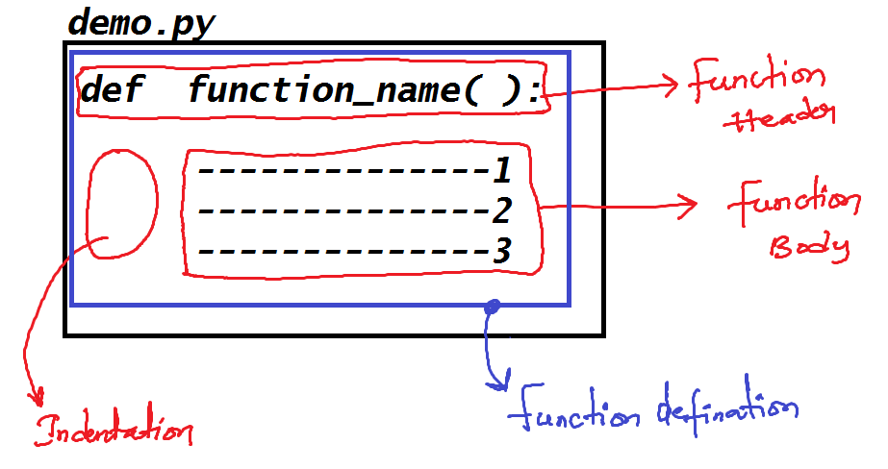

One module ( a python file ) can have any no of functions.

We can call a function in other function body

**Variable**

variable is a named memory location which store data temporarily.

**Syntax**

variable_name = value

In python we have **5 types** of variables

1) Global Variable

2) Local Variable

3) Parameter / arguments

4) Static Variable

5) Instance variable.

**Global Variables**

The Variable which is declared inside the python file (module) and outside the function or class is called as Global variable.

The scope of global variables is anywhere.

Global variables will get memory when the module is run.

**Local Variables**

The variables which are declared inside the Function body or Method body or Constructor body is called as local variable.

The scope of local variable is from declaration to function ending.

Local variable will get memory when the function is called.