**Bank Personal loan Modelling**

* **Import packages and show 5 rows value**

import pandas as pd

data=pd.read_csv("Bank_Personal_Loan_Modelling_1.csv")

data.head()

ID Age Experience ... CD Account Online CreditCard

0 1 25 1 ... 0 0 0

1 2 45 19 ... 0 0 0

2 3 39 15 ... 0 0 0

3 4 35 9 ... 0 0 0

4 5 35 8 ... 0 0 1

5 6 37 13 ... 0 1 0

6 7 53 27 ... 0 1 0

7 8 50 24 ... 0 0 1

8 9 35 10 ... 0 1 0

9 10 34 9 ... 0 0 0

* **Droping “Nan” null values**

Data=dataset.dropna()

* **Getting dependent variable**

y=data["Personal Loan"]

* **Getting independent variables**

data2=data[['Age','Experience','Income','Family','CCAvg','Education','Mortgage','Securities Account','Personal Loan','CD Account','Online','CreditCard']]

* **Import statsmodal api**

Import statsmodels.api as sm

* **Add constants**

X1=sm.add_constant(data2)

* **Performing Logit() method**

Logistic =sm.logit(y,X1)

result=logistic.fit()

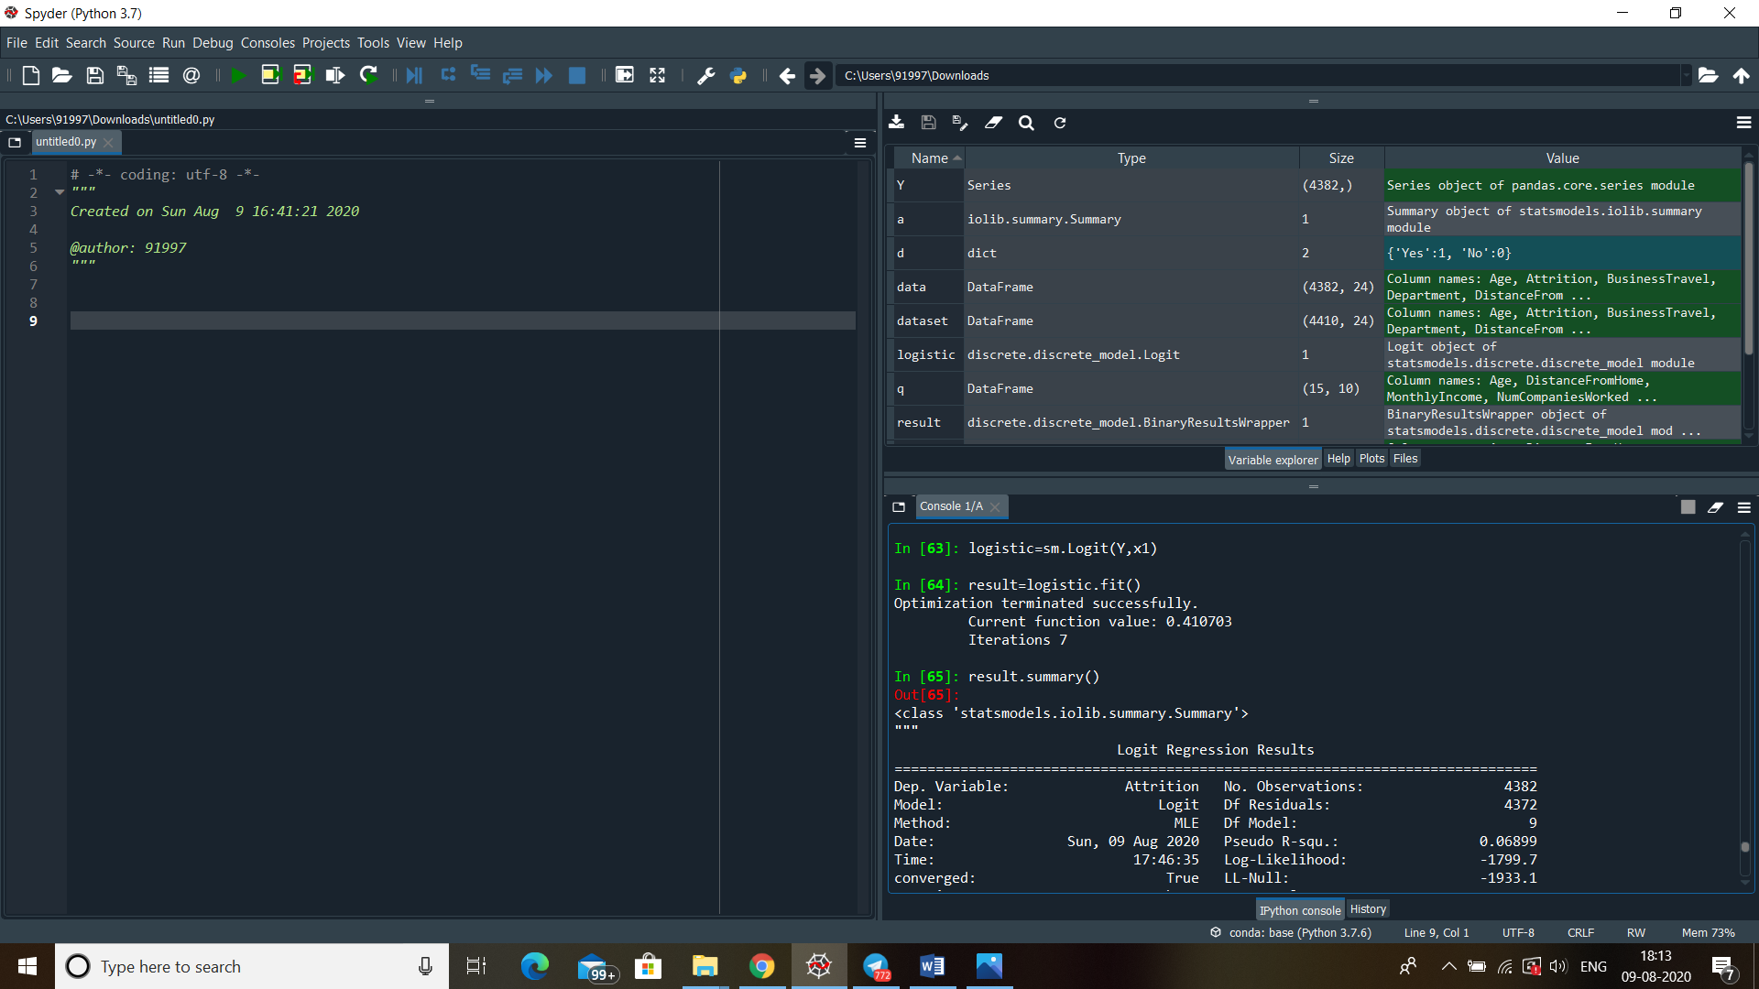

* **Displaying summary**

result.summary()

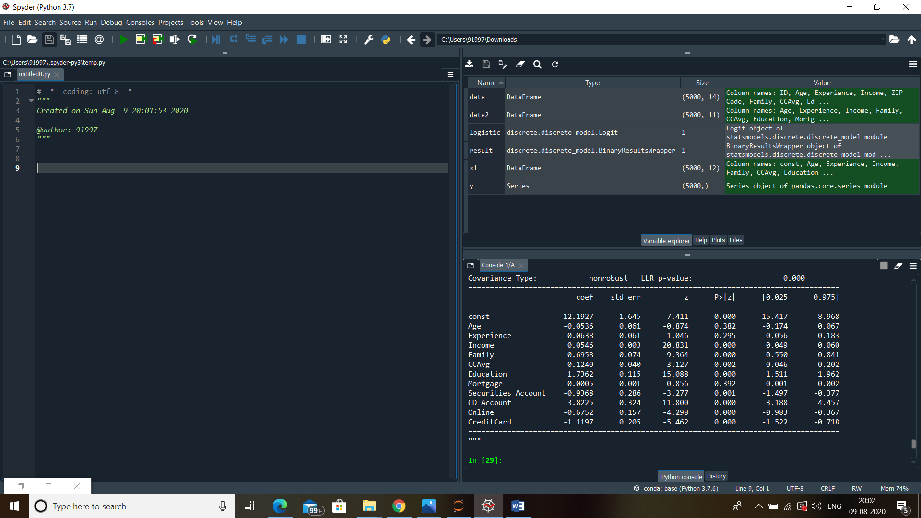

* Significant variables to form equations are

'Age' , 'Experience' , 'Income' , 'Family' , 'CCAvg' , 'Education' , 'Mortgage','Securities Account' , 'Personal Loan' , 'CD Account' , 'Online' , 'CreditCard'

* Now use coefficient of variables to form an equation (equation image)