HYPOTHESIS

1. Employee from the research and development department leave company.

new_data=dataset2[dataset2.attrition!="No"]

mode_values=new_data.mode()

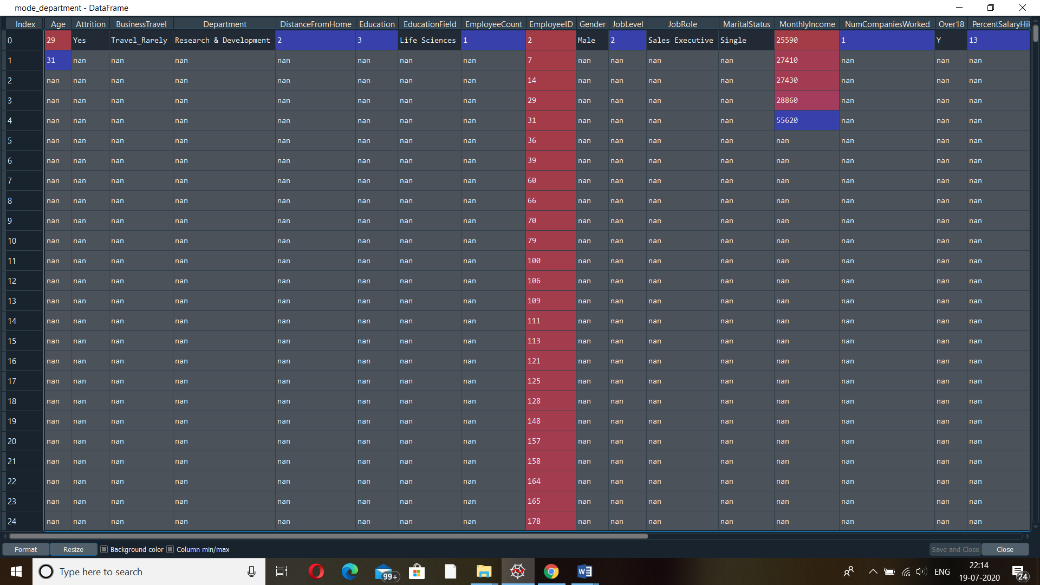

1. Employees whose marital status is single leaves company.



1. Employees having monthly salary is less than 30000 left the company.
2. Employees having Total Working Years = 10 not leaving company.
3. Employees got salary hike greater than 10 not leaving company.
4. Employees who are living in the area nearer to the company not leaving.
5. Employees whose education field was life sciences getting salary less than 25000.
6. Female employees getting less salary than male employees.
7. In research and development department employees are male .
8. Research and development department employees getting good salary hike .