**Software Requirements Specification**

**For**

**Freshop**

**Online Vegetable and Grocery Strore**

**Submitted By -**

**Group No. 95**

**Sharma Ganesh Vinod(230341220169)**

**Swapnil Kumar tamrakar (230341220206)**

**IACSD, Akurdi**

**PUNE**

**INDEX**

**Table of Contents**

1. **Introduction**

1.1 Purpose

1.2 Product Scope

1.3 References

1. **Overall Description**

2.1 Objective

* 1. **External Interfaces**

3.1 User Interfaces GUI and Help Issues

3.2 Security Issues

1. **Requirements**

4.1 Initial non-functional requirements

4.2 Functional requirement specifications

1. **List of Functions**

5.1 Functional Description

1. **Designing Documentation**

6.1 Use case Diagram

6.2 Entity Relationship

**1. Introduction**

As we know that searching of fresh vegetables in market takes quite a long time and some times we even need to suffice with what is available near by . So , With the help of this web application customers can search and order wide range of fresh vegetable/fruits/groceries just with a click.

**1.1 Purpose**

This document is meant to delineate the features of OSS, so as to serve as a guide to the developers on one hand and a software validation document for the prospective client on the other.

The Online Shopping System (OSS) for Fresh vegetable and grocery item shop web application is intended to provide complete solutions for vendors as well as customers through a single gate way using the internet .

It will enable vendors to setup online shops , customers to browse through the shop and purchase them

online without having to visit the shop physically. The administration module will enable a system administrator to approve and reject requests for new shops and maintain various lists of shop category.

**1.2 Product Scope**

This system allows the customer’s to maintain their cart for add or remove the product over the internet.

**1.3 References**

* IEEE. IEEE Std 830-1998 IEEE Recommended Practice for Software Requirements Specifications. IEEE Computer Society, 1998.

**2. Overall Description**

**2.1 Objective**

This product aimed toward a person who don’t want to visit the shop as he might not have time or might not be interested in visiting there and dealing with lot of formalities.

It will lead to error-free, secure, reliable and best job providing and job searching system. It will help user to find job in their respective field.

The user can easily Register himself/herself by providing few details and can login with the username and password. After logging to the website, he/she can look on to the listed available jobs and also the jobs for which they have applied.

**3. External Interfaces**

**3.1 User Interfaces GUI and Help Issues:**

These screens will be user friendly and help will be available at all levels. Help can be any type like site map and also online help, help for entering the standard codes i.e., List of Values will be provided wherever possible in order to reduce data entry errors. User has to select the proper value from list wherever provided.

E.g.: Picking the date from the given list.

**3.2 Security Issues:**

User at different levels in the hierarchy will have restricted access to information. Only authorized users will be able to access the confidential information. Only the System Administrator will do system administration and maintenance work. And update the information. Various security mechanisms will be provided such as password.

E.g. –

Password protection for valid user.

(Provided by RDBMS) -Password at application level.

**4. Requirements**

**4.1 Initial non-functional requirements**

* Secure access of confidential data (user’s details). SSL (Secure Sockets Layer) can be used.
* 24 X 7 availability.
* Better component design to get better performance at peak time
* Advertisement space relating to new job vacancy where it will effectively catch the user’s attention.
* In addition to the above-mentioned points, due to the highly evolving nature of the project, the following are planned to be delivered if deemed necessary.
* **Efficiency Requirement** - When an “Freshop app” is implemented Customers and suppliers can view and upload new products respectively from their homes easily without any difficulty.
* **Usability Requirement** - The “Freshop app” is designed for a user-friendly environment and ease of use.
* **Reliability Requirement** - The system should provide a reliable environment for both Suppliers and customers. All Orders should be reaching the admin without any errors and should be shown to the viewers.
* **Implementation Requirement** - Implementation of the system using ***ReactJS*** in the front end with ***JAVA Spring Boot*** as the back end and it will be used for database connectivity. And the database part is developed by ***MySQL***. Responsive web designing is used for making the portal compatible for any type of screen.
* **Delivery Requirement** - The whole system is expected to be delivered in one months of time with weekly evaluation by the project guide.
* **Database Security** - An unauthorized person cannot access the panel and database, and do not read and write the information.
* **Availability** - This “Online Job Portal” will be available online 24/7 a week.

**4.2 Functional requirements specifications**

It is the primary requirement that is fulfilled by our online store app. It is allowing the users, and suppliers to use our app at the level ease. The purpose of our app is to provide the full information that is required by the user. Here is the following requirement that is fulfilled by our system.

**USER**

* **User Login**

This feature is used by the user/admin to login into the system. A user/admin must log in with his username and password to the system after registration. If they are invalid, the user is not allowed to enter the system.

* Username and password will be provided after user registration is confirmed.
* Password should be hidden from others while typing it in the field.
* **Register New User**

A new user will have to register in the system by providing essential details in order to apply in the job. The admin must accept a new user.

* The system must be able to verify and validate the information.
* The system must encrypt the password of the user to provide security.
* **Search Products**

The user can search for the desired product. He can view different categories. After confirming the login in the search user can select it and add it into shopping cart.

* **Maintaining cart**

Customer can add delete or save the product for future reference.

**ADMIN**

* **Manage Users and Suppliers**
* The administrator can add users, delete users, and view users.
* **Manage Product List**
* The administrator can add product as per availability, delete product, hide products, and view all products.
* **Manage details**
* The system must identify the login of the admin.
* Admin account should be secured so that only the owner of the application can access that account.

**Supplier**

* Supplier can add new Product details.
* Supplier can check complete list of sold out products.
* They can also update the price for each product.

**5. List of Functions**

|  |  |  |
| --- | --- | --- |
| **Sr. No.** | **Function ID** | **Name of Function** |
|  |  |  |
| 1. | F-1 | Supplier add products. |
|  |  |  |
| 2. | F-2 | User Searches for product. |
|  |  |  |
| 3. | F-3 | User creates a cart. |
| ff |  |  |
| 4. | F-4 | Admin Checks & Maintains Suppliers and Users. |
|  |  |  |
| 5. | F-5 | Admin Updates Product list. |
|  |  |  |

**5.1 Functional Description:**

**F-1. Function :** Supplier add products**.**

**Function ID :** F-1

**Purpose:** When ever a new supplier wants to add a product he must create a account and add all the product which they wants to sell.

**F-2. Function :**  User Searches for product.

**.**

**Function ID :** F-2

**Purpose:** User searches desired product with the help of search bar they can apply filter based on categories.

**F-3. Function :** User creates a cart.

**Function ID :** F-3

**Purpose:** User selects all desired products and save it on a shopping cart which can be used for reference.

**F-4. Function :**  Admin Checks & Maintains Suppliers and Users**.**

**Function ID :** F-4

**Purpose:** Admin will be having full privilege to handle Supplier and User profile. Admin can make efficient communication between User and Supplier.

**F-5. Function :** Admin Updates Product List**.**

**Function ID :** F-5

**Purpose:** Admin can make update product list available to users.

**6. Designing Documentation**

**6.1 UML Diagram**

**User Case Diagram –**

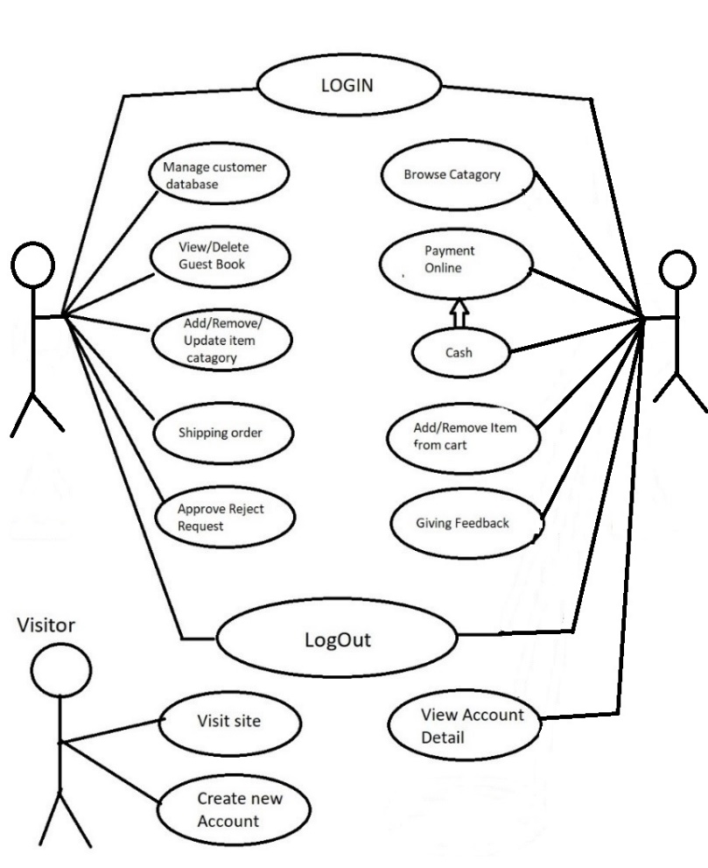

**Activity and Sequence diagram –**

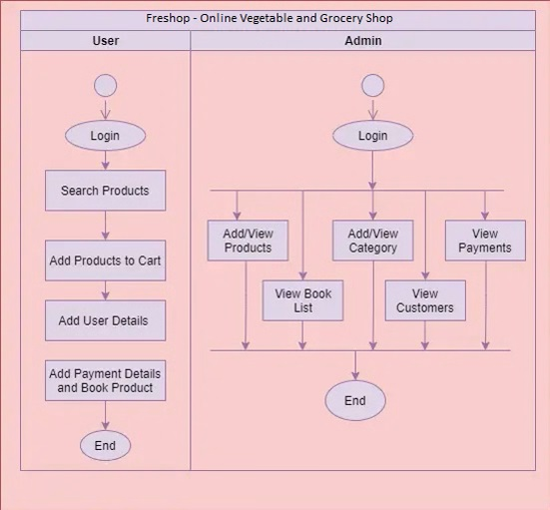

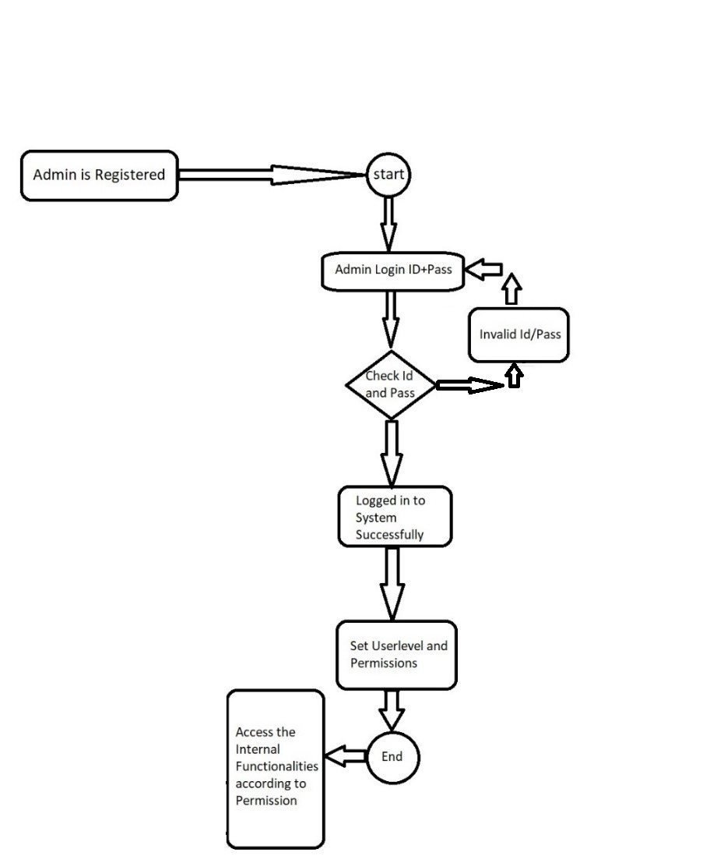

(ADMIN)

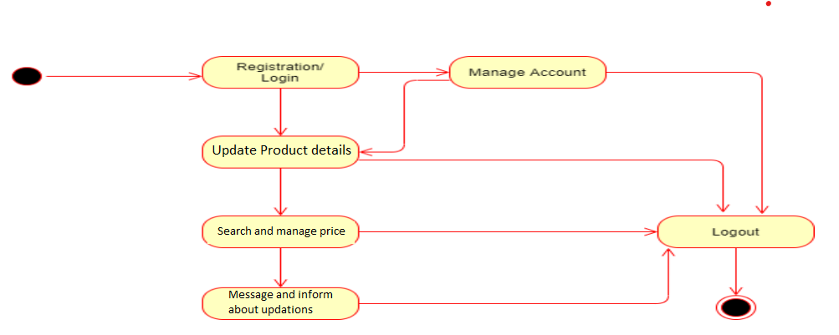

(Supplier)

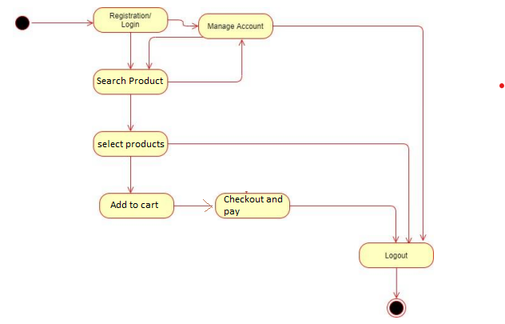

(USER)

**Sequence Diagram –**

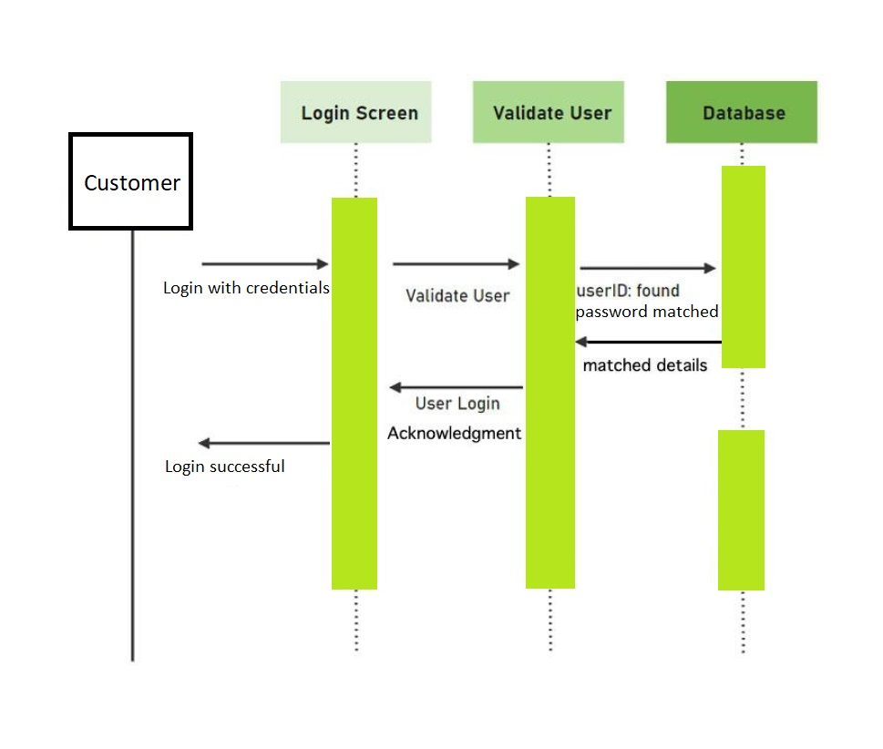

**DFD –**

**Oth Level-**

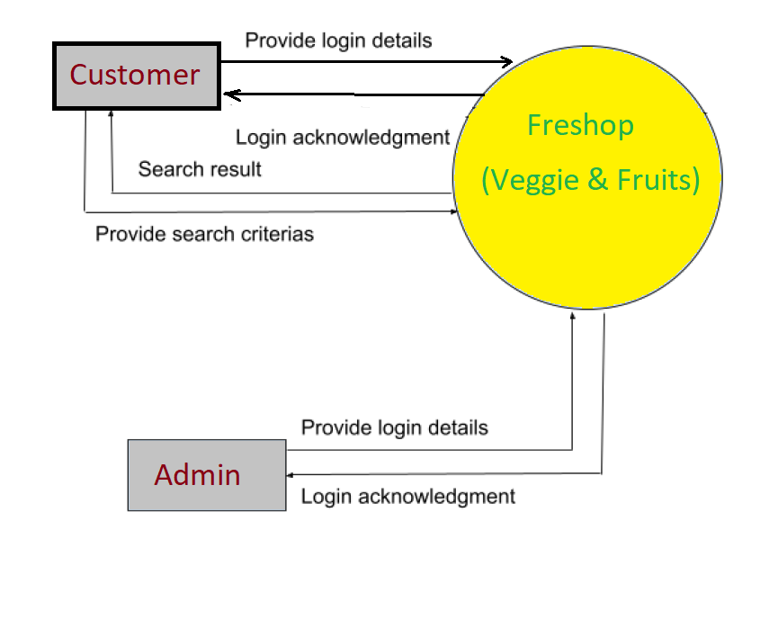

**1st Level -**

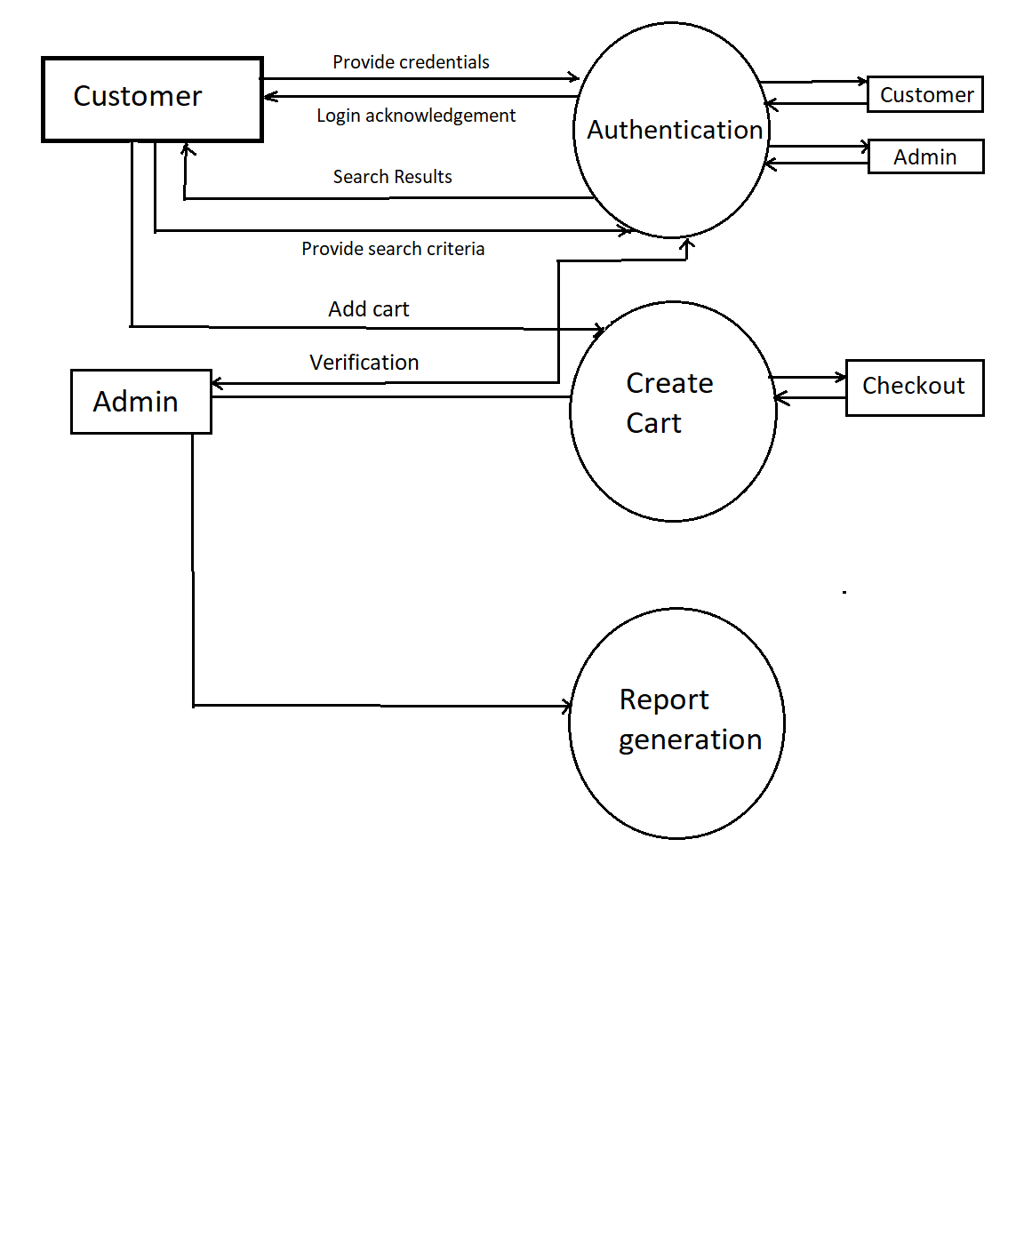

**2nd Level -**

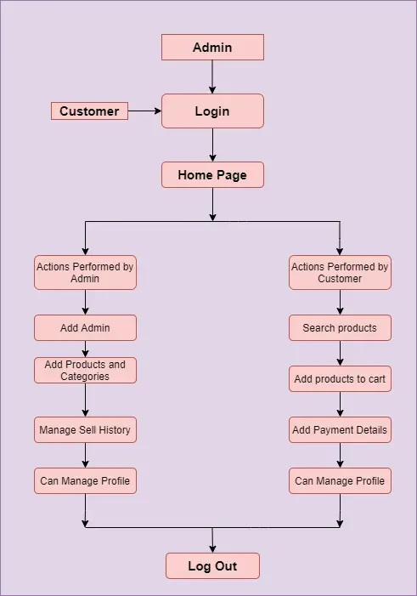

**6.2 E****ntity Relationship**