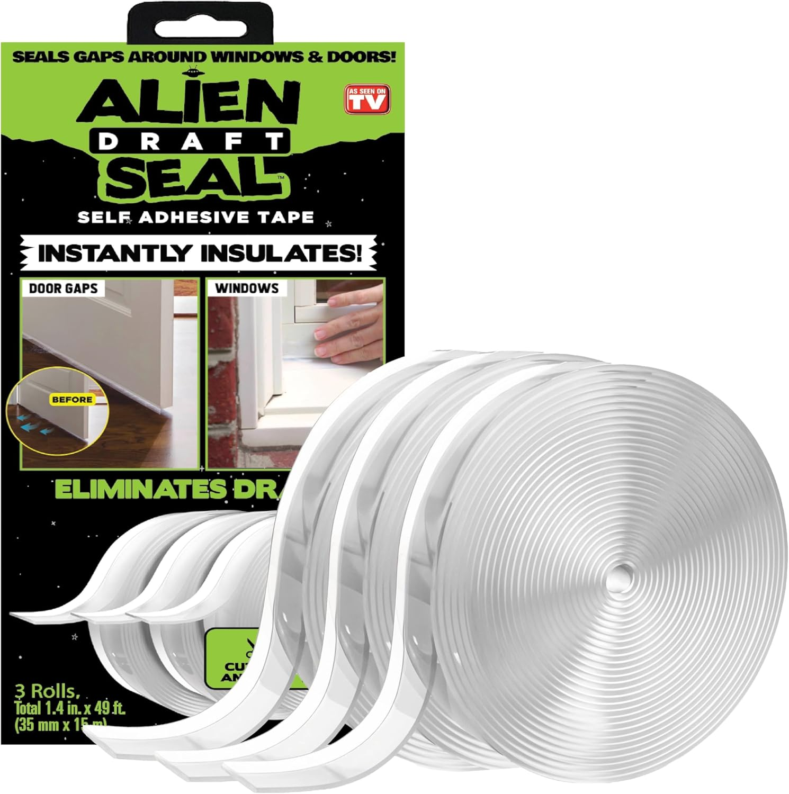

How to Seal Gaps Around Windows and Doors: A Detailed Review of the Alien Draft Seal Set
When winter drafts sneak in through the tiniest cracks, your heating bill spikes and your comfort drops. The solution often starts withhow to seal gaps around windows and doors—a simple DIY task that can make a big difference. In this review we examine theAlien Draft Seal Set of 49 Feet Anti‑Draft Adhesive and Flexible Flap, a product that promises to close those leaks quickly and affordably. Below you’ll find an in‑depth look at its features, pros and cons, and whether it’s the right choice for your home.

Overview
The Alien Draft Seal is marketed as a “door bottom seal strip” and “window sealer” that blocks cold air while keeping warm air inside. Sold as a set of three rolls, each roll measures 1.4 inches wide and 16.34 feet long, giving a total length of 49 feet (588 inches). Priced at$19.99and backed by a4.5‑out‑of‑5rating from9,201 reviewers, the product positions itself as a TV‑tested, easy‑apply solution for draft‑prone homes.
Key selling points highlighted by the manufacturer include:
- Strong, moisture‑proof adhesive that sticks to painted wood, glass, metal, ceramic, fiberglass, and plastic.
- Transparent design that blends into any surface.
- Flexible material that can be cut to any length for custom fits.
- Three rolls per package, providing ample material for multiple doors and windows.

Key Features

1. Draft Guard – Keeps Warm Air In
The primary claim of the Alien Draft Seal is its ability to block cold air infiltration. By creating a tight seal around door thresholds and window frames, the tape helps maintain indoor temperature, which can translate into lower heating costs and a cozier living space.

2. Extra Long Coverage
Each roll offers 16.34 feet of seal, and the three‑roll package totals 49 feet. This length is more than sufficient for sealing a standard front door, several windows, and even additional areas like garage doors or sliding patio doors. The generous amount reduces the need for multiple purchases.

3. Easy Application & Transparent Look
Installation is straightforward: measure the gap, cut the tape to the desired length, peel off the backing, and press it onto a clean surface. The transparent material means the seal blends into the surrounding area, so you won’t notice a bulky strip after it’s applied.

4. Super Strong Adhesion
The adhesive is designed to resist moisture, splashes, and rain, making it suitable for both interior and exterior use. It adheres to a wide variety of surfaces, including painted and powder‑painted wood, glass, metal, ceramic, fiberglass, and plastic. This versatility expands the product’s usefulness beyond just doors and windows.

Pros & Cons

Pros
- Long total length (49 ft) covers multiple doors and windows in one purchase.
- Strong, moisture‑proof adhesive that stays put in humid or rainy conditions.
- Transparent design is unobtrusive and blends with any décor.
- Easy to cut and apply—no tools required.
- Works on a variety of surfaces, from wood to glass to metal.
- Highly rated by thousands of Amazon customers (4.5/5).

Cons
- Width is limited to 1.4 inches; very large gaps may need multiple strips.
- Surface must be clean and dry for optimal adhesion; prep work may be required.
- Adhesive can leave a residue if removed later.
- Not reusable—once cut and applied, the strip cannot be repositioned.

Who Should Buy This?
The Alien Draft Seal is ideal for homeowners who are looking for a quick, low‑cost fix for drafts without hiring a professional. It’s especially useful for:
- Renterswho need a non‑permanent solution that won’t damage doors or windows.
- DIY enthusiastswho enjoy simple projects that improve energy efficiency.
- Families in colder climateswhere even small drafts can raise heating bills.
- Anyone with multiple draft points—the three‑roll set provides enough material for several doors, windows, and even garage or shower doors.
If you’re searching for a permanent, structural fix (such as replacing weatherstripping or installing new doors), this product may not be the final answer. However, as a first‑line barrier against drafts, it offers great value for the price.

FAQs

How does the Alien Draft Seal help when I’m learninghow to seal gaps around windows and doors?
The seal works by creating a continuous, airtight barrier over the gap. Its strong adhesive adheres directly to the frame or threshold, preventing cold air from slipping through. Because it’s flexible, you can cut it to fit any shape, making it a versatile tool for both windows and doors.

Can the Alien Draft Seal be used on exterior doors that are exposed to rain?
Yes. The product’s adhesive is described as moisture‑proof and resistant to splashes or rain. This makes it suitable for exterior applications such as front doors, garage doors, and even sliding patio doors, provided the surface is clean and dry during installation.

What is the best method for applying the seal to ensure a lasting result?
Start by cleaning the surface with a mild detergent and letting it dry completely. Measure the length of the gap, cut the tape to size, peel off the backing, and press firmly from one end to the other. For best results, apply the seal in a moderate temperature (around 65‑75 °F) and avoid touching the adhesive side with dirty hands.

Final Verdict
The Alien Draft Seal Set delivers on its promise to provide an easy, affordable way toseal gaps around windows and doors. With 49 feet of transparent, moisture‑proof tape, strong adhesion to a wide range of surfaces, and a high customer rating, it stands out as a practical DIY solution for anyone looking to improve home comfort and reduce energy waste. While it isn’t a substitute for professional weatherstripping in all cases, its simplicity, coverage, and price point make it a worthwhile addition to any household toolkit.
Affiliate Disclosure:This post contains affiliate links, and we may earn a commission at no extra cost to you if you purchase through the link below.
Buy the Alien Draft Seal Set on Amazon for $19.99

