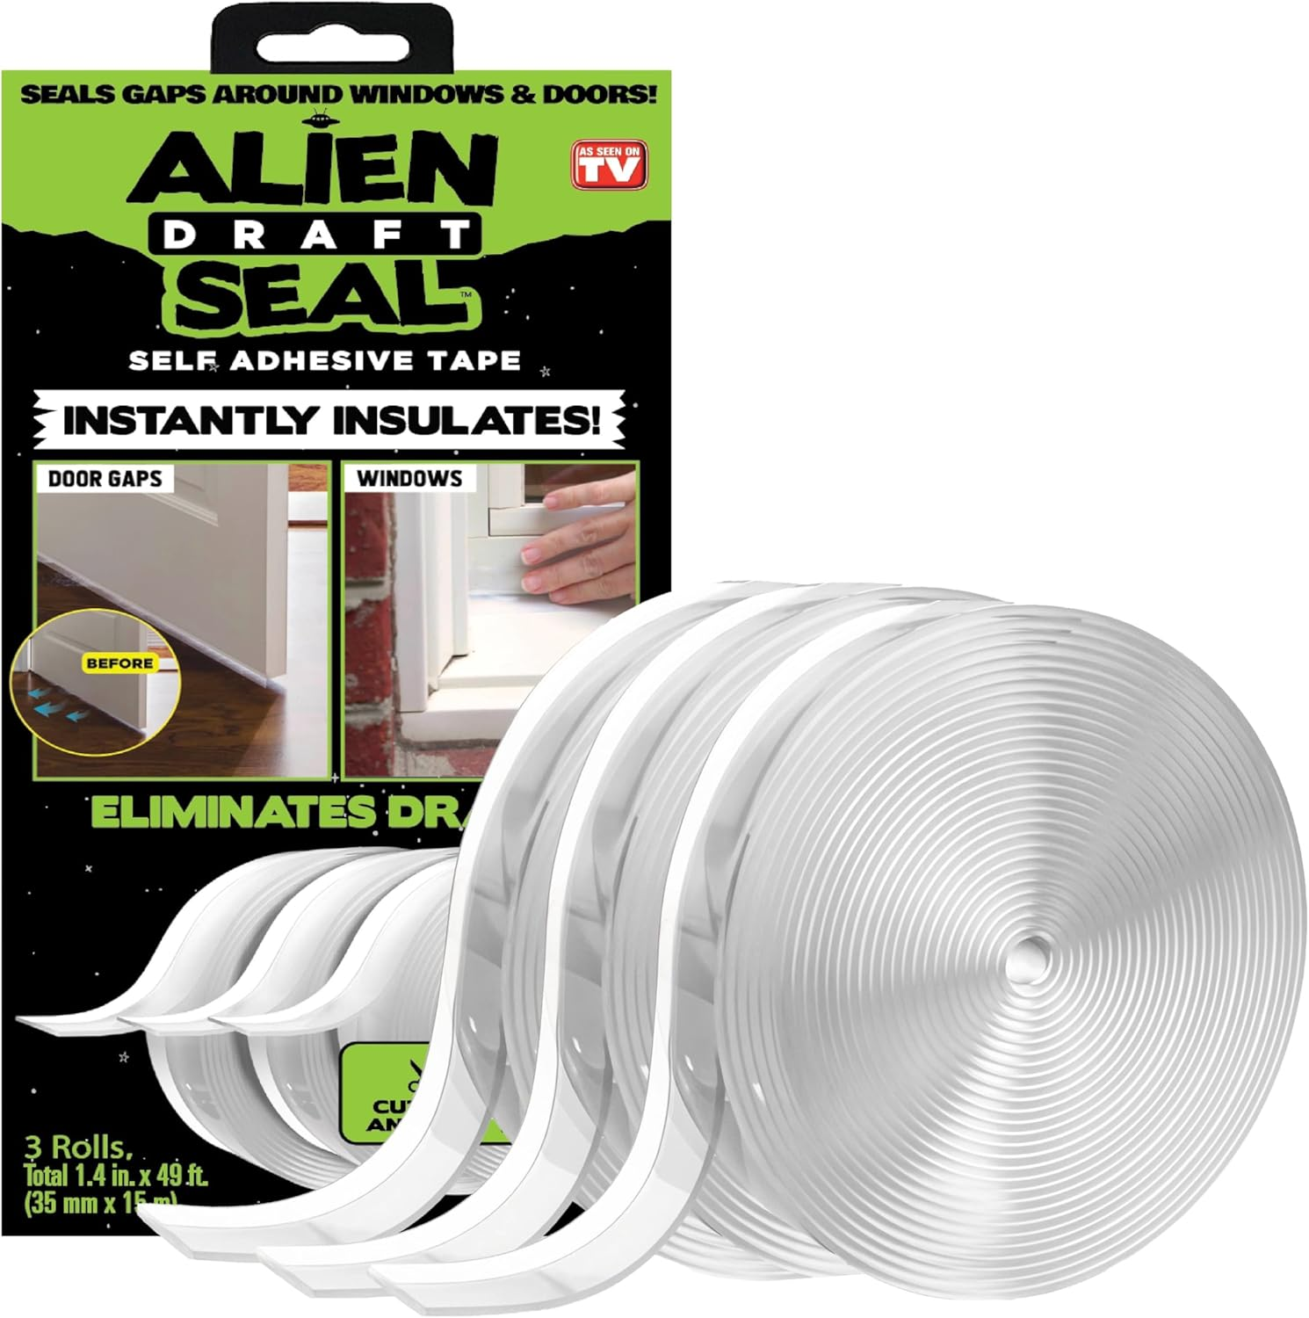
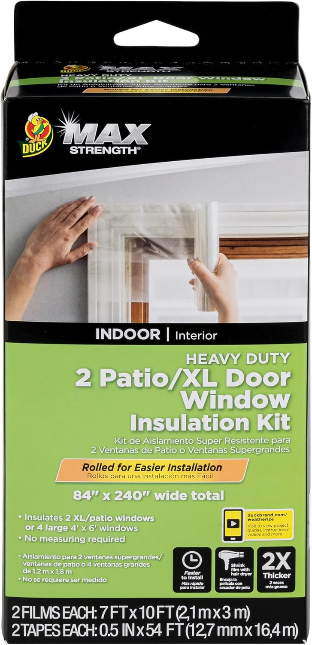

keep your house warm Winter weather comparison: Alien Draft Seal vs Duck Brand MAX Strength Window Insulation Kit
When the temperature drops and winter winds start to howl, every homeowner looks for simple, cost‑effective ways to keep the interior of their house warm and comfortable. Drafts sneaking through doors, windows, and even bathroom shower doors can raise heating bills and create chilly spots that are hard to get rid of. Two popular Amazon‑available solutions promise to seal those leaks: theAlien Draft Seal Set of 49 Feetand theDuck Brand MAX Strength Window Insulation Kit. Both are designed to block cold air and retain warm air, but they take different approaches. Below you’ll find a side‑by‑side comparison, detailed mini‑reviews, and guidance on which product fits your specific winter‑proofing needs.
Product | Price | Rating | Key Features
Alien Draft Seal Set of 49 Feet | $19.99 | 4.5 out of 5 (9,201 reviews) | Draft guard that blocks cold air and keeps warm air insideExtra long – 3 rolls, each 1.4 in × 16.34 ft (total 49 ft)Transparent, moisture‑proof design with strong adhesiveAdheres to wood, glass, metal, ceramic, fiberglass, plastic, painted or powder‑painted surfaces
Duck Brand MAX Strength Window Insulation Kit | $29.94 | 4.6 out of 5 (315 reviews) | Puncture‑resistant, twice‑as‑thick shrink film for airtight sealEasy‑install roll; cut to size after applicationTools needed: scissors and hair dryer; works on painted wood, aluminum, vinylCrystal‑clear film; removes easily after seasonIncludes 2 rolls (84 in × 120 in) and 2 rolls of 0.5 in × 54 ft tape; covers up to 2 XL/patio windows or 4 large 4′ × 6′ windows

Alien Draft Seal Set of 49 Feet – Mini Review
The Alien Draft Seal is marketed as a flexible, adhesive strip that can be cut to length and applied to a wide variety of surfaces. Its primary strength lies in its versatility. Because the tape is only 1.4 inches wide but comes in a combined 49 feet of length, it can be used to seal door thresholds, window gaps, garage doors, and even shower doors. The transparent, moisture‑proof construction means the seal blends into the surrounding frame, keeping the aesthetic of your home intact while still delivering a strong barrier against drafts.
Installation is straightforward: measure the gap, cut the strip, peel off the backing, and press it into place. The adhesive is described as “super strong,” capable of sticking to painted wood, glass, metal, ceramic, fiberglass, and plastic. This broad compatibility reduces the need for multiple products if you have different materials around your home. The product’s 4.5‑star rating from over 9,000 reviewers suggests a high level of customer satisfaction, especially considering the low price point of $19.99.
Potential drawbacks are limited to the fact that the seal is a strip rather than a full‑coverage film. It works best on linear gaps (door bottoms, window sills) and may require multiple pieces for larger window panes. However, for most typical residential drafts, the Alien Draft Seal offers an affordable, easy‑to‑apply solution that can make a noticeable difference in indoor temperature.

Duck Brand MAX Strength Window Insulation Kit – Mini Review
Duck Brand’s MAX Strength Window Insulation Kit takes a different approach by using a thick, shrink‑film that creates an airtight membrane over entire windows. The film is twice as thick as standard kits, which translates to better durability and resistance to punctures. Once the film is applied and heated with a hair dryer, it shrinks tightly to the glass, eliminating drafts that seep around the perimeter.
The kit includes two large rolls (84 in × 120 in each) and two rolls of 0.5 in × 54 ft tape, allowing you to cover up to two extra‑large or patio windows, or four standard 4′ × 6′ windows. The clear, crystal‑clear film does not obstruct the view, preserving natural light while still providing insulation. Installation requires only scissors and a hair dryer, and the instructions note that the film can be applied to painted or finished wood, aluminum, or vinyl surfaces.
At $29.94, the kit is priced higher than the Alien Draft Seal, but its 4.6‑star rating from 315 reviewers reflects strong performance for those who need full‑window coverage. The film is also removable after the heating season, which is a convenience for renters or homeowners who prefer a temporary solution. The main limitation is the need for a hair dryer and a bit more hands‑on effort to shrink the film evenly, which might be a deterrent for users looking for the quickest fix.

Which One Should You Buy?
Choosing between the Alien Draft Seal and the Duck Brand MAX Strength Window Insulation Kit depends on three key factors:budget,coverage area, andinstallation preference.
- Budget‑conscious buyers:If you want the lowest upfront cost while still addressing the most common sources of drafts, the Alien Draft Seal is the clear winner at $19.99. Its 49 feet of flexible tape can seal multiple doors and windows for a fraction of the price of a full‑window film kit.
- Best overall for whole‑window insulation:For homeowners with large, single‑pane windows or patio doors that let in a lot of cold air, the Duck Brand MAX Strength Kit offers superior coverage. The thick shrink film creates a continuous barrier over the entire glass surface, which is more effective at stopping drafts that slip around the edges of a window frame.
- Ease of installation:If you prefer a quick, cut‑and‑stick solution, the Alien Draft Seal’s transparent tape is easier for most DIYers. The Duck Brand kit requires a hair dryer and a little patience to shrink the film evenly, which may be a small hurdle for users who are less comfortable with tools.
- Versatility of application:The Alien Draft Seal can be used on doors, windows, garage doors, and even shower doors, making it a more versatile product for a variety of draft‑prone spots. The Duck Brand kit is specifically designed for windows and doors, so it excels in that niche but isn’t suitable for sealing door thresholds or other non‑window gaps.
In summary, if you are looking for a low‑cost, multi‑surface solution that can be applied quickly, go with theAlien Draft Seal Set of 49 Feet. If you need a robust, full‑coverage film for large windows and don’t mind a slightly higher price and a short installation process, theDuck Brand MAX Strength Window Insulation Kitwill likely give you the best results.

Frequently Asked Questions

How do I keep my house warm during winter weather with door and window seals?
Both products are designed to stop cold air from entering through gaps. The Alien Draft Seal provides a flexible, adhesive strip that you can cut to fit door thresholds, window sills, and even shower doors. The Duck Brand MAX Strength

