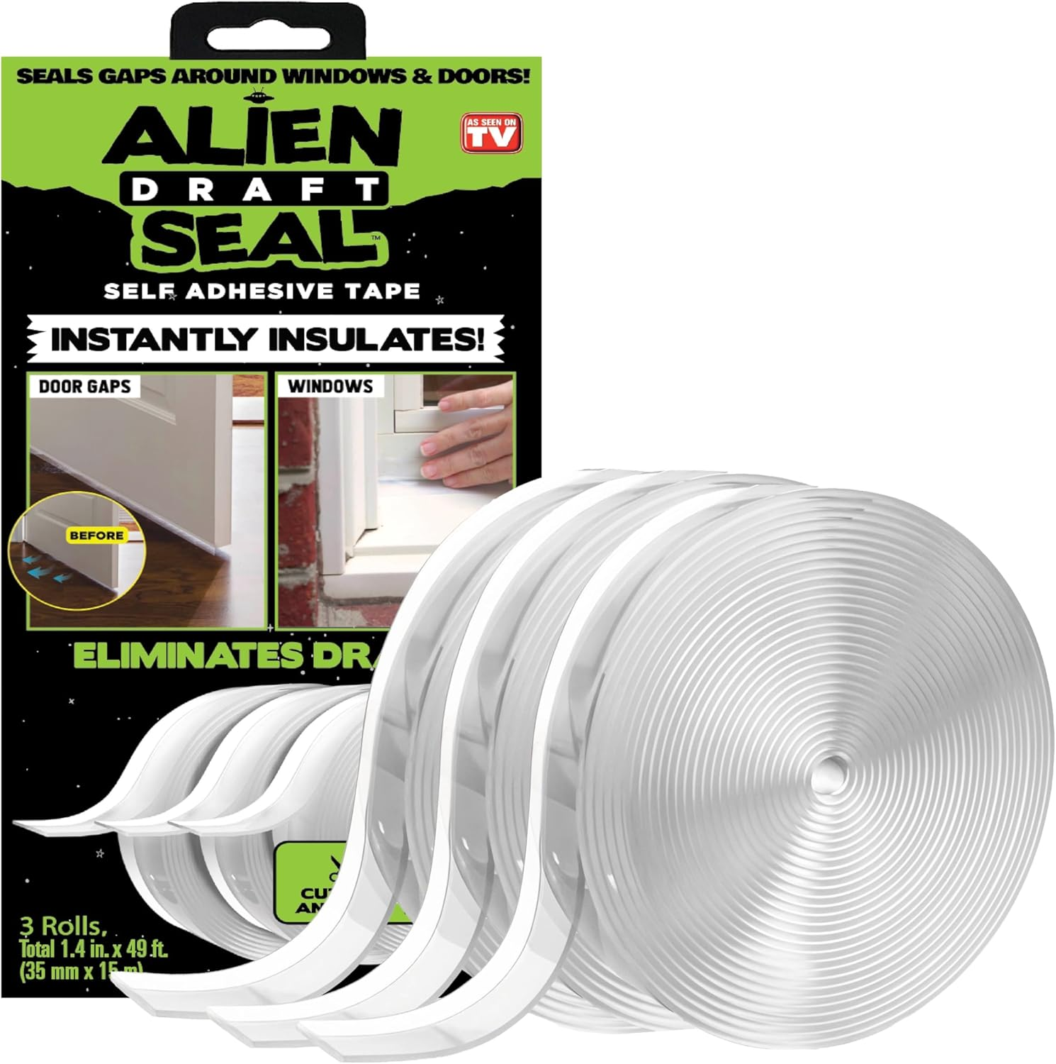
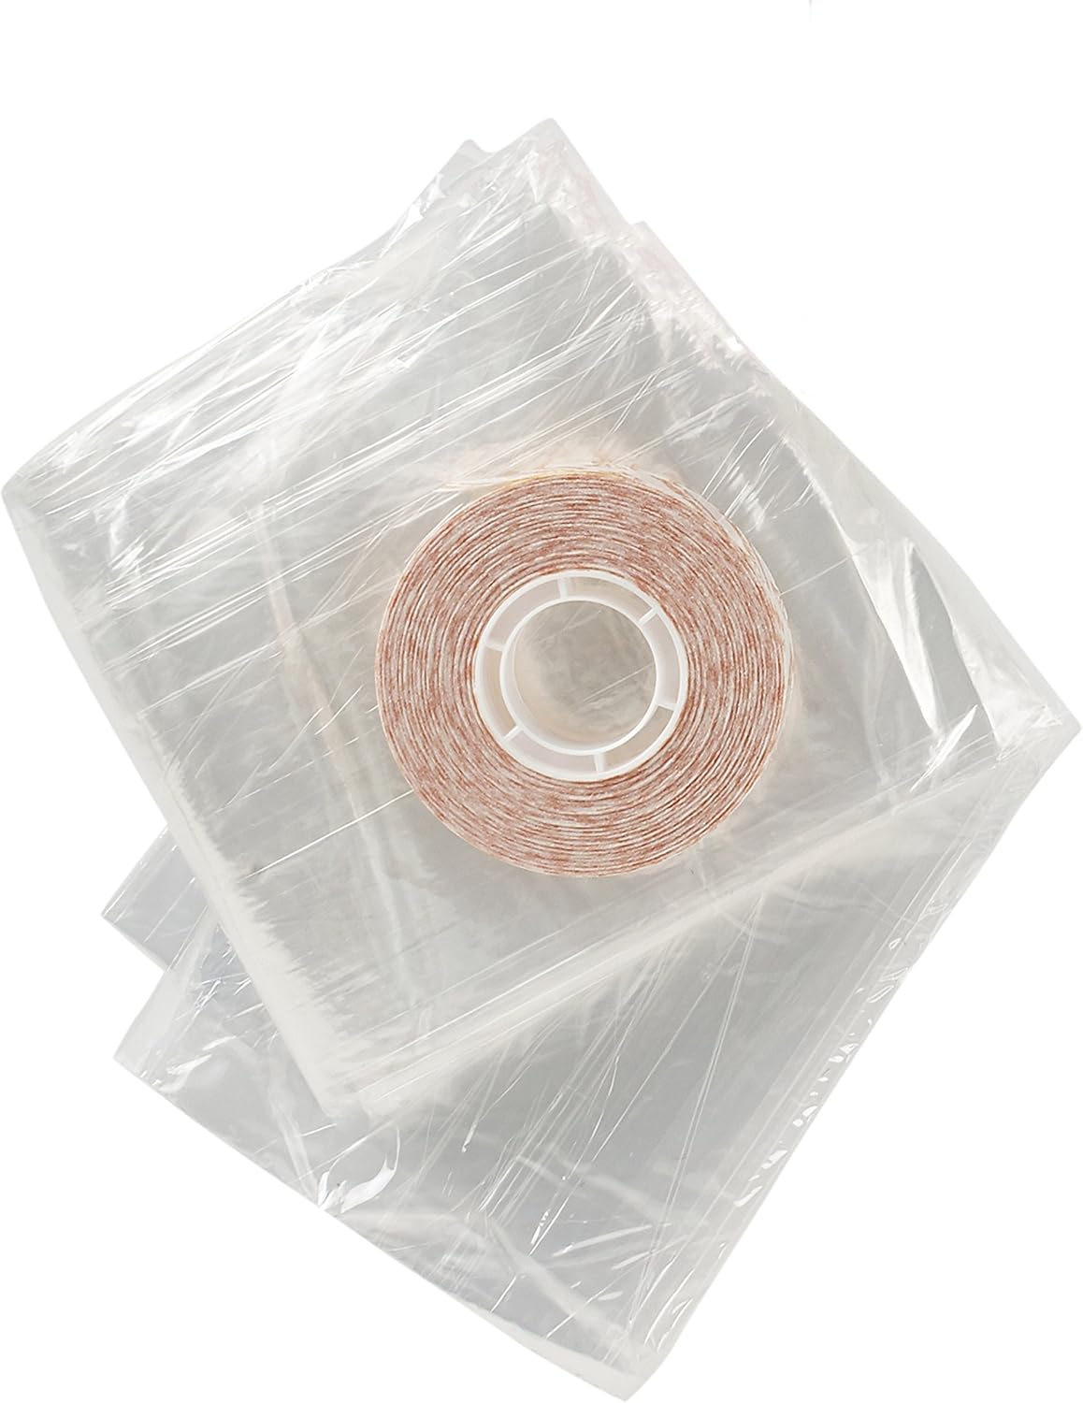

Best Way to Stop Cold Air Coming Through Windows and Doors Comparison
When winter drafts turn your home into an ice box, finding thebest way to stop cold air coming through windows and doorsbecomes a top priority. Two popular DIY solutions dominate the Amazon marketplace: theAlien Draft Seal Setand theFrost King V83/3 Heavy Duty Shrink Window Kit. Both promise to seal gaps, improve comfort, and lower energy bills, but they take different approaches. Below you’ll find a side‑by‑side breakdown, detailed mini‑reviews, and buying guidance to help you decide which product fits your home and budget.

Quick Comparison Table
Product | Price | Rating | Key Features
Alien Draft Seal SetASIN: B08S3M2HKL | $19.99 | 4.5 out of 5 (9,201 reviews) | Draft guard that blocks cold air and keeps warm air inside.Extra long – 3 rolls, each 1.4″ × 16.34 ft (total 49 ft).Transparent, moisture‑proof adhesive; easy cut‑and‑apply.Super‑strong adhesion to wood, glass, metal, ceramic, fiberglass, plastic.
Frost King V83/3 Heavy Duty Shrink Window KitASIN: B00G7009LM | $8.98 | 4.2 out of 5 (281 reviews) | Heavy‑duty 3‑pack insulation window kit.Film thickness of 1.5 mm (twice the standard).Tape width 5/8 in (wider than the usual 1/2 in).Designed for durability and child/pet safety.

Alien Draft Seal Set – Mini Review
The Alien Draft Seal Set positions itself as a versatile, all‑purpose draft blocker. Itstransparent, moisture‑proof adhesivemeans the tape blends into door frames, windows, and even shower doors without unsightly lines. With49 feet of materialspread across three rolls, you have more than enough length to seal a typical front door, multiple windows, and any additional gaps you discover during a thorough inspection.
What truly sets this product apart is itssuper‑strong adhesion. The description guarantees a grip on painted and powder‑painted wood, glass, metal, ceramic, fiberglass, and plastic. In practice, that translates to confidence that the seal will stay put through seasonal rain, humidity, and temperature swings. The high rating (4.5/5) and a robust review count of over 9,000 customers reinforce its reputation for reliability.
Strengths summed up:
- Long total length eliminates the need for multiple purchases.
- Clear, low‑visibility design keeps aesthetics intact.
- Adhesive resists moisture, reducing the risk of peeling.
- Works on a wide variety of surfaces, expanding its use beyond doors and windows.

Frost King V83/3 Heavy Duty Shrink Window Kit – Mini Review
The Frost King V83/3 kit is a classic, budget‑friendly solution focused primarily on window insulation. Its1.5 mm film thickness—twice that of standard shrink‑film kits—offers a sturdier barrier against drafts. The5/8‑inch tapeis notably wider than the typical 1/2‑inch tape, providing a larger surface area for a tighter seal.
Designed with families in mind, the kit emphasizes durability and safety. The thicker film and wider tape can better withstand the occasional tug from curious children or pets, making it a practical choice for high‑traffic households. While its rating (4.2/5) is slightly lower than the Alien Draft Seal, the product still enjoys positive feedback from over 280 reviewers who appreciate its cost‑effectiveness and straightforward installation.
Strengths summed up:
- Heavier film and wider tape create a more durable seal.
- Lower price point makes it attractive for tight budgets.
- Specifically engineered for window applications.
- Child‑ and pet‑friendly design reduces accidental damage.

Which One Should You Buy?
Both products address the same core problem—cold air infiltration—but they excel in different scenarios. Below is practical guidance based on the data provided.

1. Budget‑Conscious Shoppers
If price is your primary driver, theFrost King V83/3 Heavy Duty Shrink Window Kitwins hands down at $8.98. While it doesn’t offer the same total length as the Alien set, the kit still provides a solid, thick film that can seal standard‑size windows effectively. For households that need to address a few key windows without breaking the bank, this is the sensible choice.

2. Best Overall Value
TheAlien Draft Seal Setcommands a higher price ($19.99) but delivers 49 feet of transparent, moisture‑proof tape that adheres to virtually any surface. Its higher rating (4.5/5) and massive review count suggest superior overall performance and customer satisfaction. If you’re looking for a single purchase that can seal doors, windows, garage entries, and even shower doors, the Alien set offers the most comprehensive solution.

3. Families with Children or Pets
The Frost King kit’s “stronger and more durable” claim, combined with a wider tape, makes it a safer option for homes where little hands or paws might tug at the material. Its design explicitly mentions durability in high‑traffic environments, giving peace of mind that the seal won’t be easily ripped or peeled.

4. DIY Enthusiasts Who Want Flexibility
Because the Alien tape sticks to wood, glass, metal, ceramic, fiberglass, and plastic, it’s the go‑to for DIYers who love customizing their draft‑proofing strategy. Whether you’re sealing a sliding glass door, a garage door threshold, or a shower door, the flexible, transparent strip adapts to varied shapes and surfaces.

5. Quick One‑Time Fix
If you only need to address a single leaky window and prefer a straightforward, no‑cut‑required solution, the Frost King shrink‑film kit can be applied directly and shrunk with a hair dryer. The Alien seal requires measuring, cutting, and aligning, which is a bit more involved but yields a cleaner, less visible result.
In short, choose the **Frost King V83/3** if you’re price‑sensitive, need a robust window‑only fix, or have active children and pets. Opt for the **Alien Draft Seal Set** if you want maximum coverage, a sleek invisible finish, and the flexibility to seal doors, windows, and more.

Frequently Asked Questions

What is the best way to stop cold air coming through windows and doors?
Both the Alien Draft Seal Set and the Frost King V83/3 Heavy Duty Shrink Window Kit are proven methods for sealing gaps. The Alien set offers a transparent, moisture‑proof tape that adheres to many surfaces, making it ideal for doors, windows, and even shower doors. The Frost King kit provides a thicker, wider shrink‑film that works especially well on standard‑size windows and is budget‑friendly.

Can I use a draft seal on both doors and windows?
Yes. The Alien Draft Seal’s strong adhesive works on wood, glass, metal, ceramic, fiberglass, and plastic, allowing you to seal both doors and windows with the same material. The Frost King kit is primarily designed for windows, though creative users sometimes adapt the shrink‑film for door thresholds, keeping in mind that its tape width is 5/8 in.

Which product offers the most durable, long‑lasting protection?
Durability depends on the application. The Alien Draft Seal’s super‑strong adhesion and moisture‑proof design give it excellent longevity on a variety of surfaces. The Frost King kit’s 1.5 mm film and wider tape make it tougher against physical wear, especially in homes with children or pets. Both are durable, but the Alien seal’s broader material compatibility gives it an edge for long‑term, all‑around protection.
Affiliate Disclosure:Some of the links in this article are affiliate links. If you click through and make a purchase, we may earn a small commission at no additional cost to you. This helps keep the site running and allows us to continue providing helpful content.
Buy Alien Draft Seal Set – 49 Feet of

