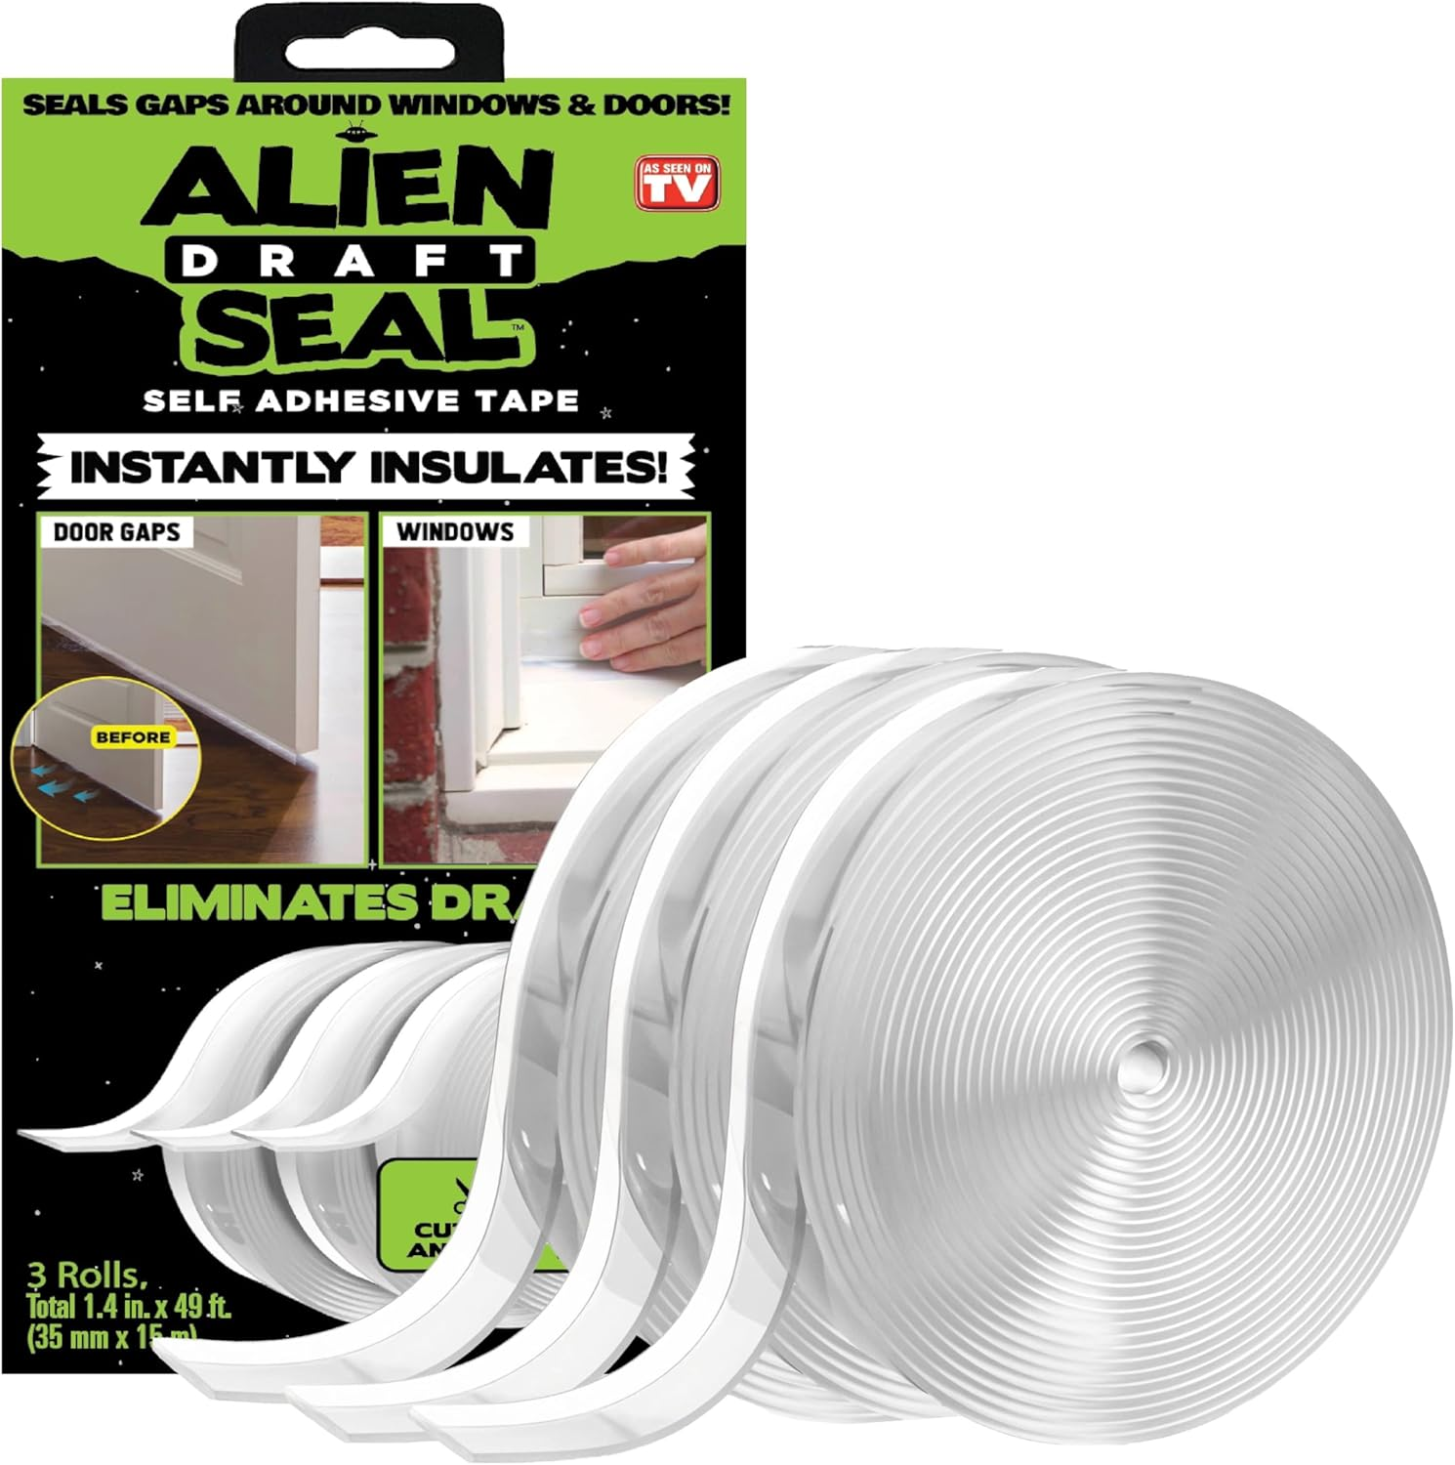
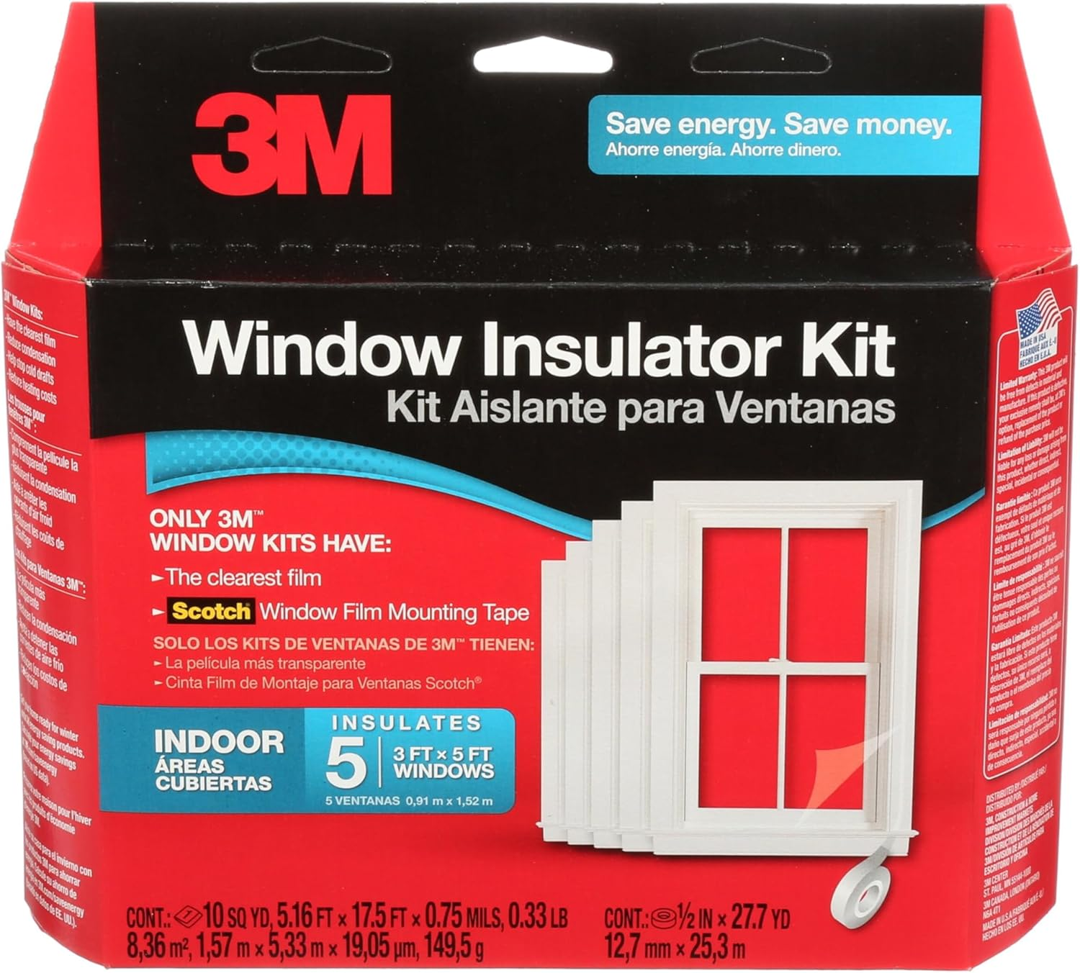

best seasonal barrier for home in winter weather comparison
When the temperature drops and the wind howls, every homeowner looks for a reliable way to keep cold air out and warm air in. A goodseasonal barriercan reduce heating bills, eliminate drafts, and improve comfort throughout the house. Two popular options on Amazon promise to seal gaps and insulate windows: theAlien Draft Seal Set of 49 Feetand the3M Indoor Window Insulator Kit – Five Pack. Both are marketed as easy‑to‑install solutions, yet they differ in design, coverage area, and overall performance. This article breaks down the facts, compares the key specifications side by side, and helps you decide which product is the best fit for your winter‑time needs.
Product | Price | Rating | Key Features
Alien Draft Seal Set of 49 Feet | $19.99 | 4.5 out of 5 (9,201 reviews) | Draft guard that blocks cold air and keeps warm air insideExtra long: 3 rolls, each 1.4″ × 16.34 ft (total 49 ft)Transparent, moisture‑proof tape with strong adhesiveAdheres to wood, glass, metal, ceramic, fiberglass, plastic
3M Indoor Window Insulator Kit – Five Pack | $17.66 | 3.9 out of 5 (15,584 reviews) | Saves energy and reduces heating costsReduces condensation and prevents frost buildupQuick and easy installationFits five 3′ × 5′ indoor windows1‑year limited warranty

Alien Draft Seal Set of 49 Feet – Mini Review
TheAlien Draft Sealpositions itself as a versatile, all‑surface sealant for doors, windows, and even shower doors. Its biggest advantage is the sheer length provided: three rolls add up to 49 feet of 1.4‑inch‑wide tape, which is more than enough to cover multiple door thresholds and window frames in a typical single‑family home. The transparent, moisture‑proof backing means the tape blends into the surrounding surface, preserving aesthetics while delivering a “no‑show” look.
Adhesion is a strong selling point. The product claims it sticks to painted wood, powder‑coated metal, glass, ceramic, fiberglass, and plastic. This broad compatibility expands its use beyond standard door and window gaps to places like garage doors or sliding shower doors, where drafts often go unnoticed. The 4.5‑star rating from over nine thousand reviewers suggests that most users find the seal both durable and easy to apply.
Installation is straightforward: measure, cut, peel, and stick. Because the tape is moisture‑proof, it resists peeling caused by rain or humidity—a common failure mode for cheaper window films. At $19.99, the price per foot is competitive, especially when you consider the flexibility to use the same material on multiple surfaces throughout the house.

3M Indoor Window Insulator Kit – Mini Review
The3M Indoor Window Insulator Kittakes a different approach by focusing exclusively on interior windows. The kit includes five pre‑cut plastic films designed to fit standard 3 × 5‑foot windows. Its primary promise is energy savings: by creating an air‑space barrier on the interior surface, it reduces heat loss, condensation, and frost buildup during the cold months.
Users appreciate the speed of installation. The film attaches with a simple adhesive strip, and the kit provides clear instructions for a quick fit. Because the product is designed for a specific window size, there is less guesswork about how much material you need, which can be reassuring for first‑time DIYers.
With a rating of 3.9 stars from more than fifteen thousand reviews, the 3M kit receives mixed feedback. Some customers praise the noticeable reduction in drafts and lower heating bills, while others note that the film can be visible and may need occasional re‑application. The inclusion of a one‑year limited warranty adds a layer of confidence, and at $17.66 the kit is modestly priced for a five‑window solution.

Which One Should You Buy?
Choosing the right seasonal barrier depends on your home’s layout, your budget, and how hands‑on you want to be during installation.
- Budget‑conscious buyers:The 3M Indoor Window Insulator Kit is slightly cheaper per unit ($17.66) and comes pre‑sized for five windows, meaning you won’t waste material on cuts or excess length. If most of your heat loss comes from standard interior windows, this kit offers a cost‑effective way to address that specific problem.
- Best overall flexibility:The Alien Draft Seal provides 49 feet of adaptable tape that can be used on doors, windows, garage doors, and even shower doors. Its higher average rating (4.5) and strong adhesion across multiple surfaces make it a more versatile, all‑round solution for homes with a variety of gap locations.
- Homeowners with larger or irregular openings:Because the Alien Seal can be cut to any length, it handles non‑standard door thresholds, oversized windows, or oddly shaped gaps better than the fixed‑size 3M films.
- Those who prefer a quick, no‑cut installation:The 3M kit’s pre‑cut panels eliminate the need for measuring and trimming, which can be appealing for renters or anyone who wants a fast, mess‑free setup.
In summary, if you need a single, easy‑to‑apply solution for a handful of standard windows, the 3M Indoor Window Insulator Kit is a solid, budget‑friendly choice. If you want a comprehensive barrier that can seal doors, windows, and other draft sources throughout the house, the Alien Draft Seal’s longer length, stronger adhesive, and higher user rating make it the more robust option.

Frequently Asked Questions

What is the best seasonal barrier for home in winter weather comparison?
Both the Alien Draft Seal and the 3M Indoor Window Insulator Kit are effective seasonal barriers, but the “best” choice hinges on your specific needs. The Alien Draft Seal offers broader coverage and higher user satisfaction, making it ideal for homes with multiple draft points. The 3M kit excels for quick, targeted insulation of standard interior windows and comes at a slightly lower price.

Can the Alien Draft Seal be used on windows as well as doors?
Yes. The product’s transparent, moisture‑proof tape adheres to wood, glass, metal, ceramic, fiberglass, and plastic, allowing you to seal both window frames and door thresholds with the same material. Its flexibility makes it suitable for a wide range of indoor and outdoor applications.

How does the 3M Indoor Window Insulator Kit reduce heating costs?
The 3M kit creates an interior air‑space barrier on 3 × 5‑foot windows. This extra layer traps warm air inside, reducing heat transfer through the glass. By minimizing drafts and condensation, the kit helps maintain a more stable indoor temperature, which can lower heating expenses during the winter months.
Affiliate Disclosure:Some of the links below are affiliate links. If you click and make a purchase, we may earn a small commission at no additional cost to you. This helps support the site and allows us to continue providing helpful content.
Buy Alien Draft Seal Set of 49 Feet on Amazon
Buy 3M Indoor Window Insulator Kit – Five Pack on Amazon

