**Software Requirements Specification (SRS) Document**

|  |  |
| --- | --- |
|  | **Pulse Point Health App** |

**Team 30 -**

**Susheel Krishna**

**Krishna Koushik**

**Deekshitha**

**Swaroop**

**Pratyush Jena**

# Brief problem statement

# The main Idea of the Project is to create a software to collect Medical Data of an individual from smart watches(Android or iOS) and process the collected data. The project will use a smartwatch to track a variety of health metrics in real time. This data will be used to generate insights into the user's health. The project aims for continuous data transfer. Also fetches the user's medical history and stores it. The Data stored is used to predict diagnostics. The project will take assistance from some machine Learning Algorithms to meet this functionality. An emergency health card is used to view critical health details and help healthcare professionals to take proper precautions. The project also aims to track and monitor the chronic conditions and send alerts to healthcare professionals and other selected contacts. It aims to create a centralized repository for health and wellness data. Some algorithms are used to measure any deviations from regular behavior or health conditions. Data security is assured by allowing only some data to be sent in smartwatch settings.

# System requirements

**1. Operating System:**

• Example: Wear OS 4, Android 14 v33.

**2. Software Dependencies:**The following technologies will be used in the course of

development of the project

• Programming Languages: Swift, React Native, curl

• Frameworks and Libraries: Android SDK, Health connect, Health kit

• Database Systems: SQL, Cloud storage

• Web Servers: Apache web server.

• Development Environment: Visual Studio Code, Xcode is used for development of

the project.

• Version Control : GitHub

**3. Documentation :** Google docs, MS Word is used for the documentation purposes

# Users profile

**1.Patient-**

Patient can give details such as height,weight,etc which can be used to derive

insights and generate a meaningful Emergency Information Card. Patient has to

wear a smartwatch and different health parameters such as Heart rate of the user,

BP,step count and so on can be captured and used for analysis. Patient can get meaningful

health insights from the application and also get access to his/her medical history.

Finally the patient can get access to his/her Emergency Information Card which

can be used for future consultations with healthcare professionals who have access

to the patient’s Emergency Information card.

Patient can view his personal health details and his/her view in a simple way that can be understood

easily. It is in such a way so that patients who are not familiar with computers also can access it

easily.

# 2.Healthcare professional-

# To ensure security and privacy of the patient’s health data only authorized

# healthcare providers can login into the application. The healthcare professional can

# do remote patient monitoring by use of the dashboard in the application. The

# a health care professional can also send alerts to the patient in case of an emergency.

# Healthcare professional can track the patient’s health by means of this application

# in a comfortable manner using graphical means and also check the patient’s medical history and

# timeline representation of health events.

These are required to be familiar with the basic usage of computers and understand the medical

reports of an individual. These are not particularly needed to be familiar with any software.

# 3.Admin-

# Admin has to make sure the security of the application should not be

# compromised at any point and every patient can only view his/her data only and

# Only doctors with authorization can only view the dashboard of a patient. Admin

# also has to make sure the application doesn’t crash at any point of time since the

# usage of the application can be critical at times.

# Admin needed to maintain the software, they are are needed to be comfortable with all the

# technology used in this project and are needed to be familiar with the code and the server.

# Feature requirements (described using use cases)

|  |  |  |  |
| --- | --- | --- | --- |
| **No.** | **User Case Name** | **Description** | **Release** |
|  | User Registration and Login | Users can create accounts by registering with their personal information. After registration, they can log in using their credentials. This allows them to access and retrieve their historical health data stored in the system. | R1 |
|  | View Personal Health Report | Once logged in, users can view a comprehensive health report that summarizes their current health status. This report includes key metrics, trends, and relevant information, providing a clear and concise overview of their well-being. This should be user understandable | R1 |
|  | Frequent Health Status Prediction | The system will regularly analyze user data and generate predictions about their future health status. This feature helps users stay proactive in managing their health by identifying potential issues before they become critical.  Based on the user's health data, the system provides personalized health suggestions. | R2 |
|  | Healthcare professional’s pictorial Interface | Healthcare professionals access a graphical interface displaying trends and patterns in a user's health data over time. Data should be understandable for the Healthcare Professional. | R2 |
|  | Emergency Health Information | The system generates a health card containing essential user information, such as blood type, allergies, and emergency contacts. This card is easily accessible in case of emergency, providing crucial details for healthcare professionals. | R2 |
|  | Access Health Data from Any Device | User data is linked to the user account, allowing seamless access from any device. This feature enhances user convenience, enabling them to monitor and manage their health data regardless of the device they are using. | R1 |
| 7. | Emergency Alerts | If there are any abnormal changes in the data, User gets an alert message regarding it. | R2 |

**Use case diagram**

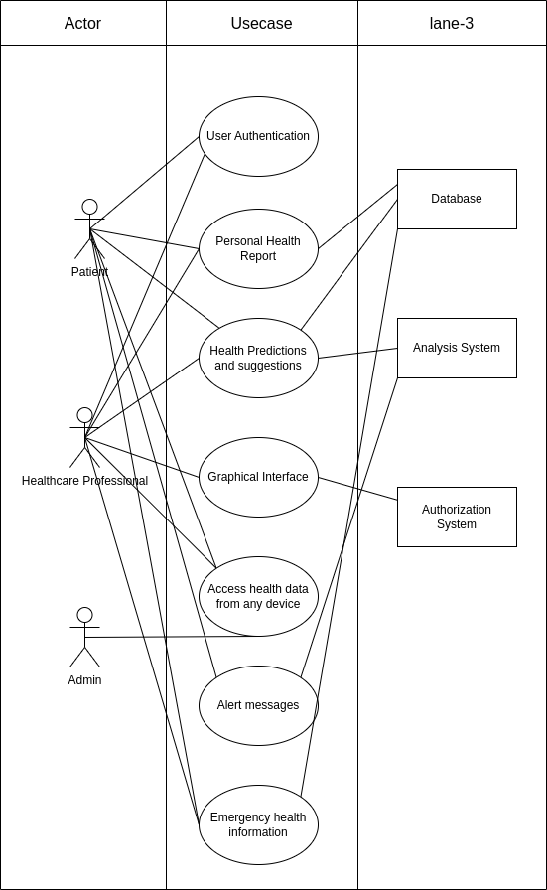

*Add correct IMG here*

**Use case description**

|  |  |
| --- | --- |
| **Use Case Number:** | UC-01 |
| **Use Case Name:** | User Registration and Login |
| **Overview:** | Users can create accounts by registering with their personal information. After registration, they can log in using their credentials. This allows them to access and retrieve their historical health data stored in the system. Data related to a single person is Stored in a single account. |
| **Actors:** | * Patient * Healthcare professional * Authentication system |
| **Pre condition:** | the user should have either a google mail account or should have already signed up. |
| **Flow:** | 1. Login page appears to the user when app is opened 2. User enters his Credentials in the fields 3. User submits his data. 4. User Logins Successfully |
|  | Alternate Flows: 2.1 : if the user doesn’t have mail and is not signed up already. Then Registration should be Done.  4.1 : if user data does not exist or the Credentials are wrong. Then Login will be unsuccessful and the user has to enter the Details once more. |
| **Post Condition:** | User is now able to access his own data. If the user is a Healthcare professional, he can access others' data. |

|  |  |
| --- | --- |
| **Use Case Number:** | UC-02 |
| **Use Case Name:** | View Personal Health Report |
| **Overview:** | Once logged in, users can view a comprehensive health report that summarizes their current health status. This report includes key metrics, trends, and relevant information, providing a clear and concise overview of their well-being. This should be understandable by the user. |
| **Actors:** | * Healthcare professional * Patient |
| **Pre condition:** | user should have been logged in with his credentials |
| **Flow:** | 1. check whether the user is Healthcare professional or Patient 2. If the user is a Health professional, then brief info of multiple patients is shown. 3. Now users can export the Data. |
|  | Alternate Flows: 2.1 : if the user is a Patient, then information regarding his health details will be displayed in brief (can be average, min_max) |
| **Post Condition:** | User is now able to access his own data. |

|  |  |
| --- | --- |
| **Use Case Number:** | UC-03 |
| **Use Case Name:** | Frequent Health Status Prediction |
| **Overview:** | The system will regularly analyze user data and generate predictions about their future health status. This feature helps users stay proactive in managing their health by identifying potential issues before they become critical. Patient is able to see the analyzed data predictions on Dashboard |
| **Actors:** | * Patient * Analysis System * Admin |
| **Pre condition:** | user should have logged in with his credentials |
| **Flow:** | 1. Patient opens the app 2. Patient logins into the app 3. Patients can now see results of data analysis. |
|  | Alternate Flows: NA |
| **Post Condition:** | Patient is now able to see analyzed results in his Dashboard. |

|  |  |
| --- | --- |
| **Use Case Number:** | UC-04 |
| **Use Case Name:** | Healthcare professional’s pictorial Interface |
| **Overview:** | Healthcare professionals can access a graphical interface displaying trends and patterns in a user's health data over time. Data should be understandable for the Healthcare professional. Healthcare professionals can choose whose data he want to see. |
| **Actors:** | * Healthcare professional * Graph generating system |
| **Pre condition:** | Healthcare professional should have been logged in with his credentials |
| **Flow:** | 1. Healthcare professional logins into the app 2. Healthcare professional sees brief info about each patient 3. Selects one of the patient 4. Healthcare professionals are now able to see fluctuations in health readings of the patient. |
|  | Alternate Flows: NA |
| **Post Condition:** | Healthcare professional is now able to see Patients’ data |

|  |  |
| --- | --- |
| **Use Case Number:** | UC-05 |
| **Use Case Name:** | Emergency Health Information |
| **Overview:** | The system generates a health card containing essential user information, such as blood type, allergies, and emergency contacts. This card is easily accessible in case of emergency, providing crucial details for healthcare professionals. |
| **Actors:** | * Patient * Healthcare professional |
| **Pre condition:** | the user should have either a google mail account or should have already signed up. Healthcare professional should have access to patient data |
| **Flow:** | 1. Healthcare professional chooses the patient 2. Healthcare professional sees Emergency Card |
|  | Alternate Flows: 1.1 Patient can show his data after logging in his/her device and share emergency card |
| **Post Condition:** | Healthprofessional is now able to see Emergency cards. |

|  |  |
| --- | --- |
| **Use Case Number:** | UC-06 |
| **Use Case Name:** | Access Health Data from Any Device |
| **Overview:** | User data is linked to the user account, allowing seamless access from any device. This feature enhances user convenience, enabling them to monitor and manage their health data regardless of the device they are using. |
| **Actors:** | * Patient * Healthcare professional * Admin |
| **Pre condition:** | user should have been signed up or have a google account |
| **Flow:** | 1. User gets logged in to the account 2. User is able to access his data on multiple devices |
|  | Alternate Flows: NA |
| **Post Condition:** | User is now able to access his own data. |

|  |  |
| --- | --- |
| **Use Case Number:** | UC-07 |
| **Use Case Name:** | Emergency Alerts |
| **Overview:** | If there are any abnormal changes in the data, Patient gets an alert message regarding it. Healthcare professionals also get alert regarding that patient. |
| **Actors:** | * Patient * Analysis System |
| **Pre condition:** | the user should have logged in with his credentials. |
| **Flow:** | 1. Abnormal activity happens to the patient 2. Health data is a Analyzed 3. Alert Generated to the Healthcare professional and Patient 4. Healthcare professional is able to see where the abnormality arised |
|  | Alternate Flows: NA |
| **Post Condition:** | Healthcare professionals and patients get alert messages. |

**Non - Functional Requirements :**

**Real-time Data :** the data points that are created by the sensors should be sent continuously to the server. So that synchronization is achieved.

**Variable-Latency :** the data transfer speed should be changeable. It depends on how fast the data should be uploaded to the server. it also depends on sessions of the Patient.

**Accurate :** Data recorded should be more accurate.

**Faster Analysis :** data analysis should be done faster. it should not depend on the server to analyze the information. Analysis algorithm should run on Patients’ device.

**Data Security :** Health data is sensitive. So data should be only accessible to the respective user. Data privacy depends on the user.

**Responsive :** Health should be able to run on most of the devices.

**Data Cleaning :** There exists some null Values in the dataset if the sensor of the device is not working properly. in that case. Analysis algorithm should be able to process these null values.