**Software Requirements Specification (SRS) Document**

|  |  |
| --- | --- |
|  | **Pulse Point Health App** |
|  |  |

**Team 30 -**

**Susheel Krishna**

**Krishna Koushik**

**Deekshitha**

**Swaroop**

**Pratyush Jena**

# Brief problem statement

# The main Idea of the Project is to create a software to collect Medical Data of an individual from smart watches Android and process the collected data. The project will use a smartwatch to track a variety of health metrics in real time. This data will be used to generate insights into the user's health. The project aims for continuous data transfer. Also fetches the user's medical history and stores it. The Data stored is used to predict diagnostics. The project will take assistance from some machine Learning Algorithms to meet this functionality. An emergency health card is used to view critical health details and help healthcare professionals to take proper precautions. The project also aims to track and monitor the chronic conditions and send alerts to healthcare professionals and other selected contacts. It aims to create a centralized repository for health and wellness data. Some algorithms are used to measure any deviations from regular behavior or health conditions. Data security is assured by allowing only some data to be sent in smartwatch settings.

# System requirements

**1. Operating System:**

• Example: Wear OS 4, Android 14 v34.

**2. Software Dependencies:**The following technologies will be used in the course of

development of the project

• Programming Languages: React Native, curl

• Frameworks and Libraries: Android SDK, Health connect, expo

• Database Systems: SQL, Firebase Database, Cloud Storage

• Web Servers: Firebase.

• Development Environment: Visual Studio Code, Android Studio is used in this project.

• Version Control : GitHub, Android Studio

**3. Documentation :** Google docs, MS Word, Jupyter Notebook is used for the documentation purposes

# Users profile

1. **Patient-**

Patient can give details such as height,weight, surgery related informations etc which can be used to derive insights and generate a meaningful Emergency Information Card. Patient has to wear a smartwatch. different health parameters such as Heart rate of the user, BP, step count and so on can be captured and used for analysis. Patient can get meaningful health insights from the application and also get access to his/her medical history. Finally the patient can get access to his/her Emergency Information Card which can be used for future consultations with healthcare professionals who have access to the patient’s Emergency Information card. Patient can view his personal health details and his/her view in a simple way that can be understood easily. It is in such a way so that patients who are not familiar with computers also can access it easily.

# Healthcare professional :

# To ensure security and privacy of the patient’s health data, only authorized healthcare providers can login into the application and view data. The healthcare professional can do remote patient monitoring by use of the dashboard in the application. The health care professional can also send alerts to the patient in case of an emergency. Healthcare professionals can track the patient’s health by means of this application in a comfortable manner using graphical means and also check the patient’s medical history and timeline representation of health events. These are required to be familiar with the basic usage of computers and understand the medical reports of an individual. These are not particularly needed to be familiar with any software.

# Admin

# Admin has to make sure the security of the application should not be compromised at any point and every patient can only view his/her data only and Only doctors with authorization can only view the dashboard of a patient. Admin also has to make sure the application doesn’t crash at any point of time since the usage of the application can be critical at times. Admin needed to maintain the software, they are needed to be comfortable with all the technology used in this project and are needed to be familiar with the code and the server.

# Feature requirements (described using use cases)

|  |  |  |  |
| --- | --- | --- | --- |
| **No.** | **User Case Name** | **Description** | **Release** |
|  | User Registration and Login | Users can create accounts by registering with their personal information. After registration, they can log in using their credentials. This allows them to access and retrieve their historical health data stored in the system. | R1 |
|  | View Personal Health Report | Once logged in, users can view a comprehensive health report that summarizes their current health status. This report includes key metrics, trends, and relevant information, providing a clear and concise overview of their well-being. This should be user understandable | R1 |
|  | Frequent Health Status Prediction | The system will regularly analyze user data and generate predictions about their future health status. This feature helps users stay proactive in managing their health by identifying potential issues before they become critical.  Based on the user's health data, the system provides personalized health suggestions. | R2 |
|  | Healthcare professional’s pictorial Interface | Healthcare professionals access a graphical interface displaying trends and patterns in a user's health data over time. Data should be understandable for the Healthcare Professional. | R2 |
|  | Emergency Health Information | The system generates a health card containing essential user information, such as blood type, allergies, and emergency contacts. This card is easily accessible in case of emergency, providing crucial details for healthcare professionals. | R2 |
|  | Access Health Data from Any Device | User data is linked to the user account, allowing seamless access from any device. This feature enhances user convenience, enabling them to monitor and manage their health data regardless of the device they are using. | R1 |
| 7. | Emergency Alerts | If there are any abnormal changes in the data, User gets an alert message regarding it. | R2 |

**Use case diagram**

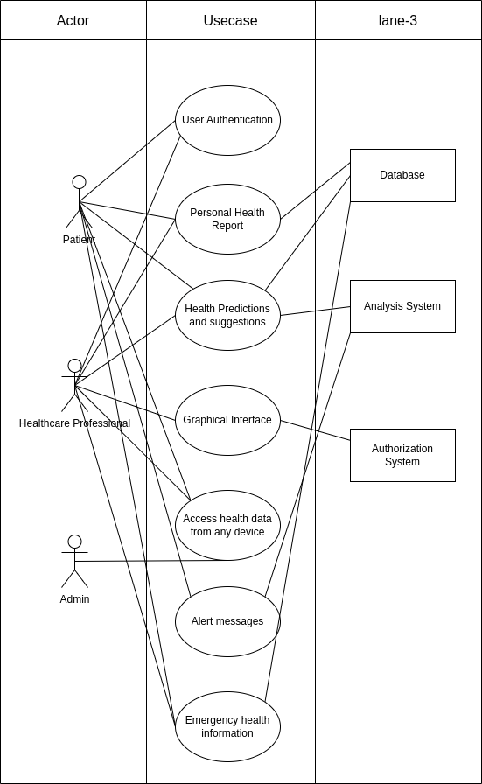

**Use case description**

|  |  |
| --- | --- |
| **Use Case Number:** | UC-01 |
| **Use Case Name:** | User Registration and Login |
| **Overview:** | Users can create accounts by registering with their personal information. After registration, they can log in using their credentials. This allows them to access and retrieve their historical health data stored in the system. Data related to a single person is Stored in a single account. |
| **Actors:** | * Patient * Healthcare professional * Authentication system |
| **Pre condition:** | the user should have either a google mail account or should have already signed up. |
| **Flow:** | 1. Login page appears to the user when app is opened 2. User enters his Credentials in the fields 3. User submits his data. 4. Users have to Allow permissions asked by the App. 5. User Logins Successfully |
|  | Alternate Flows: 2.1 : if the user doesn’t have mail and is not signed up already. Then Registration should be Done.  2.2 : In Registration, users have to provide additional information such as Name, Age, Chronicle Diseases etc.  4.1 : if user data does not exist or the Credentials are wrong. Then Login will be unsuccessful and the user has to enter the Details once more. |
| **Post Condition:** | User is now able to access his own data. If the user is a Healthcare professional, he can access others' data. |

|  |  |
| --- | --- |
| **Use Case Number:** | UC-02 |
| **Use Case Name:** | View Personal Health Report |
| **Overview:** | Once logged in, users can view a comprehensive health report that summarizes their current health status. This report includes key metrics, trends, and relevant information, providing a clear and concise overview of their well-being. This should be understandable by the user. |
| **Actors:** | * Healthcare professional * Patient |
| **Pre condition:** | user should have been logged in with his credentials |
| **Flow:** | 1. check whether the user is a Healthcare professional or Patient 2. If the user is a Health professional, then brief info of multiple patients is shown. 3. Now users can export the Data. |
|  | Alternate Flows: 2.1 : if the user is a Patient, then information regarding his health details will be displayed in detailed (can be average, min_max in aggregated form) |
| **Post Condition:** | User is now able to access his own data and Health care professional can access Patients’ data. |

|  |  |
| --- | --- |
| **Use Case Number:** | UC-03 |
| **Use Case Name:** | Frequent Health Status Prediction |
| **Overview:** | The system will regularly analyze user data and generate predictions about their future health status. This feature helps users stay proactive in managing their health by identifying potential issues before they become critical. Patient is able to see the analyzed data predictions on Dashboard |
| **Actors:** | * Patient * Analysis System * Admin |
| **Pre condition:** | user should have logged in with his credentials  user should have given required data during registration  user should have given access to permissions.  user should have internet connection. |
| **Flow:** | 1. Patient opens the app 2. Patient logins into the app 3. Patients can now see results of data analysis. |
|  | Alternate Flows: NA |
| **Post Condition:** | Patient is now able to see analyzed results in his Dashboard. |

|  |  |
| --- | --- |
| **Use Case Number:** | UC-04 |
| **Use Case Name:** | Healthcare professional’s pictorial Interface |
| **Overview:** | Healthcare professionals can access a graphical interface displaying trends and patterns in a user's health data over time. Data should be understandable for the Healthcare professional. Healthcare professionals can choose whose data he want to see. |
| **Actors:** | * Healthcare professional * Graph generating system |
| **Pre condition:** | Healthcare professional should have been logged in with his credentials. User should have internet connection. |
| **Flow:** | 1. Healthcare professional logins into the app 2. Healthcare professional sees brief info about each patient 3. Selects one of the patient 4. Healthcare professionals are now able to see fluctuations in health readings of the patient. |
|  | Alternate Flows: NA |
| **Post Condition:** | Healthcare professional is now able to see Patients’ data |

|  |  |
| --- | --- |
| **Use Case Number:** | UC-05 |
| **Use Case Name:** | Emergency Health Information |
| **Overview:** | The system generates a health card containing essential user information, such as blood type, allergies, and emergency contacts. This card is easily accessible in case of emergency, providing crucial details for healthcare professionals. |
| **Actors:** | * Patient * Healthcare professional * Database |
| **Pre condition:** | the user should have already signed up. Healthcare professional should have access to patient data. User should have Internet Connection. |
| **Flow:** | 1. Healthcare professional chooses the patient 2. Healthcare professional sees Emergency Card |
|  | Alternate Flows: 1.1 Patient can show his data after logging in his/her device and share emergency card |
| **Post Condition:** | Healthprofessional is now able to see Emergency cards. |

|  |  |
| --- | --- |
| **Use Case Number:** | UC-06 |
| **Use Case Name:** | Access Health Data from Any Device |
| **Overview:** | User data is linked to the user account, allowing seamless access from any device. This feature enhances user convenience, enabling them to monitor and manage their health data regardless of the device they are using. |
| **Actors:** | * Patient * Healthcare professional * Admin |
| **Pre condition:** | the user should have been signed up.  the user should have Internet Access. |
| **Flow:** | 1. User gets logged in to the account 2. User is able to access his data on multiple devices |
|  | Alternate Flows: NA |
| **Post Condition:** | User is now able to access his own data. |

|  |  |
| --- | --- |
| **Use Case Number:** | UC-07 |
| **Use Case Name:** | Emergency Alerts |
| **Overview:** | If there are any abnormal changes in the data, Patient gets an alert message regarding it. Healthcare professionals also get alert regarding that patient. |
| **Actors:** | * Patient * Analysis System * Healthcare professional |
| **Pre condition:** | the user should have logged in with his credentials.  user should have given permissions. |
| **Flow:** | 1. Abnormal activity happens to the patient 2. Health data is a Analyzed 3. Alert Generated to the Healthcare professional and Patient 4. Healthcare professional is able to see where the abnormality arised |
|  | Alternate Flows: NA |
| **Post Condition:** | Healthcare professionals and patients get alert messages. |

**Non - Functional Requirements :**

**Real-time Data :** the data points that are created by the sensors should be sent continuously to the server. So that synchronization is achieved.

**Variable-Latency :** the data transfer speed should be changeable. It depends on how fast the data should be uploaded to the server. it also depends on sessions of the Patient.

**Accurate :** Data recorded should be more accurate.

**Faster Analysis :** data analysis should be done faster. it should not depend on the server to analyze the information. Analysis algorithm should run on Patients’ device.

**Data Security :** Health data is sensitive. So data should be only accessible to the respective user. Data privacy depends on the user.

**Responsive :** Health should be able to run on most of the devices.

**Data Cleaning :** There exists some null Values in the dataset if the sensor of the device is not working properly. in that case. Analysis algorithm should be able to process these null values.  
  
  
​ Brief SRS for R2 (Client- Abhinav Gupta)

1.1 Scope

This document outlines the requirements for a system designed to securely transfer Electronic Medical Records (EMRs) between different healthcare systems. The system will operate in compliance with the Health Insurance Portability and Accountability Act (HIPAA) regulations, ensuring patient confidentiality and data integrity and with HL7.

1.2 Definitions, Acronyms, and Abbreviations

* EMR: Electronic Medical Record
* HL7: Health Level Seven International
* HIPAA: Health Insurance Portability and Accountability Act
* SRS: Software Requirements Specification

2. System Overview

The system aims to facilitate the secure transmission of EMRs while adhering to HIPAA and HL7 compliance standards. It will exclude demographic information from EMRs, ensuring patient confidentiality, and implement a mechanism for accurate patient identification during communication.

3. Functional Requirements

3.1 Secure EMR Transmission

* The system shall securely transfer EMRs between different healthcare systems.
* EMRs shall be transmitted using the HL7 data format.
* Confidential demographic information shall be excluded from EMRs during transmission to comply with HIPAA regulations.

3.2 Patient Identification Mechanism

* The system shall implement a mechanism for accurately identifying patients across healthcare systems.
* Patient identification shall be achieved without including demographic information in EMRs.

3.3 HIPAA Compliance

* The system shall adhere to HIPAA regulations regarding the protection of patient health information.
* Measures shall be implemented to ensure the confidentiality, integrity, and availability of patient data during transmission.

4. Non-functional Requirements

4.1 Security

* The system shall employ encryption techniques to ensure the security of EMRs during transmission.
* Access to patient data shall be restricted to authorized healthcare professionals.

4.4 Scalability

* The system shall be scalable to accommodate a growing number of healthcare systems and patient records.