Name - Swaraj Wattamwar

Roll no - 150096724157

Question no 1

Bus topology

Pcs - ip address

Pc0 - 10.0.0.1

Pc1 - 10.0.0.2

Pc2 - 10.0.0.3

Pc3 - 10.0.0.4

Pc4 - 10.0.0.5

Pc5 - 10.0.0.6

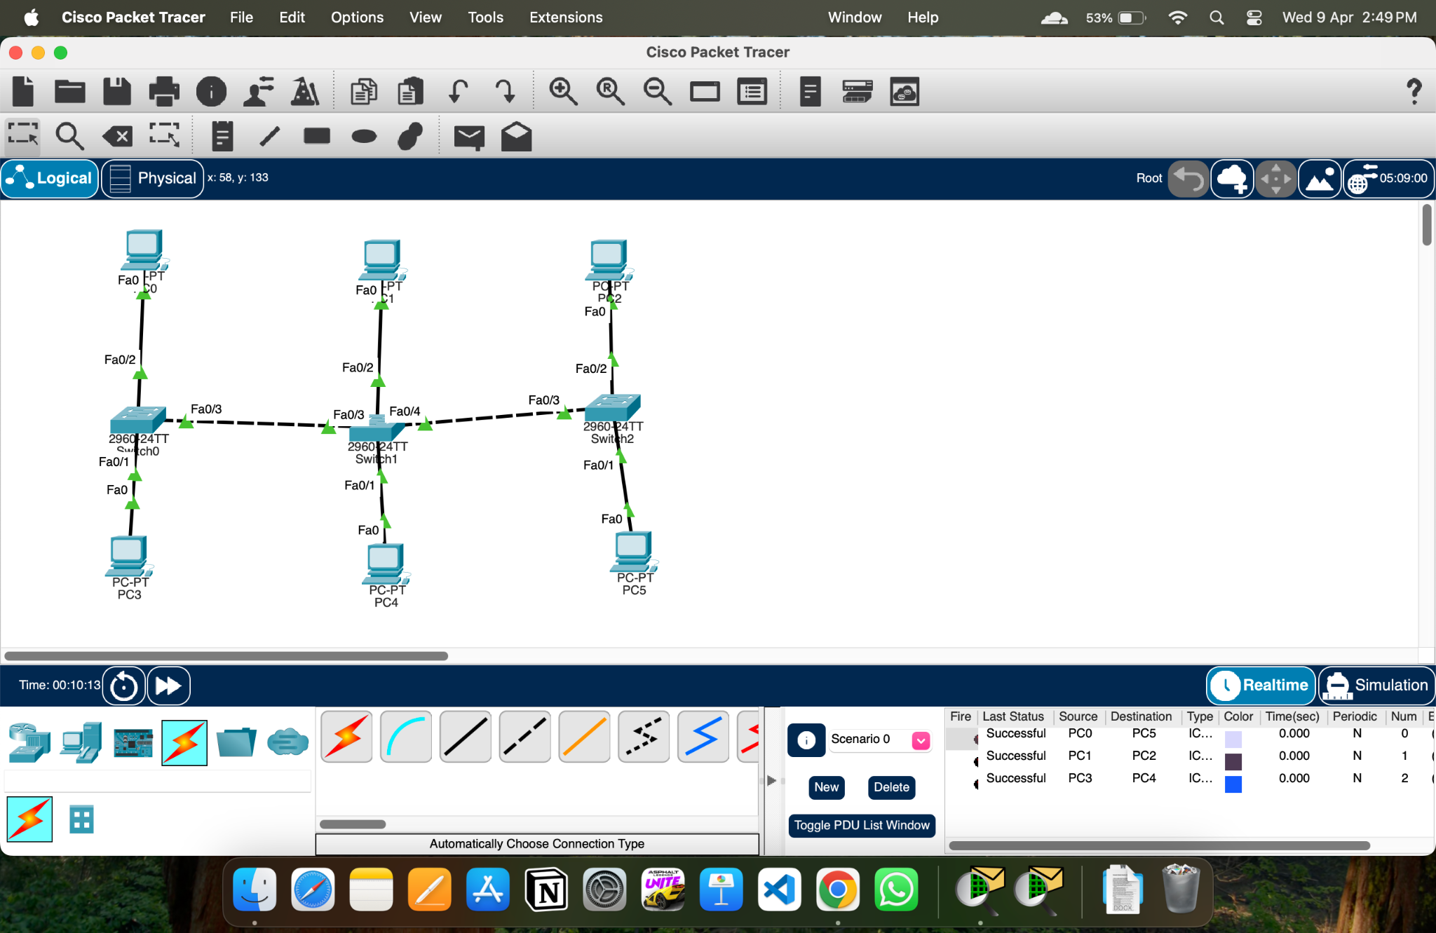

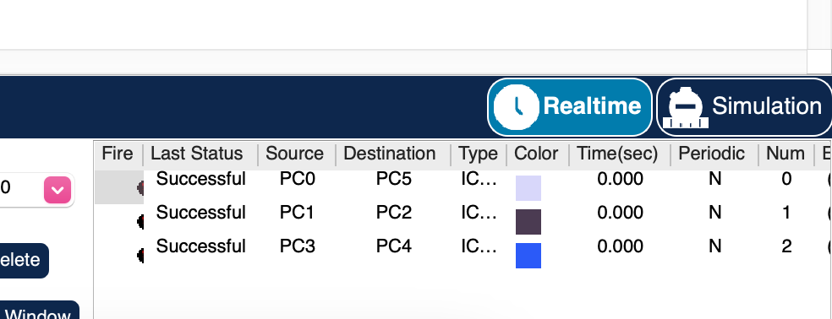

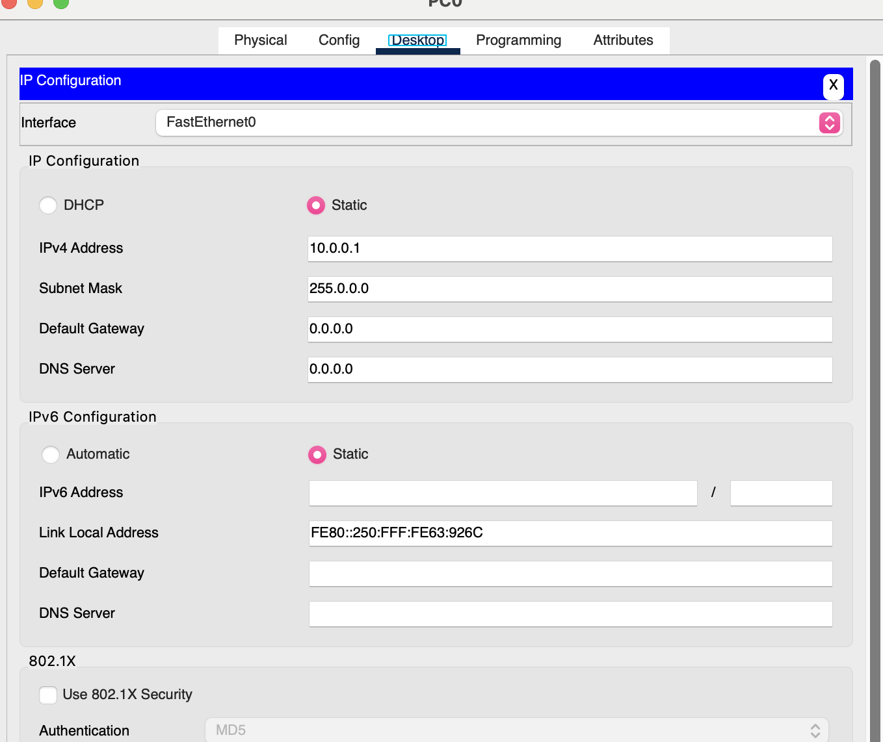

This is for pc0 ip same as above to all pcs

Question 2

Vlan has add like 10 - hr , 20 - it ,30 - cse

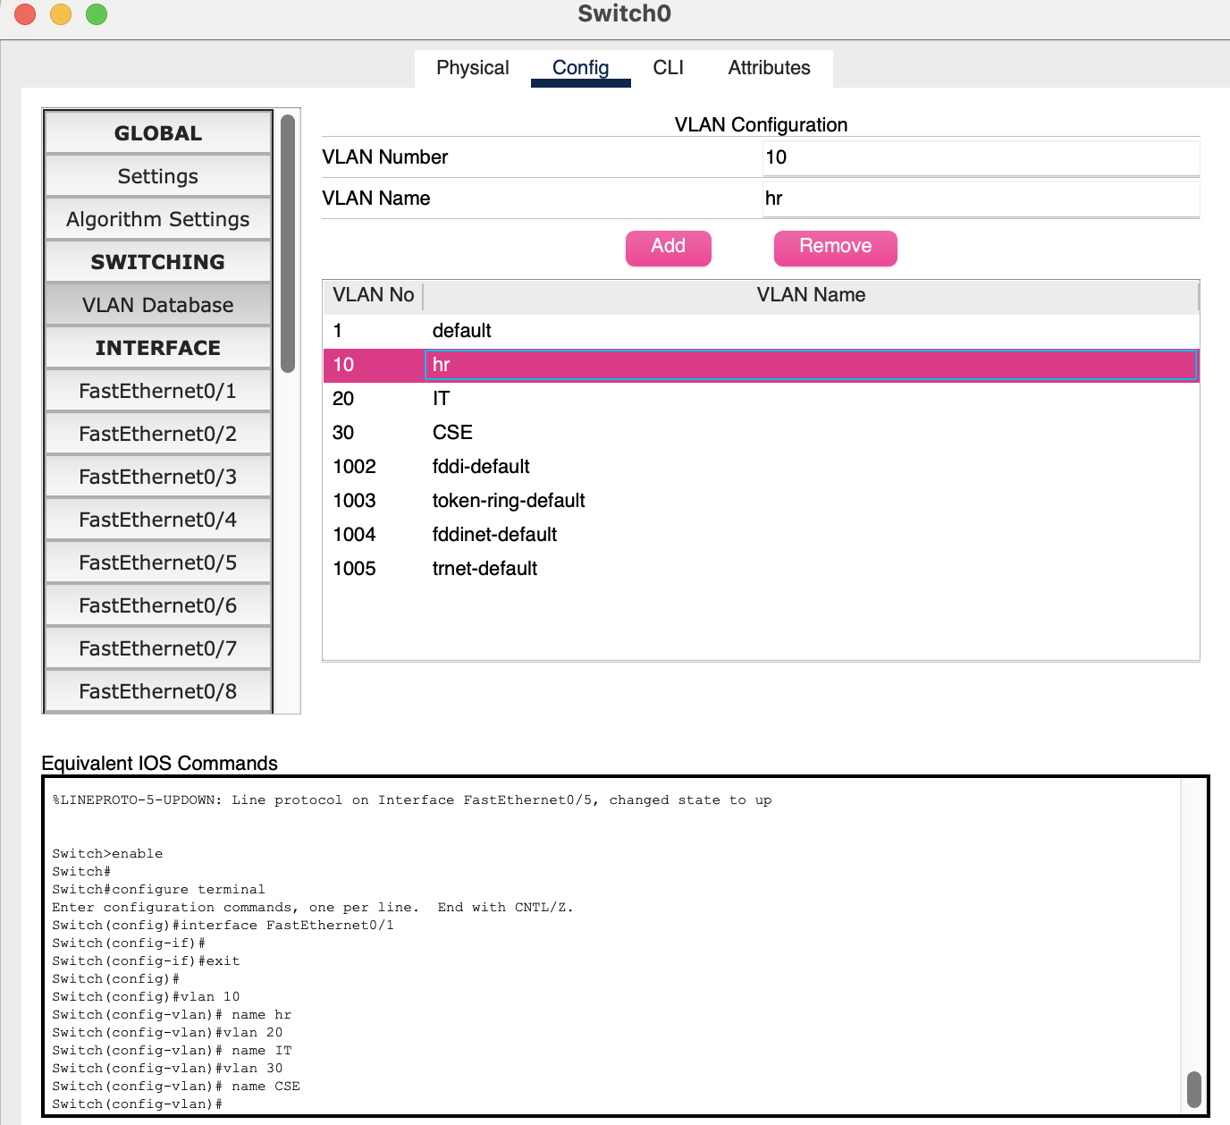

Vlan has assign to its devices