Swaraj Wattamwar

157

Retail inventory management system

ER diagram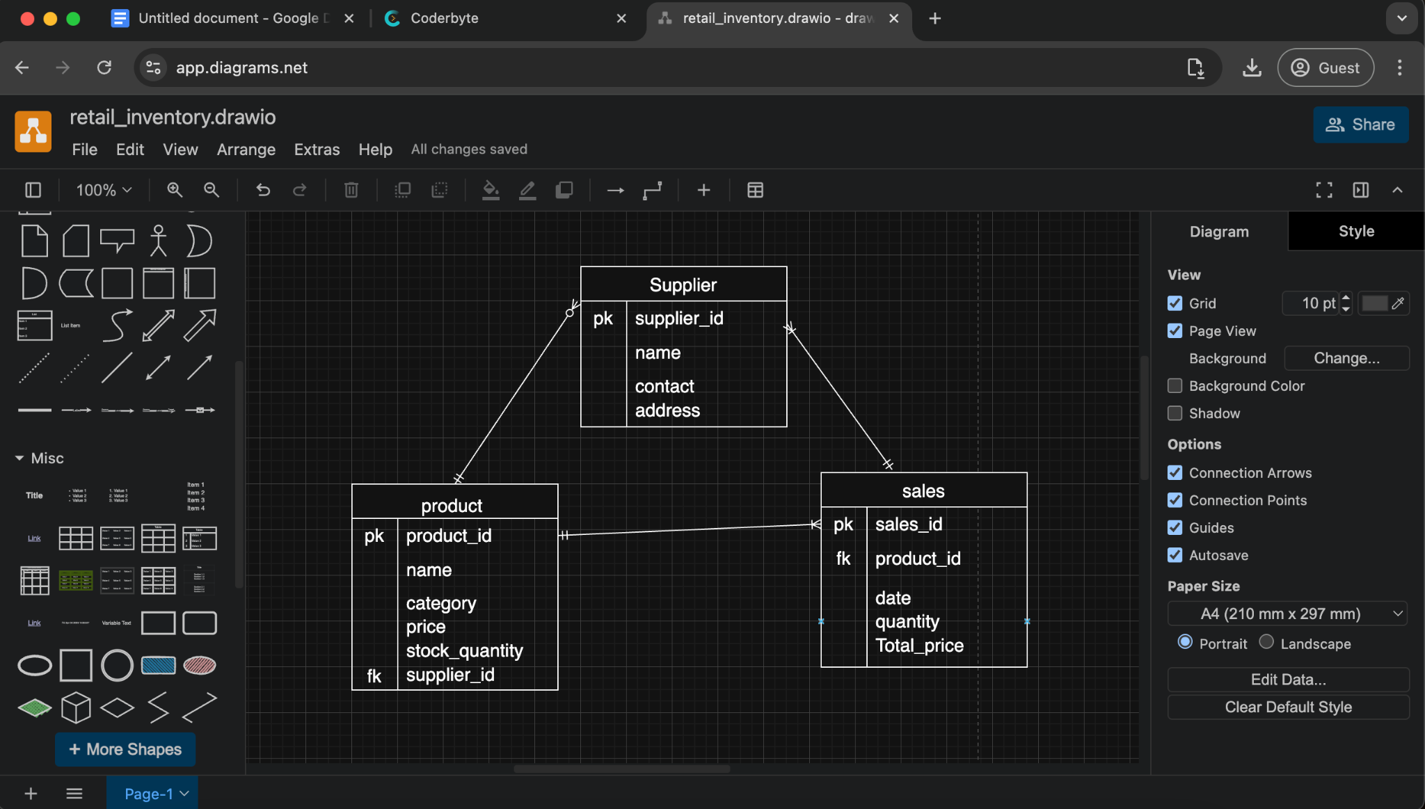

Relation schema

Supplier->Supplier_id (primary key),name ,contact,address.

Product ->product_id(primary key),name,category,price,stock_quantity,supplier_id(foreign key ref to Supplier(supplier_id)).

Sales -> sales_id (primary key),product_id(foreign key ref to Product(product_id))

