1. Create Table:  
     
   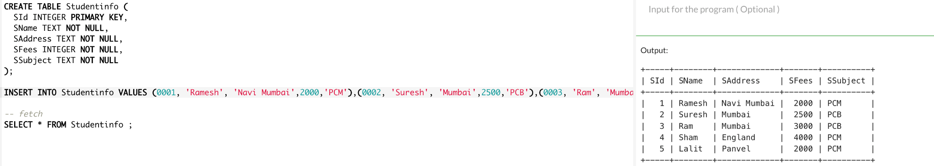

1. Insert 5 Records:  
     
   
2. Update “Navi Mumbai” to “Mumbai”:  
     
   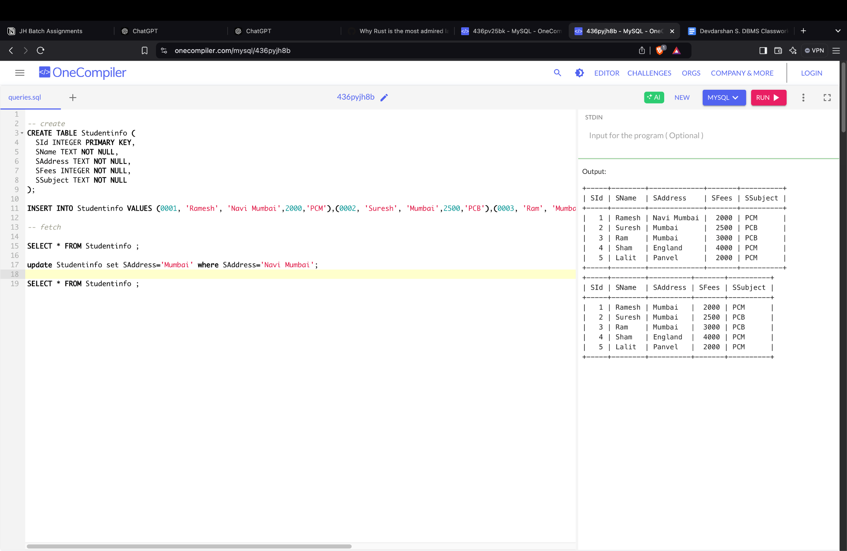
3. Delete Records Whose Fees is 2000:  
     
   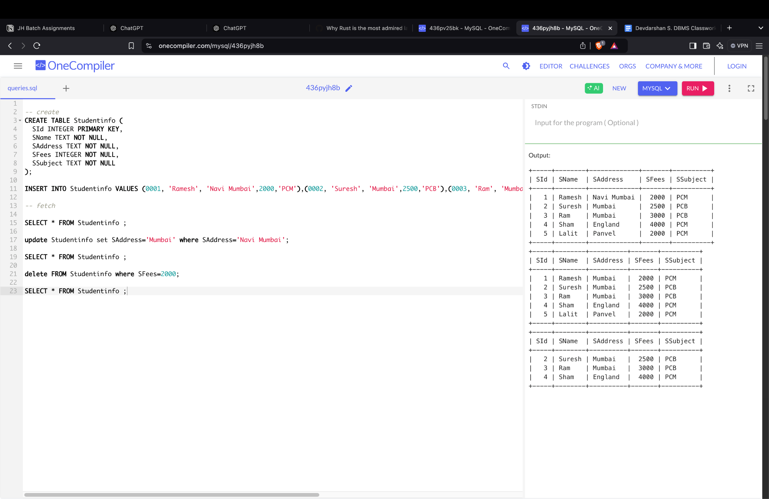
4. Retrieve name and subject:  
     
   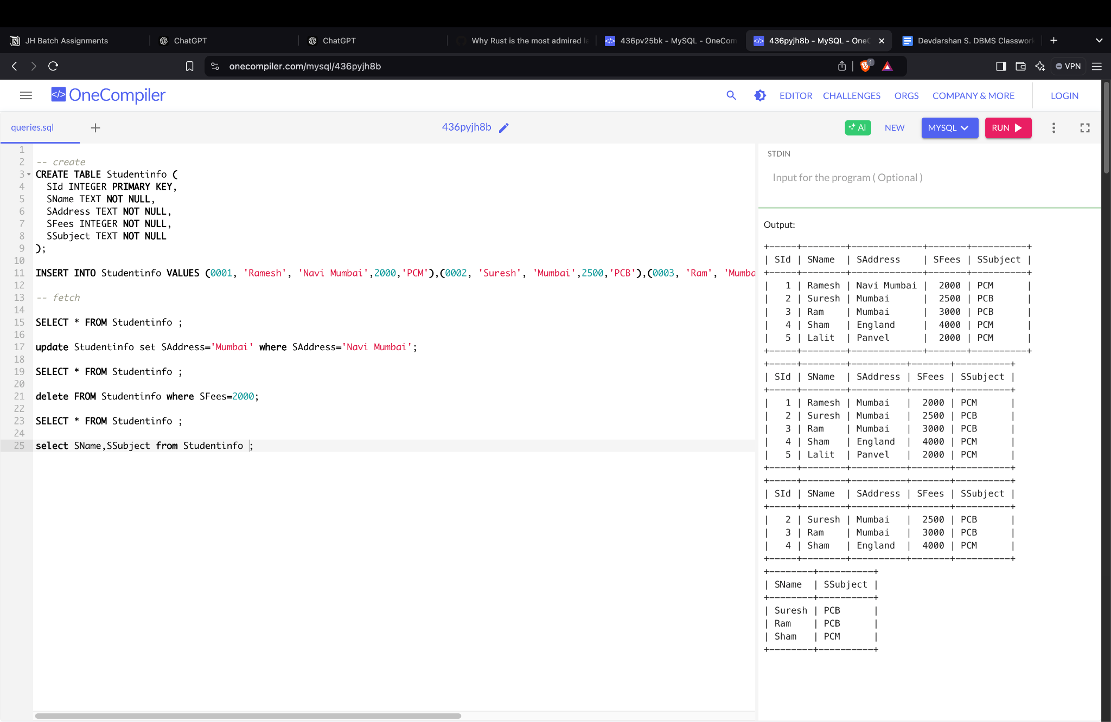
5. Retrieve Unique Records:  
     
   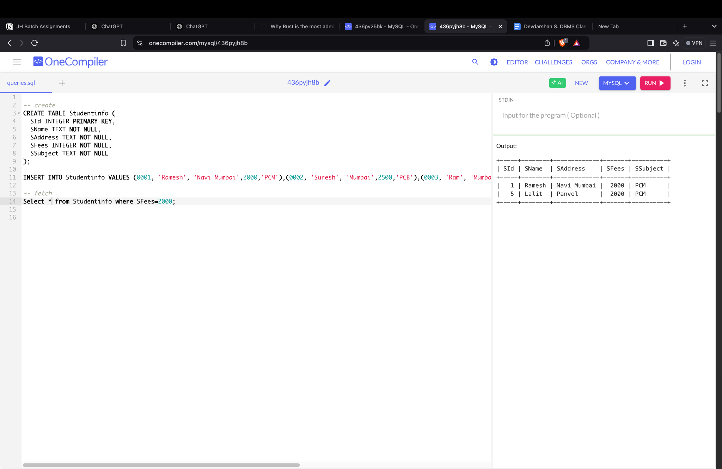
6. Retrieve Whose Address is “Mumbai”:  
     
   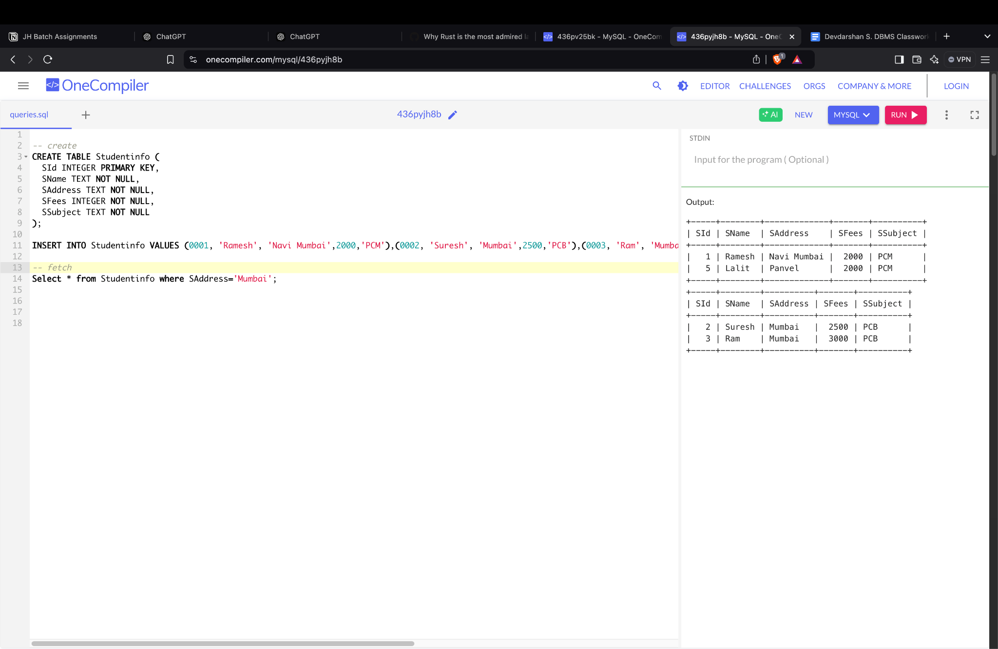
7. Retrieve how many students have taken Subject “PCM”:  
     
   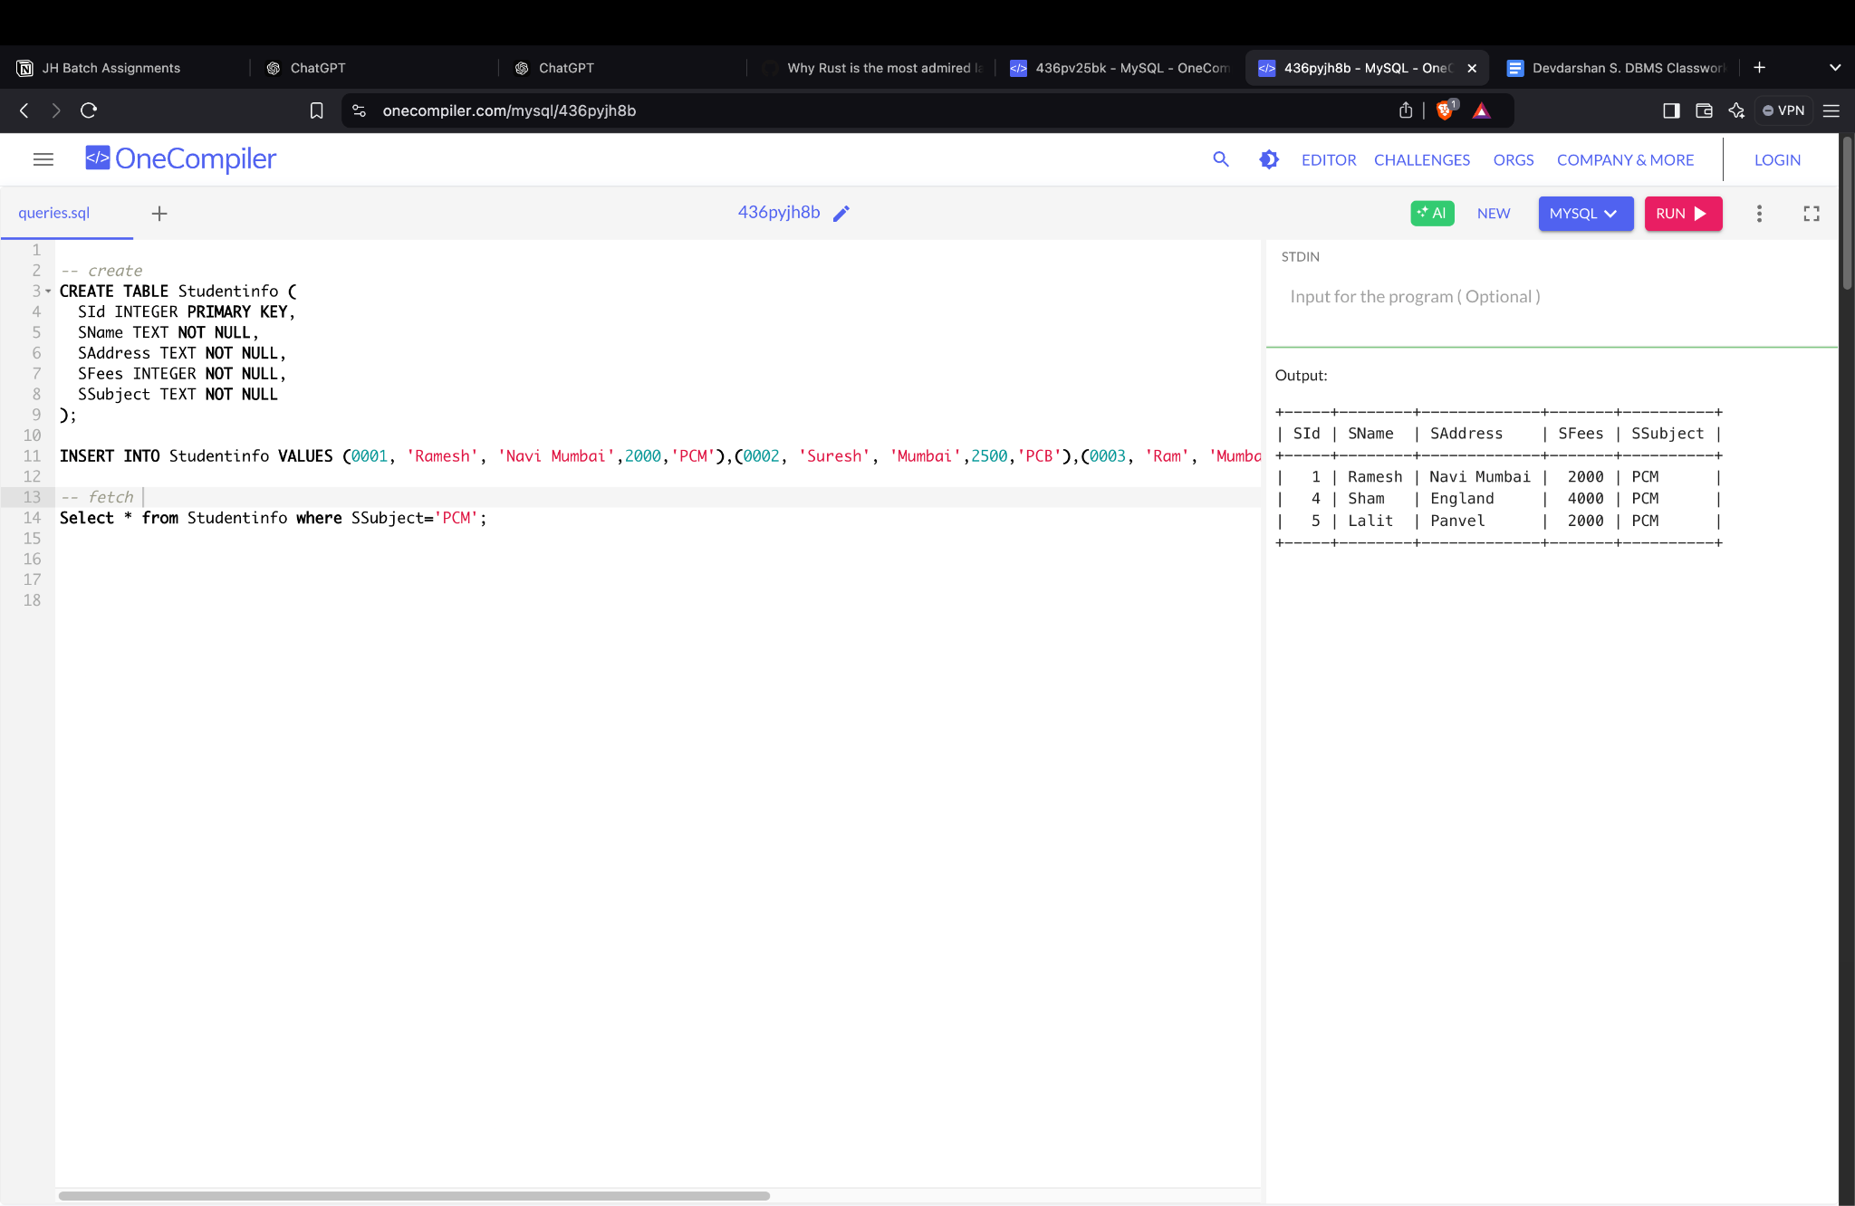
8. Retrieve No.of records:  
     
   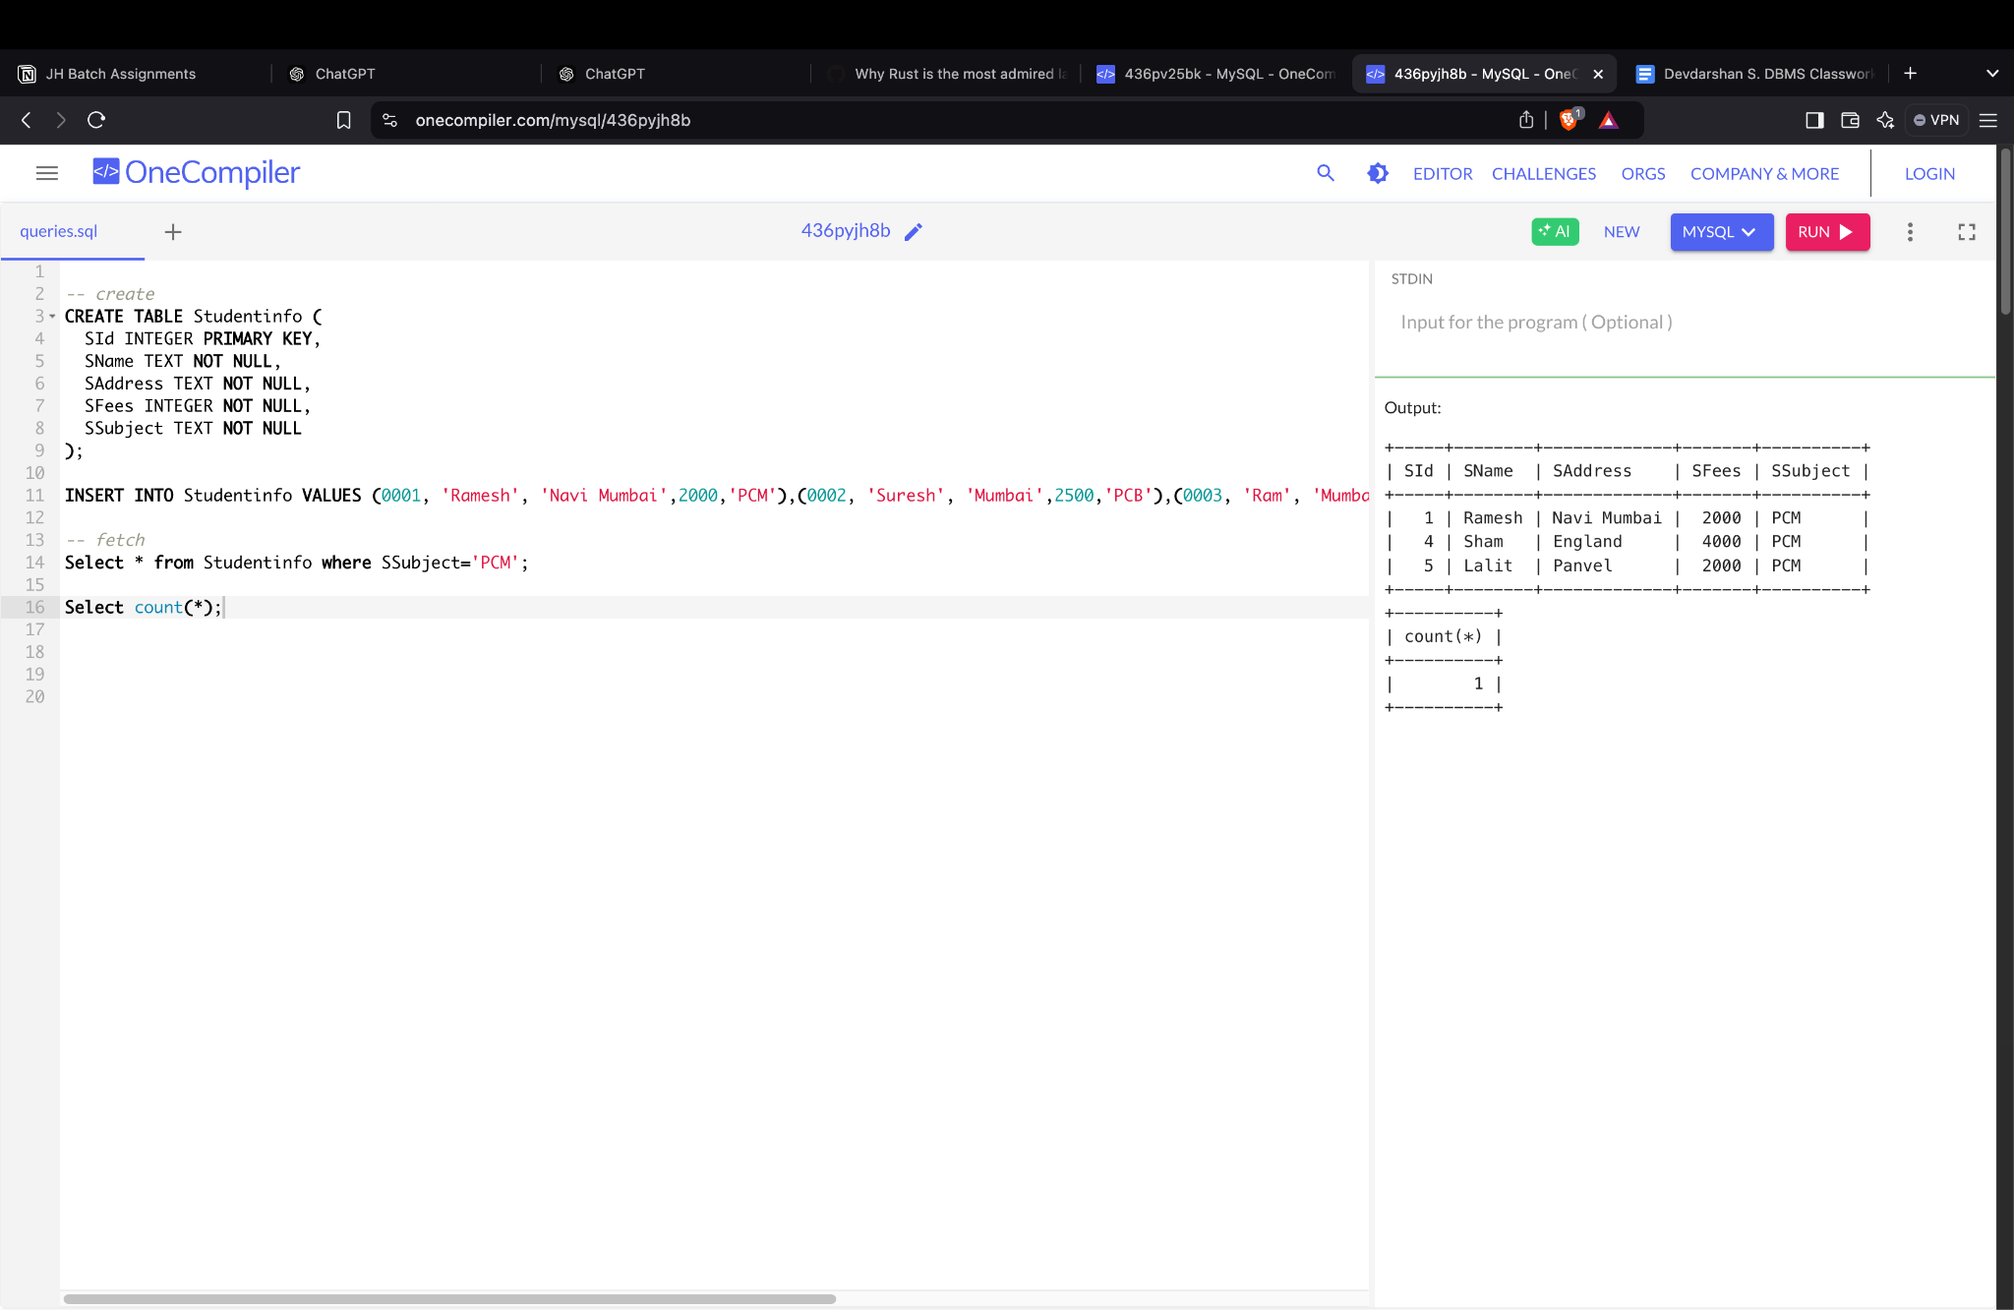
9. Display record by name of student Ascending order:  
     
   