Practical_screenshot_3/2/2025

Question no 1 - Delete data where faculty id is 2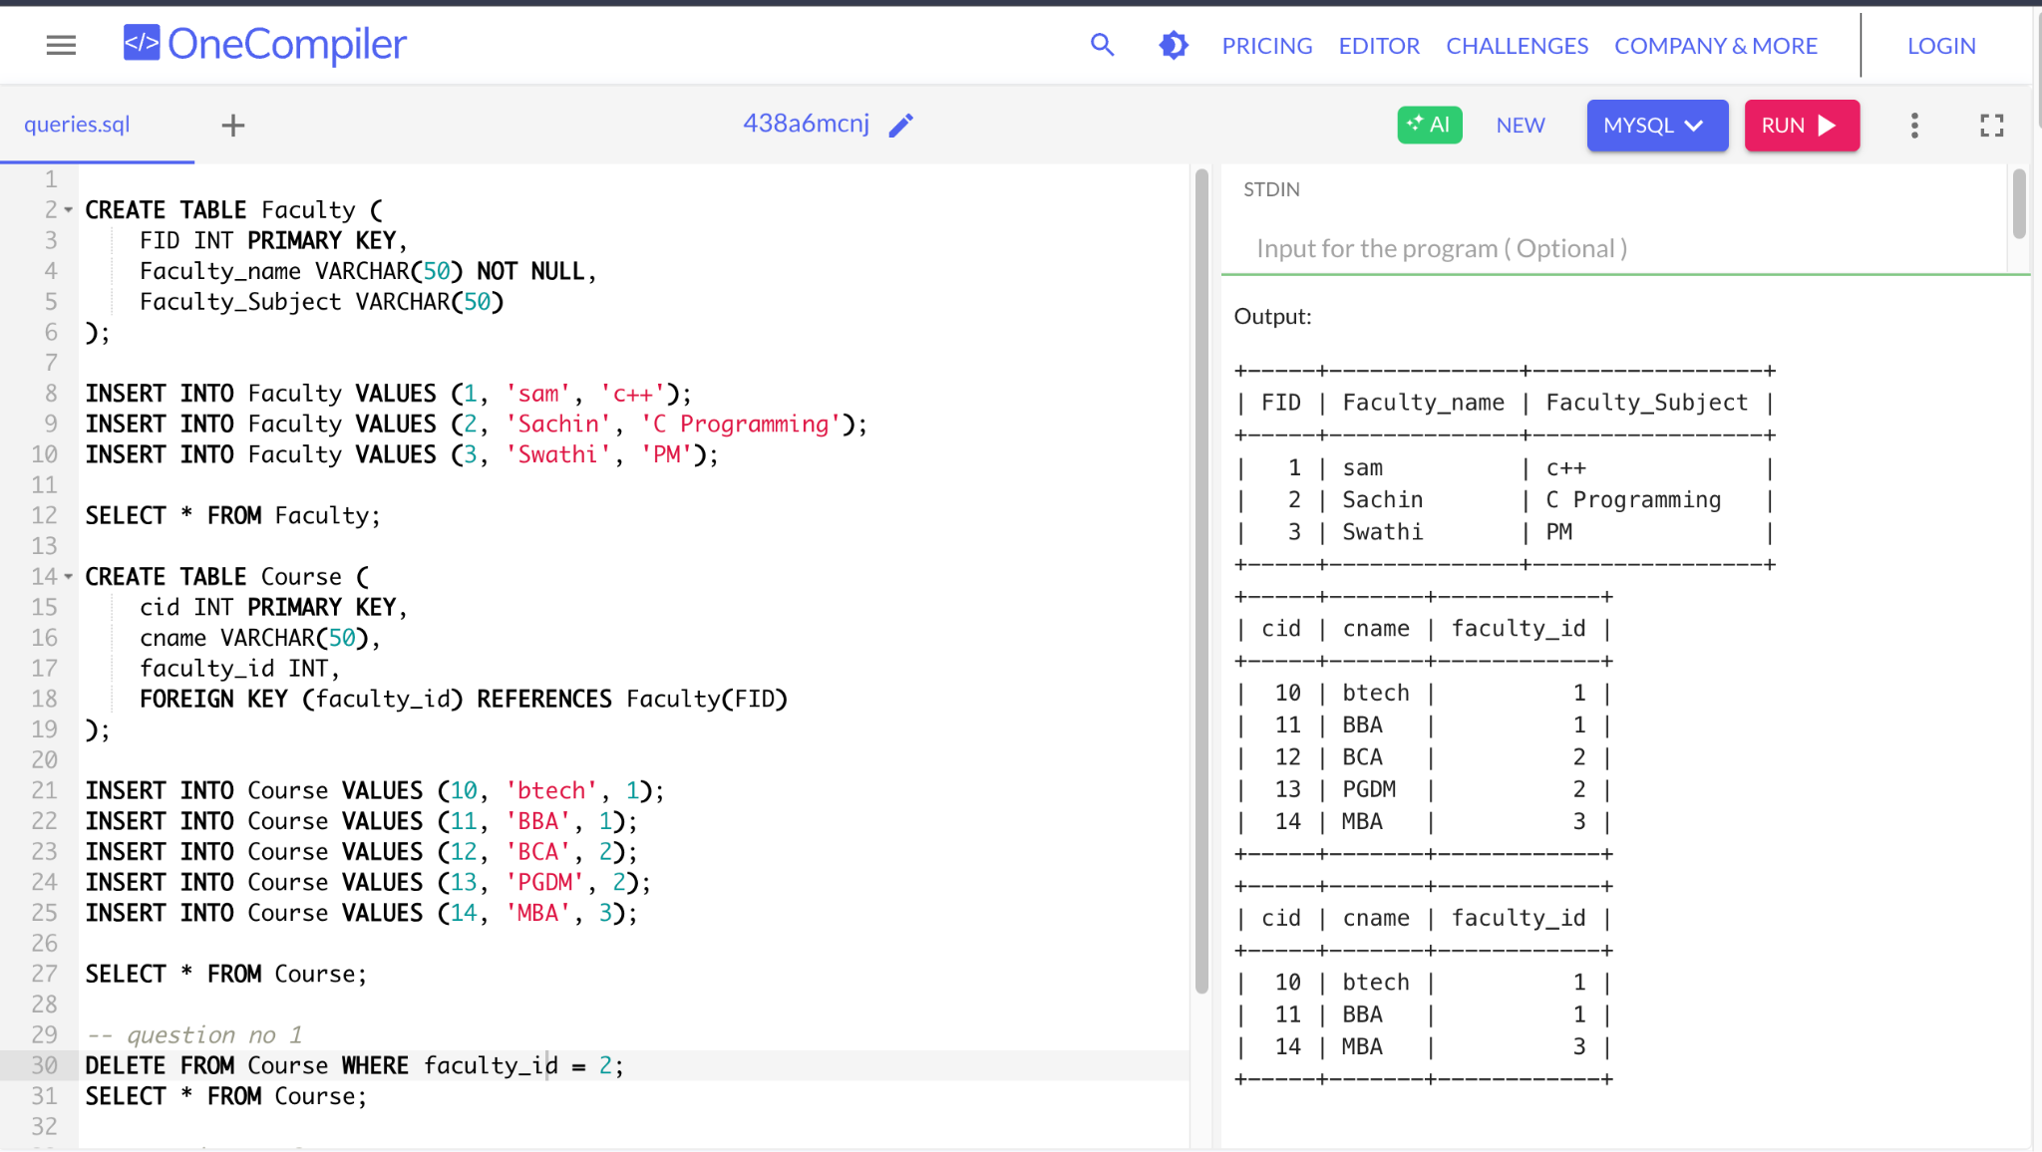

Question no2 - Create table name customers and add the primary key and foreign key

