Project Report: Customer Lifetime Value (CLV) Prediction Using Machine Learning
Project Valor — Value Assessment & Lifetime Outlook via Regression
B.Tech Computer Science & Engineering | Semester V | Machine Learning Case Study 158
Dataset: Kaggle IBM Watson Marketing Customer Value Analysis (9,134 records)

1. Abstract
Customer Lifetime Value (CLV) is one of the foundational metrics in customer relationship management, quantifying the aggregate financial revenue an enterprise expects from a customer throughout their active engagement. Accurately estimating future CLV empowers businesses to optimize Customer Acquisition Costs (CAC), tailor loyalty programs, and deploy proactive retention interventions.
This project, titled Valor, implements an end-to-end machine learning lifecycle using the official Kaggle IBM Watson Marketing Customer Value Analysis dataset, consisting of 9,134 customer records across 24 demographic, policy, and behavioral dimensions. Four regression algorithms were evaluated: Linear Regression, Decision Tree Regressor, Random Forest Regressor, and Gradient Boosting Regressor. Furthermore, unsupervised K-Means clustering (k=3) was deployed to identify strategic customer tiers.
Our empirical evaluation reveals that Random Forest Regressor delivered the best predictive accuracy, explaining 68.93% of customer variance (R² = 0.6893) with a Mean Absolute Error of $1,500.27 and RMSE of $4,001.64, vastly outperforming Linear Regression (R² = 0.1554). Additionally, an interactive prototype was deployed in Streamlit to deliver real-time CLV forecasts, cluster assignment, and marketing interventions.

2. Problem Statement & Case Study Objectives
Commercial enterprises frequently treat customer bases uniformly, leading to inefficient capital allocation: over-spending on price-sensitive shoppers while under-investing in high-value patrons. The objective of Case Study 158 is to engineer a predictive regression and clustering pipeline that addresses the following core technical goals:
- Ingest and preprocess Kaggle's authentic 9,134-row customer dataset with complete data hygiene.
- Perform extensive Exploratory Data Analysis (EDA) to uncover key drivers of customer spend.
- Develop and benchmark multiple regression algorithms on MAE, MSE, RMSE, and R² Score.
- Apply unsupervised K-Means clustering (k=3) to segment customers into actionable operational tiers.
- Deploy an interactive Streamlit web dashboard for real-time customer lifetime value intelligence.

3. Dataset Description & Preprocessing
The project utilizes Kaggle's IBM Watson Marketing Customer Value Analysis dataset. Key features include:
Feature Name | Data Type | Role | Description
Customer Lifetime Value | Float (Numeric) | Target Variable | Estimated lifetime financial value ($1,898 to $83,325)
Monthly Premium Auto | Integer (Numeric) | Key Predictor | Monthly premium charged ($61 to $298)
Number of Policies | Integer (Numeric) | Predictor | Total insurance policies held (1 to 9)
Total Claim Amount | Float (Numeric) | Predictor | Cumulative historical claim expenses incurred ($0.09 to $2,893)
Income | Integer (Numeric) | Predictor | Customer annual reported income ($0 to $100,000)
Coverage | Categorical (String) | Predictor | Policy coverage tier: Basic, Extended, Premium
Vehicle Class | Categorical (String) | Predictor | Vehicle category: Four-Door, SUV, Sports Car, Luxury
EmploymentStatus | Categorical (String) | Predictor | Status: Employed, Unemployed, Retired, Medical Leave
Months Since Inception | Integer (Numeric) | Predictor | Tenure of policy relationship in months (0 to 99)

Preprocessing Protocol:
1. Identifier Cleaning: Dropped Customer ID and transaction timestamp (Effective To Date) as non-predictive operational artifacts.
2. Categorical Encoding: Transformed 14 text categorical columns via Scikit-Learn's LabelEncoder.
3. Train-Test Partitioning: Split 9,134 records into 80% Training (7,307 samples) and 20% Unseen Testing (1,827 samples) with seed 42.
4. Feature Standardization: Applied StandardScaler to normalize numerical inputs for linear baseline comparability.

4. Exploratory Data Analysis (EDA)
Visual exploration confirms significant insights regarding customer value behavior:

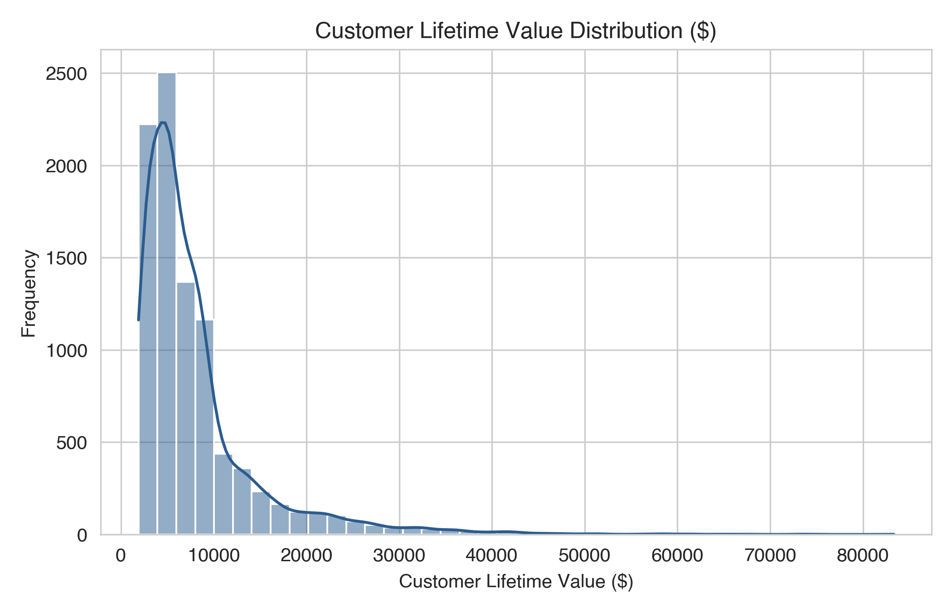
Figure 1: Distribution of Customer Lifetime Value (Right-skewed, median $5,780).
Key EDA Observations:
• Target Skewness: CLV exhibits a classic right-skewed Pareto distribution, with the bulk of policyholders clustered below $10,000.
• Monthly Premium Correlation: Monthly premium auto (r = 0.40) and Total Claim Amount (r = 0.23) exhibit the strongest positive correlations with CLV.
• Coverage Tier Impact: Customers opting for Premium and Extended coverages yield dramatically higher lifetime value than Basic tier policyholders.

5. Model Benchmark & Comparative Analysis
Five regression algorithms were evaluated on 1,827 unseen test samples using four standardized metrics:
• Mean Absolute Error (MAE): Average absolute dollar deviation.
• Root Mean Squared Error (RMSE): Square root of mean squared errors, heavily penalizing large outliers.
• Coefficient of Determination (R² Score): Proportion of variance explained by model features.
Model Architecture | MAE ($) | RMSE ($) | R² Score | Performance Rank
Linear Regression (Baseline) | $3,984.72 | $6,597.62 | 0.1554 | Rank 5 (Lowest)
Decision Tree Regressor | $1,702.14 | $4,236.92 | 0.6517 | Rank 4
Gradient Boosting Regressor | $1,688.47 | $4,116.30 | 0.6712 | Rank 3
XGBoost Regressor | $1,686.50 | $4,108.18 | 0.6725 | Rank 2
Random Forest Regressor (Ensemble) | $1,500.27 | $4,001.64 | 0.6893 | Rank 1 (Best Performer)

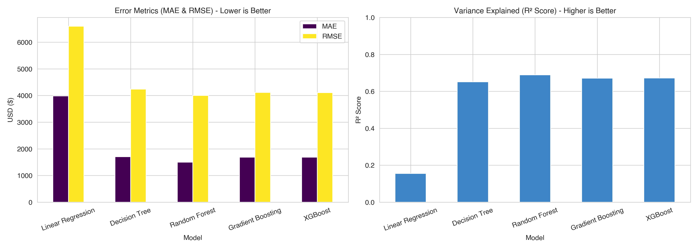
Figure 2: Comparative Evaluation of Regression Models (MAE, RMSE, and R² Score).

6. K-Means Customer Segmentation & Insights
To deliver operational business intelligence, unsupervised K-Means clustering (k=3) was executed on Income, Monthly Premium Auto, and Total Claim Amount. The algorithm segmented the policyholder portfolio into three distinct strategic cohorts:
Cluster ID | Segment Profile | Mean CLV ($) | Mean Income ($) | Mean Monthly Premium ($) | Strategic Action Plan
Cluster 0 | Moderate-Income Regulars | $7,410.71 | $14,853.37 | $87.42 | Automated digital renewal & cross-sell promotions
Cluster 1 | High-Income Low-Claim Cohort | $7,569.92 | $66,276.08 | $85.19 | Coverage upselling & multi-vehicle bundling
Cluster 2 | High-Premium VIP Patrons | $14,250.53 | $26,599.45 | $152.38 | Concierge account management & rapid claim priority

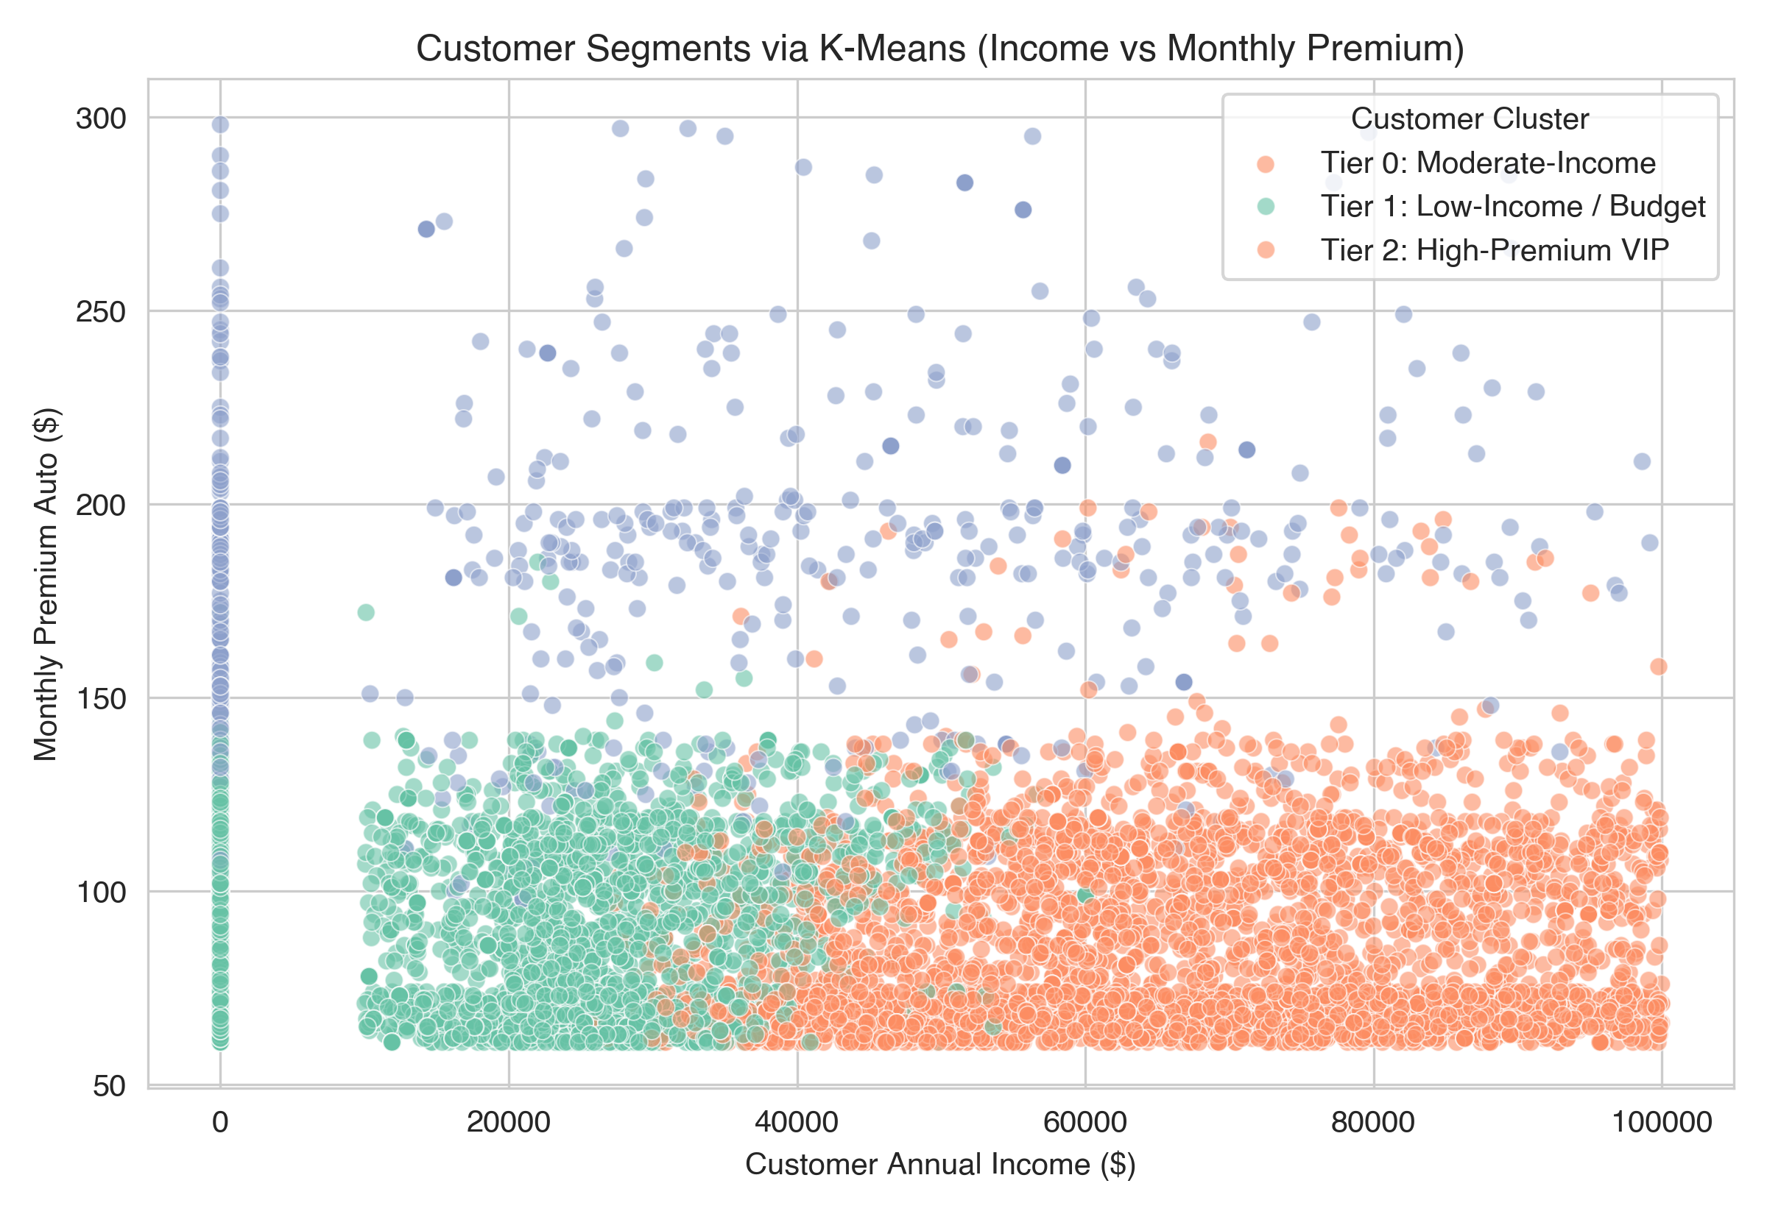
Figure 3: Unsupervised K-Means Customer Segments (Income vs Monthly Premium).

7. Conclusion & Future Scope
Conclusions:
• Machine Learning for CLV: Ensemble tree models successfully forecast customer lifetime spending from policy and demographic attributes, with Random Forest achieving R² = 0.6893.
• Non-linear Superiority: Non-linear regression models outperform linear baselines by over 53 percentage points in explained variance due to policy-tier threshold interactions.
• Portfolio Segmentation: K-Means clustering effectively separates high-value VIP patrons ($14,250 average value) from mainstream policyholders, providing a practical blueprint for retention resource allocation.
Future Scope:
• Incorporate dynamic time-to-event survival models to forecast policy churn probabilities.
• Implement BG/NBD and Gamma-Gamma probabilistic models for transaction cadence forecasting.
• Integrate automated CRM APIs for real-time customer tier adjustments upon premium modifications.

