RationSeva – Online Ration Card Services Portal
UML Design Package
Use case, class, sequence, activity and state diagrams
Case Study No. 142 | District Supply Office | Version 1.0 | Oct 2026

1. Use Case Diagram
Actors: Citizen, Supply Officer, Admin/Staff and the external SMS Gateway. Submit Service Request includes Upload Documents, Check Eligibility and Send SMS.
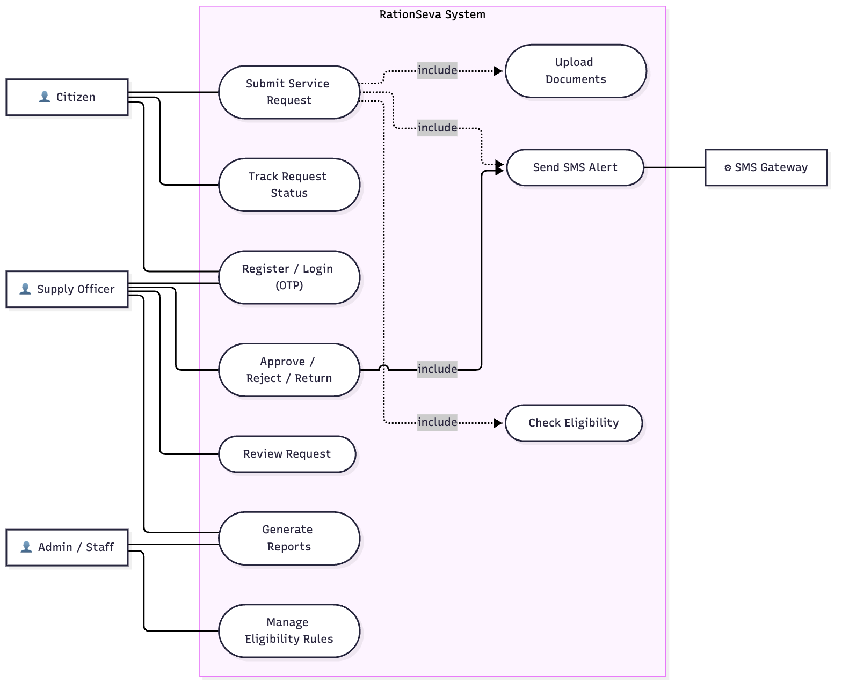
Figure 1: Use case diagram

2. Class Diagram
Core entities: ServiceRequest (one per application), RationCard with FamilyMember (composition, 1..15), Document, ApprovalTask. Versioned EligibilityRule records are evaluated by RuleEngine.
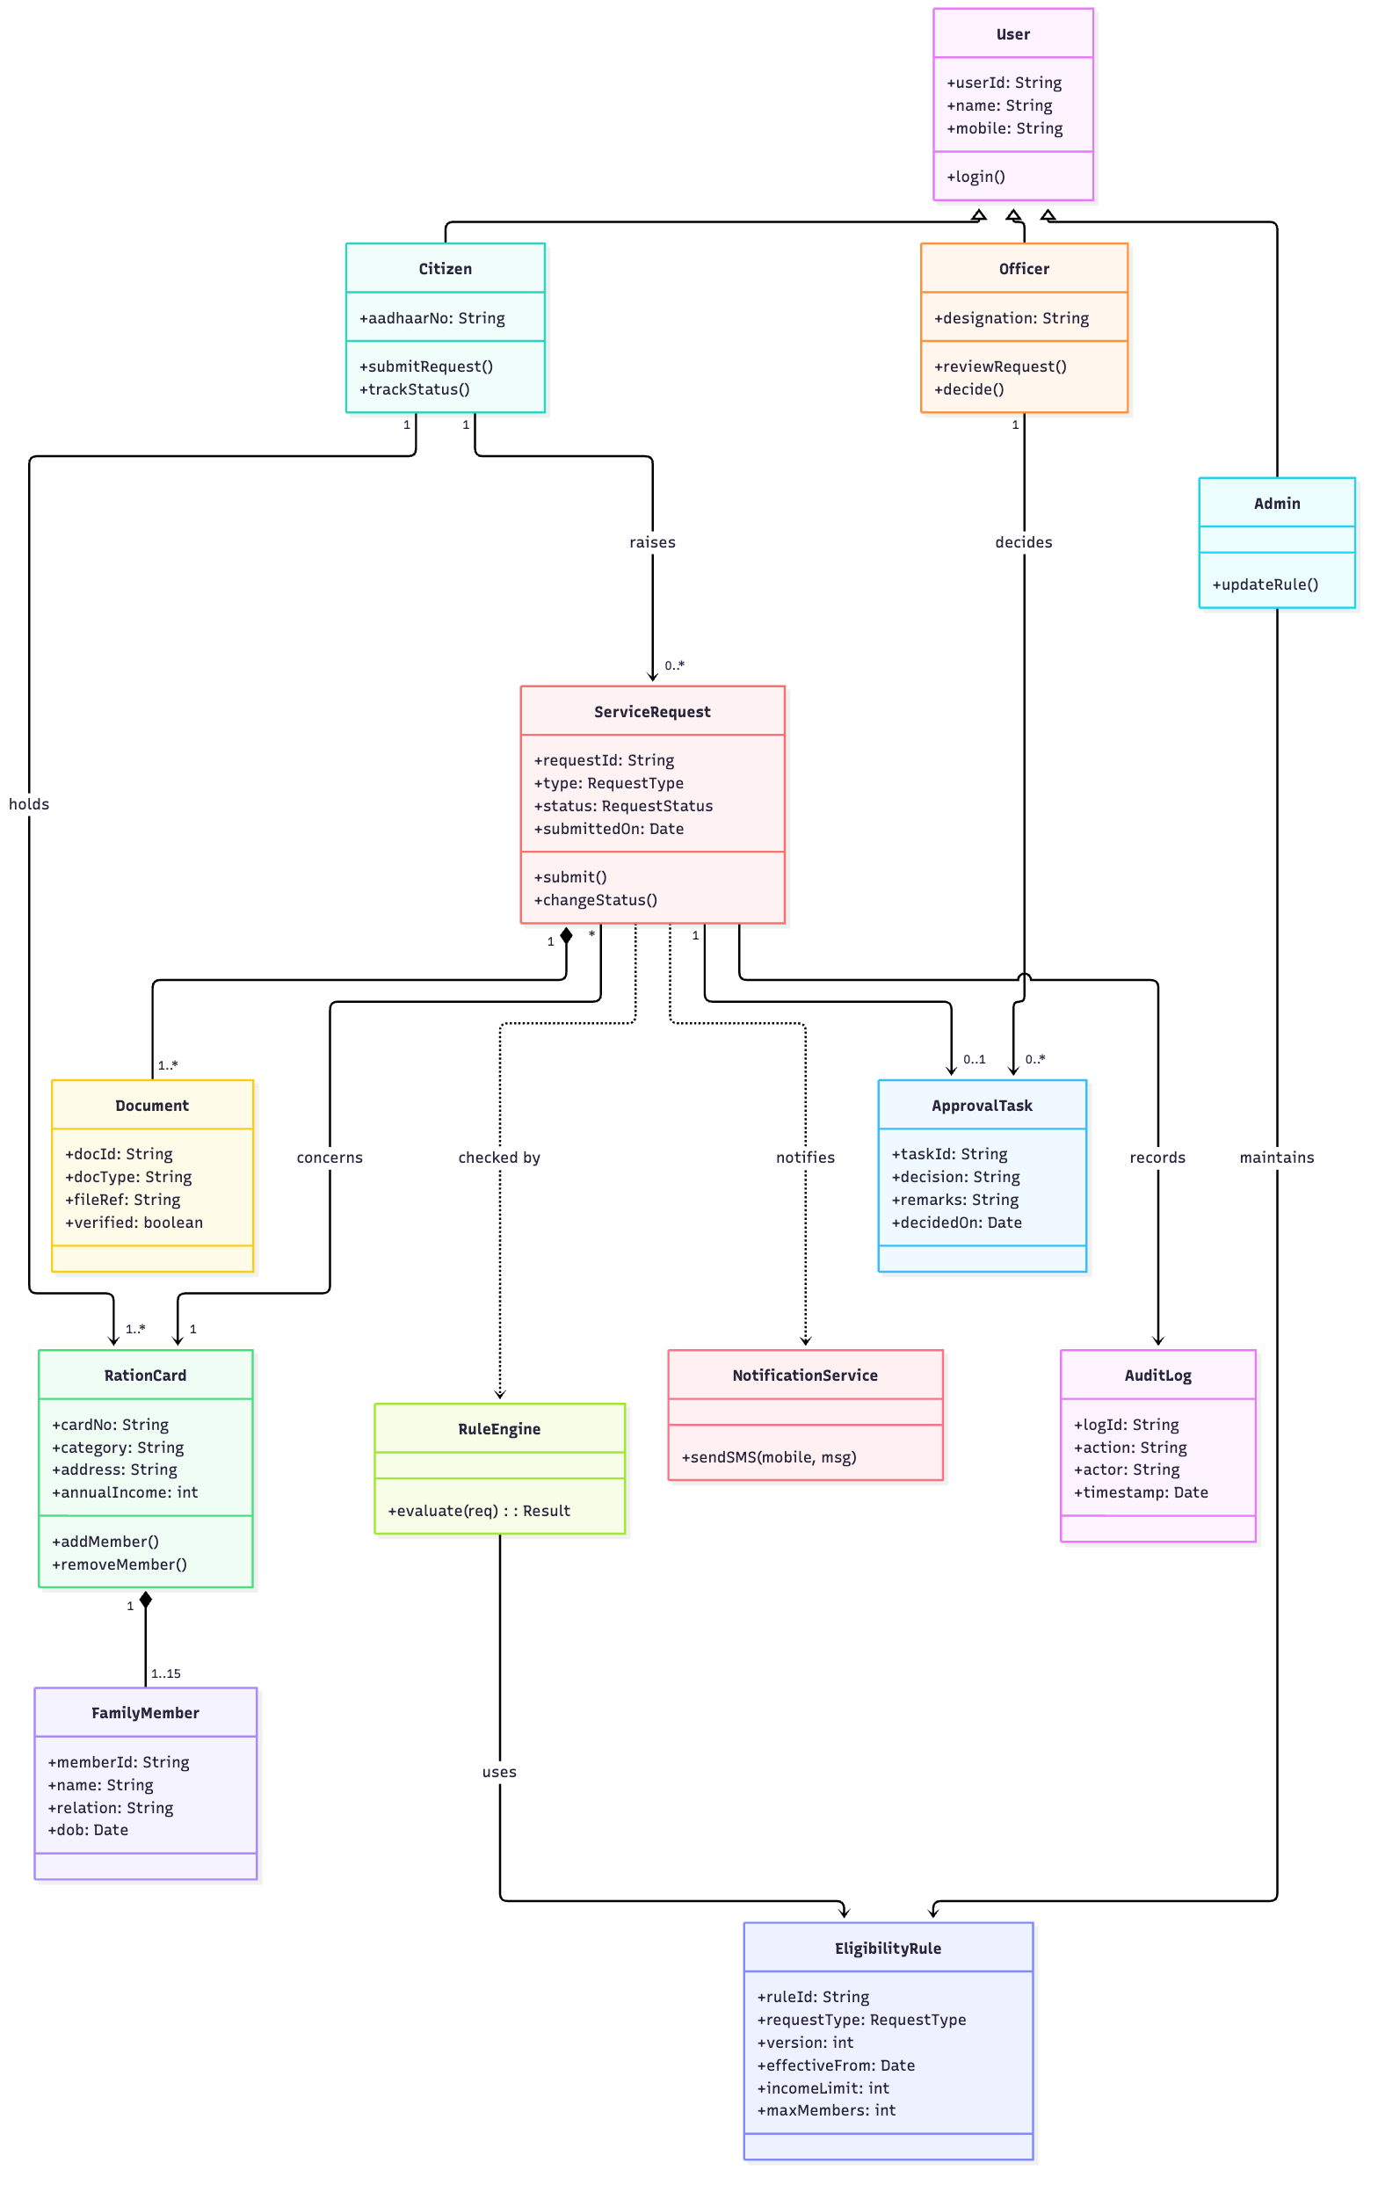
Figure 2: Class diagram

3. Sequence Diagram – Request Adding a Member to a Ration Card
The Intake Service validates the request through RuleEngine, saves it and publishes a RequestSubmitted event. The Approval Service picks the event up from the queue, so intake never calls approval directly.
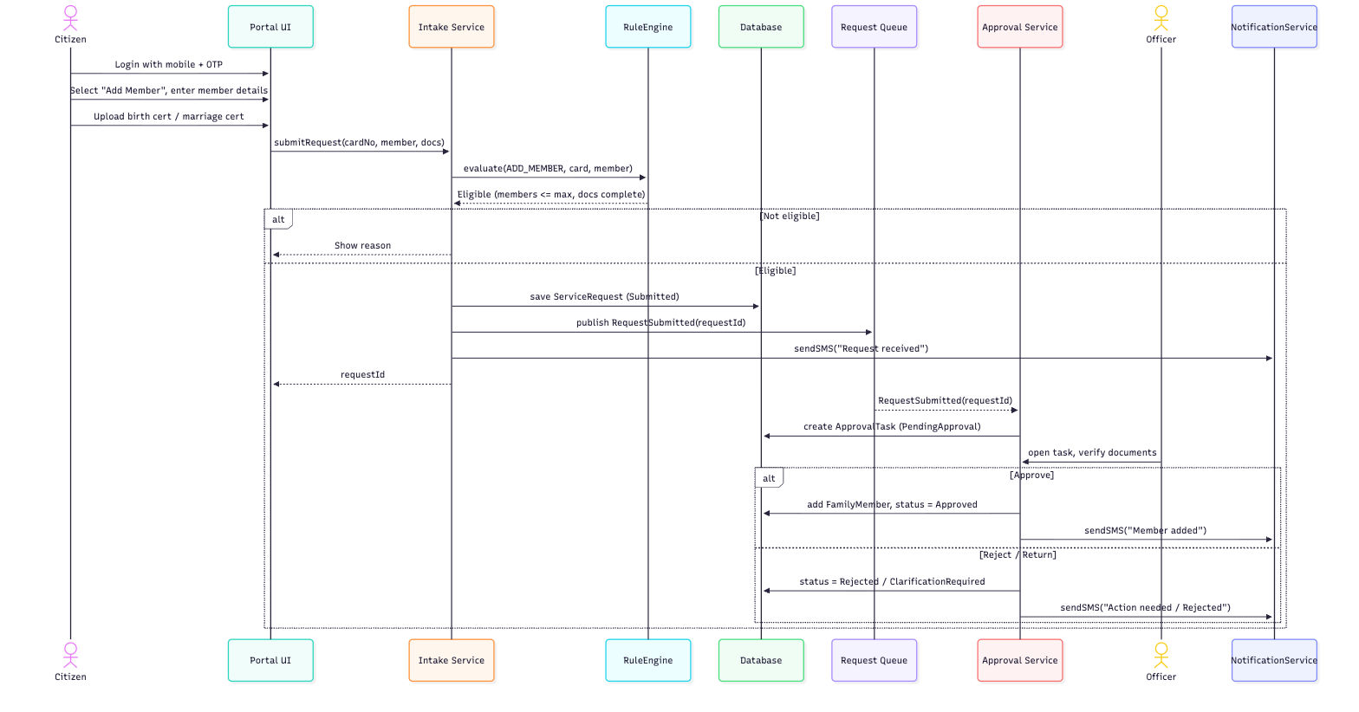
Figure 3: Sequence diagram – Add Member

4. Activity Diagram – Service Request Processing
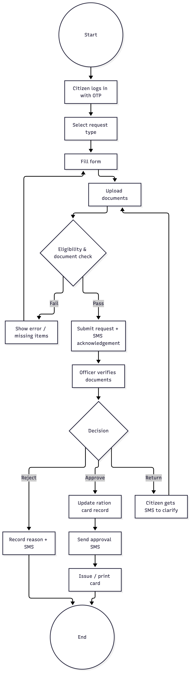
Figure 4: Activity diagram

5. State Diagram – ServiceRequest
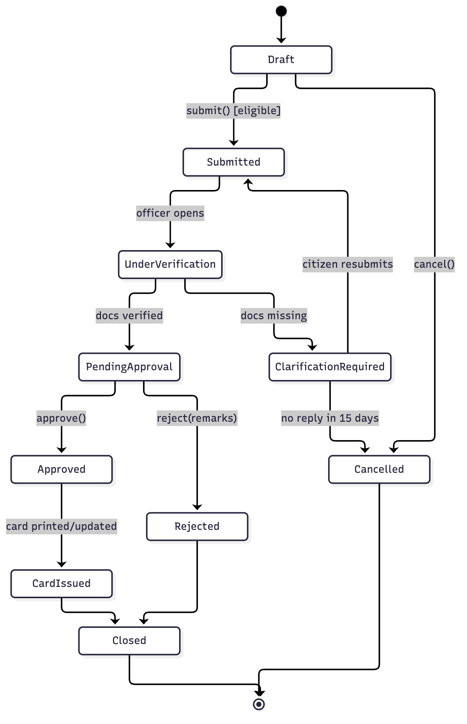
Figure 5: State diagram of ServiceRequest.status

6. Consistency Check
Element | Use case | Class | Sequence | State
Submit request | UC2 | ServiceRequest.submit() | submitRequest() | Draft → Submitted
Eligibility check | UC10 | RuleEngine.evaluate() | evaluate(ADD_MEMBER) | guard [eligible]
Officer decision | UC6 | ApprovalTask, Officer.decide() | Approve / Reject alt | PendingApproval → Approved/Rejected
Return for docs | UC6 | ApprovalTask.decision | Reject / Return | ClarificationRequired
SMS alert | UC9 | NotificationService.sendSMS() | sendSMS() | on every transition
Add member | UC2 | RationCard.addMember(), FamilyMember | add FamilyMember | Approved → CardIssued

7. Cohesion & Coupling Justification

Loose coupling: request intake vs officer approval
- Event / queue based: Intake publishes RequestSubmitted(requestId) and Approval subscribes to it. Neither calls the other directly (message coupling, the loosest kind).
- Only the ID is shared: The modules share just the requestId and the status values. No internal objects are passed between them (data coupling, not stamp or control coupling).
- Rules are external: Both modules call RuleEngine, which reads versioned EligibilityRule data. A state rule change does not touch intake or approval code.
- Benefit: If approval is down, citizens can still submit, because requests wait in the queue. The approval UI can also be redesigned without retesting intake.

High cohesion: each module has a single purpose
Module | Single responsibility | Cohesion type
Intake | Capture the application and documents, validate, save | Functional
RuleEngine | Evaluate eligibility for a request type | Functional
Approval | Officer queue and decisions | Functional
Notification | Send SMS for any event | Functional
Audit | Record every change, read-only | Functional

